**FEDERAL UNIVERSITY OF TECHNOLOGY, OWERRI**

**P.M.B 1526, OWERRI, IMO STATE**

**A TERM PAPER ON**

**MULTI DIMENSIONAL DATA ANALYSIS**

**PRESENTED BY**

**AMALAGU CHIKEZIE SIMON**

**20181097185**

**DEPARTMENT OF COMPUTER SCIENCE**

**SCHOOL OF INFORMATION AND COMMUNICATION TECHNOLOGY**

**(SICT)**

**IN PARTIAL FULFILLMENT OF THE REQUIREMENTS FOR THE DATA MINING & BIG DATA ANALYSIS (CSC 513) COURSE**

**SEPTEMBER, 2023**

**ABSTRACT**

This term paper embarks on a comprehensive journey through the realm of multidimensional data analysis. We start by defining the concept and tracing its historical evolution, laying a strong foundation for understanding its significance. The exploration includes a deep dive into data warehousing and the architecture of multidimensional models, explaining how they underpin this analytical approach. Online Analytical Processing (OLAP) is introduced as a pivotal technique, accompanied by practical examples of its operations and tools. Data cubes take center stage, with discussions on their construction, representation, and advantages. The paper also explores the art of multidimensional data visualization and its practical applications. Furthermore, we delve into how multidimensional data analysis and data mining intertwine, showcasing successful case studies. Real-world applications across diverse domains are presented, highlighting the tangible benefits. Finally, we address the challenges and future trends that shape this evolving landscape, providing a holistic view of multidimensional data analysis

**TABLE OF CONTENT**

ABSTRACT 2

I. INTRODUCTION 5

BACKGROUND AND SIGNIFICANCE OF MULTI-DIMENSIONAL DATA ANALYSIS (MDDA) 5

PURPOSE AND OBJECTIVES OF THIS TERM PAPER 5

PREVIEW OF KEY TOPICS COVERED 6

Key Concepts 6

II. UNDERSTANDING MULTI-DIMENSIONAL DATA AND MULTI-DIMENSIONAL DATA ANALYSIS (MDDA) 8

WHAT IS MULTIDIMENSIONAL DATA? 8

MULTIDIMENSIONAL DATA MODEL (OR DATABASE) 8

TYPES OF MULTIDIMENSIONAL MODELS 10

DEFINITION AND CONCEPT OF MULTI-DIMENSIONAL DATA ANALYSIS 12

HISTORICAL CONTEXT AND EVOLUTION OF MDDA 12

REAL-WORLD APPLICATIONS AND RELEVANCE 13

III. ONLINE ANALYTICAL PROCESSING (OLAP) AS THE FOUNDATION 14

EXPLANATION OF OLAP AND ITS ROLE IN MDDA 14

OLAP VS. OLTP (ONLINE TRANSACTION PROCESSING) 15

KEY FEATURES AND CHARACTERISTICS OF OLAP 16

Types of OLAP 17

1. OLAP: 17

2. MOLAP (Multidimensional OLAP): 17

3. ROLAP (Relational OLAP): 17

4. HOLAP (Hybrid OLAP): 17

5. SOLAP (Spatial OLAP): 17

OPERATIONS ON MULTIDIMENSIONAL DATA CUBE 19

IV. THE BUILDING BLOCKS OF OLAP 20

DIMENSIONS AND DIMENSION HIERARCHIES 20

MEASURES AND AGGREGATIONS 20

CUBOIDS: CREATING MULTI-DIMENSIONAL VIEWS 20

SLICING AND DICING FOR DATA EXPLORATION 21

V. MULTI-DIMENSIONAL ANALYSIS IN PRACTICE 22

USER INTERACTION AND INTERFACES 22

AD-HOC ANALYSIS CAPABILITIES 22

QUERY PERFORMANCE AND OPTIMIZATION 22

DECISION SUPPORT AND BUSINESS INTELLIGENCE 23

VI. TRANSFORMING RAW DATA INTO INSIGHTS 24

THE DATA TRANSFORMATION PROCESS 24

ROLE OF OLAP IN DATA PREPROCESSING 24

BENEFITS OF STRUCTURED DATA FOR ANALYSIS 25

VII. OLAP IN BUSINESS INTELLIGENCE (BI) 26

INTEGRATION OF OLAP INTO BI SOLUTIONS 26

HOW OLAP POWERS BI DASHBOARDS AND REPORTS 26

BI AND OLAP'S IMPACT ON DECISION-MAKING 27

VIII. SCALABILITY AND HANDLING BIG DATA 28

OLAP'S SCALABILITY FOR LARGE DATASETS 28

HANDLING THE CHALLENGES OF BIG DATA IN MDDA 28

REAL-WORLD IMPLEMENTATION OF MULTI-DIMENSIONALITY 29

RETAIL INDUSTRY (WALMART): 29

HEALTHCARE INDUSTRY (KAISER PERMANENTE): 29

X. CONCLUSION 30

SUMMARY OF KEY FINDINGS AND INSIGHTS 30

THE ENDURING IMPORTANCE OF OLAP IN MDDA 30

**I. INTRODUCTION**

**BACKGROUND AND SIGNIFICANCE OF MULTI-DIMENSIONAL DATA ANALYSIS (MDDA)**

In recent decades, the proliferation of data in various forms has transformed the way businesses, organizations, and researchers operate. The age of information has ushered in an era where vast amounts of data are generated daily, from customer transactions and social media interactions to sensor data in industrial settings. This deluge of data presents both an opportunity and a challenge. How can we extract meaningful insights, make informed decisions, and derive actionable intelligence from this data?

This is where Multi-Dimensional Data Analysis (MDDA) emerges as a pivotal concept. MDDA represents a sophisticated approach to data analysis that enables us to explore complex datasets from multiple angles, discern patterns, and gain a deeper understanding of underlying relationships. It is a powerful tool that allows us to navigate the intricate web of information that the modern world produces.

The significance of MDDA extends across various domains. In business, it empowers organizations to optimize operations, enhance customer experiences, and identify market trends. In scientific research, it aids in deciphering complex phenomena, from climate patterns to genomics. Government agencies leverage MDDA to make data-driven policy decisions, and healthcare professionals use it for disease diagnosis and treatment planning.

Understanding MDDA is not only essential but practically indispensable in today's data-driven world. As such, this term paper delves into the intricacies of MDDA, shedding light on its principles, methodologies, and applications. It aims to provide a comprehensive view of how MDDA transforms raw data into actionable insights, thereby helping businesses, researchers, and decision-makers harness the full potential of their data resources.

**PURPOSE AND OBJECTIVES OF THIS TERM PAPER**

The primary purpose of this term paper is to offer a comprehensive exploration of Multi-Dimensional Data Analysis (MDDA) and its close relationship with Online Analytical Processing (OLAP). By doing so, it aims to achieve several key objectives:

1. **Educational:** To provide readers with a clear and detailed understanding of what MDDA entails, how OLAP plays a foundational role in it, and why this knowledge is vital in the context of modern data analysis.

2. **Practical Insights:** To equip readers with practical insights into how MDDA is applied in real-world scenarios, including business intelligence, scientific research, and big data analytics.

3. **Technical Understanding:** To delve into the technical aspects of OLAP systems, their features, and their contributions to the MDDA process.

1. **Challenges and Future Prospects:** To highlight the challenges that organizations face in implementing MDDA and OLAP solutions and to explore emerging trends that are shaping the future of multi-dimensional data analysis.

**PREVIEW OF KEY TOPICS COVERED**

Throughout this term paper, we will navigate through the following key topics:

* An exploration of the fundamental concepts and principles behind Multi-Dimensional Data Analysis (MDDA).
* A detailed examination of Online Analytical Processing (OLAP) as the underlying technology that enables MDDA.
* Practical applications of MDDA in various domains, showcasing its versatility and impact.
* Insights into the transformation of raw data into actionable intelligence through OLAP systems.
* The role of MDDA and OLAP in the realm of Business Intelligence (BI) and decision-making processes.
* A discussion on scalability and handling big data challenges in MDDA.
* An overview of the common challenges faced in MDDA and OLAP implementation and a glimpse into the future trends that will shape the field.

By embarking on this journey through the world of MDDA and OLAP, readers will gain a deeper appreciation for the power of multi-dimensional data analysis and its pivotal role in harnessing the potential of data in the 21st century.

## Key Concepts

In delving into the realm of multidimensional analysis, several key concepts lay the foundation for a comprehensive understanding of the data landscape:

**Data Warehouse:** A data warehouse serves as a dedicated database for reporting and data analysis, acting as a central repository of information to address pertinent business questions. This repository is particularly designed to store historical data, enabling trend analysis over time.

**Multidimensional Database (MDB):** An MDB (multidimensional database) is crafted explicitly for data warehouses and Online Analytical Processing (OLAP). Comprising three or more dimensions (X, Y, and Z), MDBs provide a structured environment for in-depth analysis of multidimensional data.

**Data Model:** A data model functions as a visual map, depicting how information should be logically organized. This representation proves invaluable for solving diverse problems, aiding in the comprehension of complex systems, uncovering hidden patterns, and facilitating swift decision-making. Typically, data models center around a fact table that numerically represents a central theme.

**Measures:** Measures constitute numerical data, such as sales or revenue, subject to analysis and comparison. In a multidimensional data model, these are typically stored in fact tables, forming a quantitative foundation for analysis.

**Dimensions:** Dimensions are attributes describing the measures, encompassing elements like time, location, or product. Stored in dimension tables, dimensions provide context to the numerical data, enriching the analysis.

**Cubes:** Cubes stand as structural representations of the intricate relationships between measures and dimensions within a data model. They offer an expedited and efficient means to retrieve and analyze data, forming the backbone of multidimensional analysis.

**Aggregation:** Aggregation is the pivotal process of summarizing data across dimensions and levels of detail. This functionality, inherent in multidimensional data models, empowers users to swiftly analyze data at varying granularities.

**Hierarchies:** Hierarchies offer an organizational framework for dimensions, arranging them into levels of detail. For example, a time dimension might feature hierarchies structured around years, quarters, months, and days. Hierarchies facilitate seamless navigation of data and support drill-down and roll-up operations for a nuanced analysis.

**II. UNDERSTANDING MULTI-DIMENSIONAL DATA AND MULTI-DIMENSIONAL DATA ANALYSIS (MDDA)**

## What is Multidimensional Data?

In the landscape of data analysis, **multidimensional data** emerges as a dataset enriched with three or more variables or dimensions. To illustrate, consider a dataset centered around customer information, encompassing variables such as age, gender, income level, location, and purchase history. In this context, each variable assumes the role of a dimension, collectively contributing to the multidimensional nature of the dataset.

The complexity of multidimensional data intensifies as the number of dimensions expands. The exponential increase in possible combinations between these variables necessitates the use of specialized tools and techniques that surpass the capabilities of conventional charts and graphs for effective analysis.

The **structure** of a multidimensional dataset, often referred to as its **features** or **attributes**, is quantified by the number of columns. This structure is analogous to envisioning a cube with multiple planes, a departure from the constraints of two-dimensional analysis. A higher number of columns augurs well for uncovering hidden insights within the dataset.

The term "multidimensional data" transcends the limitations of traditional two-dimensional structures, offering a unique perspective that can unveil crucial information for informed decision-making. Embracing this data model confers several advantages, notably providing a holistic view that leads to comprehensive conclusions. This is exemplified in applications like predictive maintenance, where a complete picture facilitates proactive decision-making. Moreover, in fields such as health and disease analysis, exploring multidimensional datasets empowers researchers to gain a deeper understanding of public health dynamics, fostering advancements in the understanding of complex systems.

## Multidimensional Data Model (or Database)

A **multidimensional data model** or **database** represents a strategic approach to database organization, where information is structured around multiple dimensions or data points, facilitating intricate data analysis. This model finds prevalent use in business intelligence and data warehousing applications, empowering users to analyze data comprehensively from various perspectives.

At its core, a multidimensional data model is a sophisticated database design that organizes information as facts (measures) intricately linked with dimensions (attributes). In essence, it encapsulates information across diverse categories or measurements such as time, geography, product lines, customer segments, and more. These dimensions serve as the metrics to gauge performance indicators like sales revenue or profit margins.

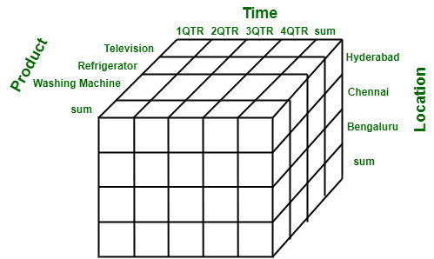

**Fig. 1: A multidimensional data cube**

To illustrate its effectiveness, consider the scenario of analyzing a company's sales performance over time. In a traditional flat database structure, you might have a single table with columns for date/time stamps and sales figures. However, embracing a multidimensional approach allows for the creation of distinct tables for each dimension—one for dates and times, another for products sold, and yet another for geographic regions. These tables are intelligently interconnected through standard keys, offering the flexibility to analyze data in any desired combination. This departure from a linear structure empowers users with a versatile analytical tool, enabling a nuanced exploration of intricate datasets from multiple angles.

## 

## Types of Multidimensional Models

In the realm of multidimensional data models, distinct structures cater to varied analytical needs, each offering a unique set of advantages and challenges:

**A. STAR Schema**

The **STAR schema** derives its name from its physical model resembling a star, with a central fact table and dimension tables radiating outwards like points of a star. This schema is a cornerstone in OLAP systems for efficiently designing OLAP cubes. Notable advantages include simplified query logic, especially when compared to highly normalized transactional schemas. Common business reporting logic, such as as-of reporting and period-over-period analysis, is streamlined in the STAR schema. However, drawbacks include challenges in data integrity enforcement due to its de-normalized state, inflexibility in meeting analytical needs compared to a normalized data model, and limited support for many-to-many relationships within business entities.

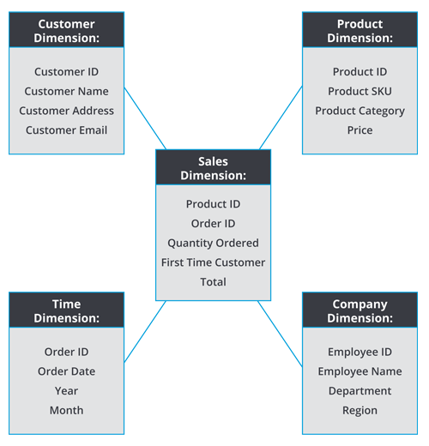

**Fig. 2: Example of a Star Schema**

**B. SNOWFLAKE Schema**

The **SNOWFLAKE schema** extends the STAR schema, presenting a logical arrangement resembling a snowflake shape in the ER diagram. Unlike the STAR schema, the dimension tables in the SNOWFLAKE schema are normalized, resulting in a more intricate structure. This schema boasts benefits such as reduced disk space usage and easier implementation when adding dimensions. However, the use of multiple tables can lead to reduced query performance, and the schema demands more maintenance efforts due to its numerous lookup tables.

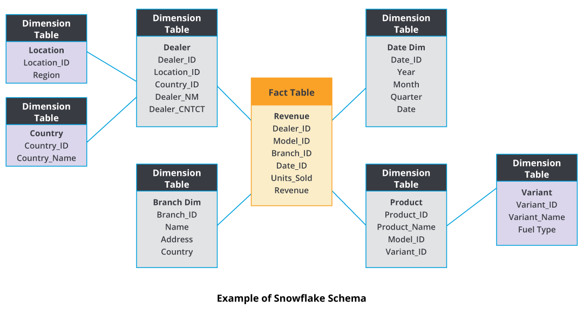

**C. FACT CONSTELLATIONS**

The **FACT CONSTELLATIONS** schema, often perceived as an extension of the STAR schema, is a measure of online analytical processing. It comprises multiple fact tables that share dimension tables, forming a collection akin to stars in a constellation. Also known as a galaxy schema, this structure is more complex than both the STAR and SNOWFLAKE schemas. Creating a FACT CONSTELLATIONS schema involves splitting an original STAR schema into additional STAR schemas. While offering flexibility in its schema design, this complexity renders it challenging to implement and maintain. The schema's advantage lies in its adaptability, while its drawback stems from the intricacies involved in managing its complexity.

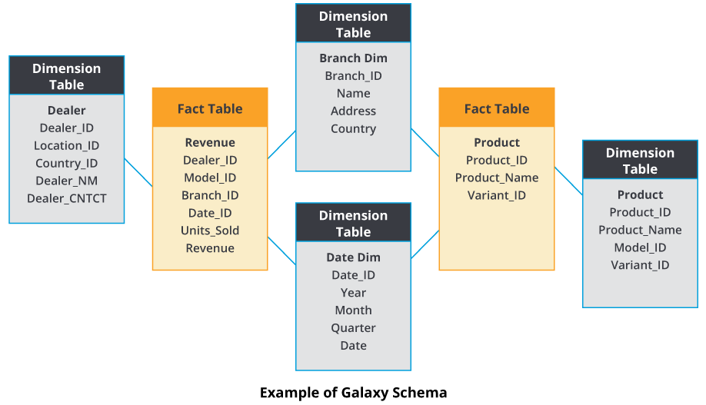

**Fig. 4: Fact Constellation Schema**

**DEFINITION AND CONCEPT OF MULTI-DIMENSIONAL DATA ANALYSIS**

Multi-Dimensional Data Analysis (MDDA) represents a data analysis approach that stands as a cornerstone in the realm of modern data analytics. At its core, MDDA involves the exploration and interpretation of complex datasets by considering multiple dimensions or perspectives simultaneously. In essence, it offers a multidimensional view of data, allowing analysts to dissect information along various axes, such as time, geography, product, or any other relevant parameter.

MDDA is built upon the fundamental idea that data is seldom one-dimensional. Real-world datasets are inherently rich and multifaceted, comprising numerous variables and attributes. Traditional statistical analysis or single-dimensional data exploration often falls short in revealing the intricate relationships and patterns within such data. MDDA, on the other hand, enables analysts to examine data from different angles, providing a holistic perspective that facilitates more profound insights.

Through MDDA, data is organized into dimensions, hierarchies, and measures, forming what is often referred to as an OLAP cube (Online Analytical Processing cube). Each dimension represents a categorical view of data, such as product categories or time periods, and dimensions can be organized into hierarchies for more granular analysis. Measures, on the other hand, are quantitative expressions, like sales revenue or customer counts, which provide the numerical basis for analysis.

**HISTORICAL CONTEXT AND EVOLUTION OF MDDA**

The historical roots of MDDA can be traced back to the field of Business Intelligence (BI) and the need for organizations to make data-driven decisions. Early forms of MDDA emerged in the 1970s and 1980s with the advent of decision support systems (DSS). These systems aimed to provide executives and managers with tools for accessing and analyzing business data.

However, it was in the 1990s that MDDA truly came into its own with the development of Online Analytical Processing (OLAP) systems. OLAP systems, such as the pioneering work of Dr. E.F. Codd, revolutionized data analysis by introducing the concept of multidimensional data cubes. These systems enabled users to interactively explore data in ways that were previously unimaginable.

As computing power increased and data storage became more affordable, MDDA gained traction across various industries and research fields. Today, it is an integral part of the data analytics toolkit, with applications spanning from finance and healthcare to marketing and scientific research.

**REAL-WORLD APPLICATIONS AND RELEVANCE**

The relevance of MDDA extends across a multitude of domains due to its capacity to uncover hidden insights and facilitate data-driven decision-making. Some prominent real-world applications of MDDA include:

* **Business Intelligence (BI):** MDDA is a linchpin in BI, enabling organizations to analyze sales trends, customer behaviors, and market dynamics. It helps in optimizing inventory management, identifying profitable product lines, and devising effective marketing strategies.
* **Scientific Research:** In fields like genomics, climatology, and particle physics, MDDA aids researchers in comprehending complex data patterns. It allows them to explore relationships between variables, leading to breakthroughs and advancements.
* **Healthcare:** MDDA plays a vital role in healthcare analytics. It assists in patient data analysis, disease diagnosis, and resource allocation optimization in healthcare facilities.
* **Finance:**Financial institutions employ MDDA for risk assessment, fraud detection, and portfolio management. It helps in identifying market trends and predicting investment outcomes.
* **Manufacturing and Supply Chain Management:** Manufacturers utilize MDDA to optimize production processes, monitor equipment health, and enhance supply chain efficiency.
* **Government and Public Policy:** Government agencies leverage MDDA to make informed decisions about resource allocation, urban planning, and disaster management.

MDDA is not just a theoretical concept but a practical and indispensable tool in the era of big data. Its historical evolution, coupled with its diverse real-world applications, underscores its significance in modern data analysis. As we delve deeper into this term paper, we will explore how Online Analytical Processing (OLAP) serves as the backbone of MDDA, enabling analysts to navigate and derive insights from multidimensional data cubes.

**III. ONLINE ANALYTICAL PROCESSING (OLAP) AS THE FOUNDATION**

**EXPLANATION OF OLAP AND ITS ROLE IN MDDA**

Online Analytical Processing (OLAP) is the bedrock upon which Multi-Dimensional Data Analysis (MDDA) is built. OLAP systems are specialized database management systems designed to facilitate complex and interactive analysis of multidimensional data. These systems provide a structured framework for storing, retrieving, and analyzing data in a way that enables users to explore data from multiple dimensions, hierarchies, and measures simultaneously.

At the heart of OLAP is the concept of the multidimensional data cube. This cube represents a three-dimensional (or higher-dimensional) space where data is organized. Each axis of the cube corresponds to a dimension, such as time, geography, or product category, and the cells within the cube contain aggregated or detailed numerical data known as measures. OLAP cubes provide a visual and interactive representation of data, allowing users to pivot, drill down, and slice and dice the data to gain insights.

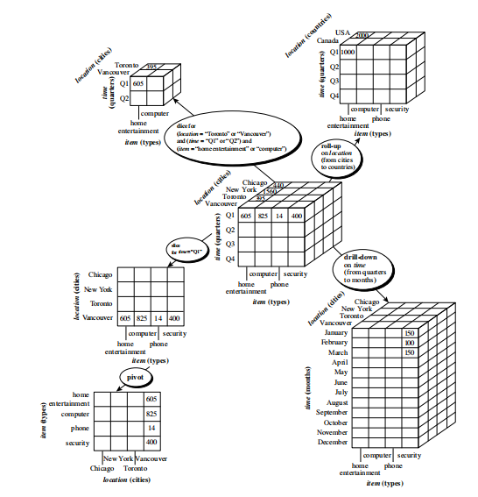**Fig.: OLAP operations on multidimensional data**

**OLAP VS. OLTP (ONLINE TRANSACTION PROCESSING)**

It's essential to distinguish OLAP from OLTP (Online Transaction Processing) systems, as they serve fundamentally different purposes within the data management landscape.

-**OLAP (Online Analytical Processing):** OLAP systems are designed for complex data analysis and reporting. They store historical data and support read-heavy operations. OLAP databases are optimized for query performance, enabling users to retrieve aggregated and summarized data quickly. The focus is on facilitating business intelligence, decision support, and data exploration.

- **OLTP (Online Transaction Processing):** OLTP systems, on the other hand, are designed for transactional operations. They are geared towards handling day-to-day business transactions, such as sales, inventory management, and order processing. OLTP databases prioritize data consistency and support frequent read and write operations. The focus is on ensuring the integrity of real-time transactional data.

In essence, OLAP and OLTP represent two sides of the data management coin. OLAP empowers analysts and decision-makers with the tools needed to explore historical data, identify trends, and make strategic decisions. OLTP, on the other hand, ensures the smooth and efficient execution of business transactions.

**KEY FEATURES AND CHARACTERISTICS OF OLAP**

OLAP systems possess several key features and characteristics that make them indispensable for MDDA:

- **Multidimensionality:** OLAP systems inherently support multidimensionality, allowing users to analyze data along various axes or dimensions simultaneously. This capability enables a comprehensive view of data relationships.

- **Aggregation:** OLAP cubes store aggregated data, which enhances query performance. Users can quickly access summary information and drill down into more granular levels when needed.

- **Interactive Analysis:** OLAP systems offer interactive interfaces that empower users to explore data intuitively. Analysts can pivot dimensions, drill down into hierarchies, and create ad hoc reports and visualizations.

- **Hierarchies:** Dimensions within OLAP cubes often have hierarchical structures, enabling users to navigate data from high-level summaries to detailed levels of information. This hierarchical organization simplifies the analysis process.

- **Data Slicing and Dicing**\* Slicing involves selecting a specific dimension or attribute, while dicing entails analyzing data by selecting multiple dimensions. These operations provide flexibility in examining data from various angles.

- **Fast Query Response:** OLAP systems are optimized for query performance, delivering rapid responses to analytical queries. This speed is crucial for facilitating on-the-fly data exploration.

- **Support for Complex Calculations:** OLAP systems include calculation engines that allow users to perform complex calculations across dimensions. This capability is valuable for deriving custom measures and KPIs.

In essence, OLAP technology forms the backbone of MDDA, enabling analysts to navigate and extract valuable insights from multidimensional data cubes. The multidimensional nature of OLAP systems harmonizes seamlessly with the diverse dimensions and measures present in real-world datasets, making it an indispensable tool for modern data-driven decision-making. As we delve further into this term paper, we will explore how OLAP cubes are constructed, queried, and utilized in practical applications of MDDA.

## Types of OLAP

OLAP, standing for Online Analytical Processing, manifests in various types, each tailored to specific analytical needs and preferences. The primary types include:

**1. OLAP:**

OLAP servers empower analysts to delve deep into performance analysis, offering a diverse array of data views. Its multidimensional approach showcases different facets of business data through operations like Pivot, slice and dice, and rollup along one or more dimensions. Key characteristics encompass summarization, projected data, fast interactive analysis, and adaptability to frequently changing business models. OLAP's conceptual model emphasizes aggregation as a pivotal operation, facilitating computations like total production by state or month with corresponding rankings.

**2. MOLAP (Multidimensional OLAP):**

MOLAP directly supports the multidimensional view of data through a specialized storage engine. While it excels in indexing properties and speed, it may not be space-efficient, particularly with sparse data. ESSBASE serves as an example of MOLAP implementation.

**3. ROLAP (Relational OLAP):**

Positioned as an intermediate server between the backend server and the client, ROLAP supports on-the-fly multidimensional OLAP queries. Leveraging the transactional and scalability features of relational systems, ROLAP may encounter performance issues due to potential mismatches between queries.

**4. HOLAP (Hybrid OLAP):**

HOLAP represents a synthesis of MOLAP and ROLAP, combining the strengths of both. When dealing with non-dense data, ROLAP servers offer superior performance, while MOLAP excels in managing dense data. HOLAP, implemented by vendors like Speedware and Microsoft, strategically stores dense regions of the cube using MOLAP and the rest using a ROLAP approach.

**5. SOLAP (Spatial OLAP):**

SOLAP explores data related to space or spatial data, integrating concepts from Geographic Information System (GIS) and OLAP. This type of OLAP provides a visual platform tailored for swift and convenient temporal analysis. It employs a multidimensional approach with various aggregation levels, presented through graphical and tabular displays.

These diverse OLAP types cater to the intricate needs of analytical exploration, offering varied approaches to handling data and extracting insights.

## Operations on Multidimensional Data Cube

Operations on a multidimensional data cube enable intricate analysis and exploration of data, offering several methods to extract meaningful insights:

**Roll-up/Drill-down:**

This method involves aggregating data along one or more dimensions to create a summary of the dataset. It facilitates drilling down into specific areas of interest within the data. For instance, in sales data for multiple products across various regions, roll-up/drill-down can reveal total sales across all regions or drill down into sales numbers for a particular product in a specific region.

**Slice-and-Dice:**

By selecting subsets of data based on specific criteria and analyzing it using different dimensions, Slice-and-Dice is instrumental in identifying patterns not immediately apparent when examining the entire dataset. Users can select subsets based on criteria such as time period or customer demographics and analyze them using dimensions like product categories or geographic locations.

**Grouping Sets:**

This method involves grouping data by multiple dimensions simultaneously, allowing for more complex dataset analysis. Grouping Sets prove beneficial when analyzing large datasets with multiple dimensions, enabling users to group by two or more dimensions concurrently. For example, total revenue broken down by both product category and region can be displayed simultaneously.

**Online Analytical Processing (OLAP):**

OLAP leverages multidimensional databases to store and analyze large amounts of data. It facilitates quick querying and analysis in various ways. OLAP databases are designed specifically for rapid analysis of multi-dimensional data, making them ideal for real-time decision-making scenarios like stock market analysis.

**SQL Queries:**

SQL queries are versatile tools for computing data cubes, allowing users to select specific columns and aggregate data based on defined criteria. This method provides flexibility and customization options, making it suitable for users with a good understanding of the underlying dataset who want real-time analysis customization.

**Materialization of Cube (Full, Iceberg, Closed, and Shell Cubes):**

A three-dimensional data cube, represented as a lattice of cuboids, offers various materialization options. These options include full, iceberg, closed, and shell cubes. Each cuboid symbolizes a group, with the fundamental cuboid (ABC) being the most specific and the apex cuboid being the most generalized. The apex cuboid stores a single number - the sum of all measures in the base cuboid's measure M. The cube structure allows users to descend into the lattice to access deeper levels of information.

These operations collectively provide a comprehensive toolkit for analysts to explore, analyze, and extract insights from multidimensional datasets.

**IV. THE BUILDING BLOCKS OF OLAP**

**DIMENSIONS AND DIMENSION HIERARCHIES**

In the realm of Online Analytical Processing (OLAP), **dimensions** are fundamental components that define the different ways in which data can be categorized or viewed. A dimension represents a specific attribute or characteristic of the data, such as time, geography, product, or customer. For instance, in a retail dataset, time dimensions could include year, quarter, month, and day, while product dimensions might encompass category, brand, and SKU.

**Dimension hierarchies** add a hierarchical structure to dimensions, organizing them into levels. This hierarchy enables users to navigate through data from a broader perspective down to finer details. For example, a time dimension hierarchy might start with the year at the highest level, followed by quarters, months, and individual days at lower levels. Similarly, a product dimension hierarchy could begin with product categories and drill down to specific products within each category.

**MEASURES AND AGGREGATIONS**

Measures, also known as facts, represent the quantitative data values that users want to analyze. Measures are stored in the cells of the OLAP cube and represent numeric data, such as sales revenue, quantity sold, or profit margins. These measures are the key indicators that users examine during data analysis.

Aggregations are precomputed summaries of measures at various levels of the dimension hierarchies. They significantly improve query performance by reducing the need to calculate results from raw data every time a query is executed. For example, aggregations can provide the total sales revenue for each quarter, year, or product category. By precalculating these values, OLAP systems deliver quicker responses to user queries.

**CUBOIDS: CREATING MULTI-DIMENSIONAL VIEWS**

Cuboids, often referred to as data cubes or hypercubes, are multi-dimensional arrays that store aggregated data. These cuboids represent specific combinations of dimensions and measures within an OLAP cube. The term "cuboid" stems from the fact that a cube can have more than three dimensions, and each cuboid is a subset of the full cube.

Cuboids serve as the basis for creating multi-dimensional views of data. They represent a way to slice and dice data along specific dimensions to examine various aspects of the dataset. For instance, if we have a sales data cube with dimensions for time and product category, a cuboid could represent sales revenue for "Q2 of 2023" and "Electronics." This cuboid provides insights into sales trends during that specific quarter for electronic products.

**SLICING AND DICING FOR DATA EXPLORATION**

Slicing and dicing are fundamental operations that users can perform within OLAP systems to explore data in-depth:

**Slicing:** Slicing involves selecting a specific value or member along one dimension to create a cross-section of the cube. For example, you can slice the data to view only the sales data for a particular quarter or product category. This operation provides a focused perspective on a single dimension.

**Dicing:** Dicing, on the other hand, entails selecting values or members from multiple dimensions to create a more detailed view of the data. For instance, you can dice the data to examine sales revenue for a specific quarter and product category simultaneously. Dicing allows for a more nuanced analysis by considering multiple dimensions at once.

Slicing and dicing operations offer users the flexibility to tailor their analysis according to their specific questions and interests. These operations make OLAP systems highly interactive, allowing analysts to explore data from various angles, identify patterns, and derive valuable insights efficiently.

That is to say, dimensions, dimension hierarchies, measures, aggregations, cuboids, and slicing/dicing operations are the foundational building blocks of OLAP systems. These elements collectively enable users to interact with multidimensional data in a structured and intuitive manner, making OLAP a vital tool for multi-dimensional data analysis (MDDA). As we progress through this term paper, we will delve into practical examples and real-world applications that showcase the power of these OLAP components in action

**V. MULTI-DIMENSIONAL ANALYSIS IN PRACTICE**

**USER INTERACTION AND INTERFACES**

Multi-dimensional analysis in practice relies heavily on user-friendly interfaces that facilitate efficient exploration of data cubes. These interfaces are designed to accommodate business users, analysts, and decision-makers who may not possess technical expertise but require meaningful insights from complex datasets.

User interaction interfaces in OLAP systems offer features such as drag-and-drop functionality, intuitive navigation, and interactive visualization tools. These elements empower users to interact with data cubes effortlessly. For instance, users can drag dimensions, measures, and hierarchies onto a workspace, allowing them to create custom views and pivot data dynamically. Visualization components like charts, graphs, and heatmaps make it easier to grasp patterns and trends within the data.

**AD-HOC ANALYSIS CAPABILITIES**

One of the primary strengths of OLAP-based multi-dimensional analysis is its support for ad-hoc analysis. Ad-hoc analysis enables users to pose on-the-fly questions and explore data interactively, without relying on predefined reports or queries. This capability is particularly valuable in dynamic business environments where new analytical questions arise regularly.

Users can perform ad-hoc analysis by selecting dimensions and measures, slicing and dicing data, and applying filters to isolate specific subsets of information. Ad-hoc queries can range from basic explorations to complex investigations, all executed in real time. This flexibility empowers analysts to gain deeper insights, identify anomalies, and respond promptly to changing business needs.

**QUERY PERFORMANCE AND OPTIMIZATION**

Query performance is a critical aspect of multi-dimensional analysis, especially when dealing with large and complex datasets. OLAP systems are optimized to deliver rapid responses to user queries, ensuring a seamless analytical experience.

To achieve this, OLAP systems employ several strategies, including:

**Aggregation:** As previously mentioned, OLAP systems precompute and store aggregated data at various levels of dimension hierarchies. When users query the data, the system can quickly retrieve these precalculated values, significantly reducing query processing times.

**Caching:** OLAP systems often employ caching mechanisms to store query results temporarily. Subsequent queries that match cached results can be served instantly, further enhancing query performance.

**Indexing:** OLAP databases use specialized indexing techniques to accelerate data retrieval. These indexes are tailored to the multidimensional nature of the data, enabling rapid access to specific slices or cuboids.

**Parallel Processing:** Some OLAP systems take advantage of parallel processing capabilities, distributing query execution across multiple processors or nodes for faster results.

Query optimization plays a pivotal role in ensuring that users can analyze multidimensional data efficiently, regardless of the complexity of their questions or the size of the dataset.

**DECISION SUPPORT AND BUSINESS INTELLIGENCE**

Multi-dimensional analysis, powered by OLAP systems, serves as a cornerstone of decision support and business intelligence (BI) initiatives within organizations. BI encompasses a range of processes, technologies, and tools designed to transform raw data into actionable insights that inform strategic decisions.

OLAP-based multi-dimensional analysis aligns perfectly with BI objectives by enabling users to:

**Analyze Historical Data:** Users can explore historical data to identify trends, assess past performance, and make data-driven predictions for the future.

**Monitor Key Performance Indicators (KPIs):** BI dashboards often incorporate KPIs derived from OLAP cubes. Decision-makers can monitor these KPIs in real time, facilitating rapid responses to changing conditions.

**Generate Reports and Visualizations:** OLAP data can be used to create a wide range of reports and visualizations, from financial statements to sales forecasts, helping organizations communicate insights effectively.

**Support Ad-Hoc Decision-Making:** Ad-hoc analysis capabilities empower decision-makers to address unforeseen challenges by dynamically exploring data from multiple angles.

In essence, multi-dimensional analysis through OLAP systems empowers organizations to harness the full potential of their data, transforming it into actionable intelligence that guides strategic decisions. This process enhances competitiveness, fosters innovation, and facilitates adaptability in today's data-driven business landscape.

**VI. TRANSFORMING RAW DATA INTO INSIGHTS**

**THE DATA TRANSFORMATION PROCESS**

The journey from raw data to actionable insights is a multi-step process, with data transformation serving as a crucial intermediary stage. Raw data, often generated by operational systems, is typically fragmented, unstructured, and not immediately suitable for analysis. To unlock its potential, organizations employ data transformation processes, which encompass several key activities:

1. **Data Extraction:** Raw data is sourced from various operational systems, databases, files, and external sources. This extraction phase ensures that all relevant data is collected.

2. **Data Cleaning:** Raw data is rarely pristine; it may contain missing values, errors, inconsistencies, or duplicates. Data cleaning involves identifying and rectifying these issues to ensure data quality and integrity.

3. **Data Integration:** Organizations often store data in multiple databases or systems. Data integration merges data from disparate sources into a single, unified repository, creating a comprehensive dataset for analysis.

4. **Data Transformation:** Data may need to be converted into a common format, standardized, or enriched with additional information. Transformation may involve calculations, aggregations, and the creation of derived variables.

5. **Data Loading:** Transformed data is loaded into an appropriate storage solution, such as a data warehouse or data mart, making it readily accessible for analysis.

**ROLE OF OLAP IN DATA PREPROCESSING**

Online Analytical Processing (OLAP) plays a pivotal role in the data preprocessing phase. While OLAP is primarily associated with multi-dimensional analysis, its capabilities extend to data preparation and transformation. Here's how OLAP contributes to the data preprocessing process:

**Data Aggregation:** As mentioned earlier, OLAP systems precompute and store aggregated data, which is valuable for analysis. These aggregated values can be used during data integration and transformation stages to speed up calculations and reduce the processing load on operational databases.

**Data Cleansing:** OLAP systems can identify and handle missing or inconsistent data as part of their data preprocessing tasks. For instance, they can perform imputations or flag data quality issues.

**Data Enrichment:** OLAP systems may incorporate external data sources to enhance the dataset's richness. This can include demographic data, market trends, or any supplementary information relevant to the analysis.

**Data Standardization:** OLAP systems can enforce data standardization rules, ensuring that data from various sources adheres to consistent formats and units. This standardization simplifies subsequent analyses.

**Data Loading:** OLAP databases serve as optimized storage solutions for structured and preprocessed data. Their multidimensional structure facilitates rapid access to data slices, promoting efficient querying during analysis.

**BENEFITS OF STRUCTURED DATA FOR ANALYSIS**

Structured data, which results from the data transformation process, offers several advantages when it comes to analysis:

1. **Consistency:** Structured data follows consistent formats and conventions, reducing the likelihood of errors during analysis. Analysts can rely on standardized measures and dimensions.

2. **Efficiency:** Structured data is well-suited for storage in databases, data warehouses, and OLAP cubes. These systems are optimized for querying and aggregating structured data, leading to faster analysis.

3. **Interoperability:** Structured data is easily integrated with various analysis tools and software. This interoperability enhances the organization's analytical capabilities.

4. **Reusability:** Once data is structured, it becomes a valuable asset that can be reused for different analyses and reporting purposes, maximizing its utility.

5. **Scalability:** Structured data can accommodate growing volumes of information, making it scalable for the evolving needs of organizations.

6. **Quality:** Structured data is associated with higher data quality due to the preprocessing steps that address errors, inconsistencies, and missing values.

The transformation of raw data into structured, analysis-ready data is a critical preparatory step that sets the stage for effective multi-dimensional analysis using OLAP systems. By leveraging the benefits of structured data, organizations can derive meaningful insights, make informed decisions, and gain a competitive edge in today's data-driven landscape.

**VII. OLAP IN BUSINESS INTELLIGENCE (BI)**

**INTEGRATION OF OLAP INTO BI SOLUTIONS**

Business Intelligence (BI) solutions are instrumental in helping organizations make data-driven decisions, and Online Analytical Processing (OLAP) plays a central role in enhancing the effectiveness of BI initiatives. The integration of OLAP into BI solutions brings several benefits:

1. **Multi-Dimensional Analysis:** OLAP's ability to provide multi-dimensional views of data aligns perfectly with BI's goal of comprehensive analysis. BI tools integrate OLAP cubes or structures to facilitate complex, multidimensional data exploration.

2. **Data Consistency:** BI solutions rely on consistent, high-quality data. OLAP helps maintain data consistency by enforcing standards and preprocessing data for optimal analysis.

3. **Advanced Analytics:** BI platforms leverage OLAP to perform advanced analytics, such as forecasting, trend analysis, and predictive modeling. OLAP's pre-aggregated data accelerates these calculations.

4. **User-Friendly Interfaces:** BI tools often feature user-friendly interfaces for interacting with OLAP cubes. This empowers business users, analysts, and decision-makers to create ad-hoc reports and dashboards.

**HOW OLAP POWERS BI DASHBOARDS AND REPORTS**

OLAP's contribution to BI dashboards and reports is substantial:

**Real-Time Data Exploration:** BI dashboards, powered by OLAP cubes, allow users to explore data in real time. They can slice, dice, pivot, and drill down into data to uncover insights and trends.

**Interactive Visualizations:** OLAP-backed BI tools enable the creation of interactive visualizations, including charts, graphs, heatmaps, and geographical maps. These visual elements enhance data comprehension and decision-making.

**Dynamic Reporting:** OLAP-driven reports are dynamic, enabling users to customize views and apply filters interactively. This flexibility ensures that reports cater to specific information needs.

**KPI Monitoring:** Key Performance Indicators (KPIs) are often integrated into BI dashboards. OLAP systems assist in calculating and presenting KPIs accurately, allowing organizations to track performance against targets.

**Drill-Through Capability:** BI dashboards and reports linked to OLAP cubes offer drill-through capabilities, enabling users to access granular details from summary views easily. This feature is crucial for root cause analysis.

**BI AND OLAP'S IMPACT ON DECISION-MAKING**

The combined capabilities of BI and OLAP significantly impact decision-making processes within organizations:

1. **Data-Driven Decisions:** BI solutions, underpinned by OLAP, promote data-driven decision-making. Executives and managers rely on accurate, up-to-date information to make informed choices.

2. **Faster Decision Cycles:** OLAP's efficient data retrieval and analysis speed up decision cycles. With BI dashboards and reports, decision-makers can access insights without delay, enabling timely actions.

3. **Improved Forecasting:** BI tools equipped with OLAP empower organizations to create more accurate forecasts and predictions. Historical data analysis and trend identification aid in proactive decision-making.

4. **Scenario Analysis:** Decision-makers can use BI dashboards to conduct scenario analysis. By altering variables and assumptions, they can evaluate the potential outcomes of different decisions.

5. **Enhanced Collaboration:** BI platforms foster collaboration by providing a shared platform for data analysis. Teams can work together to analyze data, share insights, and align on decisions.

6. **Competitive Advantage:** Organizations that effectively leverage BI and OLAP gain a competitive advantage. They can respond swiftly to market changes, customer preferences, and emerging opportunities.

7. **Risk Mitigation:** BI solutions with OLAP capabilities enable organizations to identify risks and vulnerabilities promptly. This proactive approach helps mitigate potential issues before they escalate.

**VIII. SCALABILITY AND HANDLING BIG DATA**

**OLAP'S SCALABILITY FOR LARGE DATASETS**

Online Analytical Processing (OLAP) systems are well-known for their scalability, making them a valuable tool for handling large datasets in Multi-Dimensional Data Analysis (MDDA). Here's how OLAP achieves scalability:

1. **Efficient Data Storage:** OLAP systems use specialized data storage structures like data cubes or columnar databases. These structures optimize storage and retrieval, ensuring that even vast amounts of data can be managed efficiently.

2. **Aggregation:** OLAP pre-aggregates data at multiple levels of granularity. This means that instead of storing every individual transaction, OLAP systems store summarized data, such as totals, averages, or counts. Aggregation significantly reduces the storage requirements for large datasets.

3. **Parallel Processing:** Many OLAP databases are designed to take advantage of parallel processing capabilities, allowing them to distribute query workloads across multiple servers or nodes. This parallelism enhances query performance and scalability.

4. **Indexing:** OLAP databases employ advanced indexing techniques that enable rapid data retrieval, even when dealing with extensive datasets. These indexes optimize query execution.

**HANDLING THE CHALLENGES OF BIG DATA IN MDDA**

While OLAP offers scalability advantages, there are still challenges when dealing with big data in Multi-Dimensional Data Analysis:

1. **Data Integration:** Big data often resides in disparate sources, including structured and unstructured data. Integrating this data into an OLAP system can be complex and may require data preprocessing to ensure consistency.

2. **Processing Speed:** Even with OLAP's capabilities, extremely large datasets may still require substantial processing time. To address this, organizations may employ distributed OLAP solutions or employ technologies like in-memory processing.

3. **Data Quality:** Ensuring the quality and accuracy of big data is crucial. Data cleaning, validation, and transformation steps are essential before incorporating big data into OLAP cubes.

4. **Storage Costs:** While OLAP optimizes storage through aggregation, storing massive datasets can still be costly. Organizations need to consider storage solutions that balance cost-efficiency with performance.

# Real-World Implementation of Multi-Dimensionality

The practical application of multi-dimensionality has proven transformative in diverse industries, exemplified by successful implementations in various companies:

## Retail Industry (Walmart):

Walmart strategically employs multi-dimensional modeling in its supply chain management system. This approach enables precise tracking of inventory levels on a store-by-store basis. By leveraging multi-dimensional insights, Walmart ensures optimal stock availability, enhancing the overall customer shopping experience. The implementation extends further, with the creation of predictive algorithms that forecast future demand based on historical buying patterns. This predictive capability allows Walmart to optimize ordering quantities, minimizing waste, and concurrently improving profit margins.

Healthcare Industry (Kaiser Permanente):

In the healthcare sector, Kaiser Permanente harnesses multi-dimensional modeling to map patient care delivery workflows. This strategic approach aids clinicians in diagnosing and treating patients more efficiently, contributing to a reduction in the overall costs associated with providing quality healthcare services. Kaiser Permanente goes beyond mere modeling by developing custom dashboards that track critical metrics, including medication adherence and post-hospital discharge readmission rates. These dashboards empower the healthcare provider to identify areas for improvement systematically.

In the contemporary data-driven landscape, businesses grapple with massive daily data generation from diverse sources such as social media, customer interactions, and sales transactions. To derive meaningful insights from this wealth of information, businesses increasingly rely on advanced analytical tools capable of unlocking valuable insights hidden within the data. The examples provided underscore how multi-dimensionality, when effectively implemented, becomes a powerful ally in optimizing operations and decision-making across different industries.

**X. CONCLUSION**

**SUMMARY OF KEY FINDINGS AND INSIGHTS**

In this comprehensive exploration of Multi-Dimensional Data Analysis (MDDA) and its foundational component, Online Analytical Processing (OLAP), we have uncovered several key findings and gained valuable insights:

-**MDDA is Essential for Informed Decision-Making:** We've established that MDDA is a crucial methodology for organizations seeking to leverage data as a strategic asset. By allowing data to be viewed through multiple dimensions, MDDA enables businesses to uncover patterns, trends, and actionable insights that are often hidden in vast datasets.

- **OLAP's Role as the Cornerstone:** Throughout this paper, we have underscored the pivotal role of OLAP in MDDA. OLAP's ability to structure data into dimensions, hierarchies, and measures, coupled with its support for rapid, multi-dimensional analysis, positions it as the cornerstone of effective MDDA. Without OLAP, the journey from raw data to meaningful insights would be far more challenging.

- **Real-World Relevance:** We've examined real-world applications of MDDA and OLAP, highlighting their impact on diverse industries such as retail, finance, and healthcare. These applications demonstrate that the principles and technologies discussed here are not theoretical concepts but rather practical tools that drive tangible results.

**THE ENDURING IMPORTANCE OF OLAP IN MDDA**

As we conclude, it is evident that OLAP's importance in Multi-Dimensional Data Analysis remains enduring and indispensable. Several key reasons support this assertion:

1. **Efficiency in Data Exploration:** OLAP's capacity for rapid data exploration, slicing, dicing, and pivoting enables users to navigate complex datasets intuitively. This efficiency accelerates the path from data to insights, making it invaluable for decision-makers.

2. **Scalability for Big Data:** As the volume of data continues to grow exponentially, OLAP's scalability becomes increasingly relevant. Its ability to handle large datasets efficiently positions OLAP as a critical tool for organizations grappling with big data challenges.

3. **Adaptability to Evolving Needs:** OLAP systems have evolved to meet changing business requirements. They now integrate seamlessly with Business Intelligence (BI) solutions, providing decision-makers with interactive dashboards, reports, and self-service analytics.

4. **Support for Decision Support Systems:** OLAP's ability to support decision support systems, forecasting, and scenario analysis enhances its role in driving data-driven decision-making.

In conclusion, this term paper has highlighted the enduring significance of OLAP in Multi-Dimensional Data Analysis. It has demonstrated how OLAP empowers organizations to extract actionable insights from complex datasets, paving the way for data-driven decision-making. The implications for businesses are profound, and future research holds exciting possibilities for further enhancing the capabilities of OLAP in the evolving data landscape.

**XI. REFERENCES**

* Chen, Z., & Han, J. (1996). Data mining: An overview from a database perspective. IEEE Transactions on Knowledge and Data Engineering, 8(6), 866-883.
* Inmon, W. H., & Hackathorn, R. D. (1994). Using the data warehouse. DataWarehousing, 1(1), 12-16.
* Kimball, R. (1996). The data warehouse toolkit: Practical techniques for building dimensional data warehouses. *John Wiley & Sons*
* Kimball, R., & Ross, M. (2002). The data warehouse toolkit: The complete guide to dimensional modeling. *John Wiley & Sons.*
* O'Neil, P., O'Neil, E., Chen, X., Du, H., & Hong, S. (2007). The star schema benchmark and augmented fact table indexing. *ACM SIGMOD Record, 35*(2), 15-27.
* Spärck Jones, K. (1972). A statistical interpretation of term specificity and its application in retrieval. *Journal of Documentation, 28*(1), 11-21.
* Turban, E., Sharda, R., Delen, D., & King, D. (2014). *Business Intelligence and Analytics: Systems for Decision Support*. Pearson.
* Vassiliadis, P., Simitsis, A., & Skiadopoulos, S. (2002). Conceptual modeling for ETL processes. *International Conference on Data Warehousing and Knowledge Discovery* (pp. 76-87). Springer.

.