**FEDERAL UNIVERSITY OF TECHNOLOGY OWERRI**

**P.M.B 1526 OWERRI, IMO STATE**

**A SEMINAR REPORT**

**ON**

**BACTERIAL COMMUNICATION BY MEANS OF QUORUM SENSING**

**WRITTEN BY**

**AKANDU ONYEDIKACHI DIVINE**

**20181128725**

**SUPERVISED BY**

**PROF. ADIEZE**

**IN PARTIAL FULFILLMENT OF THE REQUIREMENT FOR THE AWARD OF BACHELOR OF TECHNOLOGY (B. tech) IN MICROBIOLOGY**

**SCHOOL OF BIOLOGICAL SCIENCE**

**DEPARTMENT OF MICROBIOLOGY**

# CERTIFICATION

This is to certify that this seminar report; BACTERIA COMMUNICATION BY MEANS OF QUORUM SENSING is a work carried out by Akandu Onyedikachi Divine with the registration number 20181128725 in partial fulfillment of bachelor of science B. tech in Microbiology from the Federal University of Technology Owerri.

# DEDICATION

With deep reverence, I dedicate this study to God Almighty - the source of all knowledge and the ultimate inspiration behind every quest for truth.

# ACKNOWLEDGEMENT

I would want to genuinely appreciate my mu, my uncle and siblings for their patience, love and emotional and financial support.

Thanks to Almighty God for making all this possible I am very grateful.

# ABSTRACT

Quorum sensing is a process of cell–cell communication that allows bacteria to share information about cell density and adjust gene expression accordingly. This process enables bacteria to express energetically expensive processes as a collective only when the impact of those processes on the environment or on a host will be maximized. Among the many traits controlled by quorum sensing is the expression of virulence factors by pathogenic bacteria. Here we review the quorum-sensing circuits of Staphylococcus aureus, Bacillus cereus, Pseudomonas aeruginosa, and Vibrio cholerae. We outline these canonical quorum-sensing mechanisms and how each uniquely controls virulence factor production. Additionally, we examine recent efforts to inhibit quorum sensing in these pathogens with the goal of designing novel antimicrobial therapeutics.

**TABLE OF CONTENTS**

[CERTIFICATION 2](#_Toc156173761)

[DEDICATION 3](#_Toc156173762)

[ACKNOWLEDGEMENT 4](#_Toc156173763)

[ABSTRACT 5](#_Toc156173764)

[1.1 INTRODUCTION 7](#_Toc156173765)

[1.2 QUORUM SENSING 7](#_Toc156173766)

[1.3 MODE OF OPERATION OF QUORUM SENSING 7](#_Toc156173767)

[1.4 COMPONENTS OF QUORUM SENSING 8](#_Toc156173768)

[2.1 AUTOINDUCERS 9](#_Toc156173769)

[2.2 CLASS OF AUTOINDUCERS 9](#_Toc156173770)

[Acylated homoserine lactones 9](#_Toc156173771)

[Peptides 10](#_Toc156173772)

[Furanosylborate diester 12](#_Toc156173773)

[3.1 BIOFILM 14](#_Toc156173774)

[3.2 BIOFILM FORMATION 15](#_Toc156173775)

[3.3 BIOFILM DISPERSION 17](#_Toc156173776)

[3.4 MECHANISM OF BIOFILM DISPERSAL 18](#_Toc156173777)

[4.1 QUORUM SENSING IN BACTERIA 19](#_Toc156173778)

[4.2 QUORUM SENSING IN GRAM POSITIVE AND GRAM NEGATIVE BACTERIA 20](#_Toc156173779)

[Acyl-Homoserine Lactones (AHL) QS System in Gram-Negative Bacteria 20](#_Toc156173780)

[Autoinducing Peptides (AIP) QS System in Gram-Positive Bacteria 21](#_Toc156173781)

[4.3 APPLICATION OF QUORUM SENSING IN BACTERIA 23](#_Toc156173782)

[CONCLUSION 24](#_Toc156173783)

[REFERENCE 25](#_Toc156173784)

# 1.1 INTRODUCTION

Quorum sensing is the regulation of gene expression in response to fluctuations in cell-population density. Quorum sensing bacteria produce and release chemical signal molecules called autoinducers that increase in concentration as a function of cell density. The detection of a minimal threshold stimulatory concentration of an autoinducer leads to an alteration in gene expression. Gram-positive and Gram-negative bacteria use quorum sensing communication circuits to regulate a diverse array of physiological activities. These processes include symbiosis, virulence, competence, conjugation, antibiotic production, motility, sporulation, and biofilm formation.

# 1.2 QUORUM SENSING

Quorum sensing is a process of cell–cell communication that allows bacteria to share information about cell density and adjust gene expression accordingly. In biology, Quorum sensing or Quorum signaling is the ability to detect and respond to cell population density by gene regulation. Quorum sensing is a type of cellular signaling and more specifically can be considered a type of paracrine signaling. This process enables bacteria to express energetically expensive processes as a collective only when the impact of those processes on the environment or on a host will be maximized. Among the many traits controlled by quorum sensing is the expression of virulence factors by pathogenic bacteria.

However, it also contains traits of both [autocrine signaling](https://en.m.wikipedia.org/wiki/Autocrine_signaling): a cell produces both the autoinducer molecule and the receptor for the autoinducer. As one example, Quorum sensing enables [bacteria](https://en.m.wikipedia.org/wiki/Bacteria) to restrict the expression of specific [genes](https://en.m.wikipedia.org/wiki/Gene) to the high cell densities at which the resulting [phenotypes](https://en.m.wikipedia.org/wiki/Phenotype) will be most beneficial, especially for phenotypes that would be ineffective at low cell densities and therefore too energetically costly to express. Many species of bacteria use quorum sensing to coordinate [gene expression](https://en.m.wikipedia.org/wiki/Gene_expression) according to the density of their local population. Quorum sensing in pathogenic bacteria activates host immune signaling and prolongs host survival, by limiting the bacterial intake of nutrients, such as [tryptophan](https://en.m.wikipedia.org/wiki/Tryptophan), which further is converted to [serotonin](https://en.m.wikipedia.org/wiki/Serotonin). As such, quorum sensing allows a [commensal](https://en.m.wikipedia.org/wiki/Commensalism) interaction between host and pathogenic bacteria.

# 1.3 MODE OF OPERATION OF QUORUM SENSING

Bacterial communication relies on versatile chemical signaling molecules called autoinducers, which regulate bacterial gene expression in a process known as quorum sensing. Like languages between humans, these signals vary between species. Some bacterial species can interpret many different signals, while others respond to a select few. Quorum-sensing allows individual bacteria within colonies to coordinate and carry out colony-wide functions such as: biofilm formation , bioluminescence, virulence, competence, conjugation and sporulation.

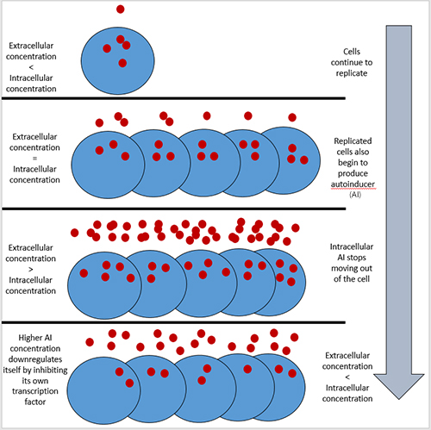During their reproductive cycle, individual bacterium synthesize autoinducers. Gram-negative bacteria produce [acyl-homoserine lactone autoinducers](https://www.annualreviews.org/doi/full/10.1146/annurev.micro.55.1.165?url_ver=Z39.88-2003&rfr_id=ori%3Arid%3Acrossref.org&rfr_dat=cr_pub++0pubmed#_i12) that can passively diffuse through their thin cell wall. In contrast, gram-positive bacterial autoinducers are made of peptide and must be [actively transported](https://www.annualreviews.org/doi/full/10.1146/annurev.micro.55.1.165) through their peptidoglycan cell wall using the [ATP-binding cassette (ABC) transporter system](https://www.annualreviews.org/doi/full/10.1146/annurev.micro.55.1.165?url_ver=Z39.88-2003&rfr_id=ori%3Arid%3Acrossref.org&rfr_dat=cr_pub++0pubmed#_i12). In both cases, autoinducers move out of individual cells as they are produced. Since the bacteria are reproducing, there are progressively more individual cells producing autoinducers and the extracellular concentration of the autoinducers increases, eventually hitting a “critical mass”.

# 1.4 COMPONENTS OF QUORUM SENSING

Understanding each of the individual components of quorum sensing enables you to understand the mechanism of action of such inter cellular communication pathways and understand its role in the regulation of psychological activities. The components of Quorum sensing in bacteria involved 2 major components they are as follow

* Autoinducers
* Receptors

# 2.1 AUTOINDUCERS

Autoinducers are signaling molecules that are produced in response to changes in cell-population density. As the density of Quorum sensing  bacterial cells increases so does the concentration of the autoinducer. Detection of signal molecules by bacteria acts as stimulation which leads to altered gene expression once the minimal threshold is reached. Quorum sensing is a phenomenon that allows both Gram-negative  and Gram-positive  bacteria to sense one another and to regulate a wide variety of physiological activities. Such activities include [symbiosis](https://en.m.wikipedia.org/wiki/Symbiosis), [virulence](https://en.m.wikipedia.org/wiki/Virulence), [motility](https://en.m.wikipedia.org/wiki/Motility), [antibiotic](https://en.m.wikipedia.org/wiki/Antibiotic) production, and biofilm formation. Autoinducers come in a number of different forms depending on the species, but the effect that they have is similar in many cases. Autoinducers allow bacteria to communicate both within and between different species. This communication alters gene expression  and allows bacteria to mount coordinated responses to their environments, in a manner that is comparable to behavior  and signaling in higher organism. Not surprisingly, it has been suggested that quorum sensing may have been an important evolutionary milestone that ultimately gave rise to multicellular life forms.

# 2.2 CLASS OF AUTOINDUCERS

In the most simplified quorum sensing systems, bacteria only need two components to make use of autoinducers. They need a way to produce a signal and a way to respond to that signal. These cellular processes are often tightly coordinated and involve changes in gene expression. The production of autoinducers generally increases as bacterial cell densities increase. Most signals are produced intracellularly and are subsequently secreted in the extracellular environment. Detection of autoinducers often involves diffusion back into cells and binding to specific [receptors](https://en.m.wikipedia.org/wiki/Receptor_(biochemistry)). Usually, binding of autoinducers to receptors does not occur until a threshold concentration of autoinducers is achieved. Once this has occurred, bound receptors alter gene expression either directly or indirectly. Some receptors are [transcription factors](https://en.m.wikipedia.org/wiki/Transcription_factor)themselves, while others relay signals to downstream transcription factors. In many cases, autoinducers participate in forward feedback loops, whereby a small initial concentration of an autoinducer amplifies the production of that same chemical signal to much higher levels.

## Acylated homoserine lactones

Acyl homoserine lactones (acyl-HSLs) are important intercellular signaling molecules used by many bacteria to monitor their population density in quorum-sensing control of gene expression. These signals are synthesized by members of the LuxI family of proteins. These are Primarily produced by Gram-negative bacteria, [acylated homoserine lactones](https://en.m.wikipedia.org/wiki/Acylated_homoserine_lactone) (AHLs) are a class of small neutral lipid molecules composed of a homoserine lactone ring with an acyl chain.[[6]](https://en.m.wikipedia.org/wiki/Autoinducer#cite_note-6) AHLs produced by different species of Gram-negative bacteria vary in the length and composition of the acyl side chain, which often contains 4 to 18 carbon atoms.[[7]](https://en.m.wikipedia.org/wiki/Autoinducer#cite_note-7) AHLs are synthesized by AHL synthases. They diffuse in and out of cells by both [passive transport](https://en.m.wikipedia.org/wiki/Passive_transport) and [active transport](https://en.m.wikipedia.org/wiki/Active_transport) mechanisms.

Receptors for AHLs include a number of transcriptional regulators called “R proteins,” which function as DNA binding transcription factors or sensor [kinases](https://en.m.wikipedia.org/wiki/Kinases).

Quorum sensing by the means of AHLs contributes to regulate the transcription of specific genes and therefore expression of specific phenotypes, including growth, [virulence](https://en.m.wikipedia.org/wiki/Virulence), [biofilm](https://en.m.wikipedia.org/wiki/Biofilm) formation, bioluminescence, production of [exopolysaccharide](https://en.m.wikipedia.org/wiki/Exopolysaccharide) (EPS).[[2]](https://en.m.wikipedia.org/wiki/N-Acyl_homoserine_lactone#cite_note-2) Over 50 [Gram-negative bacteria](https://en.m.wikipedia.org/wiki/Gram-negative_bacteria) species (including several pathogenic species) use AHLs as autoinducers and the means of their communication in Quorum sensing. in one study, AHL was shown to interact with eukaryotic cells, and mitigate an immune response and facilitates infection.[[3]](https://en.m.wikipedia.org/wiki/N-Acyl_homoserine_lactone#cite_note-3) AHLs are one of the major groups of the autoinducer (AI) molecules which are found primarily in Gram-negative proteobacteria but also in some 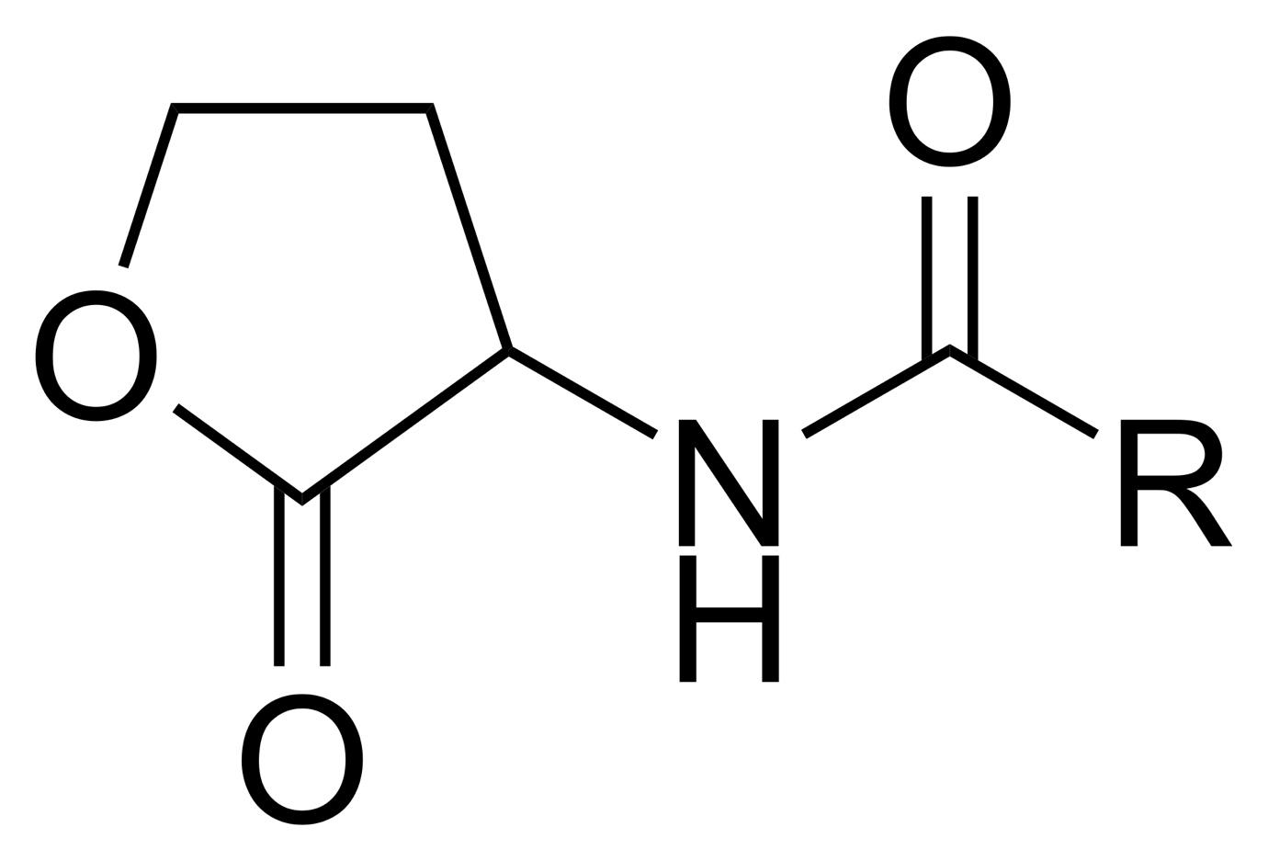bacteriodetes, cyanobacteria, and archaea.

## Peptides

Peptides are signaling molecules used by bacteria to regulate cell density-dependent group behaviors, a mechanism known as quorum sensing (QS) L.Peptides bind to membrane-associated receptors, which get autophosphorylated and activate intracellular response regulators via phosphor-transfer.

 The focus of this review is on the production of quorum sensing molecules belonging to the first three groups, i.e., AHL molecules, AI-2 molecules, and quorum sensing peptides.

Currently, ~300 quorum sensing peptides and structural analogs have been published, and the majority of these peptides have been tested by researchers on a system considered a reporter bacteria-based biosensor system.

While peptide structure elucidation was frequently performed by liquid chromatography-mass spectroscopy and/or Edman degradation, analogs of the cognate quorum sensing peptides are also frequently evaluated using a specific biosensor.  [Both Gram-negative and Gram-positive bacteria apply quorum sensing for communication, but they produce different auto-inducers. Gram-negative bacteria mainly depend on N-acyl homoserine lacton (AHL) molecules (autoinducer-1, AI-1) while](https://www.frontiersin.org/articles/10.3389/fnins.2017.00183" \t "_blank)

.Gram-positive bacteria that participate in quorum sensing typically use secreted [oligopeptides](https://en.m.wikipedia.org/wiki/Oligopeptides) as autoinducers. Peptide autoinducers usually result from [posttranslational modification](https://en.m.wikipedia.org/wiki/Posttranslational_modification)of a larger precursor molecule. In many Gram-positive bacteria, secretion of peptides requires specialized export mechanisms. For example, some peptide autoinducers are secreted by [ATP-binding cassette transporters](https://en.m.wikipedia.org/wiki/ATP-binding_cassette_transporter) that couple proteolytic processing and cellular export. Following secretion, peptide autoinducers accumulate in extracellular environments. Once a threshold level of signal is reached, a histidine sensor kinase protein of a [two-component regulatory system](https://en.m.wikipedia.org/wiki/Two-component_regulatory_system) detects it and a signal is relayed into the cell. As with AHLs, the signal ultimately ends up altering gene expression. Unlike some AHLs, however, most oligopeptides do not act as transcription factors themselves.

These peptides possess a large structural diversity and frequently undergo post-translational modifications.. A third type of autoinducers are boron-furan-derived signal molecules (autoinducer-2, AI-2) and are produced and detected by both Gram-negative and Gram-positive bacteria. Besides these 3 main groups, there is also a fourth group of miscellaneous quorum sensing molecules.

Quorum sensing molecules do not only serve as intra-species communication molecules. It has been demonstrated that certain AHLs are secreted and recognized by several species of Gram-negative bacteria, hereby potentially acting as “cross-talk” signals (interspecies communication). Another indication is the presence of AI-2 in both Gram-positive and Gram-negative bacteria. Co-culture systems of V. harveyi and E coli have indicated that AI-2 production by one species affects gene expression in the other.

Quorum sensing peptides (QSPs) play a crucial role in bacterial communication, allowing bacteria to monitor the population density of their own and closely related competing species and coordinate population-wide phenotypic alterations that aid their survival. The QS pathways control critical phenotypic traits such as bacterial virulence, biofilm formation, and antibiotic resistance.

Bacteria use QS pathways to communicate and coordinate their behavior by the use of signal molecules secreted by self, other bacteria, or both]. QS is a biological phenomenon through which bacteria communicate with each other by sending and receiving these chemical signals. They use this phenomenon to assess the size of their population by measuring the concentration of these signals.

QSPs are the signaling molecules used by Gram-positive bacteria in orchestrating cell-to-cell communication[5]. They are oligopeptides (or autoinducing peptides (AIPs) or QSPs) in Gram-positive bacteria and acylated homoserine lactone (AHL) in Gram-negative bacteria. QSPs are involved in inter-microbial communication and can also possibly cross-talk directly or indirectly with their host.

## Furanosylborate diester

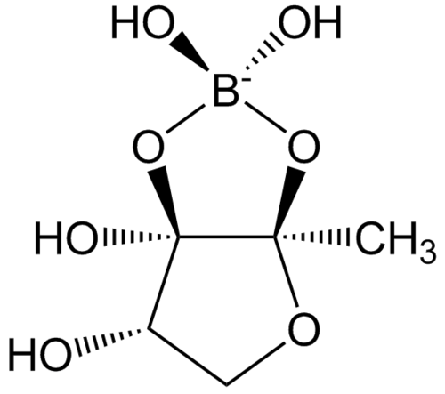Autoinducer-2 (AI-2), a furanosyl [borate diester](https://en.m.wikipedia.org/wiki/Borate_ester) or tetrahydroxy furan (species dependent), is a member of a family of [signaling molecules](https://en.m.wikipedia.org/wiki/Signaling_molecule" \o "Signaling molecule) used in [quorum sensing](https://en.m.wikipedia.org/wiki/Quorum_sensing).[[1]](https://en.m.wikipedia.org/wiki/Autoinducer-2#cite_note-1) AI-2 is one of only a few known [biomolecules](https://en.m.wikipedia.org/wiki/Biomolecules) incorporating [boron](https://en.m.wikipedia.org/wiki/Boron). First identified in the [marine bacterium](https://en.m.wikipedia.org/wiki/Marine_bacterium) [Vibrio harveyi](https://en.m.wikipedia.org/wiki/Vibrio_harveyi), AI-2 is produced and recognized by many [Gram-negative](https://en.m.wikipedia.org/wiki/Gram-negative) and [Gram-positive bacteria](https://en.m.wikipedia.org/wiki/Gram-positive_bacteria). AI-2 arises by the reaction of [4,5-dihydroxy-2,3-pentanedione](https://en.m.wikipedia.org/wiki/4,5-Dihydroxy-2,3-pentanedione), which is produced enzymatically, with [boric acid](https://en.m.wikipedia.org/wiki/Boric_acid)[[4]](https://en.m.wikipedia.org/wiki/Autoinducer-2#cite_note-4) and is recognized by the two-component sensor kinase LuxPQ in [Vibrionaceae](https://en.m.wikipedia.org/wiki/Vibrionaceae).

Autoinducer-2 (AI-2) is a signaling molecule used in quorum sensing, which is a mechanism of cell-to-cell communication in bacteria that requires the production and detection of signaling molecules called autoinducers. AI-2 is a furanosyl borate diester that is produced enzymatically by the reaction of 4,5-dihydroxy-2,3-pentanedione with boric acid. It is recognized by the two-component sensor kinase LuxPQ in Vibrionaceae and is actively transported by the Lsr ABC-type transporter into the cell in Enterobacteriaceae and few other bacterial taxa such as Pasteurella, Photorhabdus, Haemophilus, and Bacillus, where it is phosphorylated by LsrK. Phospho-AI-2 binds the transcriptional repressor protein, LsrR, which subsequently is released from the promoter/operator region of the lsr operon, and transcription of the lsr genes is initiated. AI-2 signaling is also regulated by glucose and cAMP/CRP via the lsr operon. Although AI-2 is not the only autoinducer used in quorum sensing, it is one of the few known biomolecules incorporating boron.

Autoinducer-2 (AI-2) is a signaling molecule used in quorum sensing by both gram-negative and gram-positive bacteria. It is a universal bacterial signaling molecule that plays a role in regulating gene expression and coordinating behavior in bacterial populations. AI-2 is involved in the regulation of numerous niche-specific behaviors across the bacterial kingdom, including chemotaxis and biofilm formation. It is not directly involved in pathogenesis, but rather in the regulation of bacterial behavior. AI-2 is a well-conserved QS signal that is synthesized by a large cohort of Gram-negative and Gram-positive bacteria and has the capacity to mediate communication at both intra- and interspecies levels. The molecule is actively transported by the Lsr ABC-type transporter into the cell in Enterobacteriaceae and few other bacterial taxa such as Pasteurella, Photorhabdus, Haemophilus, and Bacillus, where it is phosphorylated by LsrK. Then, Phospho-AI-2 binds the transcriptional repressor protein, LsrR, which subsequently is released from the promoter/operator region of the lsr operon – and transcription of the lsr genes is initiated.

# 3.1 BIOFILM

Biofilm is a complex structure of microbiome having different bacterial colonies or single type of cells in a group that adhere to a surface. Biofilms are surface-attached, structured microbial communities containing sessile cells (bacteria and/or fungi) embedded in a self-produced extracellular matrix. These adherent cells become encased in a matrix of primarily polysaccharide material and form a consortium of microorganisms in which cells stick to each other and often also to a surface. Biofilms are ubiquitous in organic life and can grow in the most extreme environments, from hot springs to frozen glaciers. They can form on virtually every non-shedding surface in non-sterile aqueous or humid environments. Biofilms can grow in the human environment, such as in showers, water and sewage pipes, floors, counters, and food preparation areas, and can cause clogging, corrosion, and make sanitation difficult. Biofilm formation increases the bacteria's resistance against the defense mechanisms of the body, as well as antimicrobial treatments, thereby promoting chronic infections. Biofilms are a serious global health concern due to their abilities to tolerate antibiotics, host defense systems, and other external stresses, and therefore contribute to persistent chronic infections.

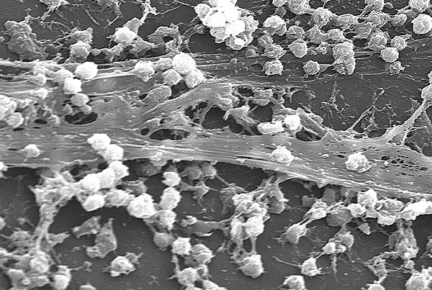

A biofilm comprises any [syntrophic](https://en.m.wikipedia.org/wiki/Syntrophy) [consortium of microorganisms](https://en.m.wikipedia.org/wiki/Microbial_consortium) in which [cells](https://en.m.wikipedia.org/wiki/Cell_(biology)) [stick to each other](https://en.m.wikipedia.org/wiki/Cell_adhesion) and often also to a surface. These adherent cells become embedded within a slimy [extracellular matrix](https://en.m.wikipedia.org/wiki/Extracellular_matrix) that is composed of [extracellular polymeric substances](https://en.m.wikipedia.org/wiki/Extracellular_polymeric_substance) (EPSs). The cells within the biofilm produce the EPS components, which are typically a [polymeric](https://en.m.wikipedia.org/wiki/Polymer) conglomeration of extracellular [polysaccharides](https://en.m.wikipedia.org/wiki/Polysaccharide), [proteins](https://en.m.wikipedia.org/wiki/Protein), [lipids](https://en.m.wikipedia.org/wiki/Lipid) and [DNA](https://en.m.wikipedia.org/wiki/DNA). Because they have three-dimensional structure and represent a community lifestyle for microorganisms, they have been metaphorically described as "cities for microbes".

Biofilms may form on living (biotic) or non-living (abiotic) surfaces and can be prevalent in natural, industrial, and hospital settings. They may constitute a [microbiome](https://en.m.wikipedia.org/wiki/Microbiome) or be a portion of it. The microbial cells growing in a biofilm are [physiologically](https://en.m.wikipedia.org/wiki/Physiology" \o "Physiology)distinct from [planktonic](https://en.m.wikipedia.org/wiki/Plankton) cells of the same organism, which, by contrast, are single cells that may float or swim in a liquid medium. Biofilms can form on the [teeth](https://en.m.wikipedia.org/wiki/Teeth) of most animals as [dental plaque](https://en.m.wikipedia.org/wiki/Dental_plaque), where they may cause [tooth decay](https://en.m.wikipedia.org/wiki/Tooth_decay) and [gum disease](https://en.m.wikipedia.org/wiki/Gum_disease).

[Microbes](https://en.m.wikipedia.org/wiki/Microorganism) form a biofilm in response to a number of different factors,[[9]](https://en.m.wikipedia.org/wiki/Biofilm#cite_note-:10-9) which may include cellular recognition of specific or non-specific attachment sites on a surface, nutritional cues, or in some cases, by exposure of planktonic cells to sub-inhibitory concentrations of [antibiotics](https://en.m.wikipedia.org/wiki/Antibiotic). A cell that switches to the biofilm mode of growth undergoes a [phenotypic shift](https://en.m.wikipedia.org/wiki/Phenotypic_shift) in behavior in which large suites of genes are differentially [regulated](https://en.m.wikipedia.org/wiki/Gene_regulation).

A biofilm may also be considered a [hydrogel](https://en.m.wikipedia.org/wiki/Hydrogel), which is a complex polymer that contains many times its dry weight in water. Biofilms are not just bacterial slime layers but biological systems; the bacteria organize themselves into a coordinated functional community. Biofilms can attach to a surface such as a tooth or rock, and may include a single species or a diverse group of microorganisms. Subpopulations of cells within the biofilm differentiate to perform various activities for motility, matrix production, and sporulation, supporting the overall success of the biofilm. The biofilm bacteria can share nutrients and are sheltered from harmful factors in the environment, such as desiccation, antibiotics, and a host body's immune system. A biofilm usually begins to form when a free-swimming bacterium attaches to a surface

# 3.2 BIOFILM FORMATION

The formation of a biofilm begins with the attachment of free-floating microorganisms to a surface. The first colonist bacteria of a biofilm may adhere to the surface initially by the weak [van der Waals forces](https://en.m.wikipedia.org/wiki/Van_der_Waals_force) and hydrophobic effects. If the colonists are not immediately separated from the surface, they can anchor themselves more permanently using [cell adhesion](https://en.m.wikipedia.org/wiki/Cell_adhesion) structures such as [pili](https://en.m.wikipedia.org/wiki/Pilus). A unique group of Archaea that inhabit [anoxic groundwater](https://en.m.wikipedia.org/wiki/Anoxic_waters) have similar structures called hami. Each hamus is a long tube with three hook attachments that are used to attach to each other or to a surface, enabling a community to develop. Hyperthermophilic archaeon [Pyrobaculum](https://en.m.wikipedia.org/wiki/Pyrobaculum" \o "Pyrobaculum)calidifontis produce bundling pili which are homologous to the bacterial TasA filaments, a major component of the extracellular matrix in bacterial biofilms, which contribute to biofilm stability.[]](https://en.m.wikipedia.org/wiki/Biofilm#cite_note-Wang2022PNAS-19) TasA homologs are encoded by many other archaea, suggesting mechanistic similarities and evolutionary connection between bacterial and archaeal biofilms.

[Hydrophobicity](https://en.m.wikipedia.org/wiki/Hydrophobicity) can also affect the ability of bacteria to form biofilms. Bacteria with increased hydrophobicity have reduced repulsion between the substratum and the bacterium. Some bacteria species are not able to attach to a surface on their own successfully due to their limited motility but are instead able to anchor themselves to the matrix or directly to other, earlier bacteria colonists. [Non-motile bacteria](https://en.m.wikipedia.org/wiki/Non-motile_bacteria) cannot recognize surfaces or aggregate together as easily as motile bacteria.

During surface colonization bacteria cells are able to communicate using [quorum sensing](https://en.m.wikipedia.org/wiki/Quorum_sensing) (QS) products such as [N-acyl homoserine lactone](https://en.m.wikipedia.org/wiki/N-acyl_homoserine_lactone) (AHL). Once colonization has begun, the biofilm grows by a combination of cell division and recruitment. [Polysaccharide](https://en.m.wikipedia.org/wiki/Polysaccharide) matrices typically enclose bacterial biofilms. The matrix exopolysaccharides can trap QS autoinducers within the biofilm to prevent predator detection and ensure bacterial survival.[]](https://en.m.wikipedia.org/wiki/Biofilm#cite_note-21) In addition to the polysaccharides, these matrices may also contain material from the surrounding environment, including but not limited to minerals, soil particles, and blood components, such as erythrocytes and fibrin. The final stage of biofilm formation is known as development, and is the stage in which the biofilm is established and may only change in shape and size.

The development of a biofilm may allow for an aggregate cell colony (or colonies) to be increasingly tolerant or [resistant to antibiotics](https://en.m.wikipedia.org/wiki/Antibiotic_resistance). Cell-cell communication or [quorum sensing](https://en.m.wikipedia.org/wiki/Quorum_sensing) has been shown to be involved in the formation of biofilm in several bacterial species.

Biofilm formation is a multi-step process that can be divided into different stages. The following are the different stages of biofilm formation:

1. Initial reversible attachment: In this stage, single free-floating microbes land on a surface and form a weak, reversible adhesion to the surface via van der Waals forces.

2. Irreversible attachment: Microbial cells gather and attach more permanently to the surface using cell adhesion structures such as pili.

3. Maturation I: Microbial colony grows and divides for biofilm formation.

4. Maturation II: Biofilm formation occurs, and the microbial cells develop into an organized structure entrapped in an extracellular polymeric matrix.

5. Dispersion: Microbes from sections of biofilm disperse and release free-floating microbes for further colonization.

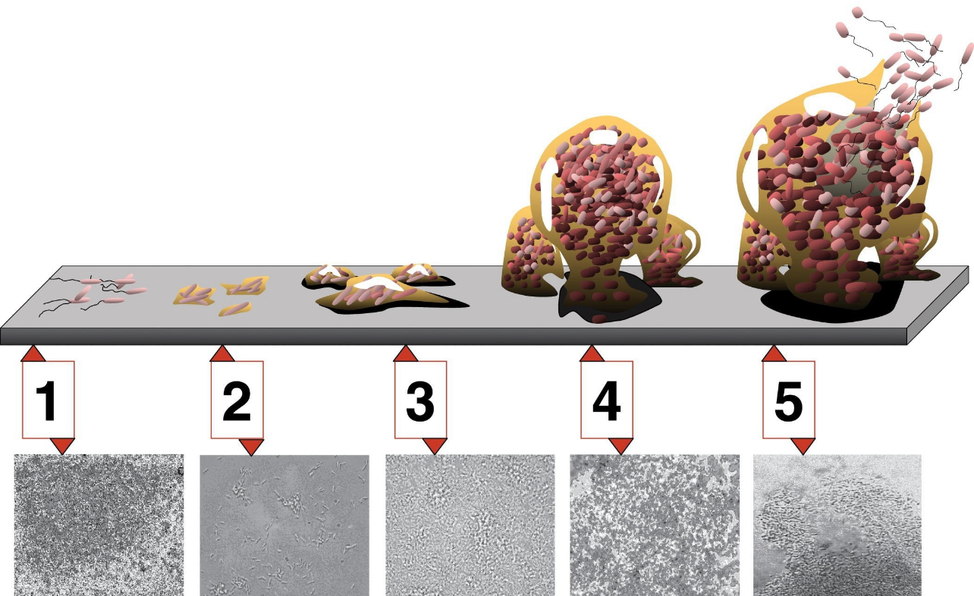

Biofilm formation is a complex process that increases the bacteria's resistance against the defense mechanisms of the body and antimicrobial treatments, promoting chronic infections. The presence of biofilms in bacterial infections can increase the pathogenicity of the bacteria. Biofilms are naturally more resilient to antimicrobial agents than their free-living planktonic counterparts, rendering the community growth harder to control. The aim of research is to develop new therapeutic approaches to eradicate biofilms.

# 3.3 BIOFILM DISPERSION

Biofilm dispersion is the process by which single cells egress from the biofilm to resume a planktonic lifestyle. This process is considered the terminal stage of biofilm development and is an active regulated event during which cells actively escape from the biofilm, leaving behind eroded biofilms and biofilms having central voids. Biofilm dispersal is being considered a promising avenue for biofilm control as the planktonic state is considered to be more vulnerable to antimicrobial agents and immune responses. The following are some key points about biofilm dispersion:

* Conditions that lead to dispersion\*\*: Environmental cues, such as nutrient depletion, and native cues, such as quorum sensing, can contribute to biofilm dispersion.
* Mechanisms of dispersion\*\*: Matrix degradation, cell death, and active motility are some of the mechanisms that contribute to biofilm dispersion.
* Phenotype of dispersed cells\*\*: Dispersed cells have a distinct phenotype that is different from that of cells in the biofilm. They are more motile, have different gene expression patterns, and are more susceptible to antimicrobial agents and immune responses.
* Therapeutic potential\*\*: Biofilm dispersal is a promising area of research that may lead to the development of novel agents that inhibit biofilm formation or promote biofilm cell detachment. Such agents may be useful for the prevention and treatment of biofilms in a variety of industrial and clinical settings.

# 3.4 MECHANISM OF BIOFILM DISPERSAL

Bacterial biofilm dispersal can be divided into three distinct phases: (i) detachment of cells from the biofilm colony

(ii) translocation of the cells to a new location

(iii) attachment of the cells to a substrate in the new location.

Thus, S. mutanscells that detach from dental plaque can be transported to the saliva of an infant by direct contact or by means of a vector such as a shared spoon, and then attach to the tooth surface and initiate colonization of the new host. Similarly, cells that detach from a Legionella biofilm growing in a cooling tower can be transported by means of air-borne water droplets to the lungs of a susceptible host, where they can attach to alveolar macrophages and initiate infection.

In general, mechanisms of biofilm dispersal can be divided into two broad categories: active and passive. Active dispersal refers to mechanisms that are initiated by the bacteria themselves, whereas passive dispersal refers to biofilm cell detachment that is mediated by external forces such as fluid shear, abrasion (collision of solid particles with the biofilm), predator grazing, and human intervention

At least three distinct modes of biofilm dispersal have been identified: erosion, sloughing, and seeding.

Erosion refers to the continuous release of single cells or small clusters of cells from a biofilm at low levels over the course of biofilm formation.

Sloughing refers to the sudden detachment of large portions of the biofilm, usually during the later stages of biofilm formation

Seeding dispersal, also known as central hollowing, refers to the rapid release of a large number of single cells or small clusters of cells from hollow cavities that form inside the biofilm colony.

Erosion and sloughing can be either active or passive processes, whereas seeding dispersal is always an active process. The following sections describe some of the mechanisms of active biofilm dispersal that have been described to date.

# 4.1 QUORUM SENSING IN BACTERIA

Quorum sensing (QS) is a bacterial cell–cell communication process that involves the production, detection, and response to extracellular signaling molecules called autoinducers (AIs). AIs accumulate in the environment as the bacterial population density increases, and bacteria monitor this information to track changes in their cell numbers and collectively alter gene expression. QS controls genes that direct activities that are beneficial when performed by groups of bacteria acting in synchrony. Processes controlled by QS include bioluminescence, sporulation, competence, antibiotic production, biofilm formation, and virulence factor secretion

Despite differences in regulatory components and molecular mechanisms, all known QS systems depend on three basic principles. First, the members of the community produce AIs, which are the signaling molecules. At low cell density (LCD), AIs diffuse away, and, therefore, are present at concentrations below the threshold required for detection. At high cell density (HCD), the cumulative production of AIs leads to a local high concentration, enabling detection and response, Second, AIs are detected by receptors that exist in the cytoplasm or in the membrane. Third, in addition to activating expression of genes necessary for cooperative behaviors, detection of AIs results in activation of AI production. This feed-forward autoinduction loop presumably promotes synchrony in the population.

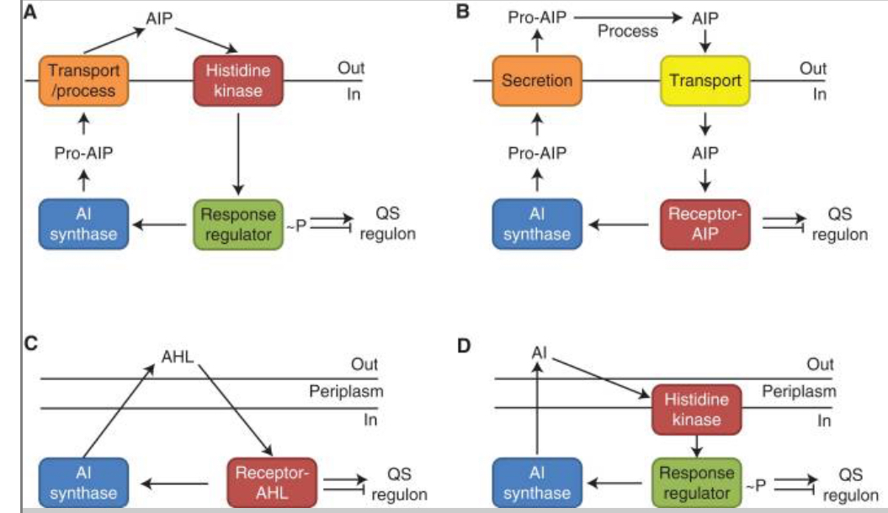Gram-positive and Gram-negative bacteria use different types of QS systems.

# 4.2 QUORUM SENSING IN GRAM POSITIVE AND GRAM NEGATIVE BACTERIA

Gram-positive bacteria use peptides, called autoinducing peptides (AIPs), as signaling molecules. Once produced in the cell, AIPs are processed and secreted. When the extracellular concentration of the AIP is high, which occurs at HCD, it binds to a cognate membrane-bound two-component histidine kinase receptor. Usually, binding activates the receptor’s kinase activity, it autophosphorylates, and passes phosphate to a cognate cytoplasmic response regulator. In some cases of Gram-positive bacterial QS, AIPs are transported back into the cell cytoplasm where they interact with transcription factors to modulate the transcription factor’s activity and, in turn, modulate gene expression changes.

Gram-negative bacteria communicate using small molecules as AIs. These are either acyl-homoserine lactones (AHLs) or other molecules whose production depends on S-adenosylmethionine (SAM) as a substrate. AIs are produced in the cell and freely diffuse across the inner and outer membranes. When the concentration of AIs is sufficiently high, which occurs at HCD, they bind cytoplasmic receptors that are transcription factors. The AI-bound receptors regulate expression of the genes in the QS regulon. In some cases of Gram-negative bacterial QS, AIs are detected by two-component histidine kinase receptors that function analogously to those described in the preceding paragraph for Gram-positive QS bacteria

## Acyl-Homoserine Lactones (AHL) QS System in Gram-Negative Bacteria

Both Gram-positive (Gram+) and Gram-negative (Gram–) bacteria use QS to communicate with each other. Although the types of QS pathways are different in Gram+ and Gram– bacteria, they all have fundamental biological roles. Gram– QS system has several common features . Firstly, AIs are molecules synthesized from S-adenosylmethionine (SAM) as a substrate. Acyl-homoserine lactones (AHLs) are the most common class of AIs. They have an N-acylated homoserine-lactone ring as the core and a 4–18 carbon acyl chain containing modifications. The length of the acyl chain affects their stability. LuxI-type enzymes are the major, but not the sole producer of AHLs. A LuxM synthase found in Vibrio harveyi, which is not a homolog of LuxI, can produce AHLs for their intra-species communication. SAM can be metabolized into special signals which can be sensed by different bacteria species. Diffusible signal factor (DSF) type molecules are synthesized by RpfF proteins in Pseudomonas aeruginosa and Burkholderia cenocepacia. Cholera autoinducer 1 (CAI-1) is produced by the CAI-1 AI synthase (CqsA) in Vibrio cholerae. Due to the common prevalence of homologs of CqsA in Vibrio spp., various CAI-1 are produced by this bacterial species. Additionally, Vibrio spp. may have different affinities to CAI-1 not produced by themselves, suggesting CAI-1 is a vibrio inter-genus communication molecule. Secondly, AIs bind to specific membrane receptors or cytoplasmic proteins. LuxR-type receptors, the cytoplasmic transcription factors, detect freely diffusible AHLs in cytoplasm and bind cognate AHLs. The stable LuxR-AHL complexes can bind to DNA while unbound LuxR proteins are rapidly degraded. These LuxR/LuxI-type systems, including LasR/LasI and RhlR/RhlI in Pseudomonas aeruginosa, mediate inter-cellular communication.

Thirdly, combined receptors work as transcription factors to regulate dozens to hundreds of genes that affect biofilm formation, virulence, and other biological processes in bacteria. QS molecule receptors establish a feed-forward loop when regulating genes expression, which is called autoinduction. This mechanism increases the autoinducers synthesis, consequently promoting synchronous genes expression in the population.

## Autoinducing Peptides (AIP) QS System in Gram-Positive Bacteria

While QS circuits share some common features, there are stark distinctions between Gram+ and Gram–bacteria. The AIs in many Gram+ bacteria are oligopeptides (AIPs). There are two kinds of canonical AIP-QS circuits. One class of AIPs is encoded as a precursor from QS operon, then processed and secreted extracellularly by specialized transporters. The AIPs ranging from 5 to 17 amino acids can be linear or cyclized. Membrane-bound, two-component sensor histidine kinases, such as Agr system in Streptococcus aureus, and Fsr system in Enterococcus faecalis serve as AIP receptors. The sensor kinases auto-phosphorylate after binding to AIPs, and the phosphoryl group is delivered to a cognate cytoplasmic response-regulator protein that controls the expression of QS-related genes. In S. aureus, AIPs are variable and have coevolved with their receptors. Non-cognate AIPs have an inhibitory effect on QS in other strains, allowing one strain to establish its specific niche.

**VIBRIO FISCHERI QUORUM SENSING**

Vibrio fischeri is a marine bacterium that uses quorum sensing to regulate its bioluminescence. The bacterium releases small signaling molecules called autoinducers that accumulate in the environment as the population density increases. This accumulation of autoinducer eventually activates transcriptional regulators for bioluminescence as well as host colonization behaviors. Some key points about vibrio fischeri are:

- Vibrio fischeri uses two quorum-sensing systems, ain and lux, using acyl homoserine lactones as signaling molecules.

- The autoinducer synthase LuxI in Vibrio fischeri makes small autoinducer molecules (AHLs) that build up in the medium at high concentrations and bind to a transcription regulator, LuxR, which then alters the gene expression by coordinating bioluminescence among the local cell population.

- The genes responsible for light production are principally regulated by the LuxR-LuxI quorum sensing system.

- Vibrio fischeri quorum sensing has been extensively characterized in bulk populations, but far less is known about how it performs at the level of the individual cell, where biochemical noise is likely to limit the precision of luminescence regulation.

- Researchers have studied the noise and crosstalk in two quorum-sensing inputs of Vibrio fischeri, which showed an extremely noisy response to 3OC6HSL alone.

- Vibrio fischeri is a model organism for studying quorum sensing and has been used to analyze the LuxR DNA binding region by alanine-scanning mutagenesis.

The bacteria live in a symbiotic association with marine animals such as squid. The luxICDABEG operon in the bacteria codes for the [proteins](https://www.vedantu.com/biology/proteins) necessary for bioluminescence. The protein is named luciferase, it is enzymatic in nature. It has two subunits named alpha and beta and these subunits are encoded by genes luxA and luxB, respectively. Light is released as a byproduct of the oxidation reaction performed by luciferase. Quorum sensing directly downregulates the bioluminescence property of the bacteria by controlling the expression of the luxA and luxB genes. The mechanism can be explained in the following step

Synthesis of autoinducer N-3-oxohexanoyl-homoserine lactone (3-oxo-C6-HSL) by luxI

↓

Binding of luxI to LuxR at the threshold concentration 100-200nM

↓

Activation of luxR

↓

Binding of LuxR/3-oxo-C6-HSL dimer upstream of the luxICDABEG operon

↓

Recruitment of RNA polymerase at the site

↓

Transcription of the operon leads to transcription of luxA and, luxB gene

↓

Expression of alpha and beta subunit of luciferase

↓

Quaternary folding of the protein

↓

The catalytic reaction that is the oxidation of the substrate yields the light or bioluminescence.

# 4.3 APPLICATION OF QUORUM SENSING IN BACTERIA

Quorum sensing is a process of cell-to-cell communication that allows bacteria to share information about cell density and adjust gene expression accordingly. Bacteria use versatile chemical signaling molecules called autoinducers to regulate bacterial gene expression in a process known as quorum sensing. Some of the key applications of quorum sensing in bacteria include:

* Virulence: Bacteria use quorum sensing to regulate the expression of virulence factors, which are molecules that allow them to cause disease in their hosts.
* Biofilm formation: Bacteria use quorum sensing to coordinate the formation of biofilms, which are communities of bacteria that adhere to surfaces and are encased in an extracellular matrix.
* Antibiotic resistance: Bacteria can use quorum sensing to regulate the expression of genes involved in antibiotic resistance, allowing them to survive in the presence of antibiotics.
* Symbiosis: Bacteria can use quorum sensing to regulate the expression of genes involved in symbiotic relationships with other organisms.

Researchers have also discovered many quorum sensing inhibiting agents that can effectively inhibit biofilm formation in bacteria, making it a promising approach to control bacterial infections.

# CONCLUSION

Quorum sensing is an important process found in the [bacterial community](https://www.sciencedirect.com/topics/agricultural-and-biological-sciences/bacterial-communities) that enables them to regulate a number of physiological processes, involved in cross species talk and is important for virulence in many pathogens. Many phytopathogenic species of bacteria produce QS signals like [AHL](https://www.sciencedirect.com/topics/agricultural-and-biological-sciences/homoserine), AI-2, peptides, and DSFs, which regulate the production of [virulence factors](https://www.sciencedirect.com/topics/pharmacology-toxicology-and-pharmaceutical-science/virulence-factor) in them and are important for establishing [pathogenicity](https://www.sciencedirect.com/topics/agricultural-and-biological-sciences/pathogenicity). One of the important strategies to control plant infections is to inhibit the QS process which leads to reduced virulence. The endophytic microbial community that resides inside plants exhibits this process of [quorum quenching](https://www.sciencedirect.com/topics/immunology-and-microbiology/quorum-sensing) and thus protects plant against attack by pathogenic bacteria. Moreover, [transgenic plants](https://www.sciencedirect.com/topics/agricultural-and-biological-sciences/transgenic-plant) can also be produced that carry the gene of interest that blocks QS process. These approaches hold promise for integrated disease management in plants and will help to maintain plant health.

# REFERENCE

Abdallah, M., Benoliel, C., Drider, D., Dhulster, P., and MyChihib, N. E. (2014). Biofilm formation and persistence on abiotic surfaces in the context of food and medical environments. Arch. Microbiol. 196, 453–472. doi: 10.1007/s00203-014-0983-1

Achinas, S., Charalampogiannis, N., and Euverink, G. J. W. (2019). A brief recap of microbial adhesion and biofilms. Appl. Sci. 9:2801.

Alav, I., Sutton, J. M., and Rahman, K. M. (2018). Role of bacterial efflux pumps in biofilm formation. J. Antimicrob. Chemother. 73, 2003–2020. doi: 10.1093/jac/dky042

Alipour M, Suntres ZE, Omri A. (2009). Importance of DNase and alginate lyase for enhancing free and liposome encapsulated aminoglycoside activity against *Pseudomonas aeruginosa. J Antimicrob Chemother* 64:317-325

Allison, D.G., Ruiz, B., SanJose, C., Jaspe, A., and Gilbert, P. (1998) Extracellular products as mediators of the formation and detachment of Pseudomonas fluorescens biofilms. FEMS Microbiol Lett 167: 179–184.

Asano Y., Hiramoto T., Nishino R., Aiba Y., Yoshihara K., Koga Y., et al.. (2012). Critical role of gut microbiota in the production of biologically active, free catecholamines in the gut lumen of mice. *Am. J. Physiol. Gastrointest. Liver Physiol.* 303, G1288–G1295. 10.1152/ajpgi.00341.2012 [[PubMed](https://pubmed.ncbi.nlm.nih.gov/23064760)]

Barraud N, Hassett DJ, Hwang SH, Rice SA, Kjelleberg S, Webb JS. (2006). Involvement of nitric oxide in biofilm dispersal of *Pseudomonas aeruginosa*. *J Bacteriol* 188:7344-7353

Bassler, B. L., Wright, M., Showalter, R. E. & Silverman, M. R.(1993). Intercellular signalling in Vibrio harveyi: sequence and function of genes regulating expression of luminescence. Mol. Microbiol. 9, 773–786

Bazaka, K., Jacob, M. V., Crawford, R. J., and Ivanova, E. P. (2012). Efficient surface modification of biomaterial to prevent biofilm formation and the attachment of microorganisms. Appl. Microbiol. Biotechnol. 95, 299–311. doi: 10.1007/s00253-012-4144-7

Bogino, P; de las Mercedes Oliva, M (July 30, 2013). ["The Role of Bacterial Biofilms and Surface Components in Plant-Bacterial Associations"](https://www.ncbi.nlm.nih.gov/pmc/articles/PMC3759889). *International Journal of Molecular Sciences*. **14** (8): 15838–15859. [doi](https://en.m.wikipedia.org/wiki/Doi_(identifier)):[10.3390/ijms140815838](https://doi.org/10.3390%2Fijms140815838). [PMC](https://en.m.wikipedia.org/wiki/PMC_(identifier)) [3759889](https://www.ncbi.nlm.nih.gov/pmc/articles/PMC3759889). [PMID](https://en.m.wikipedia.org/wiki/PMID_(identifier)) [23903045](https://pubmed.ncbi.nlm.nih.gov/23903045).

Chan KG, Atkinson S, Mathee K, Sam CK, Chhabra SR, Cámara M, et al. (March 2011). ["Characterization of N-acylhomoserine lactone-degrading bacteria associated with the Zingiber officinale (ginger) rhizosphere: co-existence of quorum quenching and quorum sensing in Acinetobacter and Burkholderia"](https://www.ncbi.nlm.nih.gov/pmc/articles/PMC3062576). *BMC Microbiology*. [doi](https://en.m.wikipedia.org/wiki/Doi_(identifier)):[10.1186/1471-2180-11-51](https://doi.org/10.1186%2F1471-2180-11-51). [PMC](https://en.m.wikipedia.org/wiki/PMC_(identifier)) [3062576](https://www.ncbi.nlm.nih.gov/pmc/articles/PMC3062576). [PMID](https://en.m.wikipedia.org/wiki/PMID_(identifier)) [21385437](https://pubmed.ncbi.nlm.nih.gov/21385437).

Chen X, Schauder S, Potier N, Van Dorsselaer A, Pelczer I, Bassler BL, Hughson FM (January 2002). ["Structural identification of a bacterial quorum-sensing signal containing boron"](https://web.archive.org/web/20040622003038/http:/www.nsls.bnl.gov/newsroom/science/2002/pdfs/2002-09-Hughson.pdf) (PDF). *Nature*. **415** (6871): 545–549. [doi](https://en.m.wikipedia.org/wiki/Doi_(identifier)):[10.1038/415545a](https://doi.org/10.1038%2F415545a). [PMID](https://en.m.wikipedia.org/wiki/PMID_(identifier)) [11823863](https://pubmed.ncbi.nlm.nih.gov/11823863). [S2CID](https://en.m.wikipedia.org/wiki/S2CID_(identifier)) [4334017](https://api.semanticscholar.org/CorpusID:4334017).

Darch, S. E., West, S. A., Winzer, K. & Diggle, S. P.(2012). Density-dependent fitness benefits in quorum-sensing bacterial populations. Proc. Natl Acad. Sci. USA 109, 8259–8263

Dunlap PV (1999) Quorum regulation of luminescence in *vibrio fischeri*. J Molec Microbiol Biotechnol 1(1): 5–12.

Engebrecht, J., Nealson, K. & Silverman, M. Bacterial bioluminescence: (1983). Isolation and genetic analysis of functions from Vibrio fischeri. Cell 32, 773–781

Fuqua, W. C., Winans, S. C. & Greenberg, E. P. (1994). Quorum sensing in bacteria: the LuxR-LuxI family of cell density-responsive transcriptional regulators. J. Bacteriol.

Galloway WR, Hodgkinson JT, Bowden S, Welch M, Spring DR (September 2012). "Applications of small molecule activators and inhibitors of quorum sensing in Gram-negative bacteria". *Trends in Microbiology*. **20** (9): 449–458. [doi](https://en.m.wikipedia.org/wiki/Doi_(identifier)):[10.1016/j.tim.2012.06.003](https://doi.org/10.1016%2Fj.tim.2012.06.003). [PMID](https://en.m.wikipedia.org/wiki/PMID_(identifier)) [22771187](https://pubmed.ncbi.nlm.nih.gov/22771187).

Galloway WR, Hodgkinson JT, Bowden SD, Welch M, Spring DR. (2011). Quorum sensing in Gram-negative bacteria: small-molecule modulation of AHL and AI-2 quorum sensing pathways. *Chem Rev.* 111:28–67.

Hall-Stoodley L, Costerton JW, Stoodley P (February 2004). "Bacterial biofilms: from the natural environment to infectious diseases". *Nature Reviews. Microbiology*. **2** (2): 95–108.

Kleerebezem, M., Quadri, L. E., Kuipers, O. P. & de Vos, W. M.(1997). Quorum sensing by peptide pheromones and two-component signal-transduction systems in Gram-positive bacteria. Mol. Microbiol. 24, 895–904

Lupp C, Urbanowski M, Greenberg EP, Ruby EG (October 2003). ["The Vibrio fischeri quorum-sensing systems ain and lux sequentially induce luminescence gene expression and are important for persistence in the squid host"](https://doi.org/10.1046%2Fj.1365-2958.2003.t01-1-03585.x). *Molecular Microbiology*. [Wiley Publishing](https://en.m.wikipedia.org/wiki/Wiley_Publishing). (1): 319–331. [doi](https://en.m.wikipedia.org/wiki/Doi_(identifier)):[10.1046/j.1365-2958.2003.t01-1-03585.x](https://doi.org/10.1046%2Fj.1365-2958.2003.t01-1-03585.x). [PMID](https://en.m.wikipedia.org/wiki/PMID_(identifier)) [14507383](https://pubmed.ncbi.nlm.nih.gov/14507383).

Nealson KH (February 1977). "Autoinduction of bacterial luciferase. Occurrence, mechanism and significance". *Archives of Microbiology*. [Springer Science and Business Media LLC](https://en.m.wikipedia.org/wiki/Springer_Science%2BBusiness_Media). [doi](https://en.m.wikipedia.org/wiki/Doi_(identifier)):[10.1007/bf00446657](https://doi.org/10.1007%2Fbf00446657). [PMID](https://en.m.wikipedia.org/wiki/PMID_(identifier)) [843170](https://pubmed.ncbi.nlm.nih.gov/843170). [S2CID](https://en.m.wikipedia.org/wiki/S2CID_(identifier)) [34239721](https://api.semanticscholar.org/CorpusID:34239721).

Ng WL, Bassler BL. Bacterial quorum-sensing network architectures. *Annu Rev Genet.* 2009;43:197–222.

Papenfort, K; Bassler, B (February 11, 2017). ["Quorum-Sensing Signal-Response Systems in Gram-Negative Bacteria"](https://www.ncbi.nlm.nih.gov/pmc/articles/PMC5056591). *Nature Reviews Microbiology*. . [doi](https://en.m.wikipedia.org/wiki/Doi_(identifier)):[10.1038/nrmicro.2016.89](https://doi.org/10.1038%2Fnrmicro.2016.89). [PMC](https://en.m.wikipedia.org/wiki/PMC_(identifier)) [5056591](https://www.ncbi.nlm.nih.gov/pmc/articles/PMC5056591). [PMID](https://en.m.wikipedia.org/wiki/PMID_(identifier)) [27510864](https://pubmed.ncbi.nlm.nih.gov/27510864).

Pierson III LS, Wood DW, Beck von Bodman S (1999). "Quorum sensing in other plant-associated bacteria". [*Cell-cell signaling in bacteria*](https://books.google.com/books?id=m0DdwAEACAAJ). [Washington, D.C.](https://en.m.wikipedia.org/wiki/Washington,_D.C.): [American Society for Microbiology](https://en.m.wikipedia.org/wiki/American_Society_for_Microbiology) Press. pp. 101–15. [ISBN](https://en.m.wikipedia.org/wiki/ISBN_(identifier)) [978-1-55581-149-5](https://en.m.wikipedia.org/wiki/Special:BookSources/978-1-55581-149-5). [OCLC](https://en.m.wikipedia.org/wiki/OCLC_(identifier)) [40075829](https://www.worldcat.org/oclc/40075829).

Rutherford ST, Bassler BL (November 2012). ["Bacterial quorum sensing: its role in virulence and possibilities for its control"](https://www.ncbi.nlm.nih.gov/pmc/articles/PMC3543102). *Cold Spring Harbor Perspectives in Medicine*. [doi](https://en.m.wikipedia.org/wiki/Doi_(identifier)):[10.1101/cshperspect.a012427](https://doi.org/10.1101%2Fcshperspect.a012427). [PMC](https://en.m.wikipedia.org/wiki/PMC_(identifier)) [3543102](https://www.ncbi.nlm.nih.gov/pmc/articles/PMC3543102). [PMID](https://en.m.wikipedia.org/wiki/PMID_(identifier)) [23125205](https://pubmed.ncbi.nlm.nih.gov/23125205).

Schauder S, Shokat K, Surette MG, Bassler BL. (2001). The LuxS family of bacterial autoinducers: biosynthesis of a novel quorum-sensing signal molecule. *Mol Microbiol.* ;41:463–476

Schuster M, Sexton DJ, Diggle SP, Greenberg EP. (2013). Acyl-homoserine lactone quorum sensing: from evolution to application. *Annu Rev Microbiol.*

Smith D, et al. Variations on a theme: (2006). diverse N-acyl homoserine lactone-mediated quorum sensing mechanisms in gram-negative bacteria. *Sci Prog.* 89:167–211

Tolker-Nielsen T, Brinch UC, Ragas PC, Andersen JB, Jacobsen CS, Molin S. 2000. Development and dynamics of Pseudomonas sp. biofilms. J Bacteriol 182:[6482–6489](tel:6482%E2%80%936489).

von Bodman SB, Willey JM, Diggle SP. (2008). Cell-cell communication in bacteria: united we stand. *J Bacteriol.* ;190:4377–4391.

Waters, C. M. & Bassler, B. L. (2005). Quorum sensing: cell-to-cell communication in bacteria. Annu. Rev. Cell Dev. Biol. 21, 319–346

Wynendaele E, Verbeke F, Stalmans S, Gevaert B, Janssens Y, Van De Wiele C, et al. (Nov 2015). ["Quorum Sensing Peptides Selectively Penetrate the Blood-Brain Barrier"](https://www.ncbi.nlm.nih.gov/pmc/articles/PMC4633044). *PLOS ONE*. **10** (11): e0142071. [Bibcode](https://en.m.wikipedia.org/wiki/Bibcode_(identifier)):[2015PLoSO..1042071W](https://ui.adsabs.harvard.edu/abs/2015PLoSO..1042071W). [doi](https://en.m.wikipedia.org/wiki/Doi_(identifier)):[10.1371/journal.pone.0142071](https://doi.org/10.1371%2Fjournal.pone.0142071). [PMC](https://en.m.wikipedia.org/wiki/PMC_(identifier)) [4633044](https://www.ncbi.nlm.nih.gov/pmc/articles/PMC4633044). [PMID](https://en.m.wikipedia.org/wiki/PMID_(identifier)) [26536593](https://pubmed.ncbi.nlm.nih.gov/26536593).

Zhang RG, Pappas KM, Pappas T, Brace JL, Miller PC, Oulmassov T, et al. (June 2002). ["Structure of a bacterial quorum-sensing transcription factor complexed with pheromone and DNA"](https://doi.org/10.1038%2Fnature10294). *Nature*. [Springer Science and Business Media LLC](https://en.m.wikipedia.org/wiki/Springer_Science%2BBusiness_Media)