Alok Malavia

2022 Feb-28

Foundations of Programming: Python

Assignment_05

Python – Lists, Dictionaries and the Magic CDInventory

# Introduction

This document covers modifying a script which we created in the last assignment, and which allows the user to create a list of dictionaries as a 2D table. We will modify the 2D data structure to use dictionaries as the inner data type. Additionally, we will be adding the functionality of loading existing data, and adding the functionality of deleting an entry. Once completed, the finished script will use a list of dictionaries as 2D table.

# Display menu which allows the user to choose

Similar to the last assignment, I will be using while loop so that the user has the option to exit out of the program at any time by pressing x. However, compared to the last assignment, I decided to modify my script this time around to give it a different look as well. By using the CDInventory_Starter.py file, my code looks different and the menu has more options. I also added two new options, which are to read the rows of data form the text file and delete an entry from the inventory. This was a requirement for the assignment and so I decided to follow the prescribed starter file. Figure 2 is a screenshot of what the script looked like this time around, and it was a quite different from my initial CDInventory script from assignment_04 - Figure 1

# 

Figure 1 - Creating a menu for the user – Assignment_04

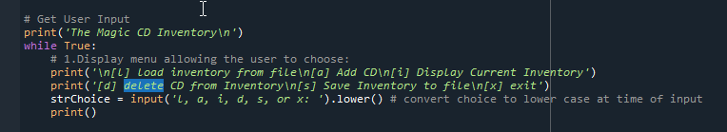

Figure 2 - Creating a menu for the user - Assginment_05

# User Input to create a list of items

Once we have a menu which allowed the user to pick an option, the rest of the code cycles though the various conditional statements of the while loop. For this week’s assignment, I added two more menu options, one of which was to load inventory from the file and the other to delete an entry. So far in this course, we have always focused on adding data to files, adding to lists, extracting from lists, but never deleted any rows of data. In this assignment, we were specifically tasked with adding functionality so that we could delete an entry. Similar to the last assignment, I used a while loop that allows the user to input data such as the ID of the CD, the Title of the CD and the Artist of the CD. The user input is then stored as variable such as strID, strTitle, strArtist. Also, before starting the user inputs, we created a base list of variables, namely strChoice, lstTbl, lstRow, dicRow, a strFilename to write data to a file, and finally, an objFile function to read and write data to the file. We will use the user input to populate the lists, and dictionaries and then extract data from said lists.

# Adding code to the TODO sections of the starter script

Once we have our inputs, we the cycle through the ‘if’ conditional statements, and based on the user input, we will either execute the code block applicable for that input or if the user wants to exit, they will just press the ‘x’ key. Since we were provided with the starter script with the relevant strChoices, I was able to add code to the relevant sections, namely option ‘l’ and option ‘d’. I added code for the section of reading the rows of data from the text file by opening the file with a ‘r’ and then adding code such as row.strip().split(‘ , ‘) so that we can extract the dictionary list from the text file as plain text. We will then append this to the lstTbl and close the file.

In this assignment, I also added the functionality of deleting an entry by adding code to delete an entry. Deleting an entry was accomplished by asking for the user input and asking them which ‘ID’ in the CD Inventory the user would like to delete. This was then converted to an integer and assigned to a variable ‘idDel’. We then wanted to subtract one row and so we assigned a -1 value to variable ‘RowNo’. Here, I went with the approach of creating another while loop, nested in our elif statement of the outer while loop. This while loop would go through and set the condition of removing a CD to False, so unless the user deleted a CD with an ID that was in the inventory, the loop would continue and print ‘Unable to find CD’ to the user. For example, if the ’id’ matched the integer assigned to variable idDel, which would make the cdRemove condition True, thereby breaking the while loop and proceeding to print ‘The CD was removed from the Inventory’.

# Example of the Script Working in Spyder and a Terminal Window

Below is the script being executed in the Spyder Console:

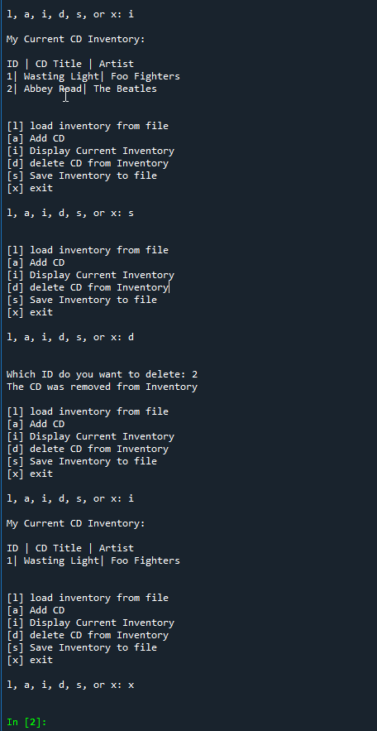

Figure 3 - Script execution in Sypder console

Below is the script execution in a Terminal Window

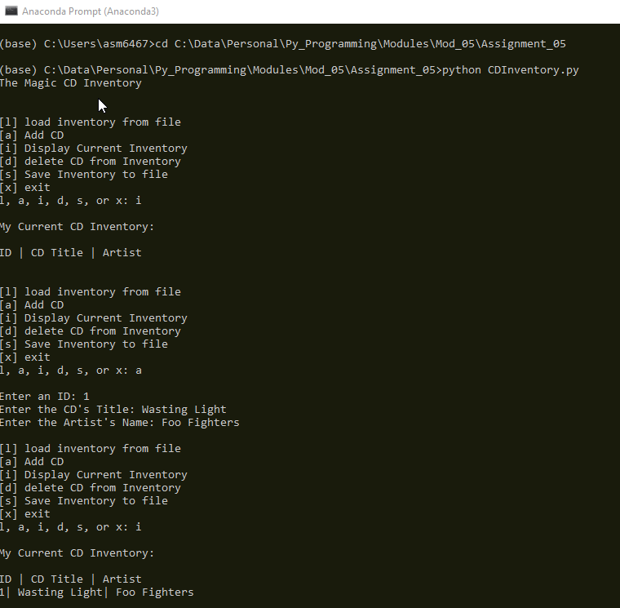

*Figure 4 - Script execution in Terminal Window-#1*

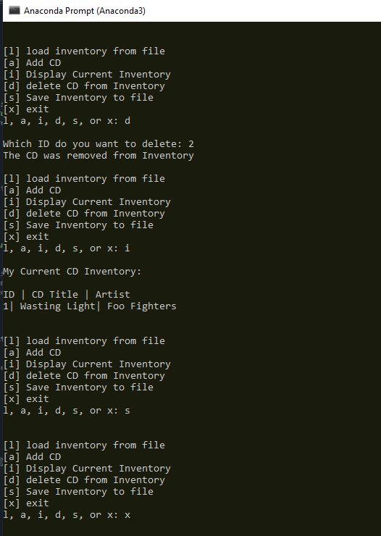

Figure 5 - Script execution in Terminal Window-#2

# Summary

This document covered the steps taken to add code to a starter script which was provided to us. The goal of the assignment was to modify the starter script to use a list of dictionaries as a 2D table. Additionally, we added code to address the functionality of loading existing data, and also, wrote code to address the functionality of deleting an entry.