Alok Malavia
2022 Mar-06
Foundations of Programming: Python
Assignment_06

Python – Working with Classes and Functions

Introduction
This document covers working with Classes and Functions. During this week we learned the concepts of how functions, work and how we can supply parameters and arguments into the functions to make them more robust. We also learned how to use return values and we learned how to use ‘Classes’ to organize our code so that the functions we are using can be grouped into their respective ‘Classes’. Finally, we covered how to use docstrings as well as variable scope and use them in our code. For this week’s assignment we were asked to take a starter script and modify the starter code, also in this case referred to as re-factoring the code so that we could create functions where indicated, and also organize the functions into their appropriate classes along with using docstrings.

Using Functions
In simple terms, a function in Python is a way of defining a code block that you can repeat elsewhere in your source code. In a function, you can pass various variables to customize the variable in the code that you execute. As a result, functions provide us a way to break up our code into manageable, bite-sized chinks. Programs that are one, long series of instructions with no logical breaks are hard to write, understand and maintain. Functions work by passing in arguments into the functions, and they are basically variables as mentioned above, that can be executed by the function. For example, we were asked to take user input such as CD ID, CD Title and CD Artist, and turn that into a function. I did so by creating a function and called it as provided below: def input_data
1  2  3 | def input_data():

This line and the corresponding block is known as a function definition. It defines what the function does, but doesn’t actually run the function. When this line is read by the program, it makes a note of the function that it exists to be used later. It will not actually run the function until it sees the call for the function, later in the program. Also, this this function we are not passing any arguments or parameters and similar to other functions, we have used, it awaits user input to use as the parameters.

Using Functions with Arguments and Return Values
Once we have a function definition, we can also supply the function with parameters. The Parameters basically catch the values sent to the function from a function call through its’ arguments. In other words, they are essentially viable names inside the parentheses of a function header. For example, we are defining another function below, but this time around we are supplying a parameter called lstTbl.
def cd_delete(lstTbl):

In the example above, I have use the cd_delete function and provided the parameter lstTbl which has been defined in the global variable list (to be discussed later) and it is assigned an empty list. Additionally, we can also define the functions, but once we have defined the function, and supply the relevant code, we can then get values back from them. These are called ‘Return Values’ and they can also be specified within the function with a ‘return’ statement. See example below:
1 | return lstTbl

The above two example demonstrate how we can define a function with parameters, and use the return statement to allow the function to come back with return values. Basically the return value can be used instantly or also, assigned to a variable. If we are assign the return value to a variable, this same return value can then be used again in the program. This allows the functions to communicate with the rest of the program and is another way to create functions. A function will always end after it hits a return statement.

Classes and Docstrings
Classes are a way to group our functions, variables, and constants. In essence they allow us to group our code together so that all the functions pertaining to a certain class can be defined in the relevant class. For example, in our assignment, we are asked to group all the Input/Output functions together. Therefore, when we defined a function asking the user for input, we added the code for this in the IO Class. If we look at the below example, we can see that we grouped all of functions that have to do with Handing Input / Output together. The class is specified as IO for Input, Output and the functions print_menu and menu_choice are grouped under class IO
1  2 | @staticmethod  def print_menu():

1  2 | @staticmethod  def menu_choice():

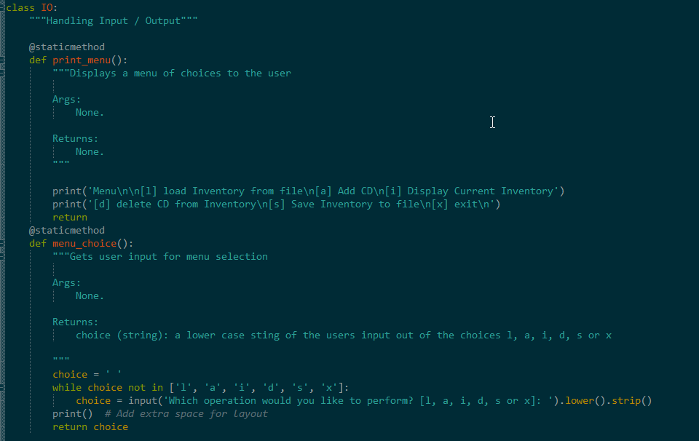
Figure 1 – Classes, Docstring, and Functions under Class IO
Docstrings provide a summary of what the function is actually doing. It provides programmers a way to understand what the function is doing and what arguments are passed int eh function. It is an explanatory header and it guides a programmer so that they can understand what the function is trying to do without having to read through each and every line of code.

Adding code to Assignment06_Starter.py script
The goal of this this assignment was to take portions of the code in the while loop where TODO sections were provided and create functions to facilitate the code. Additionally, we also had to create code under the various Classes sections of the starter script. To be more specific, we used code blocks that were part of the while loop and created new functions for them and defined them in the Classes at the beginning of the starter script. We then used the functions, and we organized them into the necessary Class types discussed in the section prior to this. In our assignment we had the following class types: class DataProcessor; class FileProcessor and class IO. We had to read through the existing starter script and find the lines where there were TODO items. We used the starter script for the CDInventory program, where the user could Add a CD, Load the CD, Save the CDInventory, Display the CD Inventory, and finally Delete a CD from the inventory. Since we were presented with a rather lengthy code, I decide to break the assignment up into portions and started with the user input section and moved it into the IO section. I then looked for parts of the while loop which talked about data processing and moved it into the DataProcessor Class and created the relevant function. Finally, in the while loop where it discussed processing data from a File, I moved that part of the code in the FileProcessor class and created the relevant TODO function. As I kept moving through the while loop, I refactored the code, I created a function for each section and created return values where appropriate.

Example of the Script Working in Spyder and a Terminal Window
Below are screenshots of the script being executed in the Spyder console window:
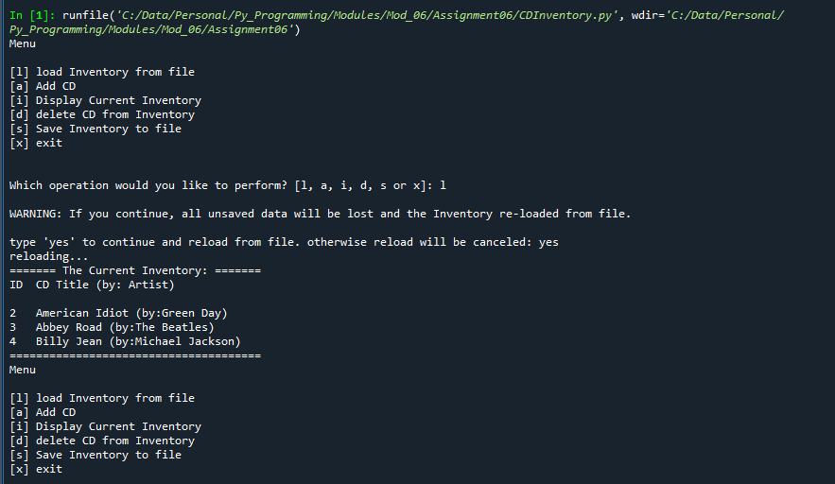
Figure 2 - Script execution in Spyder console
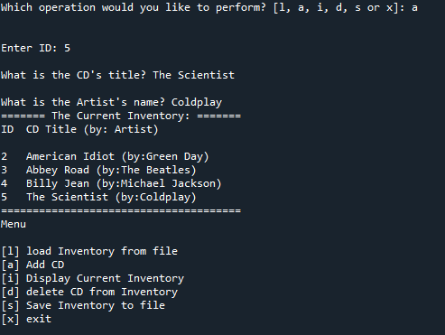
Figure 3 - Script Execution Spyder - Cont'd

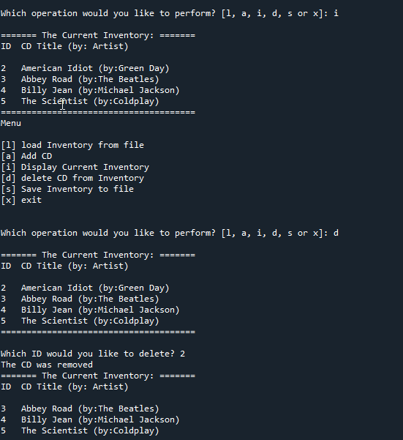
Figure 4 - Script Execution - Spyder - Cont'd

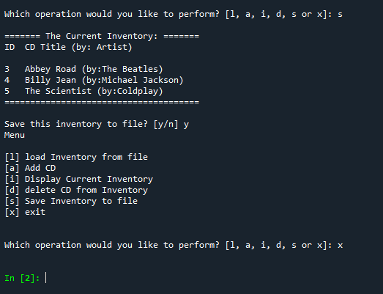
Figure 5 - Script Execution - Spyder - Cont'd

Script Execution in the Terminal Window
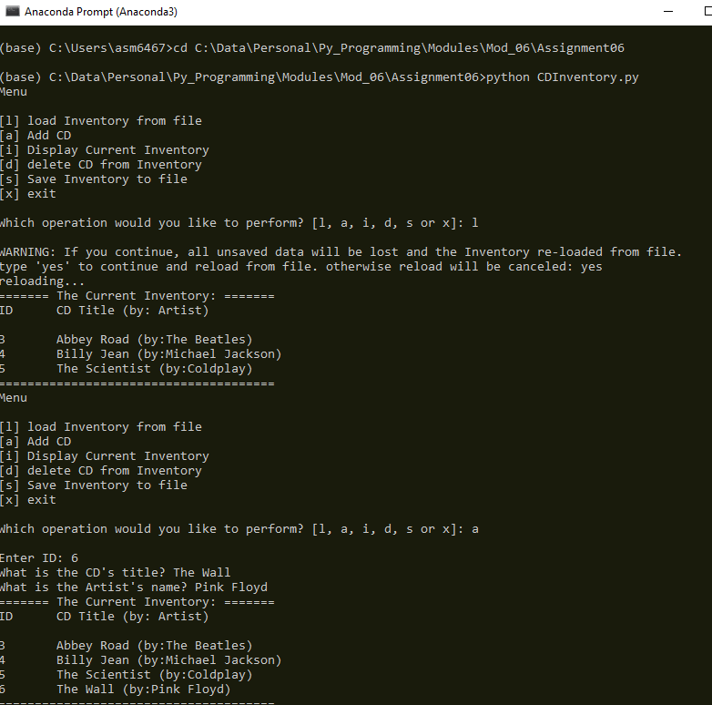
Figure 6 - Script execution in Terminal Window

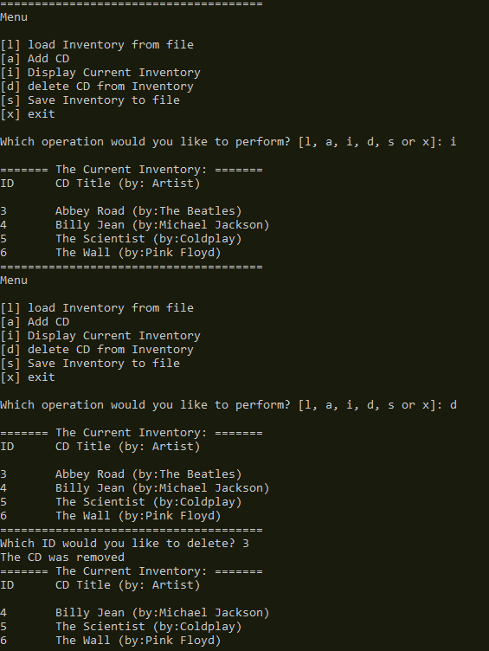
Figure 7 - Script execution in Terminal Window-Cont’d

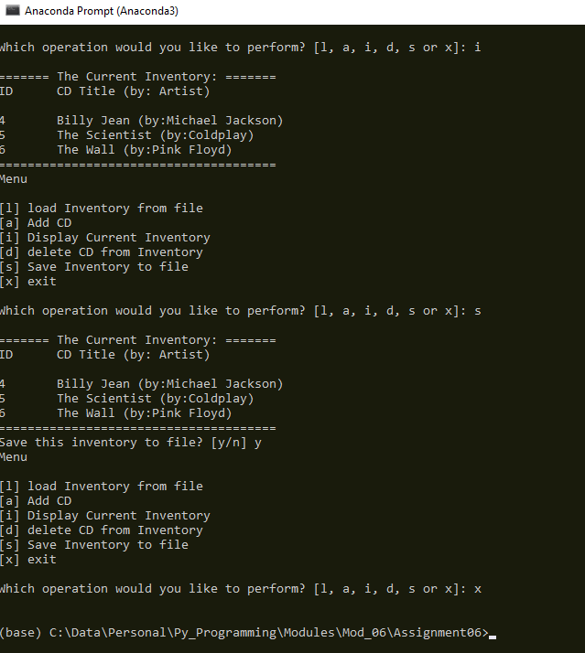
Figure 8 - Script execution in Terminal Window-Cont’d

Summary
This document covered the steps taken to add code to a starter script which was provided to us. The goal of the assignment was to modify the starter script to use functions to refactor the code. We were able to pass parameters in our functions, to accomplish the task at hand and also we were able to demonstrate using return values in a function. Additionally, the script show how we can use the return values as a variable and assign it to a different function. Finally, we took our functions and organized them into the relevant classes and adding docstrings to explain what is happening in the function. The code for this program can be found on my github repository

