Question no 1.11

Date 10-08-2024

Question.  Find the maximum of three using the conditional operator.

\*\*\*\*\*\*\*\*\*\*\*\*\*\*\*\*\*\*\*\*\*\*\*\*\*\*\*\*\*\*\*\*\*\*\*\*\*\*\*\*\*\*\*\*\*\*\*\*\*\*\*\*\*\*\*\*\*\*\*\*\*\*\*\*\*\*\*\*\*\*\*\*\*\*\*\*\*\*\*\*\*

Author : Amal Biju

Roll no :5

Semester :1

Programme : Bsc CS(DA)

#include <stdio.h>

int main()

{

int a,b,c,max;

printf("enter three numbers:");

scanf("%d%d%d",&a,&b,&c);

max=a>b?(a>c?a:c):(b>c?b:c);

printf("maximum=%d",max);

return 0;

}

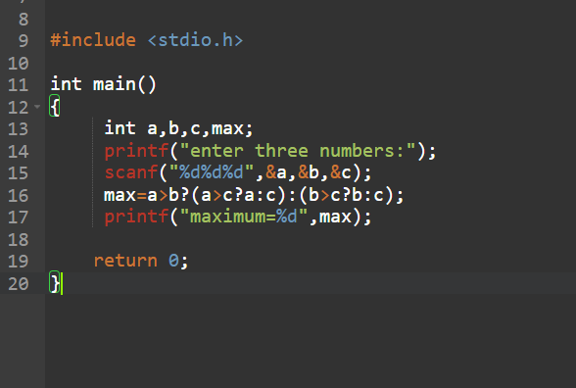

Output

