Question no 2.1

Date 09-08-2024

Question.  Find the max of 2 nos using two different logic

\*\*\*\*\*\*\*\*\*\*\*\*\*\*\*\*\*\*\*\*\*\*\*\*\*\*\*\*\*\*\*\*\*\*\*\*\*\*\*\*\*\*\*\*\*\*\*\*\*\*\*\*\*\*\*\*\*\*\*\*\*\*\*\*\*\*\*\*\*\*\*\*\*\*\*\*\*\*\*\*\*

Author : Amal Biju

Roll no :5

Semester :1

Programme : Bsc CS(DA)

#include <stdio.h>

int main()

{

int a,b,max;

printf("enter two numbers:");

scanf("%d%d",&a,&b);

if(a>b)

{

max=a;

}

else

{

max=b;

}

printf("maximum=%d",max);

return 0;

}

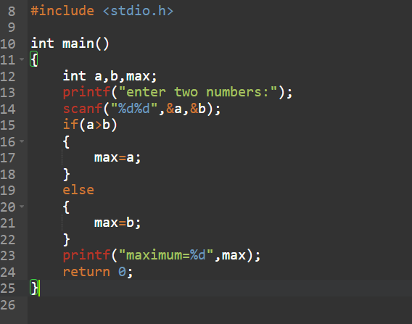

Output

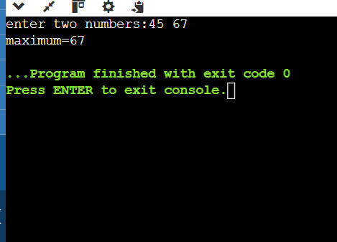

2nd method

#include <stdio.h>

int main()

{

int a,b,max;

printf("enter two numbers:");

scanf("%d%d",&a,&b);

if(a>b)

{

max=a;

}

if(a==b)

{

printf("both numbers are same");

return 1;

}

else

{

max=b;

}

printf(" maximum=%d",max);

return 0;

}

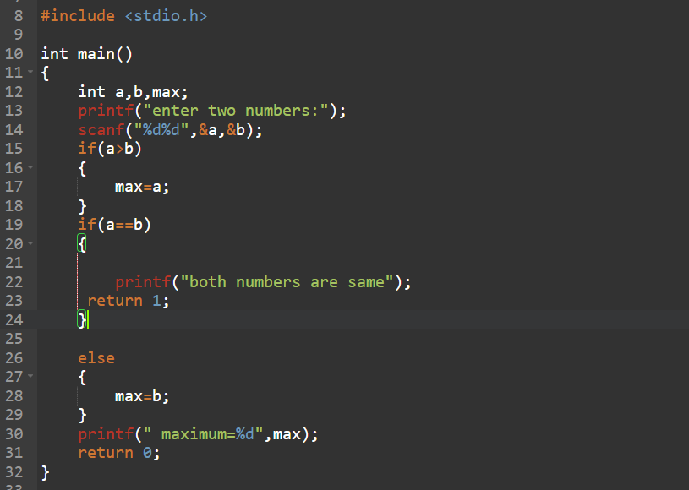

Output

