Question no 2.2

Date 09-08-2024

Question. Find the max of 3 nos using four different logic

\*\*\*\*\*\*\*\*\*\*\*\*\*\*\*\*\*\*\*\*\*\*\*\*\*\*\*\*\*\*\*\*\*\*\*\*\*\*\*\*\*\*\*\*\*\*\*\*\*\*\*\*\*\*\*\*\*\*\*\*\*\*\*\*\*\*\*\*\*\*\*\*\*\*\*\*\*\*\*\*\*

Author : Amal Biju

Roll no :5

Semester :1

Programme : Bsc CS(DA)

#include<stdio.h>

int main()

{

int a,b,c,m;

printf("enter three numbers:");

scanf("%d%d%d",&a,&b,&c);

if(a>b)

{

m=a;

}

else if(b>c)

{

m=b;

}

else

{

m=c;

}

printf("maximum=%d",m);

return 0;

}

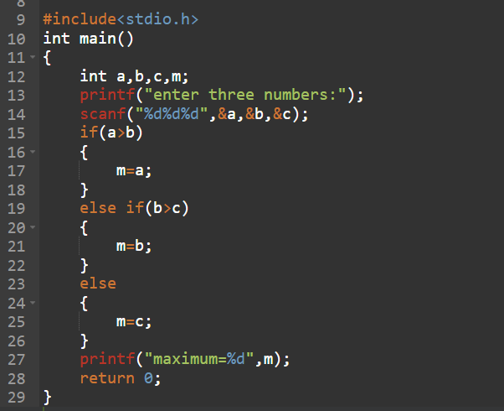

Output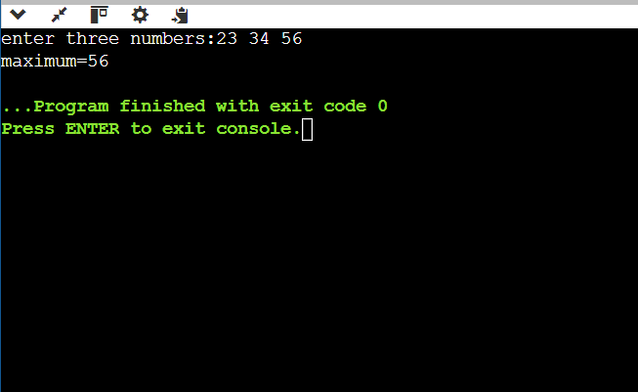

2nd method

include<stdio.h>

int main()

{

int a,b,c,m;

printf("enter three numbers:");

scanf("%d%d%d",&a,&b,&c);

if(a>b)

{

m=a;

}

else

{

m=b;

}

if(c>m)

{

m=c;

}

else

{

m=b;

}

printf("maximum=%d",m);

return 0;

}

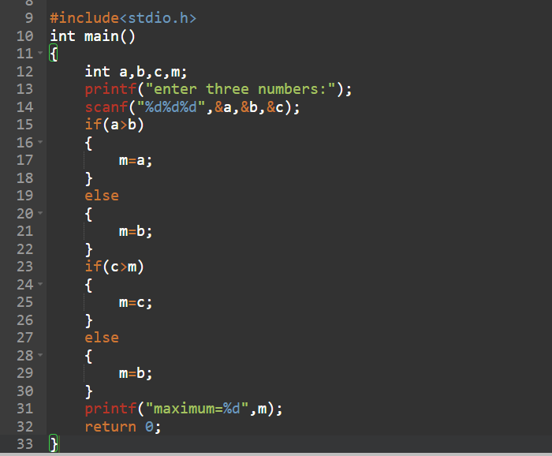

Output

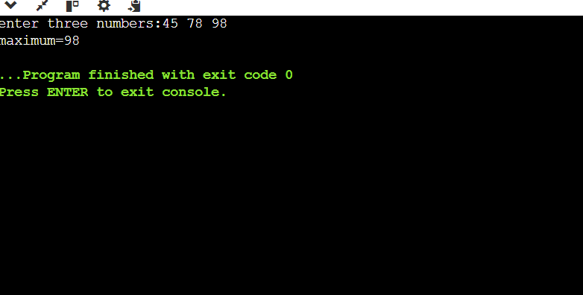

3rd method

#include<stdio.h>

int main()

{

int a,b,c,m;

printf("enter three numbers:");

scanf("%d%d%d",&a,&b,&c);

if(a>b)

{

if(a>c)

{

m=a;

}

else

{

m=c;

}

}

if(b>a)

{

if(b>c)

{

m=b;

}

else

{

m=c;

}

}

printf("maximum=%d",m);

return 0;

}

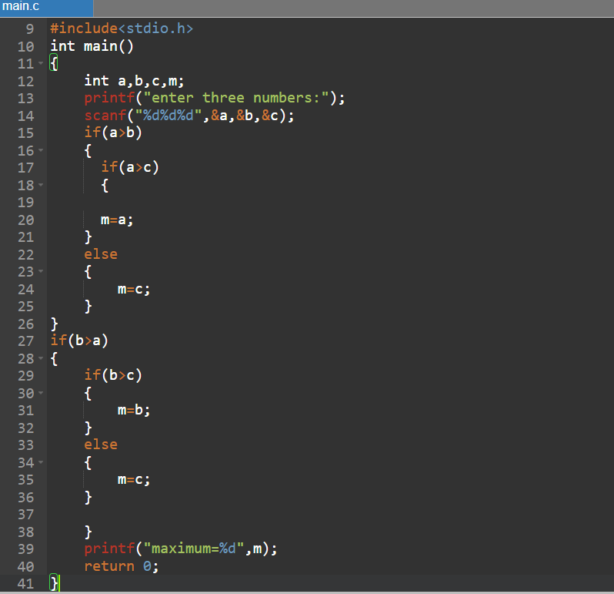

Output

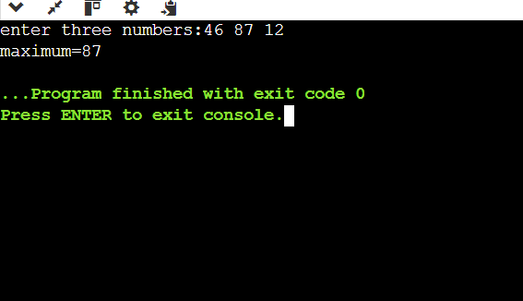

4th method

#include<stdio.h>

int main()

{

int a,b,c,m;

printf("enter three numbers:");

scanf("%d%d%d",&a,&b,&c);

if(a>b)

{

m=a;

}

else

{

m=b;

}

if(c>m)

{

m=c;

}

printf("maximum=%d",m);

return 0;

}

