Question no : 2.6

Date : 11-08 -2024

Question :Input a number and print that day of the week without using if

\*\*\*\*\*\*\*\*\*\*\*\*\*\*\*\*\*\*\*\*\*\*\*\*\*\*\*\*\*\*\*\*\*\*\*\*\*\*\*\*\*\*\*\*\*\*\*\*\*\*\*\*\*\*\*\*\*\*\*\*\*\*\*\*\*\*\*\*\*\*\*\*

Author : Amal Biju

Roll no : 5

Semester : 1

Programme : BSC(DA)

#include<stdio.h>

int main()

{

int day;

printf("enter a number to find the day:");

scanf("%d",&day);

switch(day)

{

case 1:printf("monday");

break;

case 2:printf("tuesday");

break;

case 3:printf("wednesday");

break;

case 4:printf("thursday");

break;

case 5:printf("friday");

break;

case 6:printf("saturday");

break;

case 7:printf("sunday");

break;

default:("invalid response");

break;

}

return 0;

}

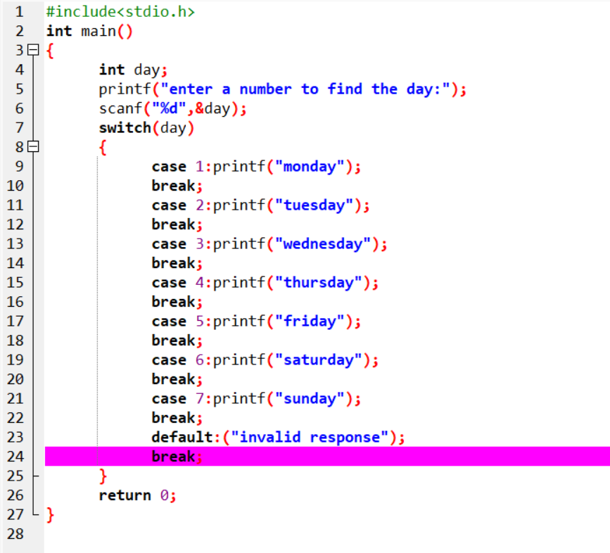

Output

