Question no : 2.6

Date : 13-08 -2024

Question : Menu driven bitwise operators using switch statement

\*\*\*\*\*\*\*\*\*\*\*\*\*\*\*\*\*\*\*\*\*\*\*\*\*\*\*\*\*\*\*\*\*\*\*\*\*\*\*\*\*\*\*\*\*\*\*\*\*\*\*\*\*\*\*\*\*\*\*\*\*\*\*\*\*\*\*\*\*\*\*\*

Author : Amal Biju

Roll no : 5

Semester : 1

Programme : BSC(DA)

\*\*\*\*\*\*\*\*\*\*\*\*\*\*\*\*\*\*\*\*\*\*\*\*\*\*\*\*\*\*\*\*\*\*\*\*\*\*\*\*\*\*\*\*\*\*\*\*\*\*\*\*\*\*\*\*\*\*\*\*\*\*\*\*\*\*\*\*\*\*\*\*

#include <stdio.h>

int main() {

int num1,num2,result,choice,shift;

do

{

printf("\nMenu:\n");

printf("1.Bitwise AND (&)\n");

printf("2.Bitwise OR (|)\n");

printf("3.Bitwise XOR (^)\n");

printf("4.Bitwise NOT (~)\n");

printf("5.Left Shift (<<)\n");

printf("6.Right Shift (>>)\n");

printf("7.Exit\n");

printf("Enter your choice:");

scanf("%d",&choice);

switch(choice)

{

case 1:

printf("Enter two numbers:");

scanf("%d %d",&num1,&num2);

result=num1 & num2;

printf("Result of %d & %d=%d\n",num1,num2,result);

break;

case 2:

printf("Enter two numbers:");

scanf("%d %d",&num1,&num2);

result=num1 | num2;

printf("Result of %d | %d = %d\n",num1,num2,result);

break;

case 3:

printf("Enter two numbers:");

scanf("%d %d", &num1, &num2);

result=num1 ^ num2;

printf("Result of %d ^ %d =%d\n",num1,num2,result);

break;

case 4:

printf("Enter a number:");

scanf("%d",&num1);

result =~num1;

printf("Result of ~%d = %d\n",num1,result);

break;

case 5:

printf("Enter a number:");

scanf("%d",&num1);

printf("Enter the number of positions to shift:");

scanf("%d",&shift);

result=num1 << shift;

printf("Result of %d << %d = %d\n",num1,shift,result);

break;

case 6:

printf("Enter a number:");

scanf("%d",&num1);

printf("Enter the number of positions to shift:");

scanf("%d",&shift);

result=num1 >> shift;

printf("Result of %d >> %d = %d\n",num1,shift,result);

break;

case 7:

printf("Exit the program\n");

break;

default:

printf("Invalid choice! Please try again.\n");

}

}

while(choice!=7);

return 0;

}

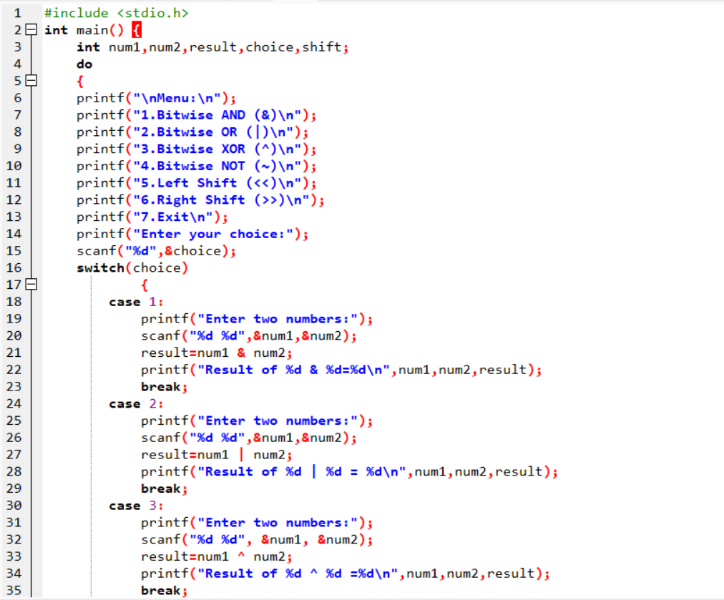

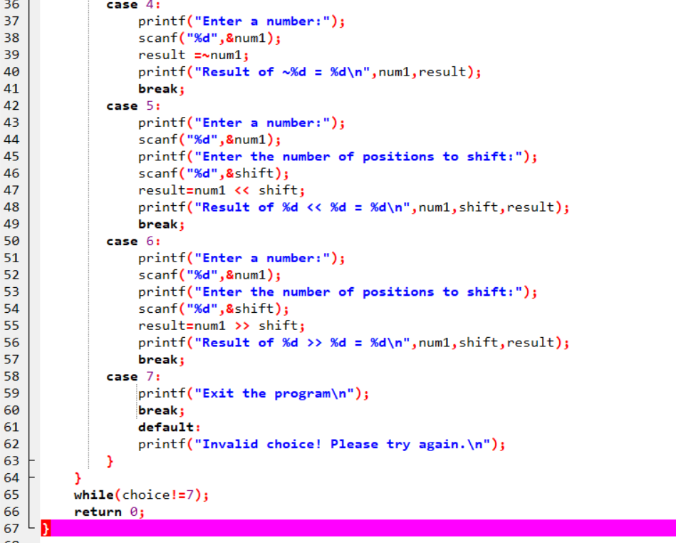

Output

