Question no : 2.6

Date : 12-08 -2024

Question : Create a Simple Calculator with +, - , \* , / and % operators using switch statements. It should also provide options for MS, MR, and MS+ once the result is generated.

\*\*\*\*\*\*\*\*\*\*\*\*\*\*\*\*\*\*\*\*\*\*\*\*\*\*\*\*\*\*\*\*\*\*\*\*\*\*\*\*\*\*\*\*\*\*\*\*\*\*\*\*\*\*\*\*\*\*\*\*\*\*\*\*\*\*\*\*\*\*\*\*

Author : Amal Biju

Roll no : 5

Semester : 1

Programme : BSC(DA)

\*\*\*\*\*\*\*\*\*\*\*\*\*\*\*\*\*\*\*\*\*\*\*\*\*\*\*\*\*\*\*\*\*\*\*\*\*\*\*\*\*\*\*\*\*\*\*\*\*\*\*\*\*\*\*\*\*\*\*\*\*\*\*\*\*\*\*\*\*\*\*\*

#include<stdio.h>

int main()

{

int a,b,result,ap,memory;

while(1)

{

printf("Arithmetic Operators:-\n");

printf("1.Addition\n");

printf("2.Subtraction\n");

printf("3.Multiplication\n");

printf("4.Division\n");

printf("5.modulus\n");

printf("Enter ur choice:");

scanf("%d",&ap);

if(ap>5)

{

printf("invalid choice.\n");

break;

}

printf("Enter any two numbers:");

scanf("%d %d",&a,&b);

switch(ap)

{

case 1:result=a+b;

printf("%d+%d is:%d\n",a,b,result);

break;

case 2:result=a-b;

printf("%d-%d is:%d\n",a,b,result);

break;

case 3:result=a\*b;

printf("%d\*%d is:%d\n",a,b,result);

break;

case 4:result=a/b;

printf("%d/%d is:%d\n",a,b,result);

break;

case 5:result=a%b;

printf("%d%%d is %d\n",a,b,result);

break;

default:printf("invalid choice..\n");

continue;

}

while(1)

{

printf("Memory:-\n");

printf("1.MS\n");

printf("2.MR\n");

printf("3.MS+\n");

printf("Enter ur choice:");

scanf("%d",&memory);

switch(memory)

{

case 1:memory=result;

printf("%d stored\n",memory);

break;

case 2:printf("MR:%d\n",memory);

break;

case 3:memory=memory+result;

printf("%d added\n",result);

printf("new memory is:%d\n",memory);

break;

default:printf("invalid choice..\n");

continue;

}

break;

}

}

return 0;

}

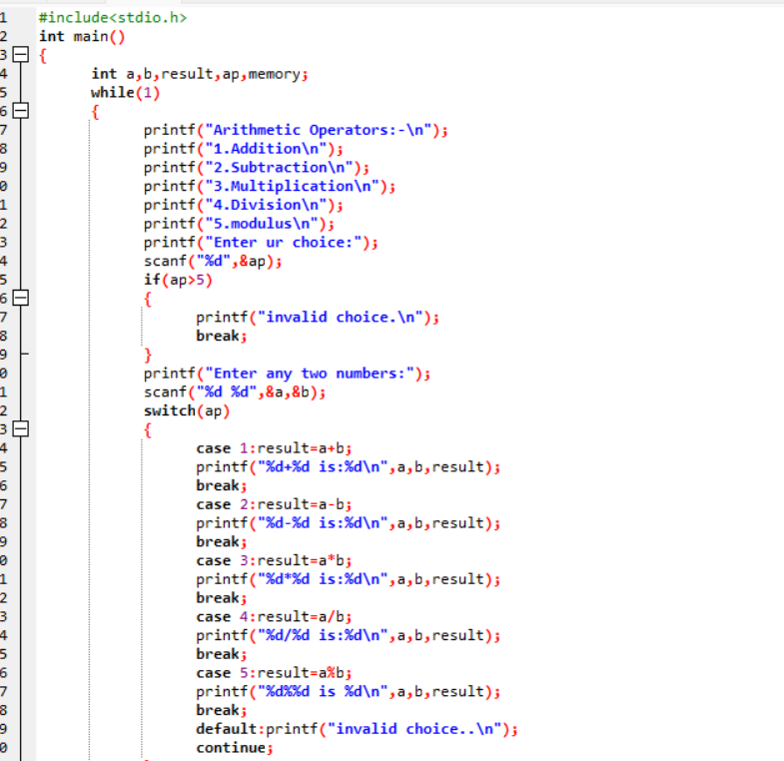

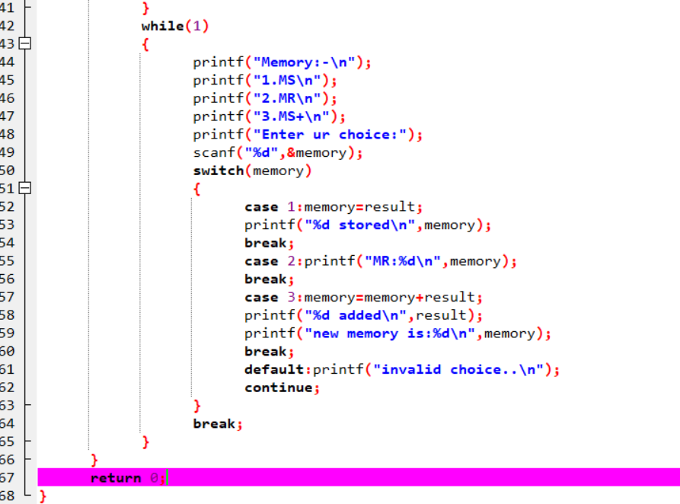

Output

