Question no 3.4

Date 09-08-2024

Question  Find the sum of n given numbers using a while loop

\*\*\*\*\*\*\*\*\*\*\*\*\*\*\*\*\*\*\*\*\*\*\*\*\*\*\*\*\*\*\*\*\*\*\*\*\*\*\*\*\*\*\*\*\*\*\*\*\*\*\*\*\*\*\*\*\*\*\*\*\*\*\*\*\*\*\*\*\*\*\*\*\*\*\*\*\*\*\*\*\*

Author : Amal Biju

Roll no :5

Semester :1

Programme : Bsc CS(DA)

#include <stdio.h>

int main()

{

int n,sum=0,num,i=0;

printf("enter the number of value:");

scanf("%d",&n);

while(i<n)

{

printf("Enter number %d:",i+1);

scanf("%d",&num);

sum=sum+num;

i++;

}

printf("The sum of the %d numbers is: %d\n", n, sum);

return 0;

}

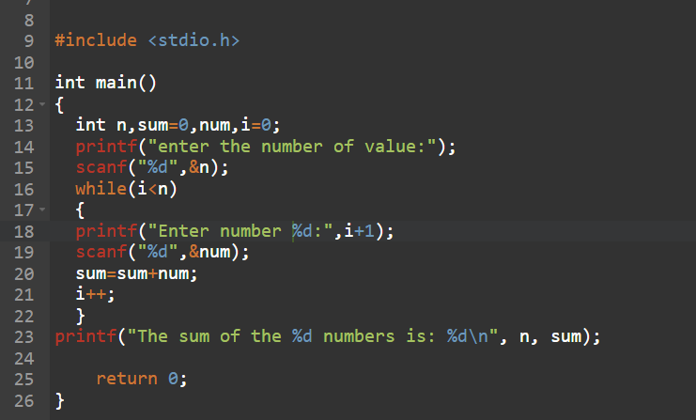

Output

