Question no 3.5

Date 09-08-2024

Question.    Find the sum of the digits of a given number

\*\*\*\*\*\*\*\*\*\*\*\*\*\*\*\*\*\*\*\*\*\*\*\*\*\*\*\*\*\*\*\*\*\*\*\*\*\*\*\*\*\*\*\*\*\*\*\*\*\*\*\*\*\*\*\*\*\*\*\*\*\*\*\*\*\*\*\*\*\*\*\*\*\*\*\*\*\*\*\*\*

Author : Amal Biju

Roll no :5

Semester :1

Programme : Bsc CS(DA)

#include<stdio.h>

int main()

{

int n,sum=0;

printf("enter the number:");

scanf("%d",&n);

while(n>0)

{

sum=sum+n%10;

n/=10;

}

printf("The sum of the digits is: %d\n", sum);

return 0;

}

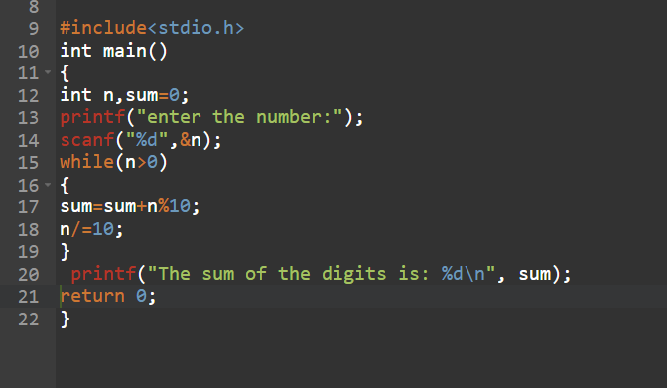

Output

