Question no : 3.7

Date : 14-08 -2024

Question : Find the sum of 1+(1+2) + (1+2+3) + …. + (1+2+3+...+n) using a single while loop

\*\*\*\*\*\*\*\*\*\*\*\*\*\*\*\*\*\*\*\*\*\*\*\*\*\*\*\*\*\*\*\*\*\*\*\*\*\*\*\*\*\*\*\*\*\*\*\*\*\*\*\*\*\*\*\*\*\*\*\*\*\*\*\*\*\*\*\*\*\*\*\*

Author : Amal Biju

Roll no : 5

Semester : 1

Programme : BSC(DA)

#include<stdio.h>

int main()

{

int n,i=1,sum=0,total=0;

printf("enter a positive number:");

scanf("%d",&n);

while(i<=n)

{

sum=sum+i;

total=total+sum;

i++;

}

printf("The sum of series is:%d\n",total);

return 0;

}

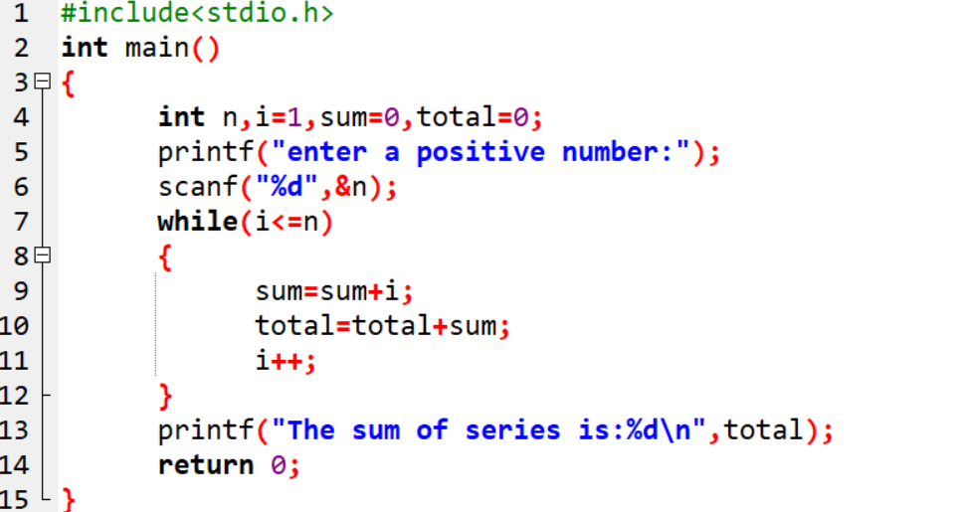

Output

