Question no 4.1

Date 09-08-2024

Question.  Display from 1 to n and n to 1 using two for loops, where n is a positive integer given by the user.

\*\*\*\*\*\*\*\*\*\*\*\*\*\*\*\*\*\*\*\*\*\*\*\*\*\*\*\*\*\*\*\*\*\*\*\*\*\*\*\*\*\*\*\*\*\*\*\*\*\*\*\*\*\*\*\*\*\*\*\*\*\*\*\*\*\*\*\*\*\*\*\*\*\*\*\*\*\*\*\*\*

Author : Amal Biju

Roll no :5

Semester :1

Programme : Bsc CS(DA)

#include <stdio.h>

int main()

{

int n,i;

printf("enter a number:");

scanf("%d",&n);

for (i =1; i<=n;i++)

{

printf("%d ",i);

}

printf("\n");

for (i=n; i>=1;i--)

{

printf("%d ",i);

}

printf("\n");

return 0;

}

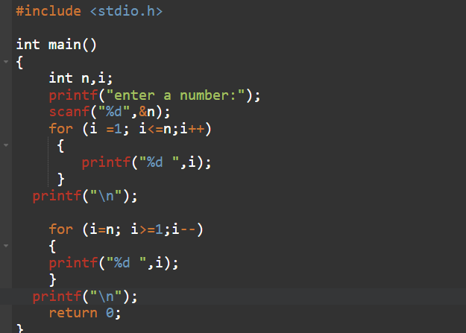

Output

