Question no 4.2

Date 09-08-2024

Question Find the factorial of a given number

\*\*\*\*\*\*\*\*\*\*\*\*\*\*\*\*\*\*\*\*\*\*\*\*\*\*\*\*\*\*\*\*\*\*\*\*\*\*\*\*\*\*\*\*\*\*\*\*\*\*\*\*\*\*\*\*\*\*\*\*\*\*\*\*\*\*\*\*\*\*\*\*\*\*\*\*\*\*\*\*\*

Author : Amal Biju

Roll no :5

Semester :1

Programme : Bsc CS(DA)

#include<stdio.h>

int main()

{

int i,n,fact=1;

printf("enter the number:");

scanf("%d",&n);

for(i=1;i<=n;i++)

{

fact=fact\*i;

}

printf("factorial of the given number=%d",fact);

return 0;

}

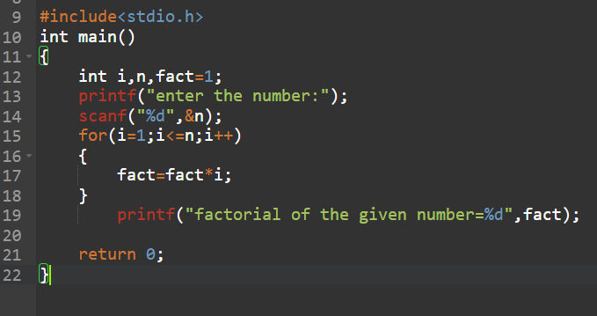

Output

