Question no 4.3

Date 09-08-2024

Question.  Find the sum of 1+2! +3!+...+n! Using one for loop \*\*\*\*\*\*\*\*\*\*\*\*\*\*\*\*\*\*\*\*\*\*\*\*\*\*\*\*\*\*\*\*\*\*\*\*\*\*\*\*\*\*\*\*\*\*\*\*\*\*\*\*\*\*\*\*\*\*\*\*\*\*\*\*\*\*\*\*\*\*\*\*\*\*\*\*\*\*\*\*\*

Author : Amal Biju

Roll no :5

Semester :1

Programme : Bsc CS(DA)

#include <stdio.h>

int main()

{

int n,fact=1,i,sum=0;

printf("enter a number:");

scanf("%d",&n);

for(i=1;i<=n;i++)

{

fact\*=i;

sum+=fact;

}

printf("the sum of the series =%d",sum);

return 0;

}

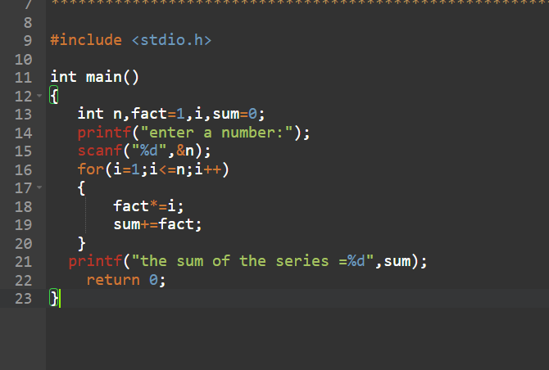

Output

