Question no : 5.1

Date : 14-09 -2024

Question : Program to check if the given number is prime or not.

\*\*\*\*\*\*\*\*\*\*\*\*\*\*\*\*\*\*\*\*\*\*\*\*\*\*\*\*\*\*\*\*\*\*\*\*\*\*\*\*\*\*\*\*\*\*\*\*\*\*\*\*\*\*\*\*\*\*\*\*\*\*\*\*\*\*\*\*\*\*\*\*

Author : Amal Biju

Roll no : 5

Semester : 1

Programme : BSC(DA)

#include <stdio.h>

int main()

{

int n,Prime=1;

printf("Enter a number:");

scanf("%d",&n);

int i=2;

if(n<2)

{

Prime=0;

}

else

{

do

{

if(n%i==0)

{

Prime=0;

}

i++;

}

while (i<=n/2);

}

if(Prime)

{

printf("%d is prime\n",n);

}

else

{

printf("%d is not prime\n", n);

}

return 0;

}

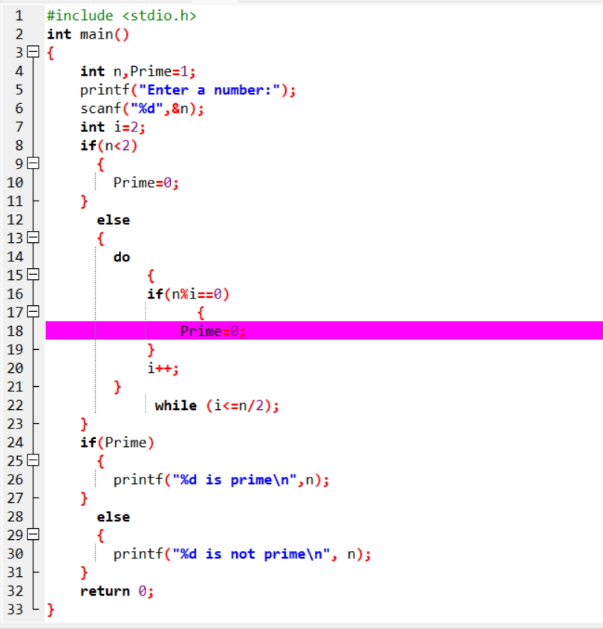

Output

