Question no : 5.2

Date : 14-09 -2024

Question : Program to check the given number is armstrong number or not using do..while loop

\*\*\*\*\*\*\*\*\*\*\*\*\*\*\*\*\*\*\*\*\*\*\*\*\*\*\*\*\*\*\*\*\*\*\*\*\*\*\*\*\*\*\*\*\*\*\*\*\*\*\*\*\*\*\*\*\*\*\*\*\*\*\*\*\*\*\*\*\*\*\*\*

Author : Amal Biju

Roll no : 5

Semester : 1

Programme : BSC(DA)

#include<stdio.h>

int main()

{

int r,n,sum=0,temp;

printf("Enter the number:");

scanf("%d",&n);

temp=n;

do

{

r=n%10;

sum=sum+(r\*r\*r);

n=n/10;

}

while(n>0);

if(temp==sum)

{

printf("armstrong number.");

}

else

{

printf("Not armstrong number.");

}

return 0;

}

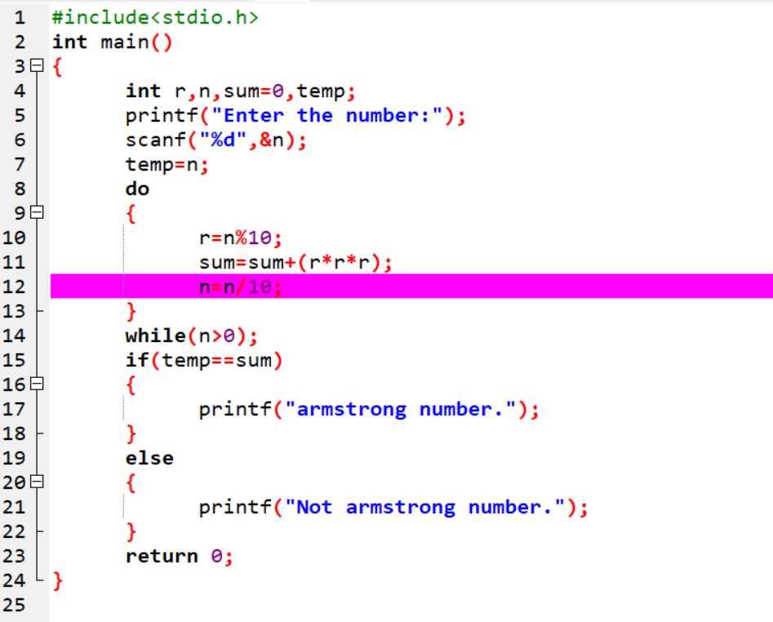

Output

