Question no :5.3

Date       14-10-2024

Question:.  Keep a secret number between 20 and 30 in your program. Ask the user to predict the number between 20 and 30. Use do while loop until the user predicts your secret number and displays the count of attempts.

\*\*\*\*\*\*\*\*\*\*\*\*\*\*\*\*\*\*\*\*\*\*\*\*\*\*\*\*\*\*\*\*\*\*\*\*\*\*\*\*\*\*\*\*\*\*\*\*\*\*\*\*\*\*\*\*\*\*\*\*\*\*\*\*\*\*\*\*\*\*\*\*\*\*\*\*\*\*\*\*\*\*\*\*\*\*\*\*\*\*\*\*\*\*\*\*\*\*\*\*\*\*\*\*\*

Author   : Amal Biju

Roll no    :4

Semester :1

Programme : Bsc CS(DA)

\*\*\*\*\*\*\*\*\*\*\*\*\*\*\*\*\*\*\*\*\*\*\*\*\*\*\*\*\*\*\*\*\*\*\*\*\*\*\*\*\*\*\*\*\*\*\*\*\*\*\*\*\*\*\*\*\*\*\*\*\*\*\*\*\*\*\*\*\*\*\*\*\*\*\*\*\*\*\*\*\*\*\*\*\*\*\*\*\*\*\*\*\*\*\*\*

#include<stdio.h.>

int main()

{

int sec=27,guess;

do

{

printf("enter your guess:");

scanf("%d",&guess);

}

while(guess!=sec);

printf("\n Yes!! the secret number is %d",guess);

return 0;

}

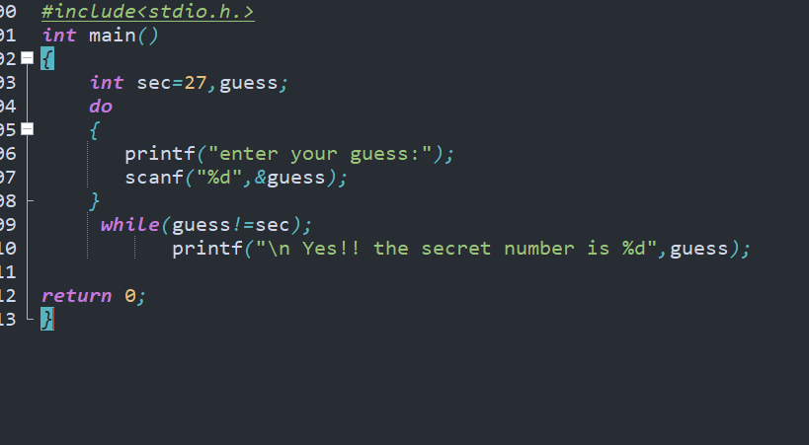

Output

