Question no 6.1(a)

Date 16-10-2024

Question 1. display the following in 2 different logic

a) if the input is 4

1

1 2

1 2 3

1 2 3 4

\*\*\*\*\*\*\*\*\*\*\*\*\*\*\*\*\*\*\*\*\*\*\*\*\*\*\*\*\*\*\*\*\*\*\*\*\*\*\*\*\*\*\*\*\*\*\*\*\*\*\*\*\*\*\*\*\*\*\*\*\*\*\*\*\*\*\*\*\*\*\*\*\*\*\*\*\*\*\*\*\*

Author : Amal Biju

Roll no :5

Semester :1

Programme : Bsc CS(DA)

#include<stdio.h>

int main()

{

int i,n,j;

printf("enter the value of n:");

scanf("%d",&n);

for(i=0;i<=n;i++)

{

for(j=1;j<=i;j++)

{

printf("%d\t",j);

}

printf("\n");

}

return 0;

}

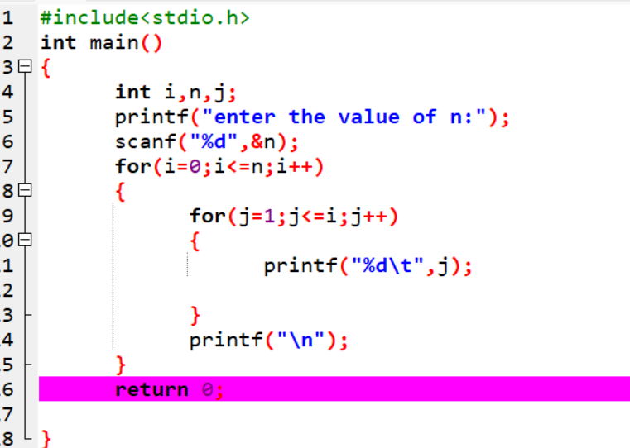

Output

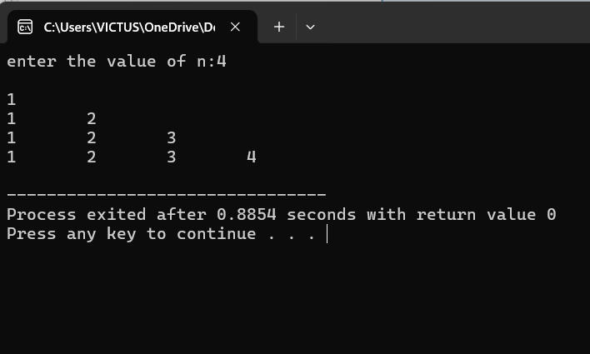

2nd method

#include<stdio.h>

int main()

{

int i,n,j;

printf("enter the value of n:");

scanf("%d",&n);

i=1;

while(i<=n)

{

j=1;

while(j<=i)

{

printf("%d\t",j);

j++;

}

i++;

printf("\n");

}

return 0;

}

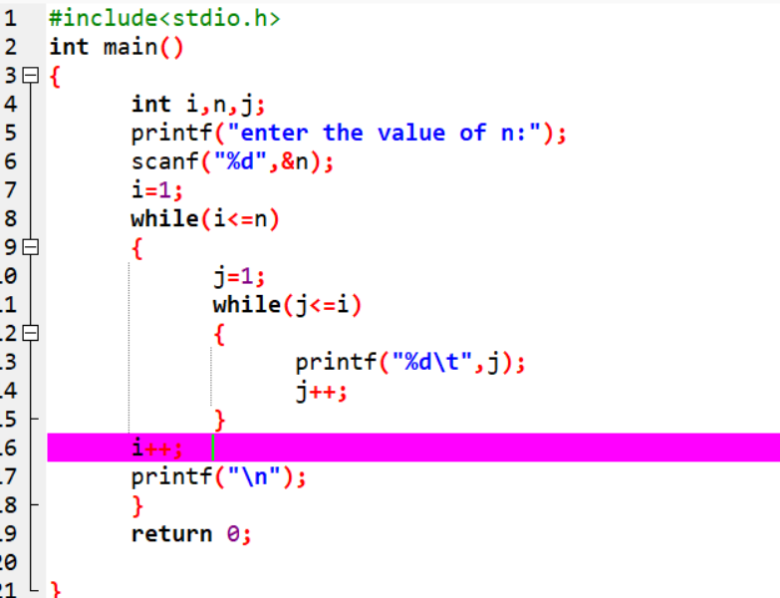

Output

