Question no 6.1(c)

Date 16-10-2024

Question 1. display the following in 2 different logic

c) 1

1 0

1 0 1

1 0 1 0

\*\*\*\*\*\*\*\*\*\*\*\*\*\*\*\*\*\*\*\*\*\*\*\*\*\*\*\*\*\*\*\*\*\*\*\*\*\*\*\*\*\*\*\*\*\*\*\*\*\*\*\*\*\*\*\*\*\*\*\*\*\*\*\*\*\*\*\*\*\*\*\*\*\*\*\*\*\*\*\*\*

Author : Amal Biju

Roll no :5

Semester :1

Programme : Bsc CS(DA)

#include<stdio.h>

int main()

{

int i,j,n;

printf("enter the value of n:");

scanf("%d",&n);;

i=1;

while(i<=n)

{

j=1;

while(j<=i)

{

printf("%d\t",j%2);

j++;

}

i++;

printf("\n");

}

return 0;

}

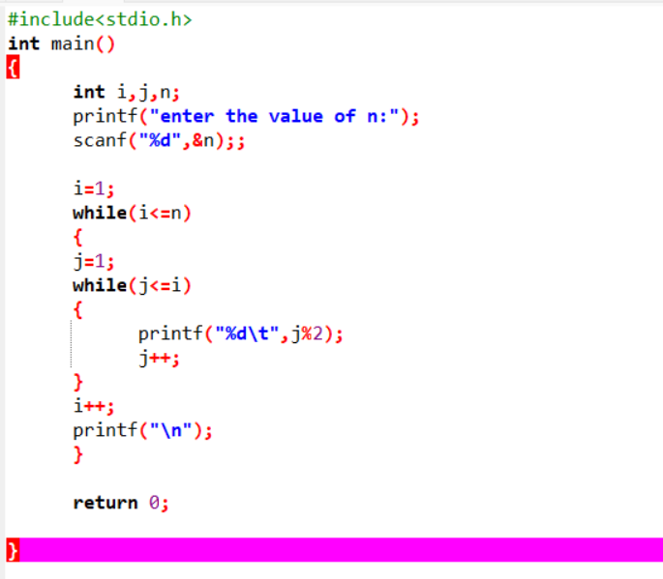

Output

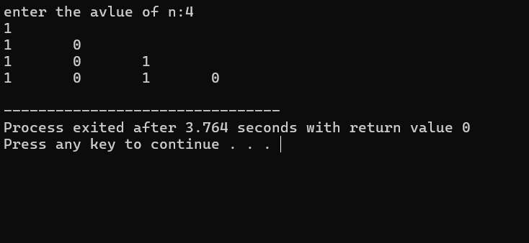

2nd method

#include<stdio.h>

int main()

{

int i,j,n;

printf("enter the avlue of n:");

scanf("%d",&n);;

for(i=1;i<=n;i++)

{

for(j=1;j<=i;j++)

{

printf("%d\t",j%2);

}

printf("\n");

}

return 0;

}

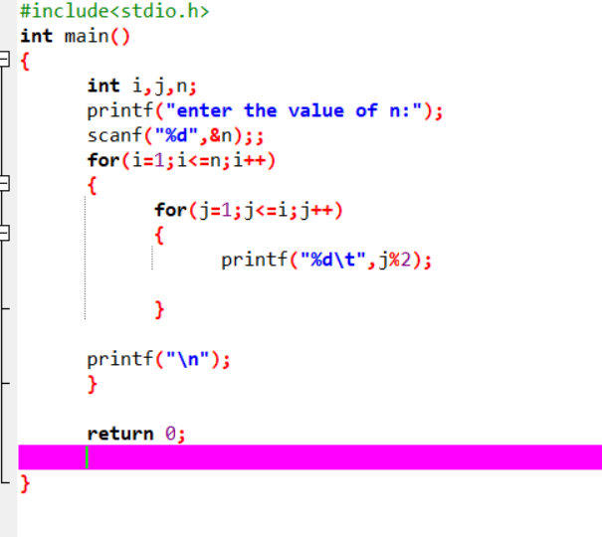

Output

