**PROGRAM NO:08** **DATE:14-09-2022**

**AIM:** Develop an application that toggles image using FrameLayout.

**PROGRAM CODE:**

**activity.xml**

<?xml version="1.0" encoding="utf-8"?>

<FrameLayout xmlns:android="http://schemas.android.com/apk/res/android"

xmlns:app="http://schemas.android.com/apk/res-auto"

android:id="@+id/frameLayout"

xmlns:tools="http://schemas.android.com/tools"

android:layout_width="match_parent"

android:layout_height="match_parent"

tools:context=".MainActivity">

<ImageView

android:id="@+id/image1"

android:layout_width="match_parent"

android:layout_height="239dp"

android:scaleType="centerCrop"

android:src="@drawable/image1" />

<ImageView

android:layout_width="match_parent"

android:layout_height="239dp"

android:scaleType="centerCrop"

android:src="@drawable/image2"

android:id="@+id/image2"/>

</FrameLayout>

Mainactivity.java

package com.example.myapplication11;

import androidx.appcompat.app.AppCompatActivity;

import android.os.Bundle;

import android.view.View;

import android.widget.ImageView;

public class MainActivity extends AppCompatActivity {

ImageView i1,i2;

@Override

protected void onCreate(Bundle savedInstanceState) {

super.onCreate(savedInstanceState);

setContentView(R.layout.activity_main);

i1=findViewById(R.id.image1);

i2=findViewById(R.id.image2);

i2.setOnClickListener(new View.OnClickListener() {

@Override

public void onClick(View view) {

i2.setVisibility(View.GONE);

i1.setVisibility(View.VISIBLE);

}

});

i1.setOnClickListener(new View.OnClickListener() {

@Override

public void onClick(View view) {

i1.setVisibility(View.GONE);

i2.setVisibility(View.VISIBLE);

}

});

}

}

**RESULT:** Program compiled successfully and output verified.

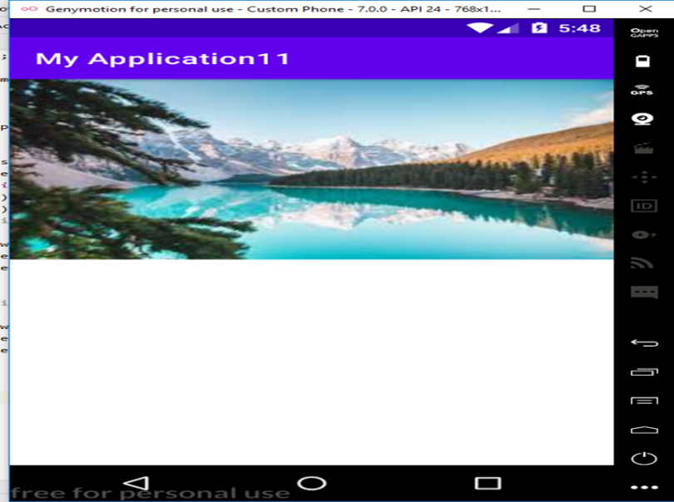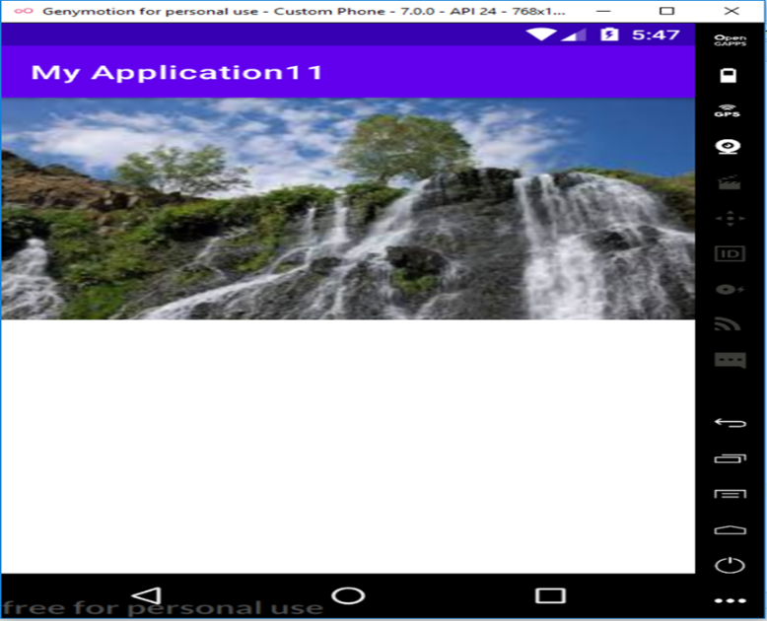**OUTPUT**