1.Count the number of Salesperson whose name begin with **‘a’**/**’A’**.



2. Display all the Salesperson whose all orders worth is more than Rs. 2000.

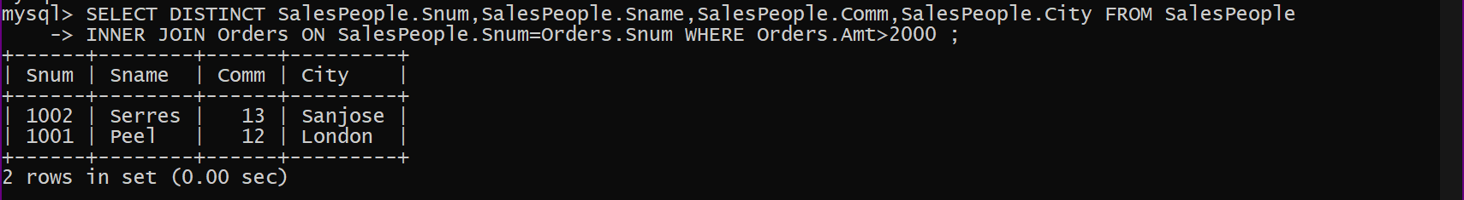

3. Count the number of Salesperson belonging to **Newyork**.



4. Display the number of Salespeople belonging to **London**and belonging to **Paris**.



5. Display the number of orders taken by each Salesperson and their date of orders.

