

**Faculty of Engineering and Technology**

**Electrical And Computer Engineering Department**

**Digital signals processing**

**ENCS4310**

**Course Project Report**

**Done By:**

Amal Ziad_1192141

Shaymaa Tariq_1191708

Malak Raddad_1192408

**Instructor:** AlHareth Zyoud

**Sections:** 1

**Date:** 15/6/2022

**Introduction**

The aim of this project is to build a program that recognizes and differentiate between the two genders by entering voices. All of this by using matlab codes connected with Arduino, LDC and PC speaker. The followed method is by entering “hi” or “bye” from both genders, described in the rest of the report.

# Problem specification

There was a problem in determining the gender of the speaker in some cases. Sometimes, the system gave ‘female’ as a result of the spoken record while it was ‘male’ and vice versa (referred to the degree of their voices like sometimes there are males who sounds a bet lighter than the known degree of male voices and again vice versa).

# Data

Many had been gathered for the two words that we followed as a point of the preference with diversity between female records and male records.

# Evaluation criteria

The main criterium is the energy for both words. There were two folders: train and test folders. The total average of the energy for the whole records was evaluated, and then the average for ‘Hi’ records and the average for ‘Bye’ records were evaluated separately. Finding the average of the energy was to compare between these averages and the averages of the records in test folder. According to this comparison, the results were recognized. In addition, zero-crossing rate was a vital criterium that played the main role to compare between the records according to the times the frequencies of the record cross the X axis. The successes rate was 70% which is a good rate. It also includes simple short-time pitch frequency (or fundamental frequency F0) which can be estimated from the short frames (20-30ms) using auto-correlation method. The fundamental frequency represents the vibration rate of the vocal folds of the speaker, which is usually high for the children, female speakers, and relativity low for the male speakers.

Where, R(k) is the autocorrelation function at k. s[n] is the short frame samples with length N samples.

# Approach

To solve the problem, the records have been clarified more than the first attempt. This solution is important to evaluate the average of the energy accurately for the ‘Hi’ records and compare them with the energy of the ‘Bye’ records. In addition, many other obvious records were added and the files were divided into another files which makes the scope of comparison more precise so we can get more accurate results, especially when determining the gender ‘female’ or ‘male’.

# Results and Analysis:

All the results were good as expected. Some results were sometimes wrong, but they are still few times and having some mistakes is possible due to many reasons, such as the surrounded noise while speaking the word. All the results are shown in the figures below.

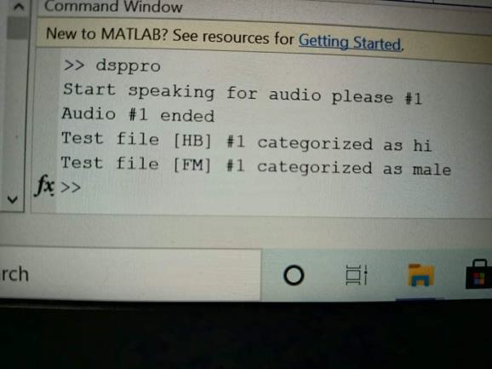

Fig.1.1 (command screen for result 1)

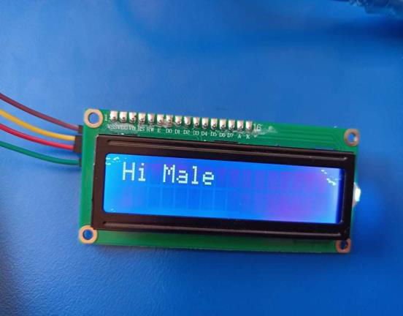

Fig.1.2 (Arduino screen for result 1)

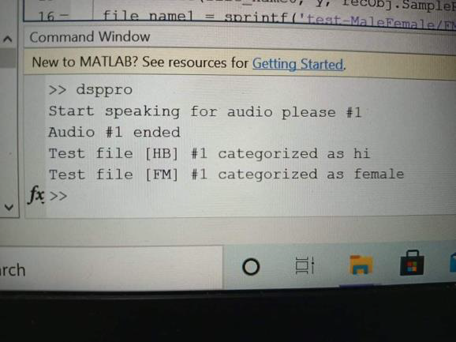

Fig.2.1 (command screen for result 2)



Fig.2.2 (Arduino screen for result 2)

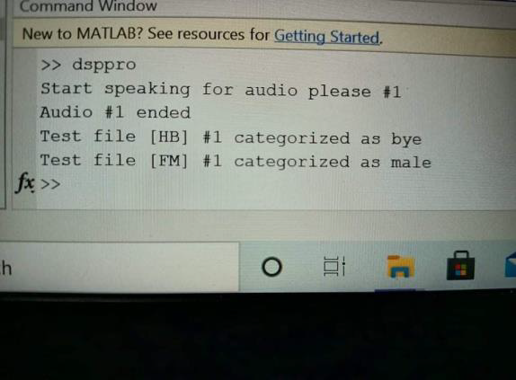

Fig.3.1 (command screen for result 3)

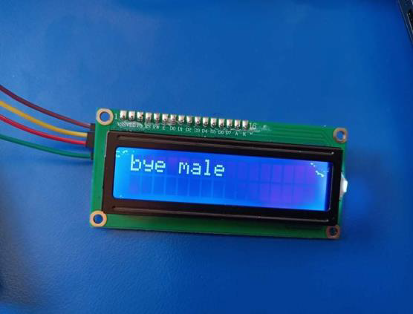

Fig.3.2 (Arduino screen for result 3)



Fig.4.1 (command screen for result 4)



Fig.4.2 (Arduino screen for result 4)

# Development

This is the developed system building on the software system. Maybe in the future, students can complete this system to determine the range of the ages of the speaker.

# Conclusion:

This phase helped us to become more familiar with many concepts in Digital Signal Processing like energy and zero-crossing rate, which made students able to deal with any system, built using such these concept.

# References:

ºhttps://www.youtube.com/watch?v=aczsVEtAkps&list=PLnyw1IVZpaTsFgcU2QlK9x2jU8vIFaRBl Accessed on 10/6/2022 at 10:00 pm.

º <https://www.youtube.com/watch?v=s2P3xnTM1G4> Accessed on 12/6/2022 at 6:00 pm.

º <https://www.youtube.com/watch?v=00Zq4yC0J6o> Accessed on 15/6/2022 at 10:30 am.