

**Faculty of Engineering & Technology – Electrical & Computer Engineering Department**

**First Semester 2022 – 2023**

**Circuits and electronics lab**

**ENEE2103**

**PRELAB EXP.3**

**Name: Amal Ziad**

**ID: 1192141**

**Section: 2**

**Instructor: Dr. Nasser Ismael**

**TA: Eng. Yazan Yousef**

**Date: 4th Nov 2022**

## A.RC Circuit

PER=period=1/f=1/50=20m, PW= pulse width=0.5T=10m.

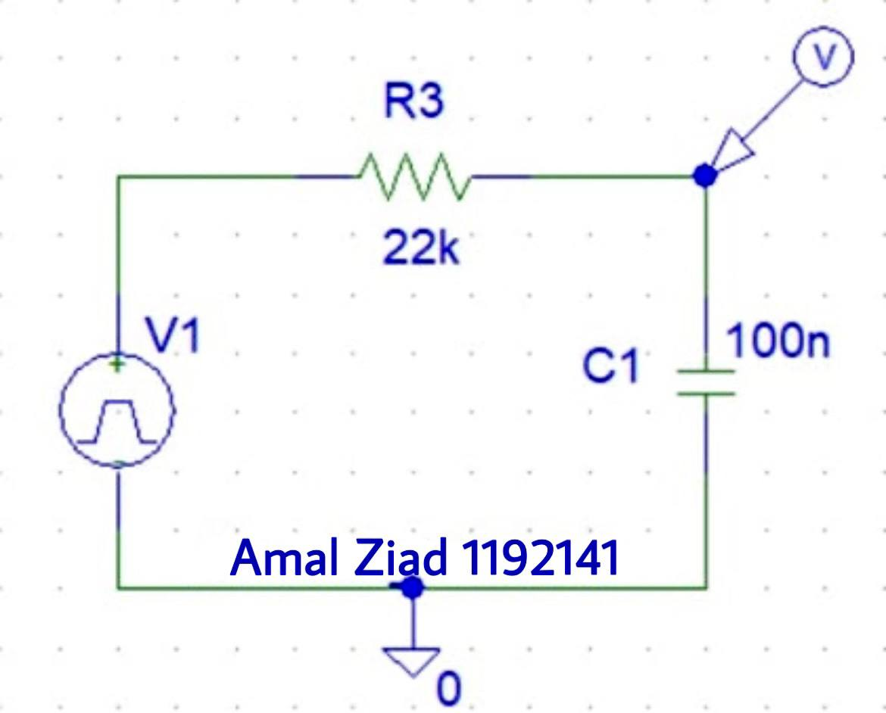

Figure 3.1

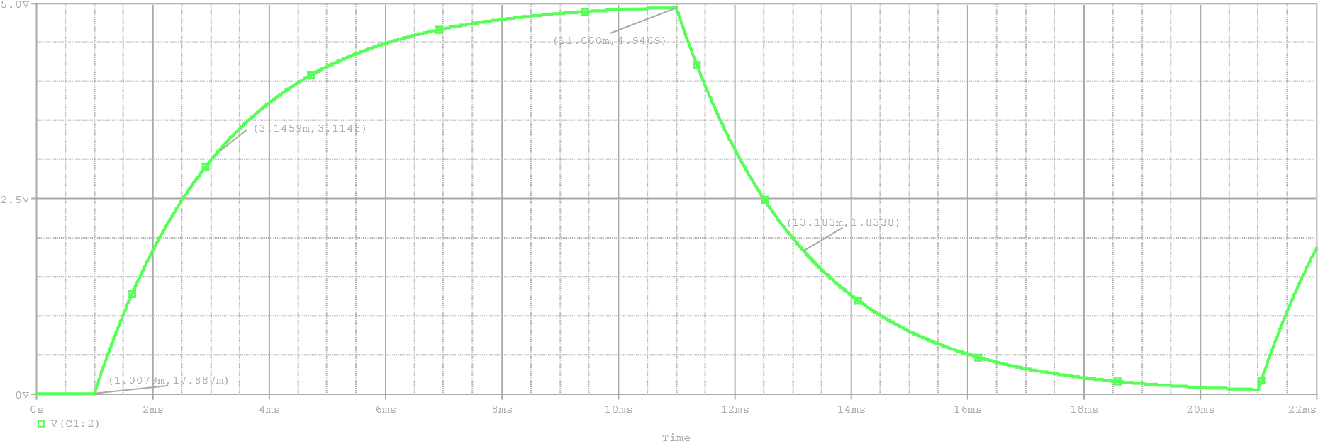

Figure 3.2

the time constant that starts from the beginning of the rising (1.0079ms) equals to 3.1459 – 1.0079 = 2.1380ms.

## B.RL Circuit

PER=period=1/f=1/500=2m, PW= pulse width=0.5T=1m.

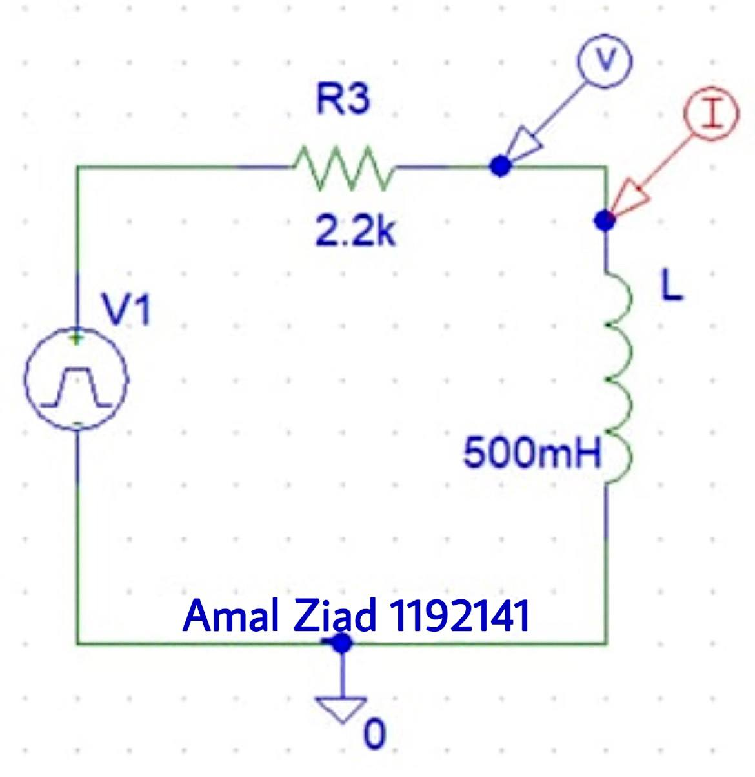 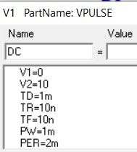

Figure 3.3 Figure 3.4

Time

0

s

0.5

ms

ms

1.0

1.5

ms

ms

2.0

2.5

ms

ms

3.0

V(L:1)

V

-10

0

V

V

10

(1.0000m,10.000)

Figure 3.5

As shown in figure 3.5 the steady state voltage is equal to 10v.

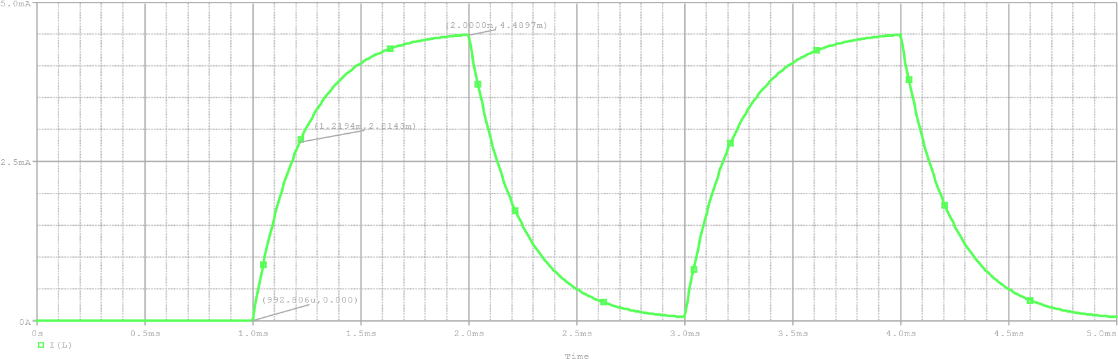

Figure 3.6

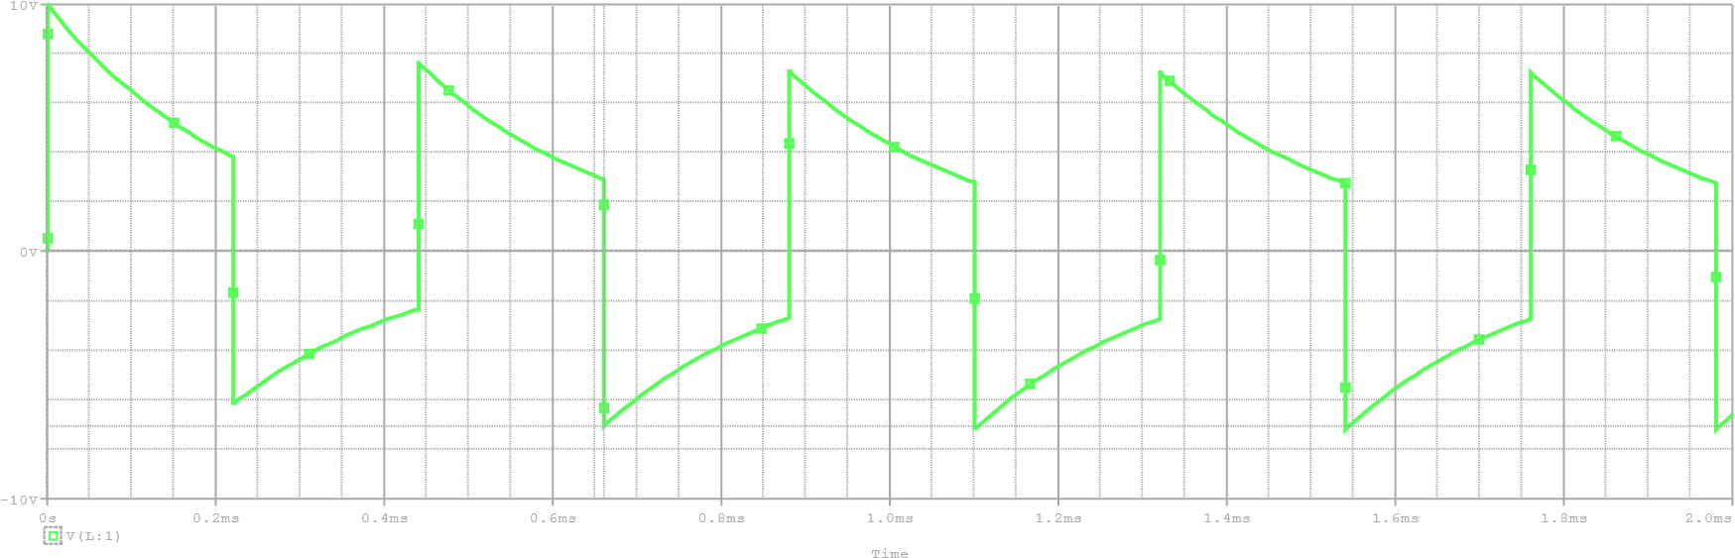

Figure 3.7

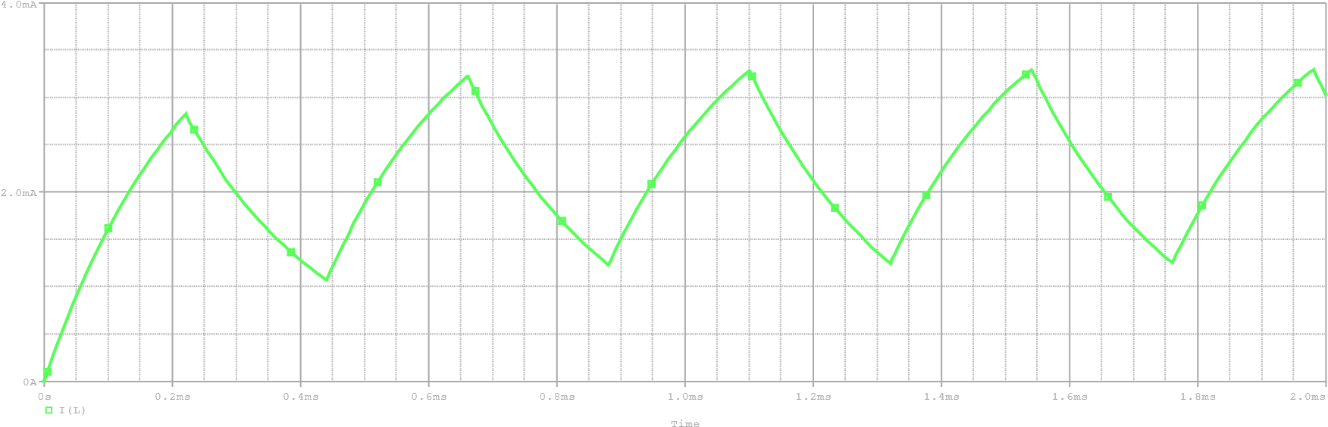

Figure 3.8

## C.RLC Circuit

I. **Response Type**

PER=period=1/f=1/30=33.33m, PW= pulse width=0.5T=16.67m.

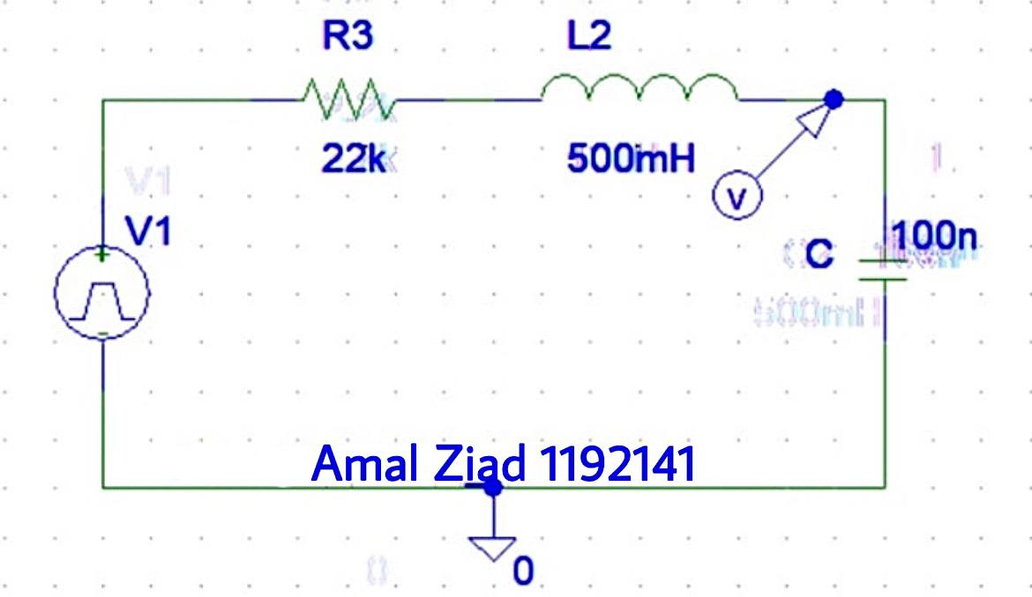 Figure 3.9

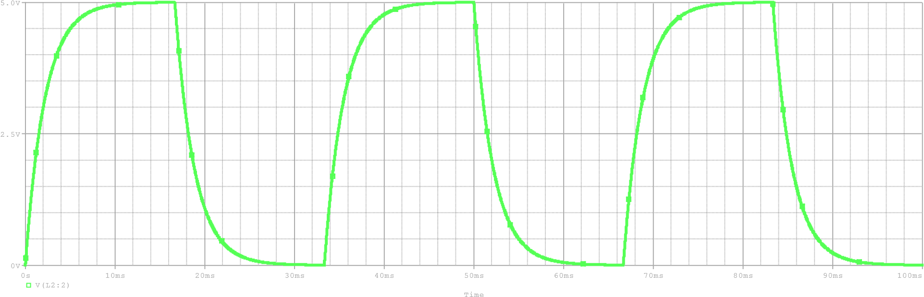

Figure 3.10

Figure 3.11 shows the calculations in order to calculate R3 to give critically damped response.

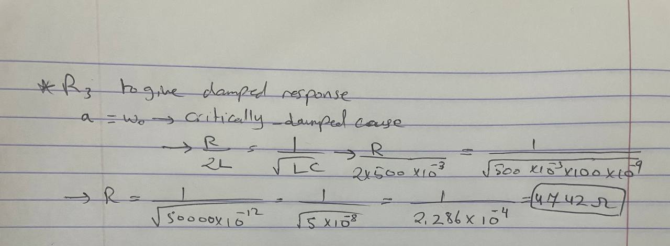 Figure 3.11

⇨ R3 = 4742Ω

Critical Damping → R3 = 4.742kΩ as shown in figure 3.12, underdamped → R3 = 600Ω as shown in figure 3.13, overdamped → 22kΩ as shown previously in figure 3.10.

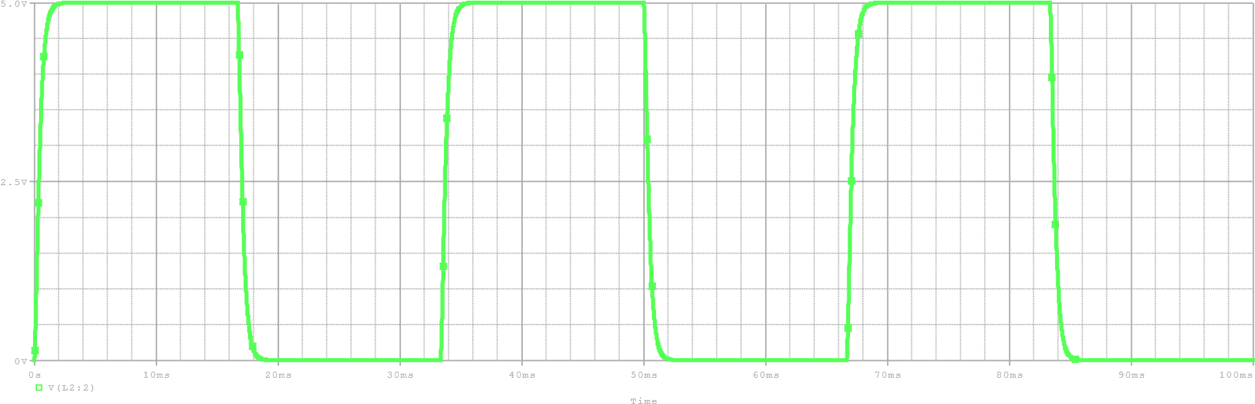

Figure 3.12

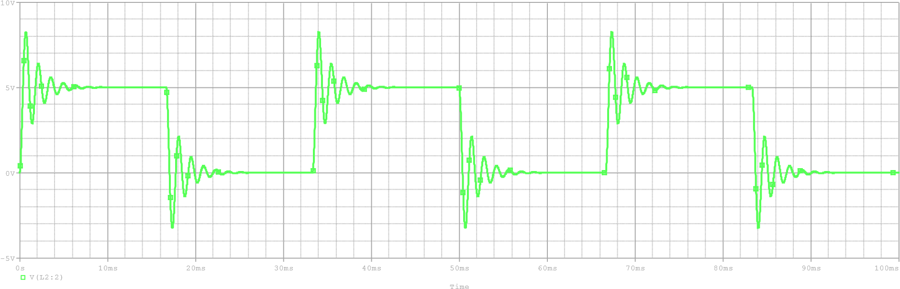

Figure 3.13

### II. Response Parameters

R3 is set to 750Ω, which is an underdamped response case as shown in figure 3.14.

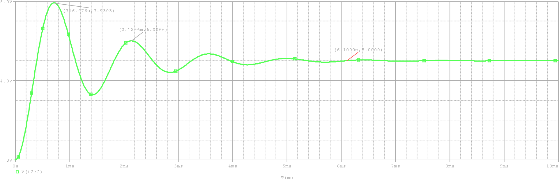

Figure 3.14

As shown in figure 3.14: -

Ta = 716.5us, Va = 7.93v, Tb = 2.1367ms, Vb = 6v, Vo = 5v

Figure 3.15 shows the calculations in order to get τ, α, ωd.

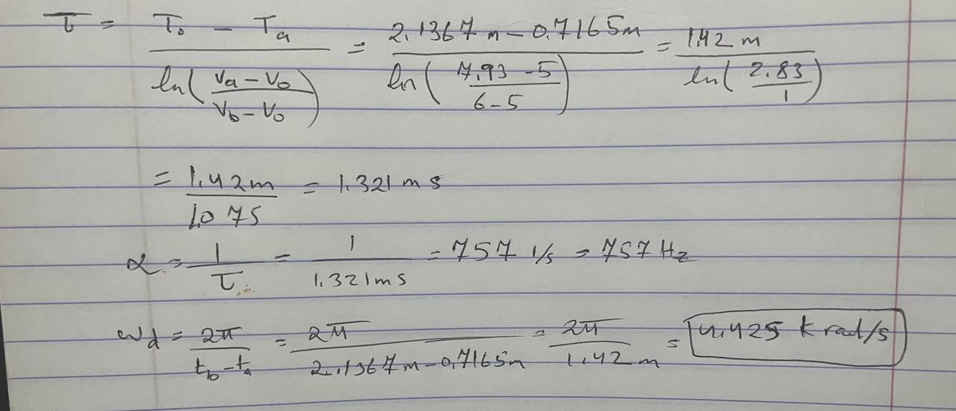 Figure 3.15

* τ = 1.321 ms
* α = 757 1/s
* ωd = 4.42478k rad/s