**Faculty of Engineering and Technology**

**Department of Electrical and Computer Engineering**

**ENEE2360-Analog Electronics**

**Project 2**

Prepared by:

Malak shabanah

Amal Ziad

Malak Radad

Instructor:

Mohammad Jehad Al Ju'Beh

# Abstract

In this project will complete design of circuit. This project to understand the room Thermostat. This circuit consist Schmitt Trigger comparator, BJT transistor and diode.

Table of Contents

Abstract i

Design calculations 1

1.1. Calculation of Vo1. 1

1.3. The circuit 3

Simulation results 4

2.1. Part A 4

2.1.1. Vo1 4

2.1.2. Vo2 4

2.1.3. Vo1 and Vo2: 5

2.2. Part B 6

2.2.1. Vo1 7

2.2.2. Vo2 7

2.3. Part C: 8

Comparison of simulation result to design 9

List of Figures

Figure 1:Vo1 calculation 1

Figure 2 calcuataion 2

Figure 3:The Circuit 3

Figure 4 Vo1 4

Figure 5 Vo2 4

Figure 6 Vo1 and Vo2 5

Figure 7 part2 : 6

Figure 8 part 3 : Vo1 8

# Design calculations

## Calculation of Vo1.

upper threshold and the lower threshold temperature (VUT and VLT)

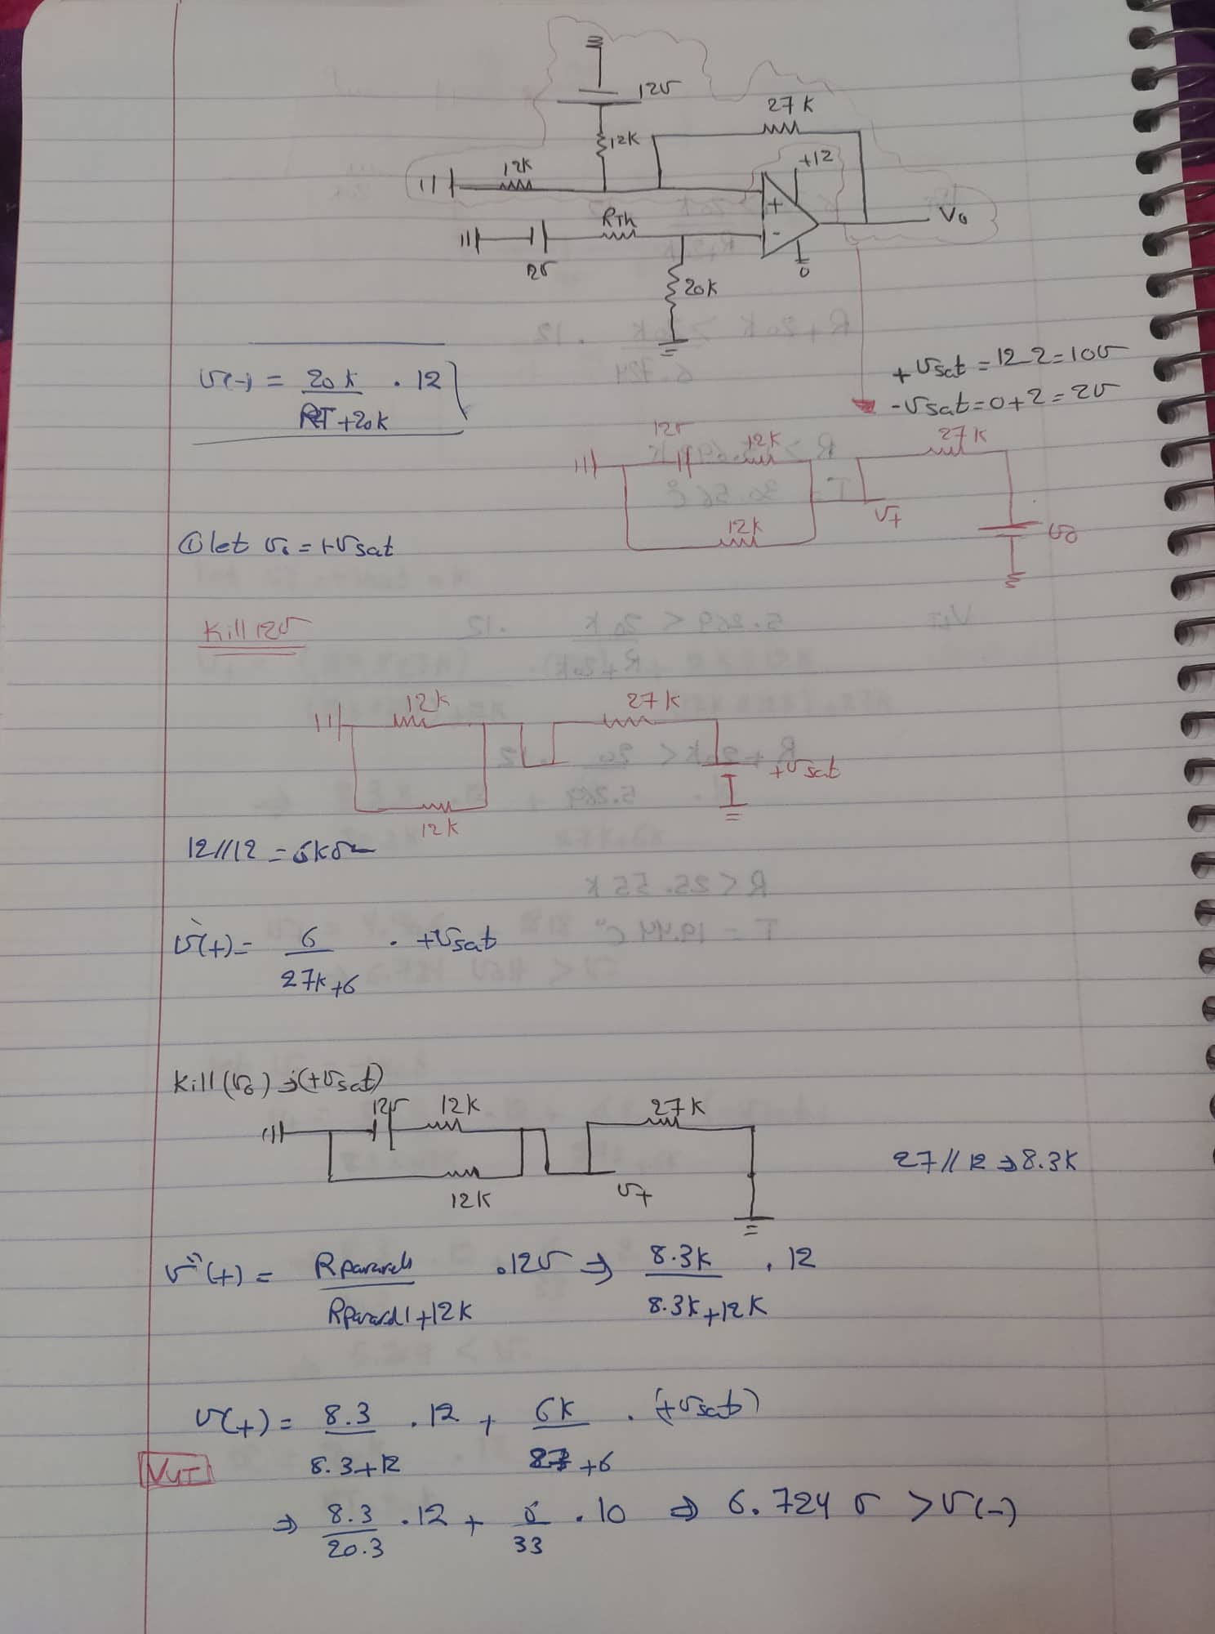

Figure 1:Vo1 calculation

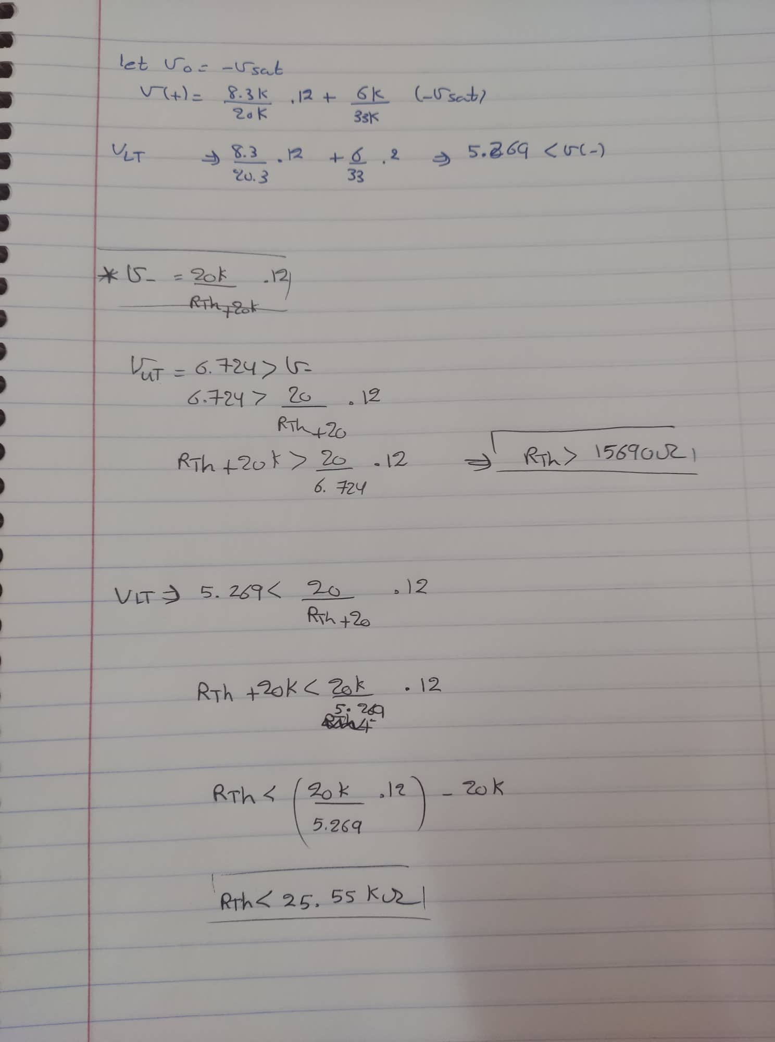

Figure 2 calculation

## 1.3. The circuit

My circuit as shown in Figure 3.

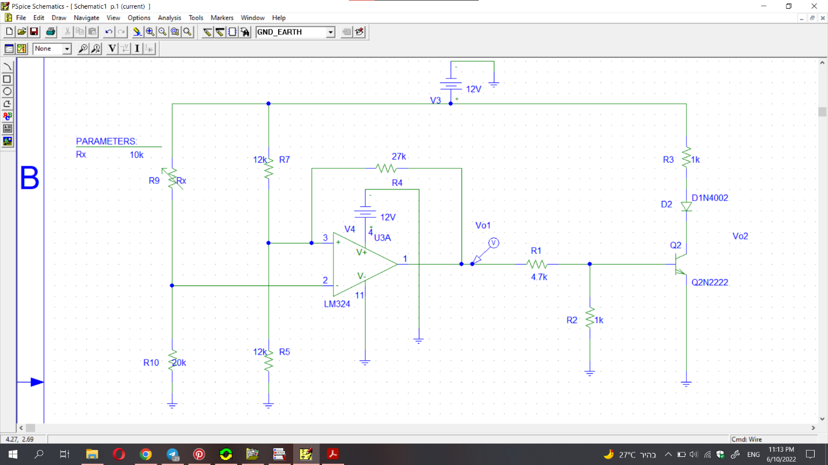

Figure 3:The Circuit

# Simulation results

## 2.1. Part A

Determine the voltages Vo1 When Rx is applied.

### 2.1.1. Vo1

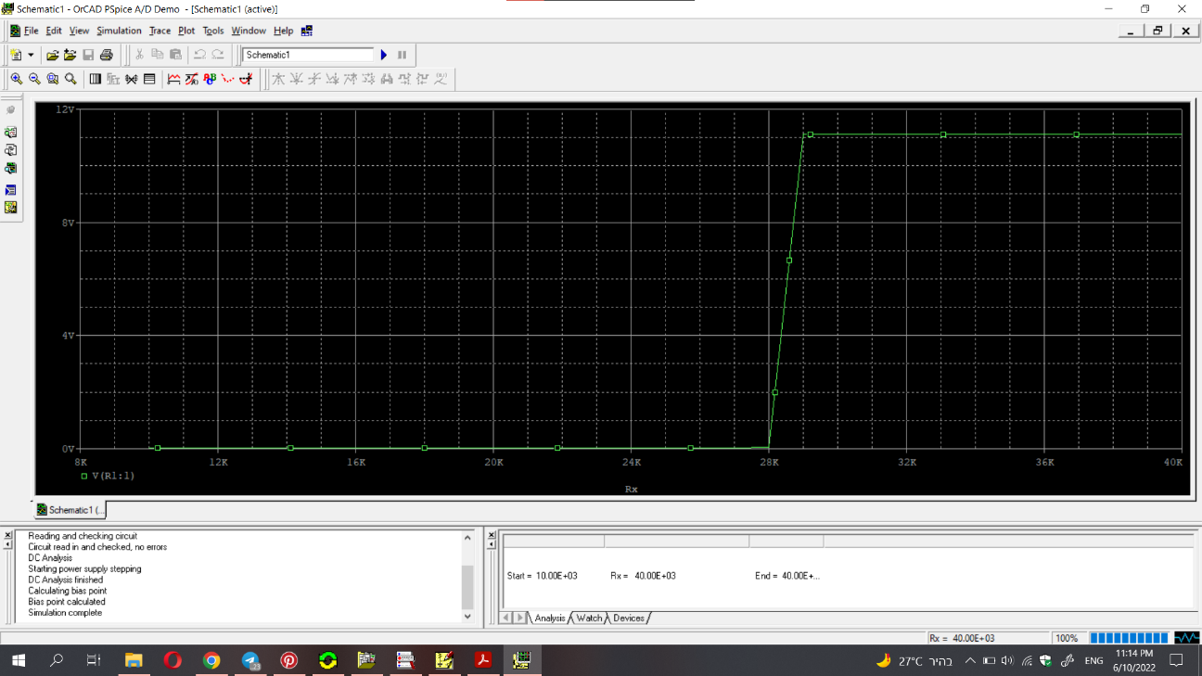

Figure 4 Vo1

### 2.1.2. Vo2

Vo2 when Rx is applied.

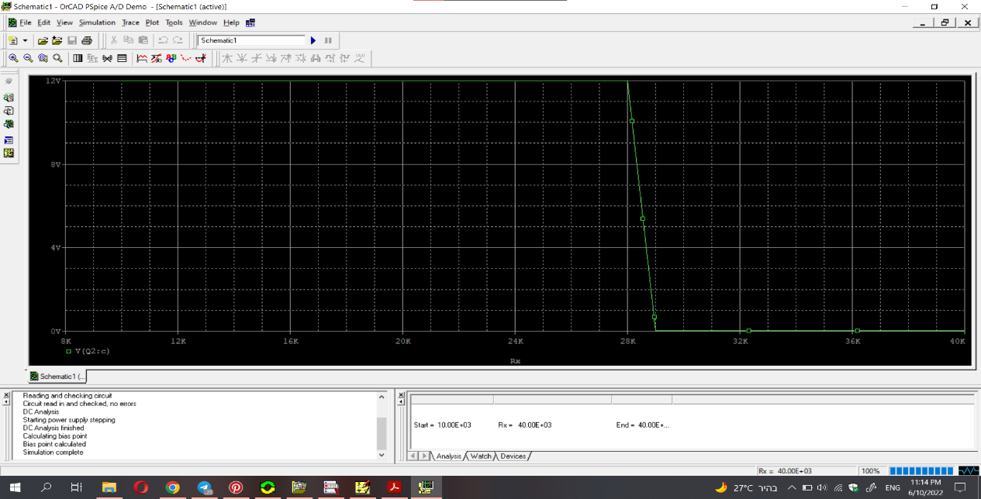

Figure 5 Vo2

### 2.1.3. Vo1 and Vo2:

Vo1 and Vo2 when Rx is applied

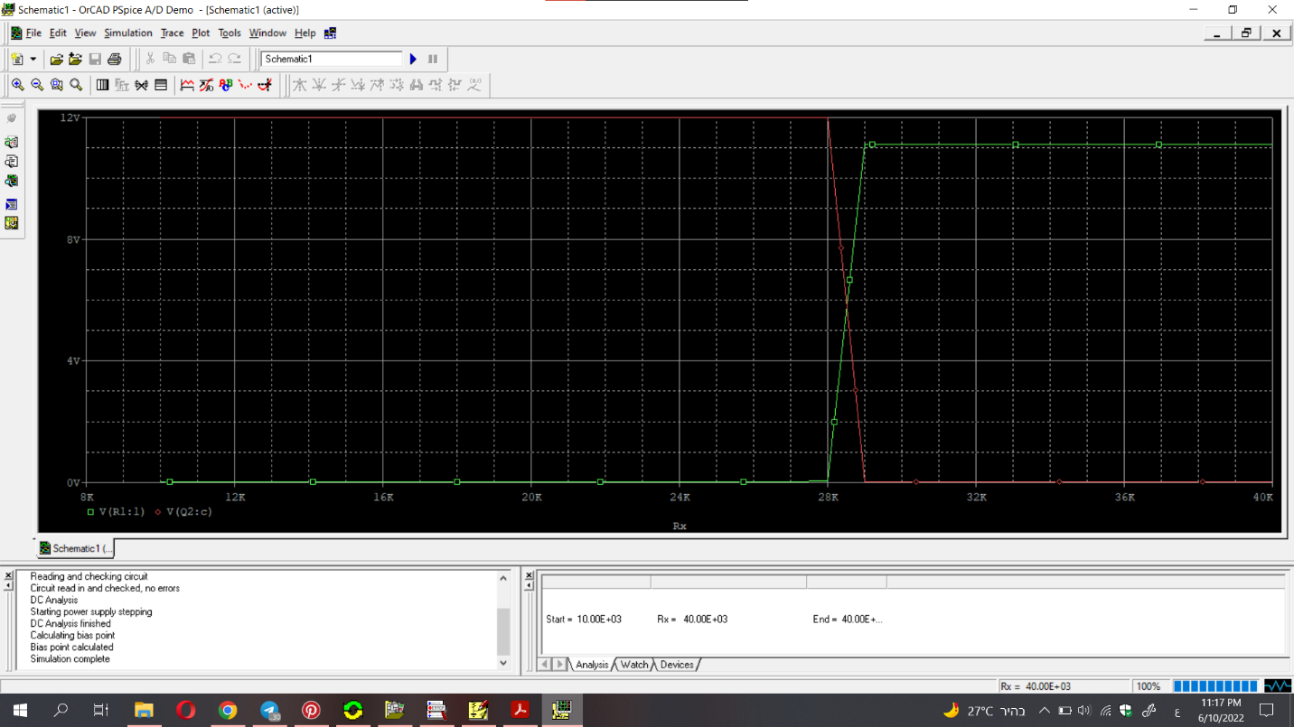

Figure 6 Vo1 and Vo2

## 2.2. Part B

Replacing the thermistor and the 20kΩ by a VPWL Voltage

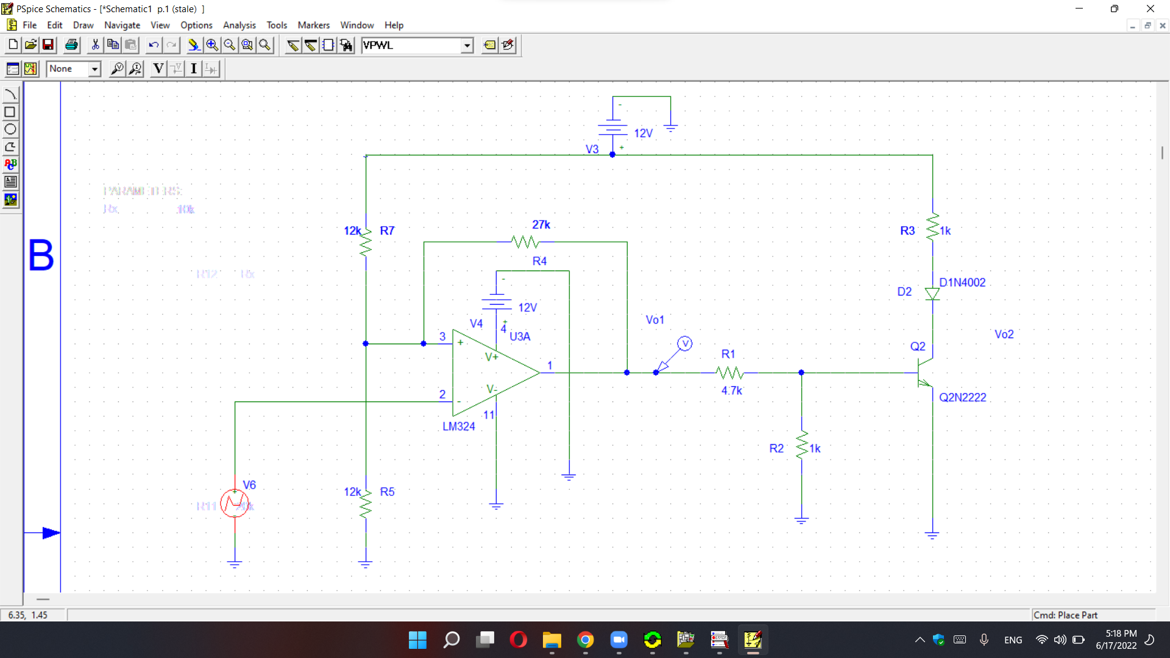

Figure 7 part2 Circuit

### 2.2.1. Vo1

Vo1 when VPWL is applied

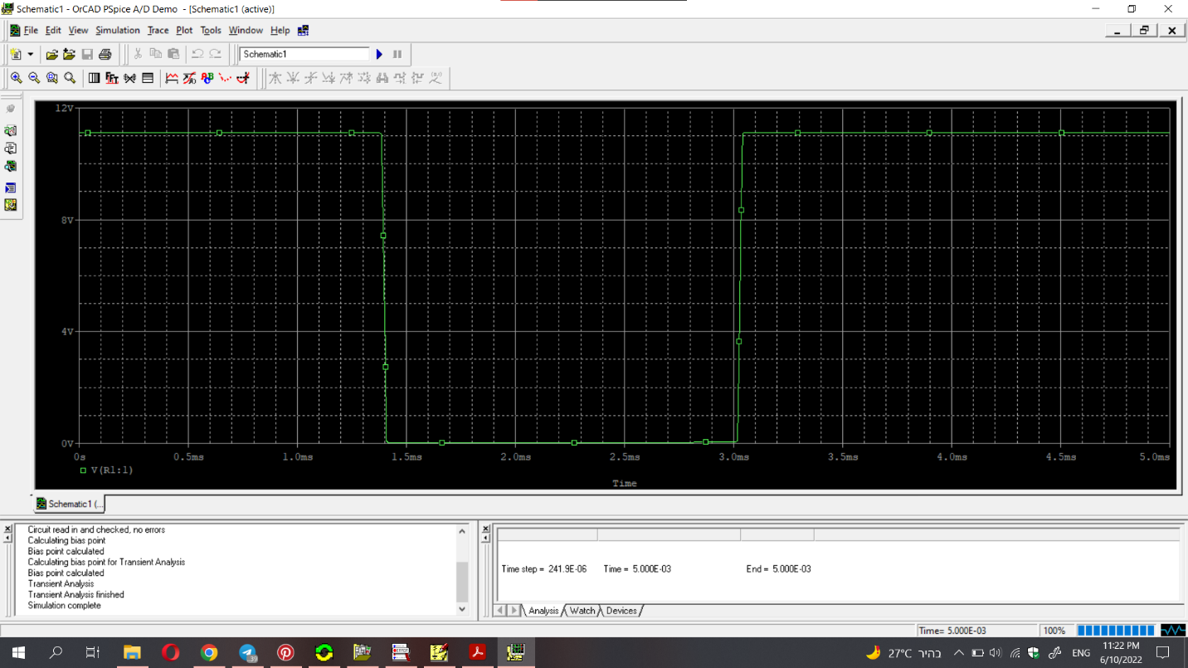

### 2.2.2. Vo2

Vo2 when VPWL is applied

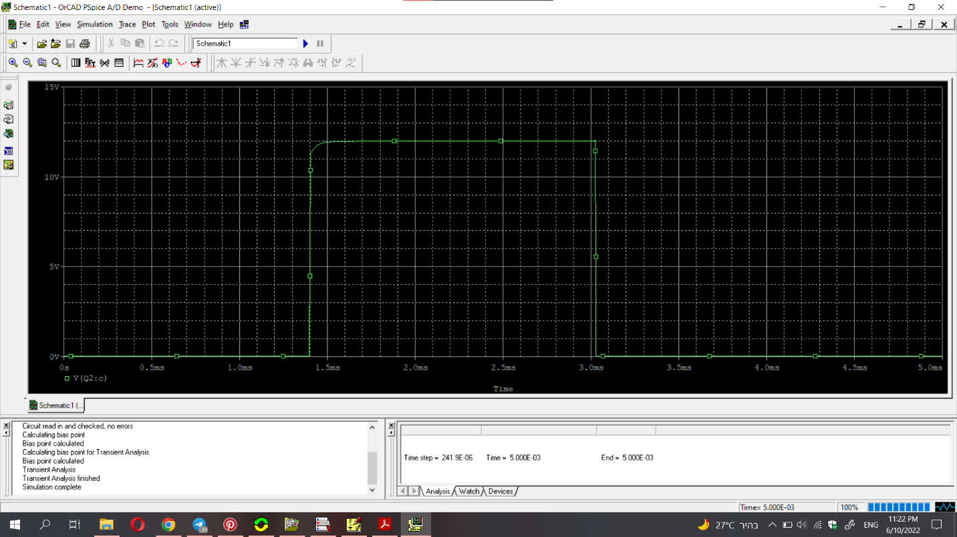

## 2.3. Part C:

upper threshold and the lower threshold temperatures from Vo1

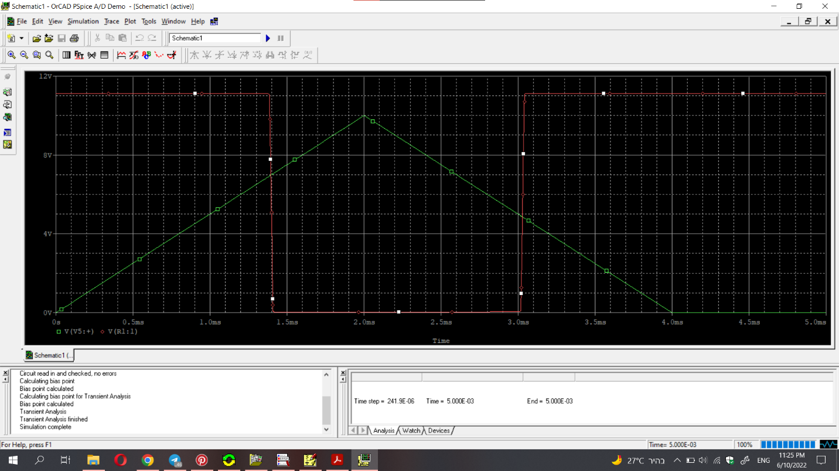

Figure 8 part 3 : Vo1

**Calculate from the graph:**

For the first point:

Vo1=6.9493V (upper)

I(Vo1)=2.2mA

---> R=3.159k ohm (almost R=3163 ohm in the table)

---> upper threshold C=69.44 & F=157

for the second point:

Vo1=4.8764V (lower)

I(Vo1)=2.2mA

---> R=2.216k ohm (almost R=2208 ohm in the table)

---> lower threshold C=79.44 & F=175

# Comparison of simulation result to design

Vo1:

From the calculation Vo1 🡺

VUT =6.724

VLT=5.269

From the graph 🡺

VUT = 6.9493V

VLT=4.8764V

Finally, in this project understand the Schmitt comparator. The actual value from calculation and the value from simulation very soon almost equal.