

**Faculty of Engineering and Technology**

**Electrical And Computer Engineering Department**

**Computer Design Lab**

**ENCS4110**

DC Motors and PWM Report

**Done By:** Amal Ziad_1192141

**Instructor:** Ahmad Afaneh

**Assistant**: Hiba Qadah

**Sections:** 2

**Date:** 5/6/2022

# Abstract:

The aim of this experiment is to know how to deal with driving circuits with DC motors, and to learn how to use PMW. All of this by using Arduino in **tinkercad** website.

# **Contents**

Abstract: 2

Background: 4

• Driver circuits: 4

• PWM (Pulse Width Modulation circuit) 5

• H-Bridge: 5

Procedure: 6

• **Task1:** Use a transistor and make the user to control the speed of a DC-Motor: 6

• **Task2:** Write code such that you can control the direction and speed of a DC-Motor from the keyboard. 8

Conclusion: 9

# Background:

## Driver circuits:

In electronics, a driver is an electrical circuit or other electronic component used to control another circuit or component, such as a high-power transistor, liquid crystal display (LCD), and numerous others.[1] As shown in fig.1.1

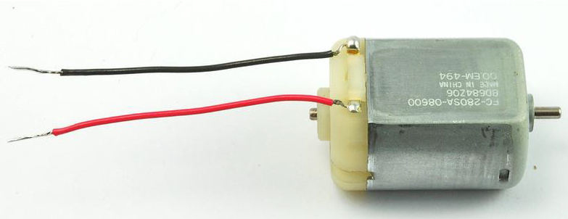

Fig.1.1

Therefore, we need a driving circuit to run the motor. We can use a BJT transistor as a driver for the DC motor. We need a resistor on the base to limit the current from the digital pin. The diode is needed to protect the transistor.[2] As shown in fig.1.2.

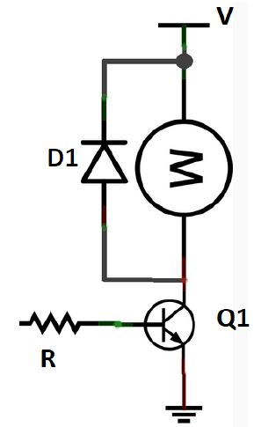

Fig.1.2

## PWM (Pulse Width Modulation circuit)

Pulse Width Modulation (PWM) is a technique to generate low frequency output signals from high frequency pulses. Rapidly switching the output voltage of an inverter leg between the upper and lower DC rail voltages, the low frequency output can be thought of as the average of voltage over a switching period.[3]

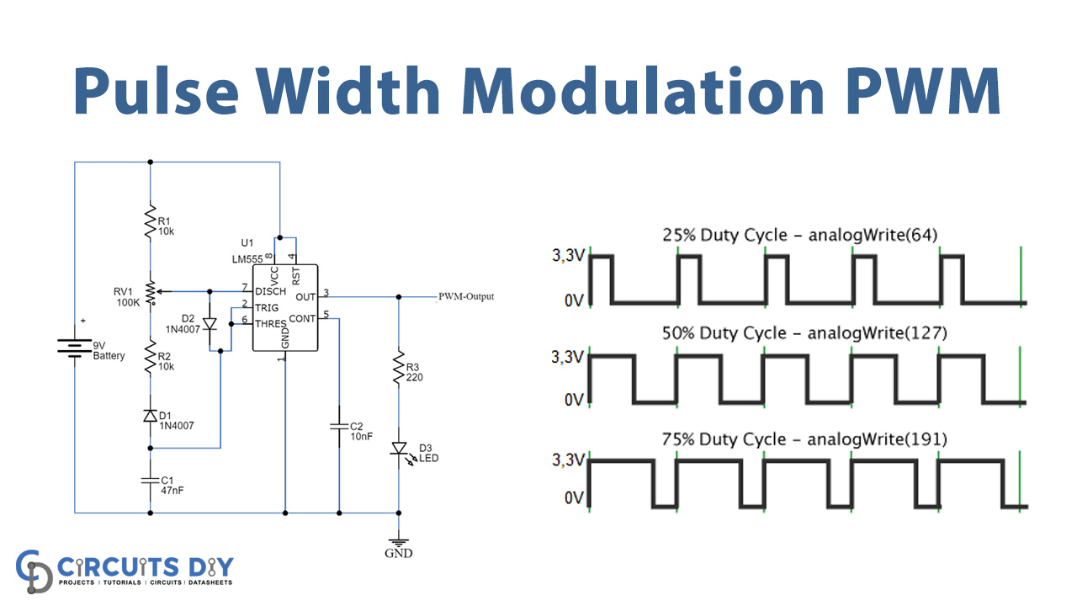

Fig.1.3

We can pulse output on and off fast such that the connected device sees the result as a lower voltage. This way, we can control the speed of a DC-motor. The main rule is: duty cycle= (ON period)/ (ON+OFF periods).

So, for a duty cycle of 50% and source voltage =12 volt, the load will see 6 volts.

In Arduino we can use ***analogWrite(pin, value)*** to generate a PWM signal with duty cycle value/255 where 0≤value≤ 255 [4]

## H-Bridge:

An H-Bridge (Full-Bridge) driver is quite popular in driving loads such as brushed DC motors and it is widely used in robotics and industry. The main advantages of using an H-Bridge driver are: high efficiency, rotation direction change, and braking the motor.[5]

To change the rotation direction of a DC-motor we need to reverse the polarity. This can be done using H-Bridge as shown in Figure 4. If Q1 and Q4 are ON while Q2 and Q3 are OFF, the motor can run clockwise, now of Q2 and Q3 are ON, while Q1 and Q4 are OFF, the motor is going to reverse the direction. As shown in fig.1.4.[6]

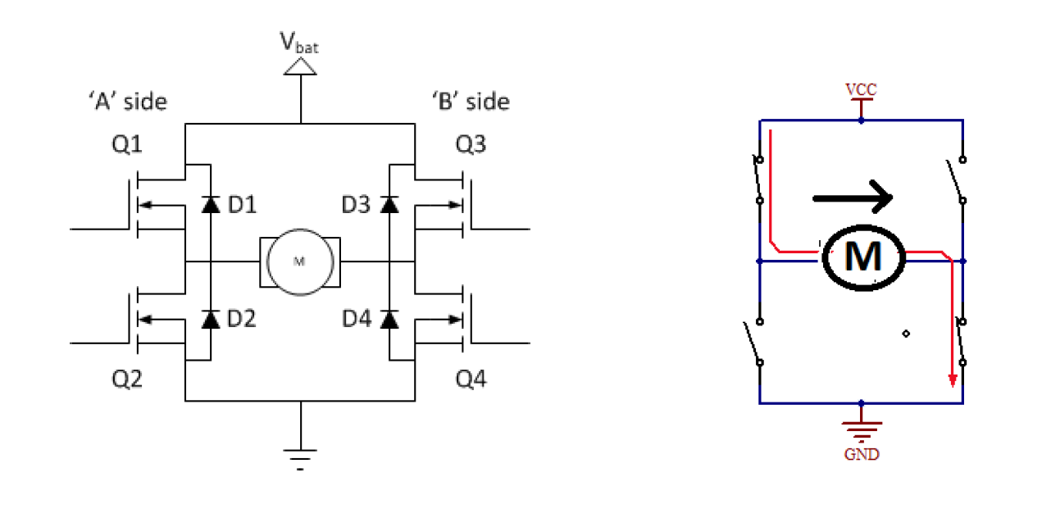

Fig.1.4

# Procedure:

## **Task1:** Use a transistor and make the user to control the speed of a DC-Motor:

The circuit: (fig.2.1)

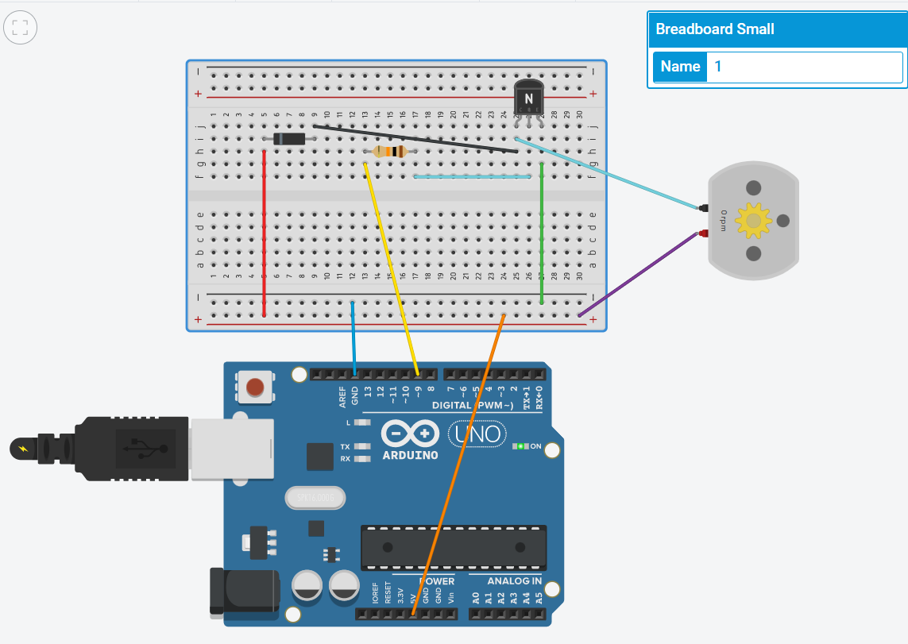

Fig.2.1

The code: (fig.2.2):

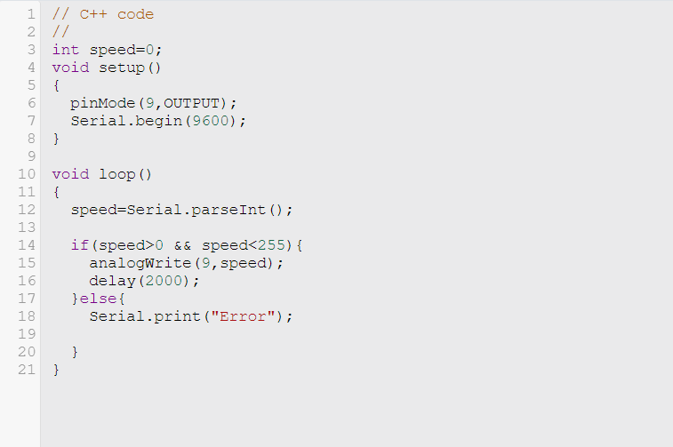

Fig.2.2

Discussion:

In fig.2.1, we used BJT transistor as a driver to the DC motor, such that it works as a switch, on and off, transmitting from saturation region to cut off region. Also a resistor on the base to limit the current from the digital pin. In addition, the diode to protect the transistor from breaking. In fig.2.2, after defining output pin (which is “9” in the Arduino) and the speed at 0. The program will read the speed you enter and if the speed is between 0 and 255, it will work at output 9, which is connected, to the DC motor and in result the motor will work too, with a delay of 2000. If the user entered a speed not in the range then it will give him error.

## **Task2:** Write code such that you can control the direction and speed of a DC-Motor from the keyboard.

The circuit: (shown in fig.3.1)

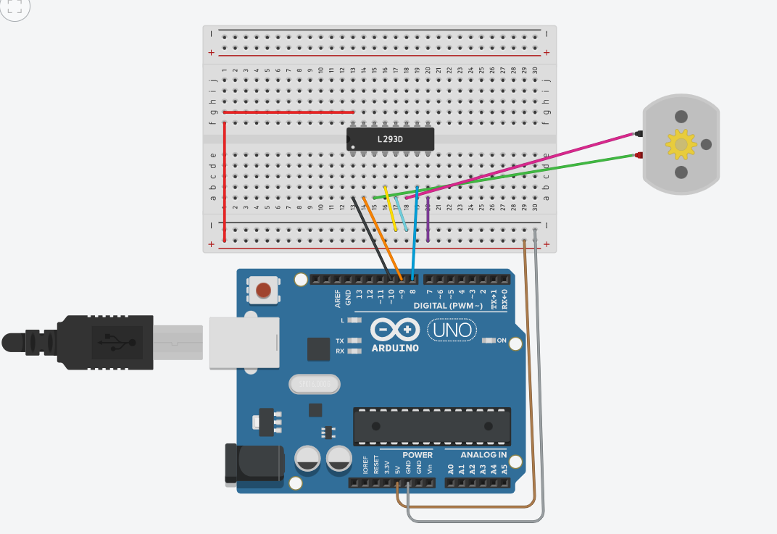

Fig.3.1

The code: (shown in fig.3.2)

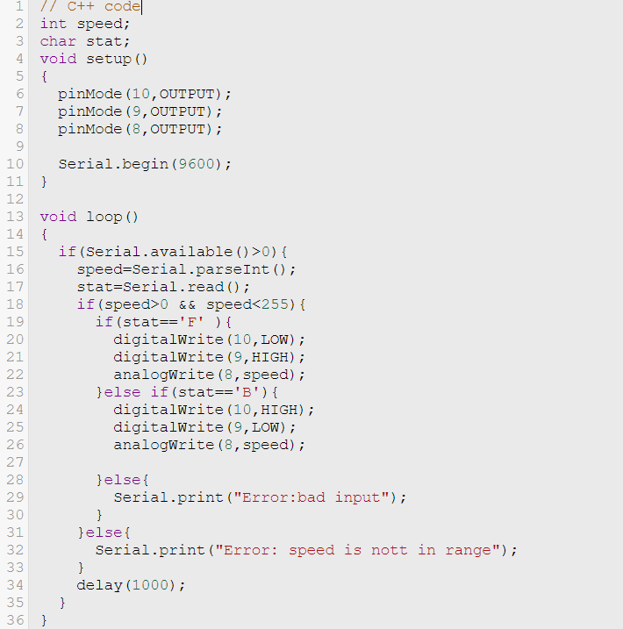

Fig.3.2

Discussion:

As shown in fig.3.1, we used the H-Bridge (L298) to control the speed and direction of a DC-Motor. The program will read speed and mode of the direction of DC-motor, “F” for forward and “B” for backward. Forward direction moves from low to high with the given speed. Backward direction moves from high to low with the given speed.

# Conclusion:

In conclusion, I used to deal with Arduino and other electronic components such as DC-motor and H-bridge and control it as I wish. Also I learnt how to write a code to simulate the circuit.

1. https://www.quora.com/What-is-the-usage-of-driver-circuit
2. Manual notes exp.10
3. https://wiki.analog.com/university/courses/electronics/electronics-lab-pulse-width-modulation#:~:text=Pulse%20Width%20Modulation%20(PWM)%20is%20a%20technique%20to%20generate%20low,voltage%20over%20a%20switching%20period.
4. Manual lab exp.10
5. https://community.element14.com/challenges-projects/project14/b/blog/posts/pwm-h-bridge-dc-motor-control
6. Manual lab exp.10