

**Faculty of Engineering & Technology – Electrical & Computer Engineering Department**

**First Semester 2022 – 2023**

**Machine learning and data science**

**ENCS5341**

**Homework 2**

**Name: Amal Ziad**

**ID: 1192141**

**Instructor: Dr. Yazan AbuFarha**

**Date: 12th Jan 2023**

Output of logistic regression model without using scikit learning;

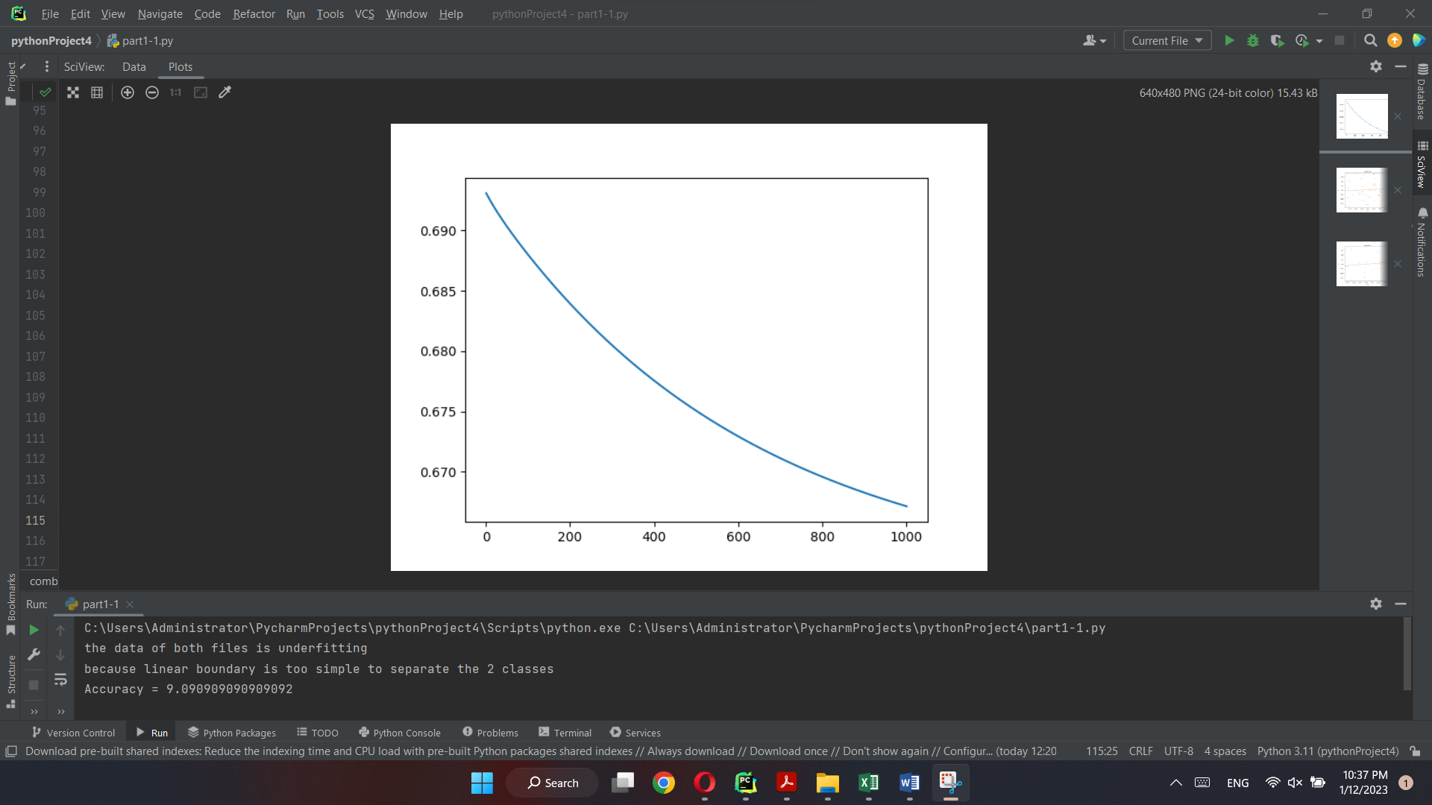

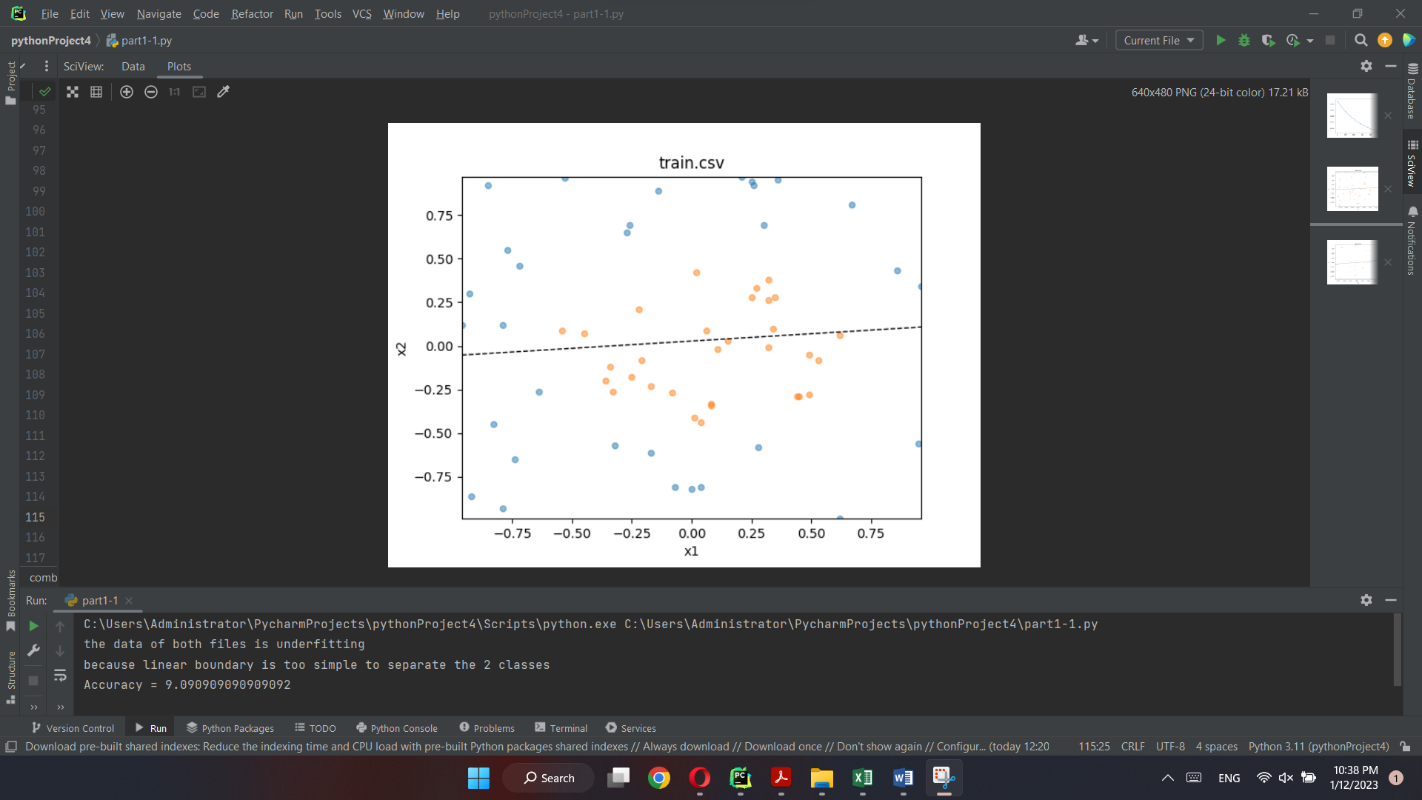

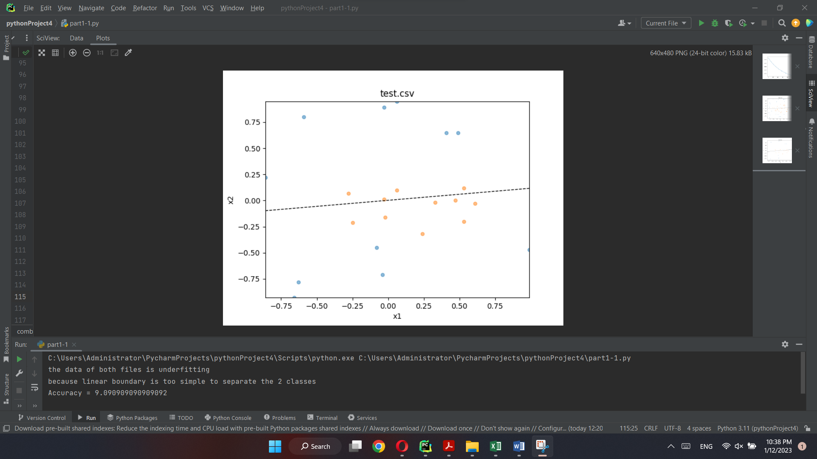

Output of logistic regression model using scikit learning;

