

Faculty of Engineering and Technology

Electrical and Computer Engineering Department

Computer Networks Laboratory ENCS4130

**EXP. No. 4. Dynamic Routing 2 (Link State Routing Protocols) Open Shortest Path First (OSPF)**

Prepared by: Amal Ziad_1192141

Instructor: Ismael Khater

Teacher assistant: Ayham Hashesh

BIRZEIT

29/7/2022

# Abstract

In this experiment, we will learn how to configure and verify IP routing with Cisco routers in Packet tracer. In addition, we will get to know what is ospf routing, how to deal with it in routers, and what are its advantages over other routing protocols in computer networking.

# Table of Contents

Abstract II

Table of Contents III

Acronyms and Abbreviations 4

List of Figures 5

List of Tables 6

1. Introduction 7

1.1 OSPF summarization 7

1.2 Routing Hierarchy 8

1.3 OSPF Neighbor Relationships 8

1.4 Enabling OSPF 9

1.4.1 Configuring OSPF on the Router 9

1.4.2 Adding networks to the OSPF protocol 9

2. Procedure and Discussion 9

2.1 Building the topology 10

2.1.1 Filling routers’ interfaces IPs 10

2.1.2 Filling PCs ips 11

2.2 Configuring OSPF Routing 12

2.3 Changing the Cost 12

2.4 Summarization 13

3. Results 14

3.1 Building the topology 14

3.2 Configuring OSPF 15

4. Conclusion 16

# Acronyms and Abbreviations

OSPF Open Shortest Path First

RIP Routing Information Protocol

VLSM Variable Length Subnet Masks

ABRs Area Border Routers

AS Autonomous System

# List of Figures

Figure ‎1.1 example on ospf summarization 7

Figure ‎1.2 routing table example 8

Figure ‎1.3 routing hierarchy example 8

Figure ‎1.4 ospf neighbor relationships 9

Figure 2.‎2.1 topology on packet tracer 10

Figure ‎2.2 configuring ospf for router0 12

Figure ‎2.3 changing cost of router0 12

Figure ‎2.4 summarization of loopbacks networks by ospf 13

Figure ‎2.5 showing ospf work 13

Figure ‎3.1 Result of building the topology perfectly 14

Figure ‎3.2 Result of building the topology perfectly 14

Figure ‎3.3 Result of configuring osp 15

# List of Tables

Table ‎2‑1 IPs for router 0 10

Table ‎2‑2 IPs for router 1 10

Table ‎2‑3 IPs for router 2 11

Table ‎2‑4 IPs for router 3 11

Table ‎2‑5 IPs of connected devices 11

# Introduction

The OSPF (Open Shortest Path First) protocol is one of a family of IP Routing protocols, and is an Interior Gateway Protocol (IGP) for the Internet, used to distribute IP routing information throughout a single Autonomous System (AS) in an IP network. The OSPF protocol is a link-state routing protocol, which means that the routers exchange topology information with their nearest neighbors. The topology information is flooded throughout the AS, so that every router within the AS has a complete picture of the topology of the AS. This picture is then used to calculate end-to-end paths through the AS, normally using a variant of the Dijkstra algorithm. Therefore, in a link-state routing protocol, the next hop address to which data is forwarded is determined by choosing the best end-to-end path to the eventual destination. Each router calculates its own routing table using a Shortest Path First (SPF) or Dijkstra algorithm. This routing table contains all the destinations the routing protocol knows about, associated with a next hop IP address and outgoing interface. [1]

## OSPF summarization

Route summarization helps reduce OSPF traffic and route computation. OSPF, unlike EIGRP, doesn’t support automatic summarization. Also, unlike EIGRP, where you can summarize routes on every router in an EIGRP network, OSFP can summarize routes only on ABRs and ASBRs.[2]

Let us take the example shown in figure 1.1.1.

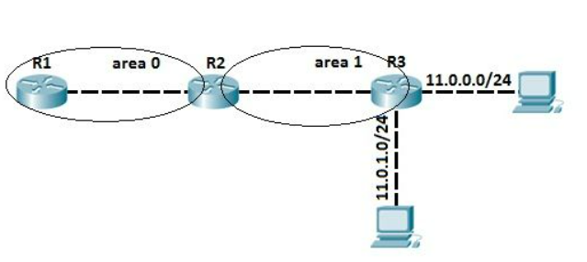

Figure ‎1.1 example on ospf summarization

All three routers are running OSPF and exchanging routes. Before OSPF summarization is configured, the router R1 inside the backbone area has two entries for the networks 11.0.0.0/24 and 11.0.1.0/24 in its routing table as shown in figure 1.1.2.

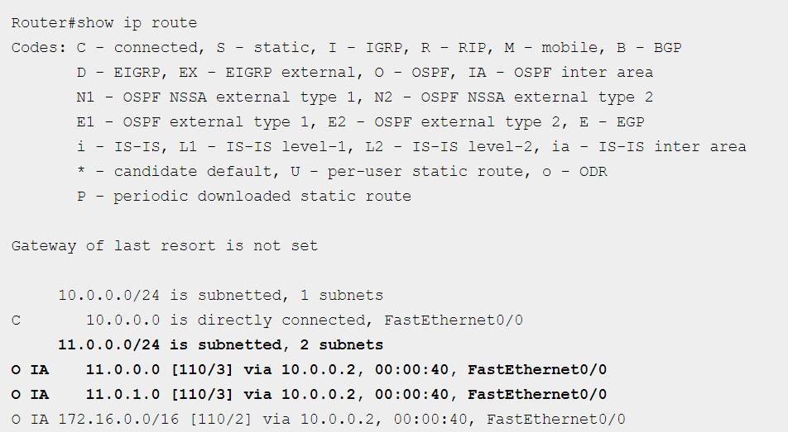

Figure ‎1.2 routing table example

## Routing Hierarchy

Unlike RIP, OSPF can operate within a hierarchy. It allows the network to be designed in two layer hierarchies. Area 0 at one layer and all other Areas at other layer. The OSPF Area must be configured as a group of contiguous IP networks. This allows Route Summarization at Area level.[3] Area level example is shown in figure 1.2.

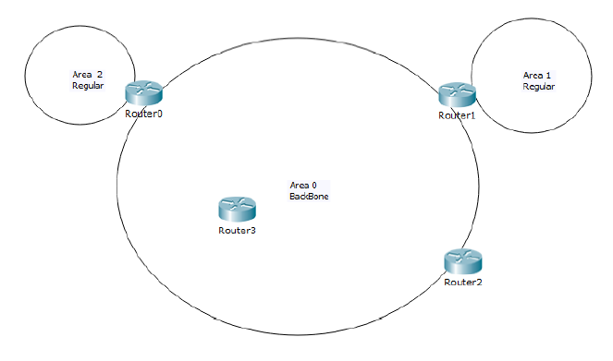

Figure ‎1.3 routing hierarchy example

## OSPF Neighbor Relationships

Once OSPF is enabled on a router interface, a Link State Database (LSD) is established and all interfaces running OSPF are added to this table to be used in Link State Advertisements (LSAs), OSPF then the begins neighbor discovery and forming adjacency process.[4] An example is shown in figure 1.3.

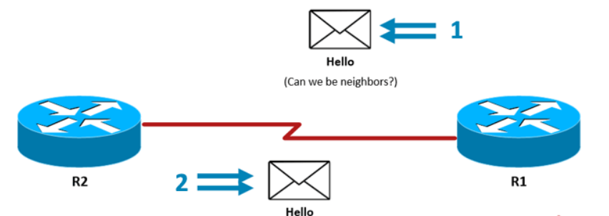

Figure ‎1.4 ospf neighbor relationships

## Enabling OSPF

As with other routing protocols, enabling OSPF requires that you create an OSPF routing process, specify the range of IP addresses to be associated with the routing process, and assign area IDs to be associated with that range of IP addresses.[5]

### 1.4.1 Configuring OSPF on the Router

To configure ospf use this command: Router(config)# router ospf *<PROCESS-ID>*

### 1.4.2 Adding networks to the OSPF protocol

To add neighboring networks to ospf protocol by this command for each network:

Router(config-router)# network *<ID-ADDRESS> <WILDCARD-MASK>* area *<AREA-ID>*

# Procedure and Discussion

In this lab, we will connect router-PTs and several PC-PTs on different networks and Loopback networks. This will require configuring routing protocols between the routers. We will configure dynamic routing (OSPF) which will be used as a routing protocol.

## 2.1 Building the topology

I have built the topology as shown in figure 1

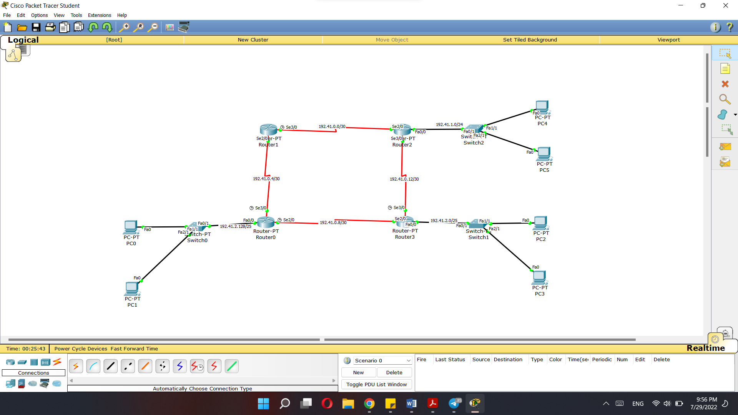

Figure 2.‎2.1 topology on packet tracer

### 2.1.1 Filling routers’ interfaces IPs

Starting from router0 to router3, I have filled is as shown from table 2.1 to table

|  |  |  |  |
| --- | --- | --- | --- |
| **Router0 Interfaces** | | | |
| **Interface** | **IP address** | **Subnet Mask** | **Wildcard Mask** |
| Se2/0 | 192.41.0.9 | 255.255.255.252 | 0.0.0.3 |
| Se3/0 | 192.41.0.6 | 255.255.255.252 | 0.0.0.3 |
| Fa0/0 | 192.168.2.129 | 255.255.255.128 | 0.0.0.127 |

Table ‎2‑1 IPs for router 0

|  |  |  |  |
| --- | --- | --- | --- |
| **Router1 Interfaces** | | | |
| **Interface** | **IP address** | **Subnet Mask** | **Wildcard Mask** |
| Se2/0 | 192.41.0.5 | 255.255.255.252 | 0.0.0.3 |
| Se3/0 | 192.41.0.1 | 255.255.255.252 | 0.0.0.3 |

Table ‎2‑2 IPs for router 1

|  |  |  |  |
| --- | --- | --- | --- |
| **Router2 Interfaces** | | | |
| **Interface** | **IP address** | **Subnet Mask** | **Wildcard Mask** |
| Se2/0 | 192.41.0.2 | 255.255.255.252 | 0.0.0.3 |
| Se3/0 | 192.41.0.13 | 255.255.255.252 | 0.0.0.3 |
| Fa0/0 | 192.168.1.1 | 255.255.255.0 | 0.0.0.255 |
| LookBack 0 | 172.16.0.1 | 255.255.255.0 | 0.0.0.255 |
| LoopBack 1 | 172.16.1.1 | 255.255.255.0 | 0.0.0.255 |
| LoopBack 2 | 172.16.2.1 | 255.255.255.0 | 0.0.0.255 |
| LoopBack 3 | 172.16.3.1 | 255.255.255.0 | 0.0.0.255 |
| LoopBack 4 | 172.16.4.1 | 255.255.255.0 | 0.0.0.255 |
| LoopBack 5 | 172.16.5.1 | 255.255.255.0 | 0.0.0.255 |

Table ‎2‑3 IPs for router 2

|  |  |  |  |
| --- | --- | --- | --- |
| **Router3 Interfaces** | | | |
| **Interface** | **IP address** | **Subnet Mask** | **Wildcard Mask** |
| Se2/0 | 192.41.0.10 | 255.255.255.252 | 0.0.0.3 |
| Se3/0 | 192.41.0.14 | 255.255.255.252 | 0.0.0.3 |
| Fa0/0 | 192.41.2.1 | 255.255.255.128 | 0.0.0.127 |

Table ‎2‑4 IPs for router 3

### 2.1.2 Filling PCs ips

Each PCs ips and its networks are shown in table 2-5.

|  |  |  |  |  |
| --- | --- | --- | --- | --- |
|  |  | Devices IPs |  |  |
| PC | IP | Network | Subnet Mask | Wildcard Mask |
| PC0 | 192.41.2.130 | 192.41.2.128 | 255.255.255.128 | 0.0.0.127 |
| PC1 | 192.41.2.131 | 192.41.2.128 | 255.255.255.128 | 0.0.0.127 |
| PC2 | 192.41.2.2 | 192.41.2.0 | 255.255.255.128 | 0.0.0.127 |
| PC3 | 192.41.2.3 | 192.41.2.0 | 255.255.255.128 | 0.0.0.127 |
| PC4 | 192.41.1.2 | 192.41.1.0 | 255.255.255.0 | 0.0.0.255 |
| PC5 | 192.41.1.3 | 192.41.1.0 | 255.255.255.0 | 0.0.0.255 |

Table ‎2‑5 IPs of connected devices

## 2.2 Configuring OSPF Routing

In this section we will configured ospf as the following command: router ospf *<PROCESS-ID>* where process id can take numbers between [1 – 65535] for the OSPF routing protocol. In addition, we must tell the ospf which network to advertise, the command used for adding a network is: network <NETWORK-ID> <OSPF-WILDCARD-BITS> area <AREA-ID>

Where the network we enter is around the router. For example, for router0, I configured ospf as shown in figure 2.2.

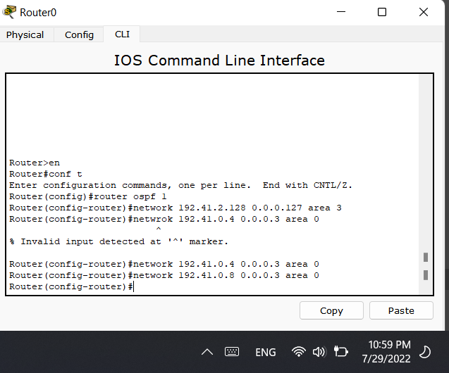

Figure ‎2.2 configuring ospf for router0

Discussion: After applying the ospf routing protocol configuration, the devices are now able to ping each other in different networks (shown in results).

## 2.3 Changing the Cost

We can change the cost of a path by changing its bandwidth of the signal in a specific path. The ospf routing protocol will choose the shortest path depending on Dijkstra algorithm, the end-to-end cost is the summation of the cost through all interfaces. By using the following syntax inside an interface: Router(config-if)#bandwidth <BANDWIDTH-IN-KILOBITS>

We used the bandwidth 20000 as cost=1. The commands shown in fig.2.3 will be applied to all other routers.

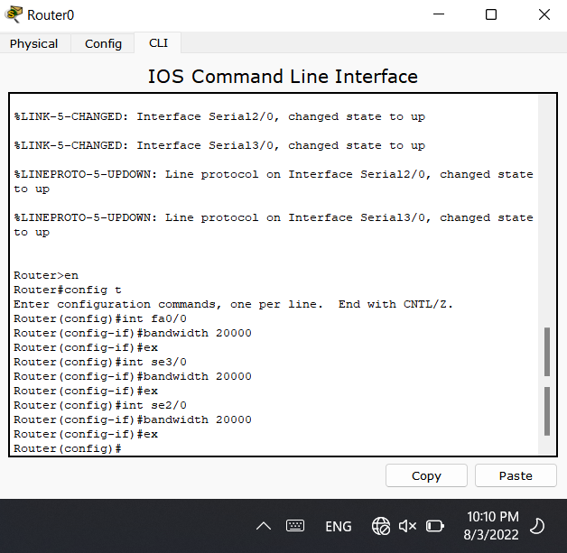

Figure ‎2.3 changing cost of router0

## 2.4 Summarization

After adding 5 loopbacks to router2, the ospf will combine them and take the largest number to be the router ID. This is why very useful to reduce the CPU execution and not dealing with 6 networks but with only two. If we apply some of the loopbacks into ospf configuration as shown in fig.2.4, we will se how summarization works will by ospf protocol.

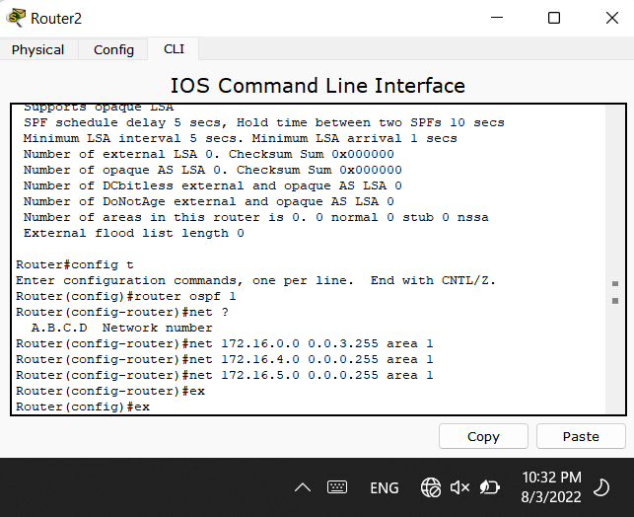

Figure ‎2.4 summarization of loopbacks networks by ospf

To be sure that the ospf chose the largest network to be router’s ID, shown in fig.2.5.

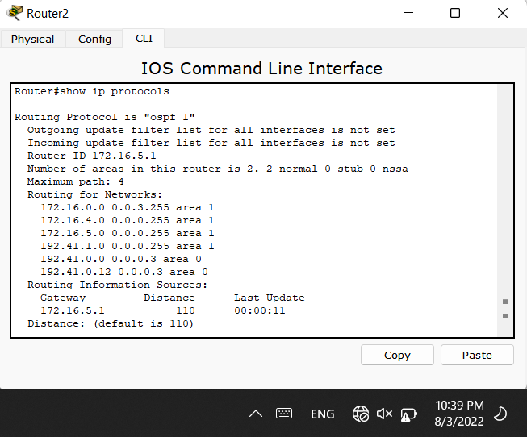

Figure ‎2.5 showing ospf work

Discussion: as we can see, the networks that are added to ospf protocol are shown, also the gateway of the router has been chosen from the loopback network 172.16.5.0, which is the largest network between other loopbacks. This how summarization works.

# Results

## 3.1 Building the topology

After building the topology, each PC must ping the other PC in the same network as shown in fig3.1 and this will be tested for other PCs as will. And each router must ping each router that has connection between them as shown in fig.3.2, and this will be applied for each router as well.

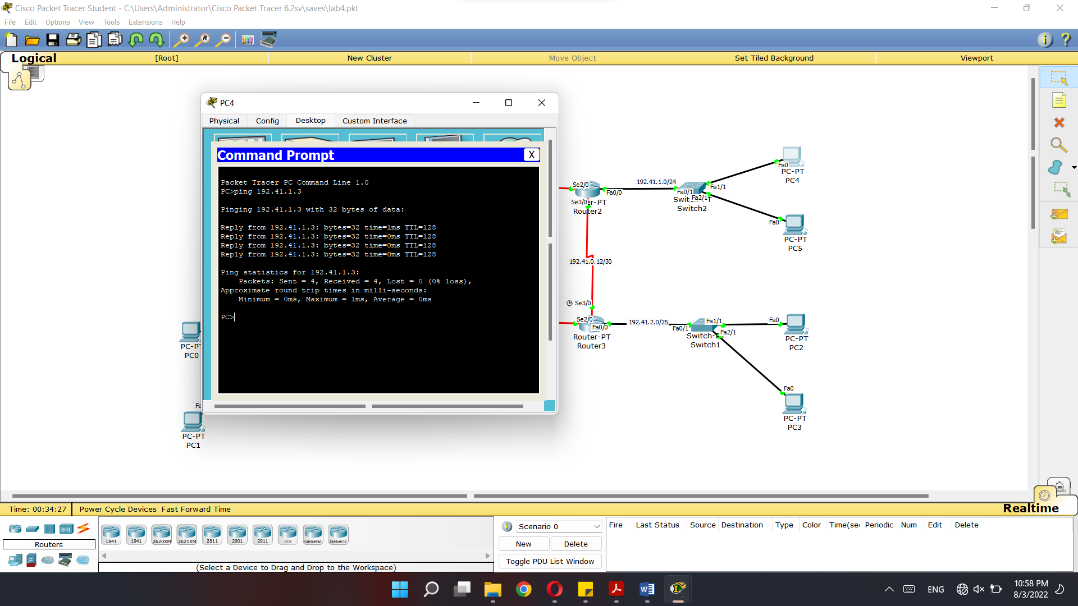

Figure ‎3.1 Result of building the topology perfectly

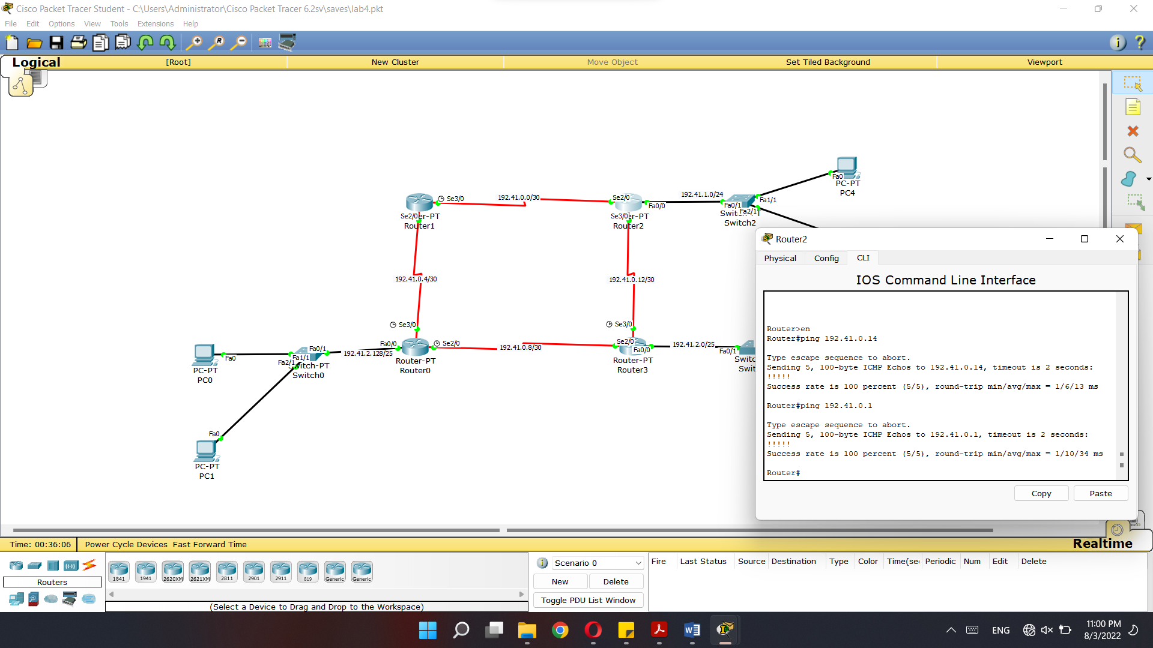

Figure ‎3.2 Result of building the topology perfectly

## 3.2 Configuring OSPF

After configuring ospf for each router, PCs should ping PCs from other networks as shown in fig.3.3.

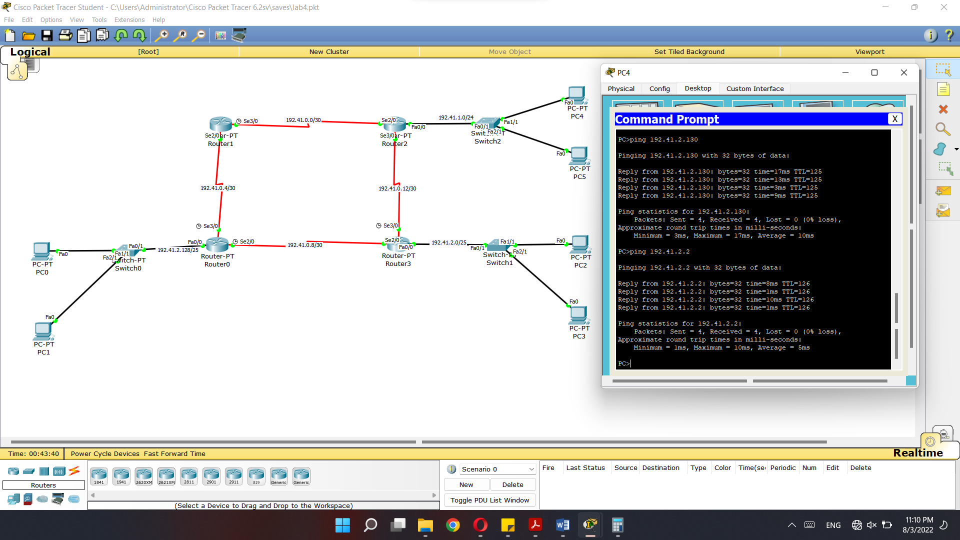

Figure ‎3.3 Result of configuring osp

# Conclusion

In this experiment, we learnt about what is ospf and how it works, what are its advantages of using above other routing protocols, and how the ospf choose the gateway of the router. Finally, we have learnt how to change the cost of a path and how ospf use Dijkstra algorithm in calculating the shortest path to other routers.

1. <https://www.metaswitch.com/knowledge-center/reference/what-is-open-shortest-path-first-ospf> 29/7/2022 at 8:20 pm
2. <https://study-ccna.com/ospf-summarization/> 29/7/2022 at 8:30 pm
3. <https://www.omnisecu.com/cisco-certified-network-associate-ccna/what-is-ospf-area-hierarchical-network-design-and-advantages-of-ospf-areas.php#:~:text=Open%20Shortest%20Path%20First%20(OSPF)%20supports%20hierarchical%20network%20design.,group%20of%20contiguous%20IP%20networks>. 29/7/2022 at 8:41 pm
4. <https://www.firewall.cx/networking-topics/routing/ospf-routing-protocol/1129-ospf-adjacency-neighbor-forming-process-hello-packets-lsr-lsu.html#:~:text=How%20OSPF%20Forms%20Neighbor%20Relations,discovery%20and%20forming%20adjacency%20process>. 29/7/2022 at 9:12pm
5. Lab manual at 9:14 pm