Exam Instructions:

For Graders Only:

A: _________/10

B: _________/10

C: _________/10

D: _________/10

E: _________/10

Total: _________/50

1. Marks add up to 50.
2. Several parts of the exam have bonus questions, each worth one mark. **The bonus mark may be used to make up a lost mark in that part of the exam only**, but will ***not*** count towards lost marks in other parts of the exam.
3. No aids are permitted. Put all electronic devices away.
4. Answer all questions, and write your answers on the exam itself.
5. Write your name, student number, and section on this page and any ***separated*** pages.
6. *Place your student card on your desk.*

# Part A: Predict the output [10 × 1 MARK + bonus]

There is a separate problem in each row of the table below. In each one, mentally execute the code fragment on the left and enter the expected output in the box on the right. ***None result in an error.*** Use the last page of the exam for scrap work.

|  |  |  |
| --- | --- | --- |
|  | *Code Fragment* | *Expected output* |
| 1. | **print(-3**2 % 4)** | -32.3  [order of operations] |
| 2. | **print(2 == 1 or 3 and 4)** | 4 1/2 for True  Boolean Expressions |
| 3. | **print("{0:}{1:}".format(20, "\N{DEGREE SIGN}"))** | 20o  Unicode String processing |
| 4. | **foo = [xx % 3 == 0 for xx in range(1, 10, 2)]**  **print(foo)** | [False, True, False, False, True]  list comprehension |
| 5. | **import numpy as np foo = np.resize(np.arange(6), (2,3)) print(foo[1])** | array([3, 4, 5])  ½ for [3, 4, 5]  matrices |
| 6. | **import numpy as np print(np.array([1,2,3,4])*np.array([2,0,3,2]))** | array([2,0,9,8])  Vector Expressions |
| 7. | **print("mississippi"[-9:-1:2])** | 'sisp'  Slicing |
| 8. | **print(5 % 2 * 'python')** | 'python' |
| 9. | **print("*{0:^8.4f}*".format(1 / 3))** | * 0.3333 * |
| 10. | **bb = set(list('mississippi'))**  **print(len(bb))** | 4 |
| Bonus | **print('{0:.{1:d}f}'.format(1/3, 8))** | 0.33333333 |

# Part B: B.1 + B.2 + B.3 form one program [3 + 5 + 2 = 10 MARKS]

Write a program that reads tabular data from a text file. The text file has a header line, followed by data lines. The file includes both continuous (X-Y values as floats) data and discrete (integer) data. The data is then plotted in two separate plots: an X-Y plot for the continuous data and a histogram for the discrete data.

# B.1 Function readData [3 MARKS]

This function accepts one parameter: a string containing the name of a text file (such as data.csv). The file contains tabular data in comma-separated value format. It opens that file and reads the header information and data. The header is a tuple of strings, and the data is a list of lists. Continuous data must be stored as float values, and discrete data must be stored as integer values. In order to tell which column is integer data, the header for that column contains the string ‘discrete’.  
The function returns the headers and data.

Some of the code is provided. Complete the function by providing the missing parts.

[3] **def** readData(filename) :  
 *"""Read tabular data from a file. Assume the file contains a header line  
 followed by data lines. Two columns are float data, and the third  
 column is integer data. Return the headers and data."""*

infile = open(filename, 'r')  
 headers = infile.readline().strip().split(',')  
 data = []  
 for item in headers:  
 data.append([])  
  
# ADD YOUR CODE HERE  
 for line in infile:  
 items = line.strip().split(',')  
 for header, item, column in zip(headers, items, data):  
 if header == 'discrete':  
 column.append(int(item))  
 else:  
 column.append(float(item))  
  
  
  
  
  
  
  
  
  
  
  
  
  
 infile.close()  
 return headers, data

# Part B: B.1 + B.2 + B.3 form one program [3 + 5 + 2 = 10 MARKS]

# B.2 Function plotData [5 MARKS]

This function produces two plots of the data read by the previous function. Each plot is produced in a separate figure. This function accepts three parameters; the headers, the data, and a dictionary. The dictionary contains one item for each of the headers. The value of each item is the index of the column in data for that header.  
For example, if the header line in the data file was “X,Y,discrete”, the dictionary will contain the following items: {“X”: 0, “Y”: 1, “discrete”:2}.

The first plot is a plot of the continuous data. Label the axes using the header information, and add a title. No legend is required.

The second plot is a normed histogram of the discrete data. Use the dictionary to determine which column in data contains the discrete data. Add appropriate axis labels and title. Make sure you produce one bin for each value the range of values (e.g. if the values range from 10 to 20 you should have 11 bins). DON’T hard-code 11 into your answer!

[5] def plotData(headers, data, dataDict) :  
 """Produce two plots. One is a plot of continuous data. The second  
 is a histogram of discrete data. """  
  
 plt.figure(1)   
 plt.clf()  
 colX = dataDict['X']   
 colY = dataDict['Y']   
 plt.xlabel('X')   
 plt.ylabel('Y')   
 plt.title('Continuous plot')   
 plt.plot(data[colX], data[colY])   
 plt.show()  
 plt.figure(2)   
 colD = dataDict['discrete']   
 nBins = max(data[colD]) - min(data[colD]) + 1  
 plt.xlabel('bin')   
 plt.ylabel('frequency')   
 plt.title('histogram')   
 plt.hist(data[colD], bins=nBins, normed=True)   
 plt.show()  
 return

# Part B: B.1 + B.2 + B.3 form one program [3 + 5 + 2 = 10 MARKS]

# B.3 Function main [2 MARKS]

Complete the code for the main function below. Prompt the user for the name of the data file. Call readData. Using the headers returned, produce a dictionary with one item for each of the values in the headers (as described in the previous question). Call plotData to produce the plots shown. Print an end of processing message.

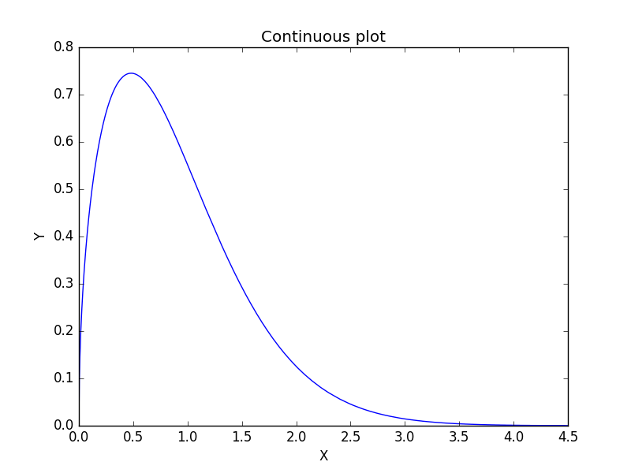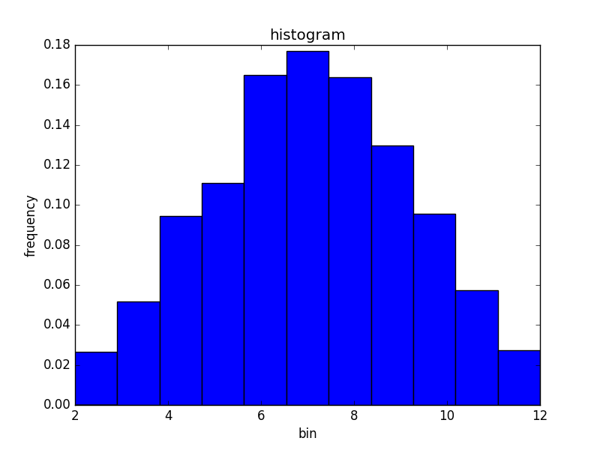

[2] def main( ) :  
 """The main function"""  
 fileName = input("Enter the input file name: ")  
 headers, data = readData(fileName)   
 dataDict = {}  
 for pos, header in enumerate(headers):   
 dataDict[header] = pos  
 plotData(headers, data, dataDict)   
 print("End of processing")  
 return

# Part C: Individual Programs

# C.1 Utility Functions [3 x 2 MARKS + 1 bonus mark]

On this page, four function headers are provided. Choose **two** and implement them **on the next page**. You may assume without checking that all parameters are valid (i.e. no one has given you an integer where you need a string, and so on). Unless specifically noted in the function, you are **not permitted** to use any python libraries (such as math, numpy, or statistics).

**def** averageIf(collection, condition) :

*"""This function returns the average value of all the items in* ***collection*** *that meet the given* ***condition****. The parameter* ***condition*** *will be a function that returns either True or False. This function should call* ***condition*** *on each value in* ***collection*** *and then return the average of the values for which* ***condition*** *returns True. If* ***collection*** *is empty or contains no entries that meet* ***condition****, then this function returns 0."""*

*#example: averageIf([0,1,2,3], bool) returns 2 (the average of 1,2,3)*

*#because bool(0) is False but bool(x) is True for x = 1, 2, or 3*

**def** shift(data, num) :

*"""Returns a copy of* ***data****, where the entries of* ***data*** *have been shifted to the left by* ***num*** *places. This function should work on collections (lists, strings, tuples) as well as integers, but not floats"""*

*#Note: this function is very easy for collections, but making it work*

*#for integers will take more work*

*#example: shift(“smile”,1) returns “miles”*

*#example: shift([1,2,3,4,5], 3) returns [4, 5, 1, 2, 3]*

*#example: shift(1234, 2) returns 3421*

**def** gcf(numList) :

*"""Returns the greatest common factor of the numbers in* ***numList****. That is, it returns the largest integer X such that X evenly divides every number in* ***numList****. There is a well-known algorithm for doing this, but you may use any method you wish."""*

**def** blackjack(c1, c2) :

*"""Accepts two cards (two-character strings, like '5H' for the five of hearts). Returns two things: the total of the card values and a string that is either empty or contains the word 'Blackjack' if the total is 21."""*

*#Note: Jacks, Queens, and Kings are worth 10 points*

*#Aces are worth 1 unless the other card is worth 10,*

*#in which case they are worth 11.*

# C.1 Utility Functions

[6] Implement your chosen functions in the space provided here, ***including reproducing the header from the previous page.*** You do not need to reproduce the doc string or any comments.

*Bonus: If you choose, you may implement three functions instead of just two. If you do so, the first two functions will be for marks, and the third will be given one bonus mark if it is correct.*

def superIndex(myList, item, left=True):

if left:

search = myList

else:

search = myList[-1::-1]

pos = 0

for xx in search:

if item == xx:

return pos if left else len(myList) - pos - 1

else:

pos += 1

return -1

def splice(string1, string2):

newStr = ""

pos = 0

while pos < min(len(string1), len(string2)):

newStr += string1[pos] + string2[pos]

pos += 1

newStr += string1[pos:]

newStr += string2[pos:]

return newStr

def onlyPrimes(numList):

if len(numList) == 0:

return False

for item in numList:

for factor in range(2,int(item**.5)+1):

if item % factor == 0: #Composite number

return False

return True

def reverseLookup(someDict, value):

return [xx for xx in someDict.keys() if someDict[xx] == value]

# C.3 FizzBuzz [4 MARKS]

Write a program that will play the children’s game FizzBuzz with the user. The game is simple: players count in turn, starting at 1. If it is your turn, you say the next number, unless the next number is a multiple of 3 (in which case you say “Fizz”), 5 (say “Buzz”) or both 3 and 5 (say “FizzBuzz”). The first player to make a mistake loses. Since the computer can’t make a mistake, the program accepts one argument: a maximum number to play to. If the user makes it that far without making a mistake, the user wins. The program starts the game by saying “1”.

The program should have a loop which does the following:

1. Print out the correct response (the next number, “Fizz”, ”Buzz”, or “FizzBuzz”)
2. Ask the user for the next number
3. Check to see if the user was correct. If so, continue. If not, the computer wins
4. Check to see if the next number is the stopping point. If so, the user wins. If not, go back to step 1

Note: The program must print out a message indicating who won once the game is over.

Hint: You may find it useful to create a second function that takes a number and determines what the correct output (itself, “Fizz”, “Buzz”, “Fizzbuzz”) for it is.

[4] **def** fizzBuzz(stop) :

*"""**Plays FizzBuzz until* ***stop*** *is reached or the user makes a mistake."""*

# Part D: Multiple Choice [10 x 1 MARKs + 1 bonus mark]

For each of the following multiple-choice questions, circle the ***single best*** answer. The bonus question is worth 1 mark.

[1] 1. Given the following code, what is the value of totalItems?

items = [[xx,xx+1] * xx for xx in range(-1,5,2)]  
totalItems = sum([len(yy) for yy in items])

a) 20

b) 24

c) 12

d) 10

e) 8 This One

[1] 2. Given word="accuratenesses", which of the following produces the result "cans"?

a) word[-1::-3]

b) word[1::3]

c) word[2::2]

d) word[1:-2:2]

e) word[2:-1:3] This One

[1] 3. Given nn = -7 / 3, which of the following print statements will contain **no** padding?

a) print("{0:8.3g}".format(nn))

b) print("{0:8.3f}".format(nn))

c) print("{0:8.1E}".format(nn)) This One

d) print("{0:8.6g}".format(abs(nn)))

e) print("{0:<8.6s}".format(str(nn)))

[1] 4. All of the following functions exist in both the **random** library and the **numpy.random** library. Which one behaves differently in the numpy version than the normal one, assuming both were given the same inputs?

1. randint This one
2. randrange
3. random
4. seed
5. choice

[1] 5. Given the following code, which of the expressions below has the **largest** value?

w4,w2,w1,w3 = set("apple"), set("orange"), set("banana"), set("peach")

a) len(w1.intersection(w2).union(w3) – w4)

b) len(w1.intersection(w4).union(w2) – w3)

c) len(w4.intersection(w3).union(w2) – w1) This One

d) len(w2.intersection(w3).union(w4) – w1)

e) len(w3.intersection(w1).union(w2) – w4)

[1] 6. Once this code has been run, which of the following lines will crash?

import matplotlib.pyplot as plt

import numpy as np

xx = np.linspace(-10,10,101)

yy = xx**2

a) plt.figure(); plt.add_subplot(321) This One

b) fig = plt.figure(); plt.clf(); fig.clf()

c) plt.xlim(0,10)

d) plt.plot(xx,yy,label="$xx$ vs $yy$")

e) plt.savefig("myplot.png")

[1] 7. What is the output of the program below?

**import** numpy as np

var1 = np.ones(5)

var2 = np.linspace(1,3,5)

var2[:3:] = var1[::2]

var1[::2] += 2

var2 *= 2

print(var2 - var1)

a) [-2. 0. -2. 5. 4.]

b) [-1. 1. -1. 4. 3.] This One

c) [-1. 1. 1. 4. 3.]

d) [ 0. 1. 0. 4. 4.]

e) [ 1. -1. 1. 2. 5.]

[1] 8. After this code runs, how many **even** numbers have been printed?

counter = 0

**def** go(pp):

**global** counter

counter += 1

if pp:

print(counter)

**for** xx in **range**(5):

go(xx)

**for** yy in **range**(5):

go(yy>xx)

**if** counter % 4 == 0:

**break**

a) 1

b) 2 This One

c) 3

d) 4

e) 5

Use this space for scrap work

Questions 9 and 10 are on the next page

[1] 9. Given this code, which of the following plots could be produced?

import numpy as np

import matplotlib.pyplot as plt

nums = np.array(np.random.randint(1,6,1000))

bb = np.linspace(min(nums)-.5,max(nums)+.5,max(nums)-min(nums)+2)

plt.hist(nums,bins=bb,normed=True,ec="black")

plt.show()

1. 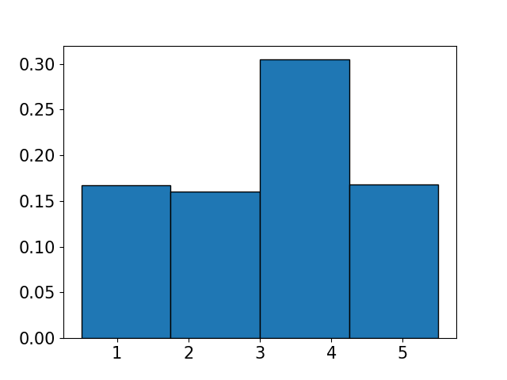 b) 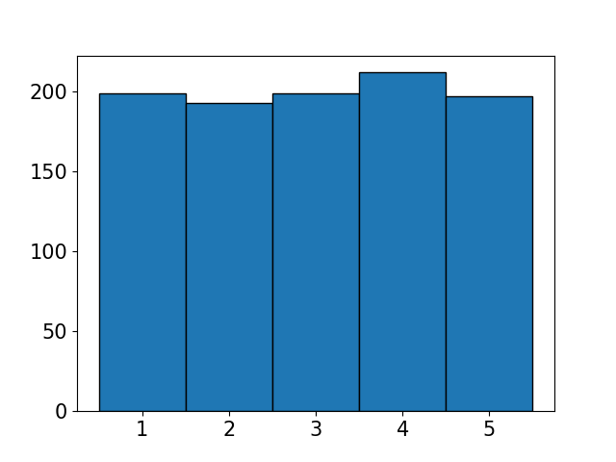
2. 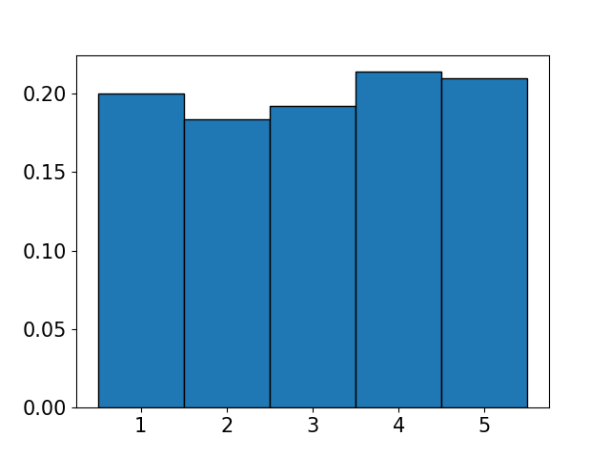 d) 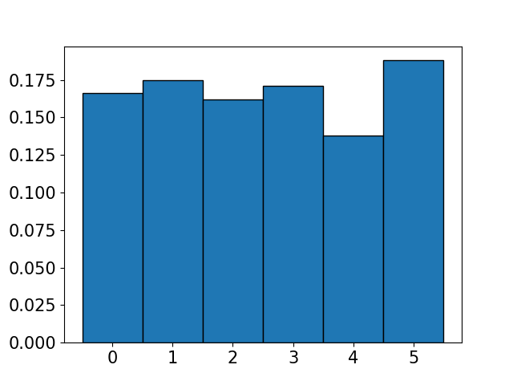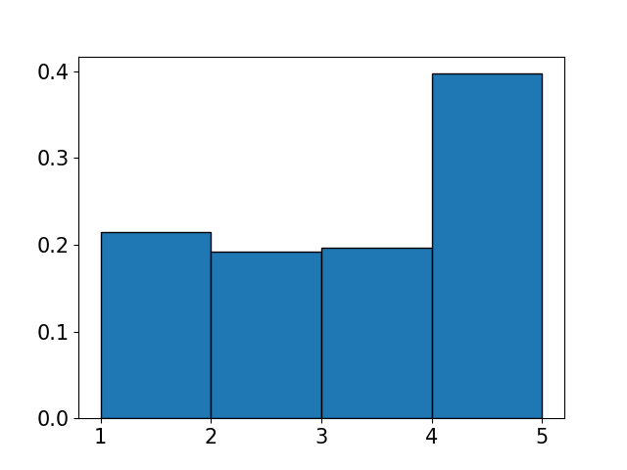

[1] 10. Consider the following 3D array, which of the following is **false**?

threeD = np.reshape(np.arange(24), (4,2,3))

a) np.size(threeD) = 24

b) np.size(threeD,axis=1) = 2

c) threeD[0][1][2] = 4 This One

d) np.sum(threeD[1][0] < threeD[1][1]) = 3

e) np.shape(np.transpose(threeD)) = (3, 2, 4)

Bonus. Recall the Alice and Bob dice game from the course notes (Rolling one die repeatedly. Alice wants every face to show up once, Bob wants one face to show up 4 times). With a 6-sided die, Bob wins about 2/3 of the time. If an 8-sided die was used instead, which of these is the closest approximation to **Bob’s** winning percentage?

a) 20%

b) 40%

c) 60%

d) 80% This One

e) 100%

# Part E: Debugging [5 x 2 MARKS]

[10] On this page there are five small functions. Each one contains a single error. On the next page, either describe what the error is and how to fix it or rewrite the program correctly. Each error is one of the following: **missing/extra/incorrect item, where item is punctuation, constant, operation, library, function, or variable** (including mismatched brackets or quotes).

This function accepts two parameters, **data** and **order**, and returns a copy of **data** sorted according to **order**. Ex: sortBy(['a','b','c'],[3,1,2]) returns ['b','c','a']

def sortOrder(data,order):

paired = zip(order,data)

paired.sort()

return [item[1] for item in paired]

This function accepts two lists and returns True if **list1** is a sublist of **list2** (otherwise it returns False). This happens if and only if every item in **list1** occurs at least as often in **list2** as it does in **list1**. So [1,2,3] is a sublist of [1,2,3,4] but [1,2,2,3] is not because [1,2,3,4] only has one 2.

def isSublist(list1,list2):

counts = [list1.count(item) <= list2.count(item) for item in list1]

return sum(counts) == len(list2)

This function accepts two numpy arrays of the same length as parameters. It compares every pair of numbers (e.g. the fourth number in **array1** with the fourth number in **array2**) and returns an array containing the smaller of each pair. Ex: getMins([1 2 3], [3 2 1]) returns [1 2 1]

def getMins(array1, array2):

mins = np.zeros(len(array1))

mins[array1 < array2] = array1[array1 < array2]

mins[array1 >= array2] = array1[array1 >= array2]

return mins

This function takes two parameters: a list of items and the name of a function. It returns a list containing the results of calling **func** with each item in **args** as an argument. Ex: applyFunction(['a','b'],str.upper) returns ['A','B']

def applyFunction(args, func):

return [func[arg] for arg in args]

This function accepts one parameter, a dictionary. This function inverts **someDict**, that is, switches its keys and values, and returns that as a new dictionary. The new dictionary’s keys are the values of **someDict** and the new dictionary’s values are lists (i.e. newDict[xx] is a list of all keys yy such that someDict[yy] == xx).

Ex: invertDictionary({1:2, 3:4, 4:5, 6:5}) returns {2:[1], 4:[3], 5:[4,6]}

def invertDictionary(someDict):

newDict = {}

for kk, vv in someDict.values():

if vv in newDict:

newDict[vv].append(kk)

else:

newDict[vv] = [kk]

return newDict

**Write your corrections/rewrites below**

def sortOrder(data,order):

paired = **list**(zip(order,data)_

paired.sort()

return [item[1] for item in paired]

def isSublist(list1,list2):

counts = [list1.count(item) <= list2.count(item) for item in list1]

return sum(counts) == len(**list1**) #counts also acceptable here

def getMins(array1, array2):

out = np.zeros(len(array1))

out[array1 < array2] = array1[array1 < array2]

out[array1 >= array2] = **array2**[array1 >= array2]

return out

def applyFunction(args, func):

return [func**(arg)** for arg in args]

def invertDictionary(someDict):

newDict = {}

for kk, vv in someDict.**items**():

if vv in newDict:

newDict[vv].append(kk)

else:

newDict[vv] = [kk]

return newDict

