University Of Engineering and Technology, Lahore
Computer Engineering Department

Course Name: Programming Fundamentals and data science | Course Code: CMPE-112L
Assignment Type: | Dated: April 20, 2026
Semester: 1 | Session: Spring 2026
Lab/Project/Assignment #: 1 | CLOs to be covered: CLO
Lab Title: Local and Global Variables | Teacher Name: Hafiz Muhammad Mubashar
Lab Evaluation:

CLO2 | Apply appropriate programming techniques to create executable programs to solve well defined problems
 | Level1 | Level2 | Level3 | Level4 | Level5 | Level6
(5)
Total |  |  |  |  |  | /5
Rubrics for Current Lab Evaluation
Scale | Marks | Level | Rubric
Excellent | 5 | L1 | Submitted all lab tasks, BONUS task, have good understanding.
Very Good | 4 | L2 | Submitted the lab tasks but have good understanding
Good | 3 | L3 | Submitted the lab tasks but have weak understanding.
Basic | 2 | L4 | Submitted the lab tasks but have no understanding.
Barely Acceptable | 1 | L5 | Submitted only one lab task.
Not Acceptable | 0 | L6 | Did not attempt
LAB No 6
Lab Goals/Objectives:
Upon successful completion of this lab, students will be able to design, write, and execute programs that correctly use local and global variables within functions.

- Understand the difference between local and global variable scope in Python.
- Identify how variables declared inside a function differ from those declared outside it.
- Use the global keyword to modify a global variable from within a function.
- Analyze scenarios where local and global variables share the same name and understand variable shadowing.
- Apply the concept of variable scope to write error-free and predictable programs.

Equipment Required:

- Python interpreter (Python 3.x)
- Code editor / IDE (e.g., VS Code, PyCharm)

Theory:

A local variable is defined inside a function and can only be accessed within that function, while a global variable is defined outside any function and can be accessed throughout the program. When a variable with the same name exists both locally and globally, the local variable takes precedence inside the function unless the global keyword is used to explicitly modify the global variable. Understanding variable scope is essential to avoid unexpected behavior and errors in programs that use functions.

Lab Work:

Task 1:
Program to Increment a Global Variable Using a Function with the Global Keyword
Result:

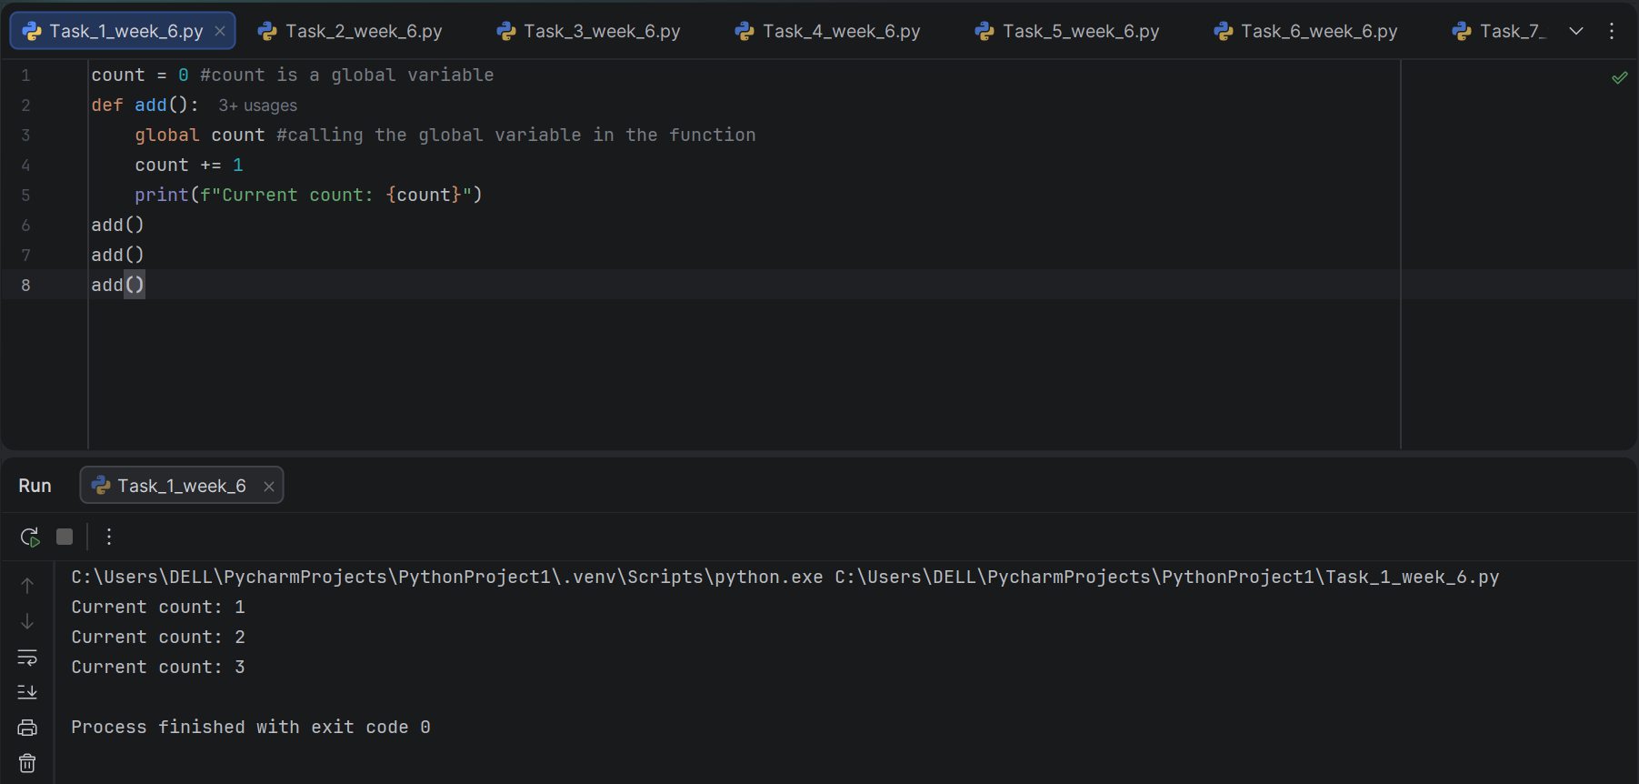

Task 2:
Program to Increment a Local Variable Using a Function with Return Value (No Global Variable)
Result:

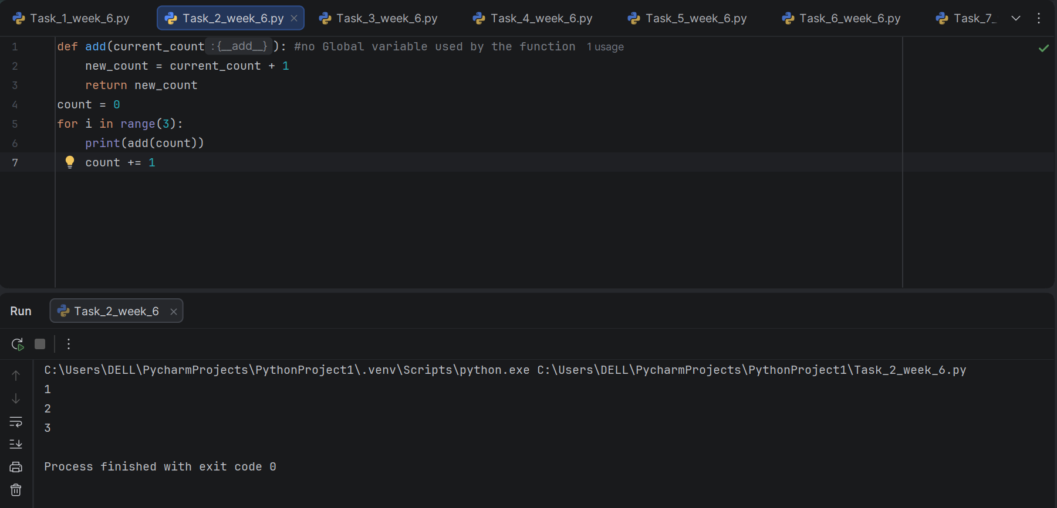

Task 3:
Program to Add Two Global Variables Using the Global Keyword Inside a Function.

Result:

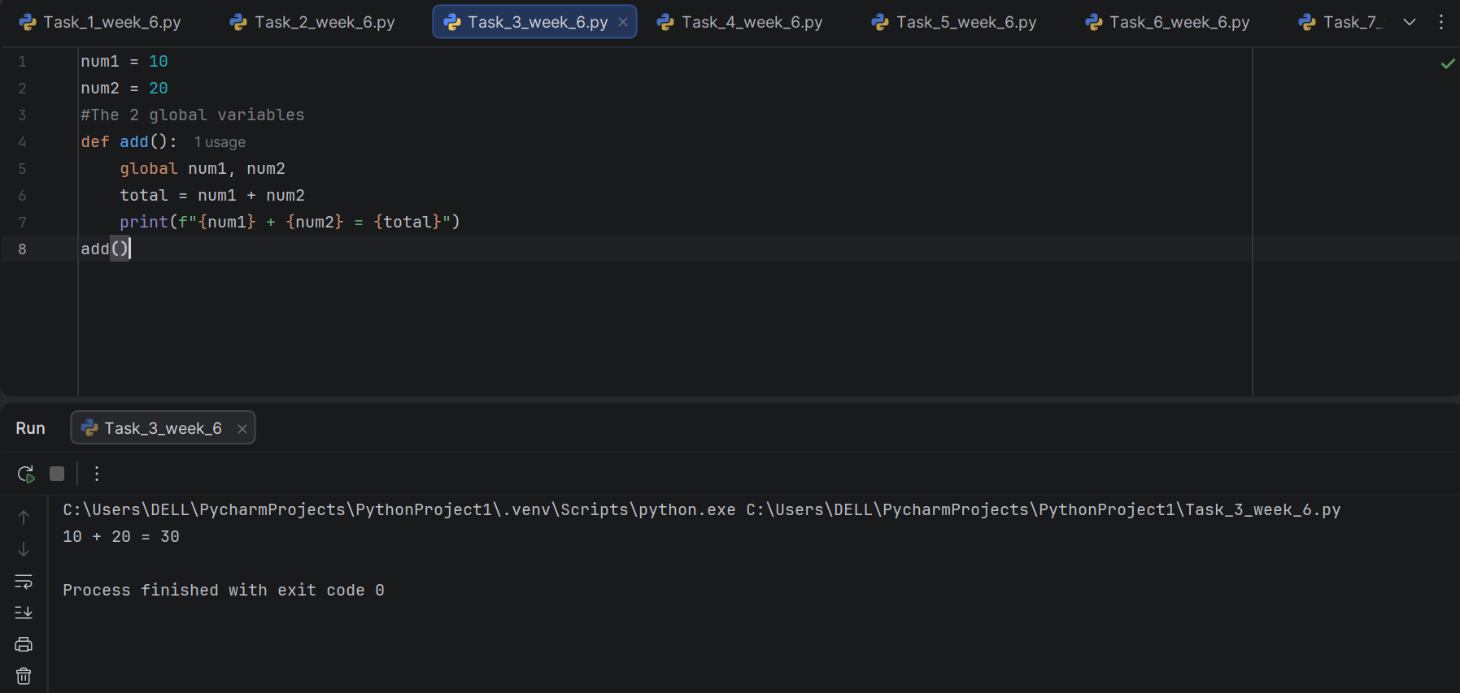

Task 4:
Program to Add Two Numbers Using Local Variables Passed as Parameters.

Result:

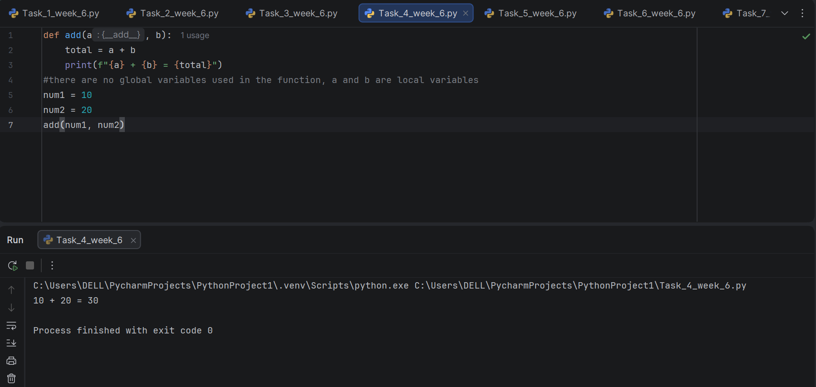

Task 5:
Program to Check System Status Using a Global Variable with the Global Keyword.

Result:

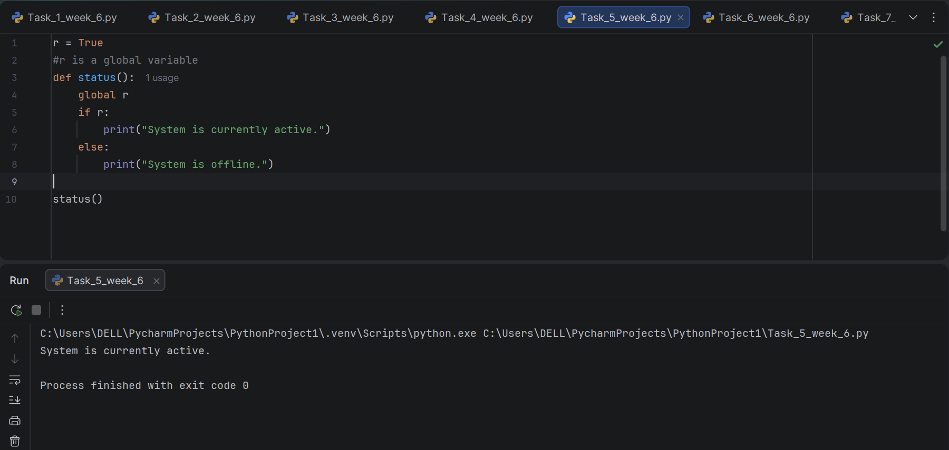

Task 6:
Program to Check System Status Using a Local Variable Passed as a Parameter.

Result:

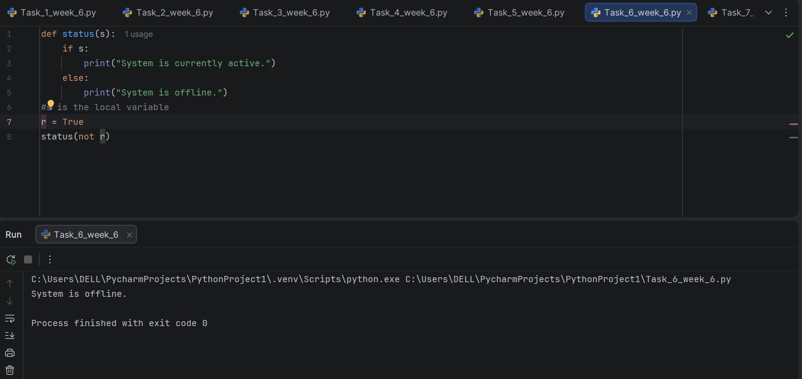

Task 7:
Program to Calculate Running Total Using a Global Variable Across Multiple Function Calls.

Result:

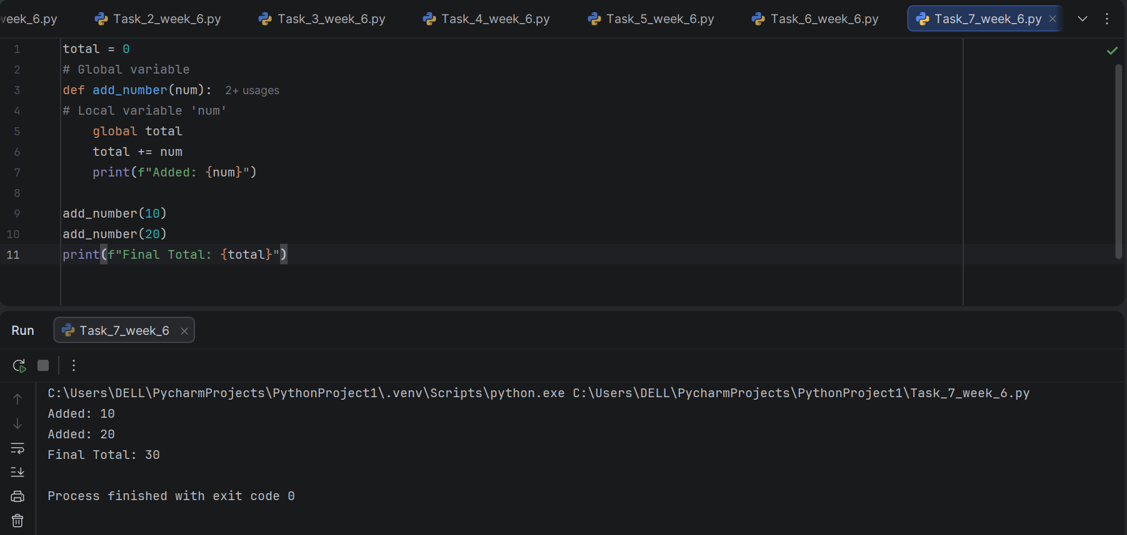

Conclusion:

In this lab, the concepts of local and global variables were practically implemented in Python. Various programs demonstrated how variables declared inside a function remain local, while the global keyword allows a function to access and modify variables declared outside it. Comparisons between local and global variable usage helped in understanding variable scope, and how the same task can be achieved differently depending on whether a variable is passed as a parameter or accessed globally. This lab reinforced the importance of proper variable scope management in writing predictable and error-free programs.

