University Of Engineering and Technology, Lahore
Computer Engineering Department

Course Name: Programming Fundamentals and data science | Course Code: CMPE-112L
Assignment Type: | Dated: March 30, 2026
Semester: 1 | Session: 2026 Spring
Lab/Project/Assignment #: 1 | CLOs to be covered: CLO
Lab Title: Functions | Teacher Name: Hafiz Muhammad Mubashar
Lab Evaluation:

CLO2 | Apply appropriate programming techniques to create executable programs to solve well defined problems
 | Level1 | Level2 | Level3 | Level4 | Level5 | Level6
(5)
Total |  |  |  |  |  | /5
Rubrics for Current Lab Evaluation
Scale | Marks | Level | Rubric
Excellent | 5 | L1 | Submitted all lab tasks, BONUS task, have good understanding.
Very Good | 4 | L2 | Submitted the lab tasks but have good understanding
Good | 3 | L3 | Submitted the lab tasks but have weak understanding.
Basic | 2 | L4 | Submitted the lab tasks but have no understanding.
Barely Acceptable | 1 | L5 | Submitted only one lab task.
Not Acceptable | 0 | L6 | Did not attempt
LAB No 5
Lab Goals/Objectives:
Upon successful completion of this lab, students will be able to design, write, and use functions to create modular, reusable, and organized code.

- Understand the syntax and purpose of defining functions using the def keyword.
- Differentiate between function parameters, arguments, and return values.
- Implement functions with and without parameters, and with and without return statements.
- Apply the concept of variable scope (local vs global) within functions.
- Use functions to break down complex problems into smaller, manageable, and reusable blocks of code.

Equipment Required:

- Python interpreter (Python 3.x)
- Code editor / IDE (e.g., VS Code, PyCharm)

Theory:

A function is a reusable block of code that performs a specific task, defined using the def keyword. Functions help in organizing code, avoiding repetition, and improving readability. They can accept input values called parameters/arguments and may return a result using the return statement. Variables defined inside a function have local scope, meaning they are only accessible within that function, while variables defined outside have global scope. Functions form the foundation for writing modular and maintainable programs.

Lab Work:

Task 1:
Program to Add Two Numbers Using a Function with Return Value
Result:

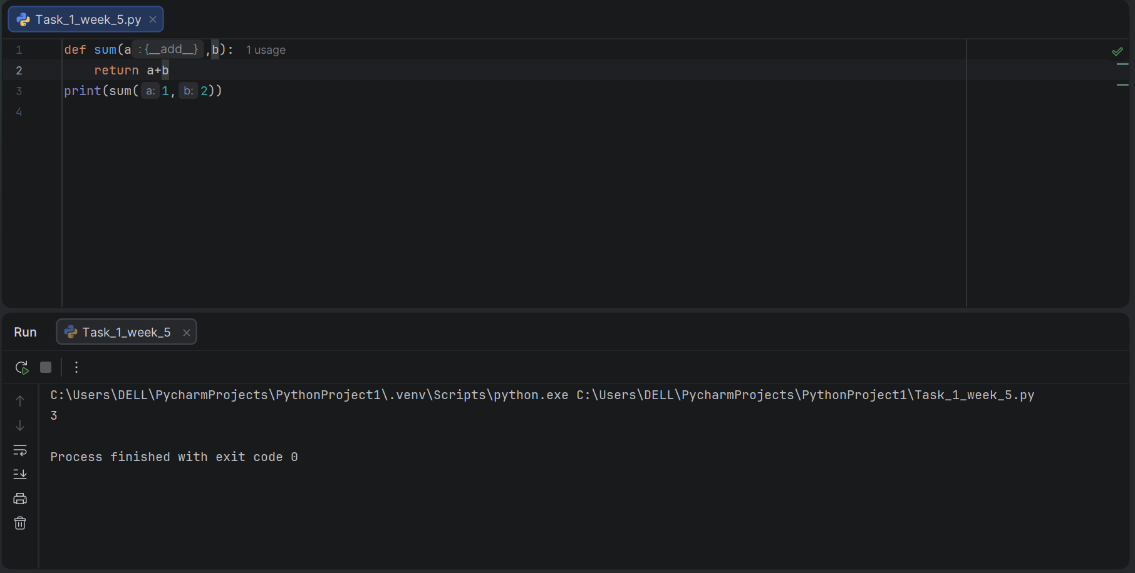

Task 2:
Program to Demonstrate Function Reusability by Calling the Same Function with Different Arguments.

Result:

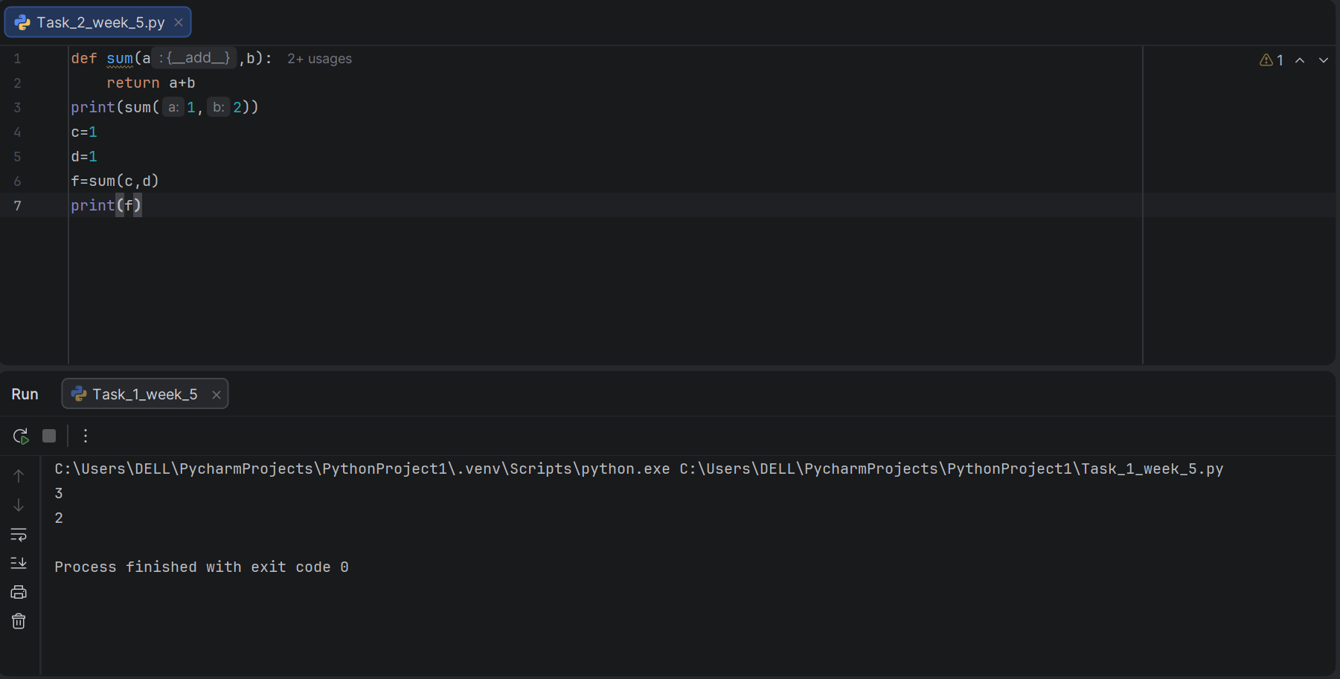
Task 3:
Program to Greet Multiple Users Using a Function with Parameters.

Result:

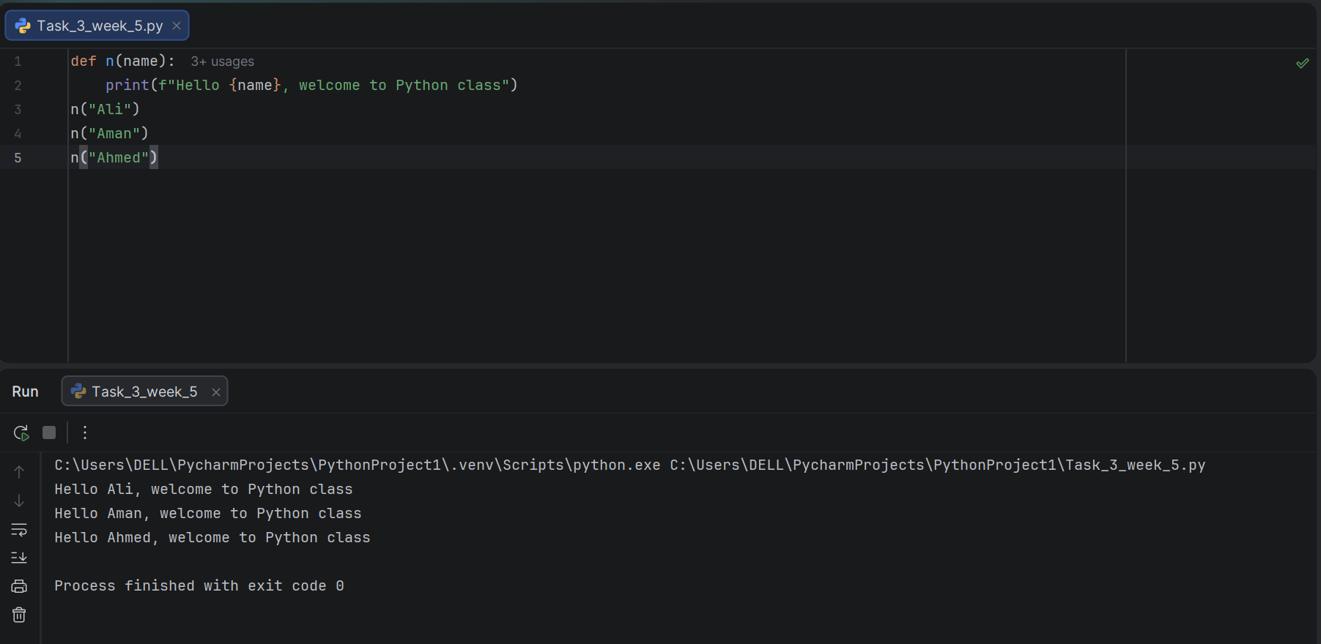

Task 4:
Program to Check Data Type of User Input and Convert It Accordingly Using a Function.

Result:

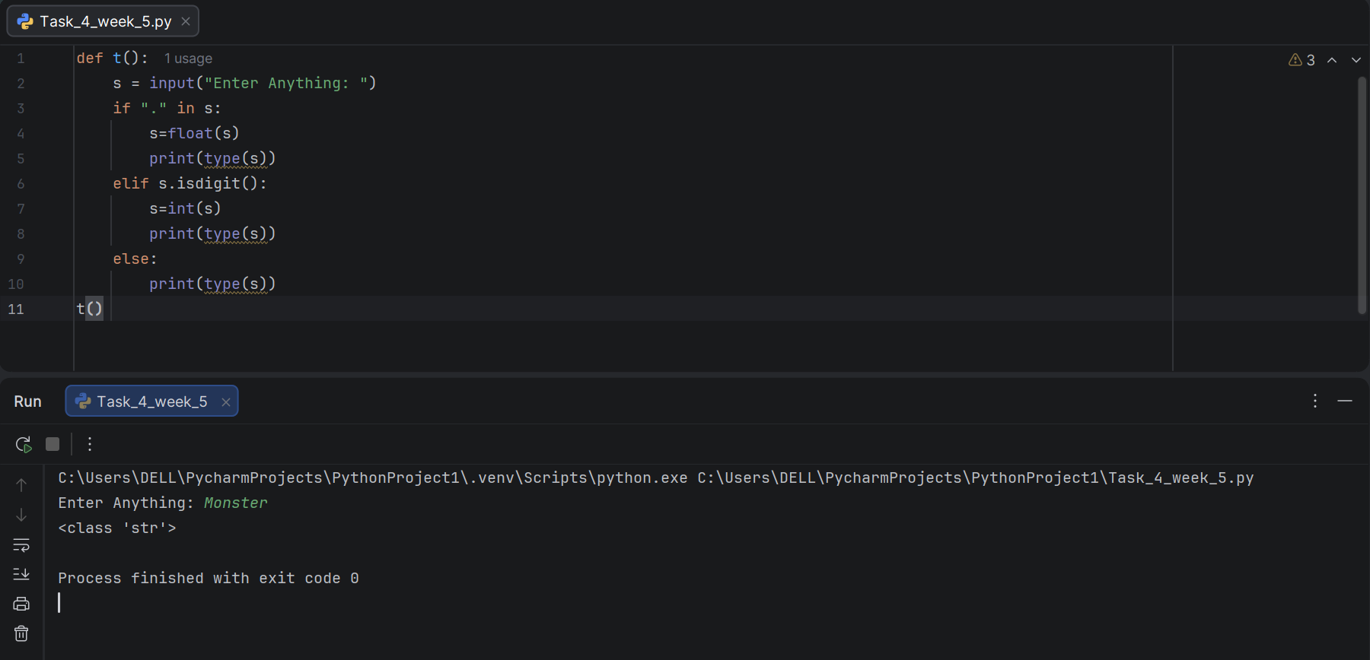

Conclusion:

In this lab, the concept of functions was practically implemented to write modular and reusable Python code. Functions were defined to perform tasks such as addition, greeting multiple users, and dynamic type checking and conversion based on user input. This lab helped in understanding how functions accept parameters, return values, and can be reused multiple times with different arguments, reinforcing the importance of writing clean and organized code.

