University Of Engineering and Technology, Lahore
Computer Engineering Department

Course Name: Programming Fundamentals and data science | Course Code: CMPE-112L
Assignment Type: | Dated: March 02, 2026
Semester: 1 | Session: 2026 Spring
Lab/Project/Assignment #: 1 | CLOs to be covered: CLO
Lab Title: For Loops | Teacher Name: Hafiz Muhammad Mubashar
Lab Evaluation:

CLO1 | Apply appropriate programming techniques to create executable programs to solve well defined problems
 | Level1 | Level2 | Level3 | Level4 | Level5 | Level6
(5)
Total |  |  |  |  |  | /5
Rubrics for Current Lab Evaluation
Scale | Marks | Level | Rubric
Excellent | 5 | L1 | Submitted all lab tasks, BONUS task, have good understanding.
Very Good | 4 | L2 | Submitted the lab tasks but have good understanding
Good | 3 | L3 | Submitted the lab tasks but have weak understanding.
Basic | 2 | L4 | Submitted the lab tasks but have no understanding.
Barely Acceptable | 1 | L5 | Submitted only one lab task.
Not Acceptable | 0 | L6 | Did not attempt
LAB No 2
Lab Goals/Objectives:
Upon successful completion of this lab, students will be able to design, write, and execute programs using for loops to perform repetitive tasks efficiently.
• Understand the syntax and working of the for loop in Python.
• Use the range() function to control loop iterations.
• Apply for loops to traverse and process elements of strings, lists, and other sequences.
• Implement nested for loops to solve multi-level repetitive problems.
• Analyze and solve problems involving counting, summation, and pattern generation using for loops.

Equipment Required:

• Python interpreter (Python 3.x)
• Code editor / IDE (e.g., VS Code, PyCharm)

Theory:
A for loop is used to execute a block of code repeatedly for a fixed number of times or over the elements of a sequence. The range() function is commonly used with for loops to generate a sequence of numbers to iterate over. For loops are useful for tasks like counting, summation, traversing data structures, and generating patterns, making repetitive operations efficient and easy to manage.

Lab Work:

Task 1:
Program to Print a Pattern of Stars Using a For Loop

Result:

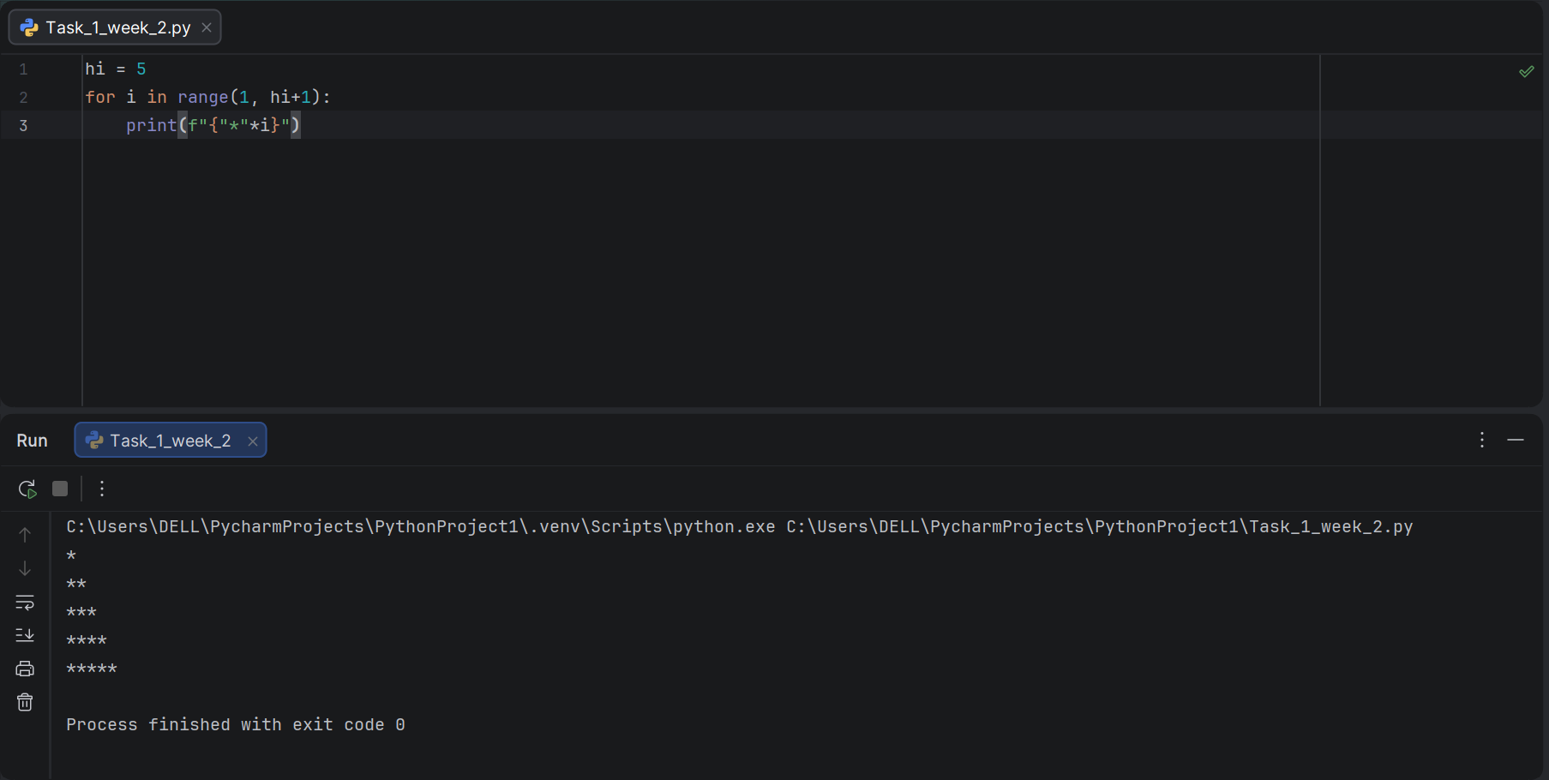

Task 2:
Program to Print a Pyramid Pattern of Stars Using a For Loop

Result:

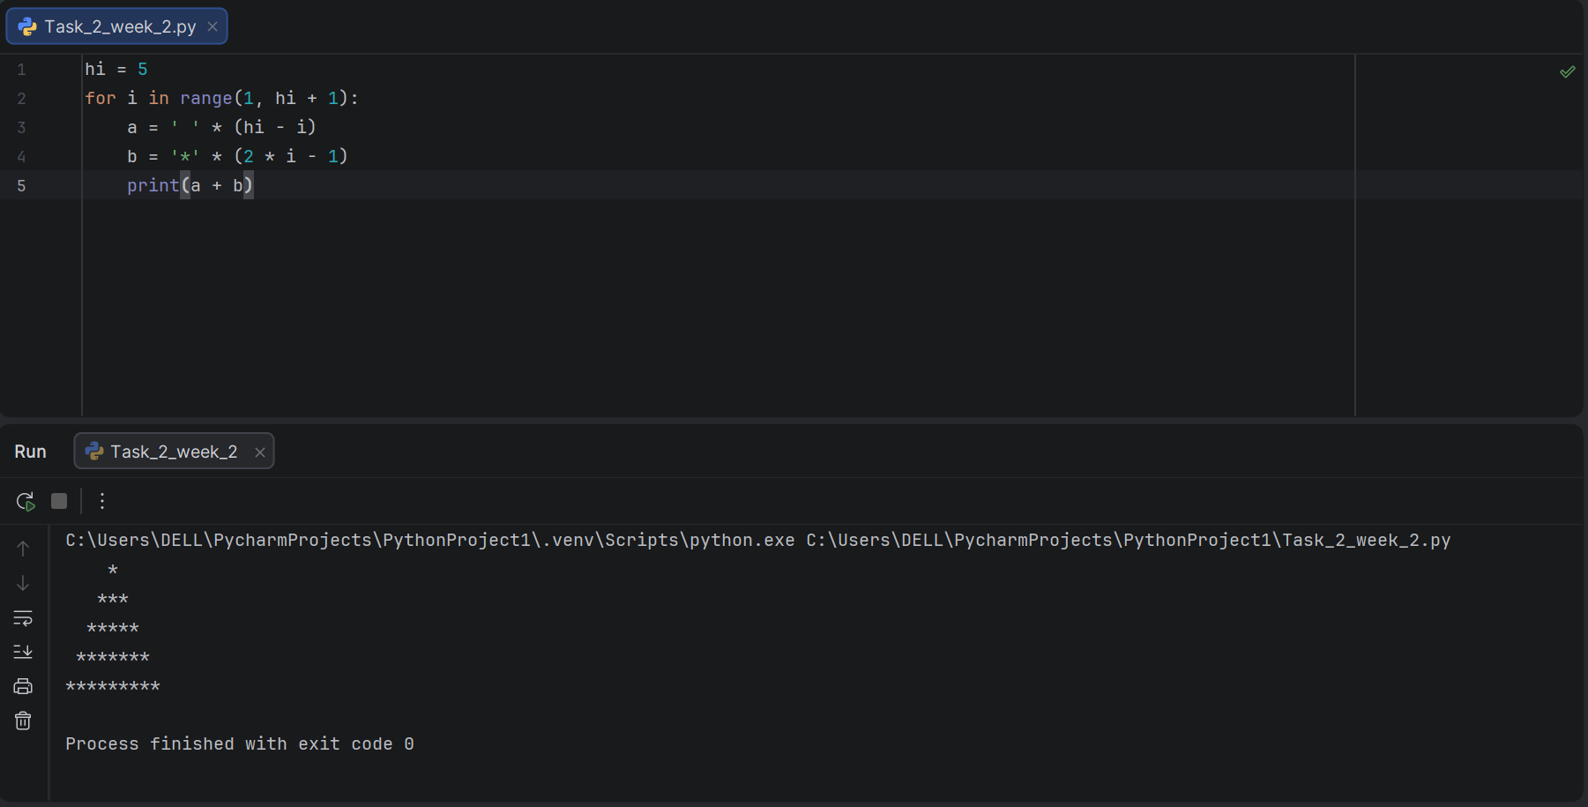
Task 3:
Program to Print Numbers from 1 to 100 Using a For Loop

Results:

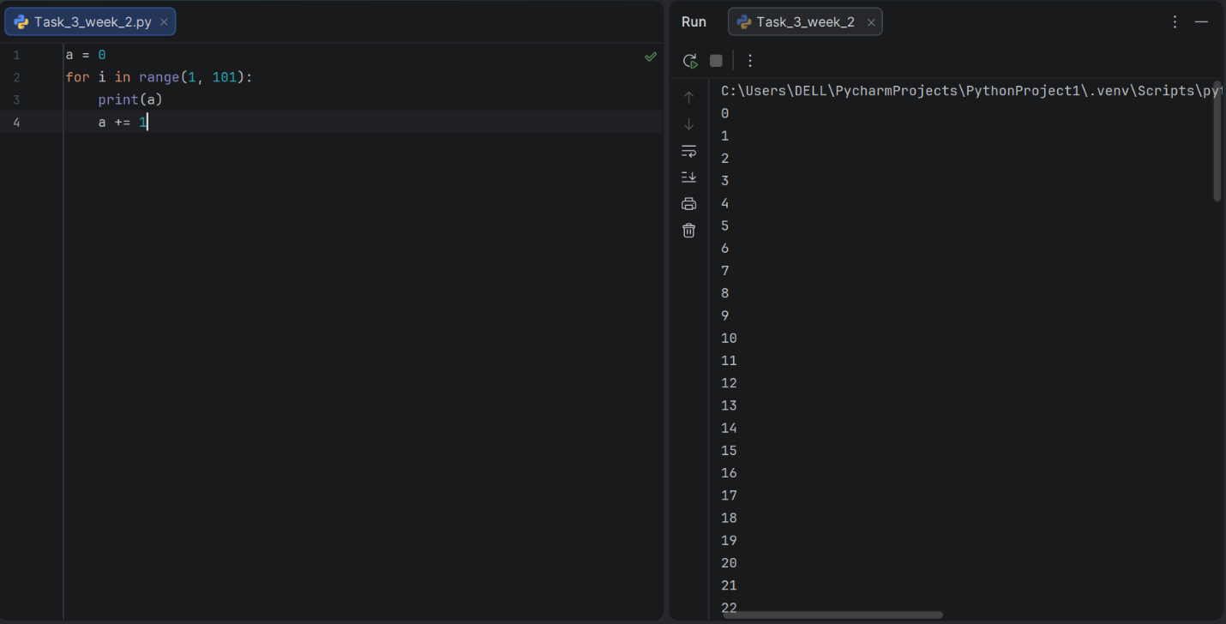

Task 4:
Program to Print Odd Numbers from 1 to 100 Using a For Loop.

Result:

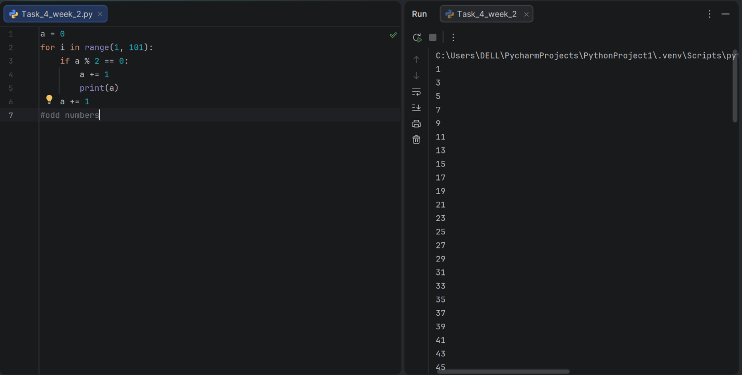
Task 5:
Program to Print Squares of Numbers Using a For Loop.

Result:

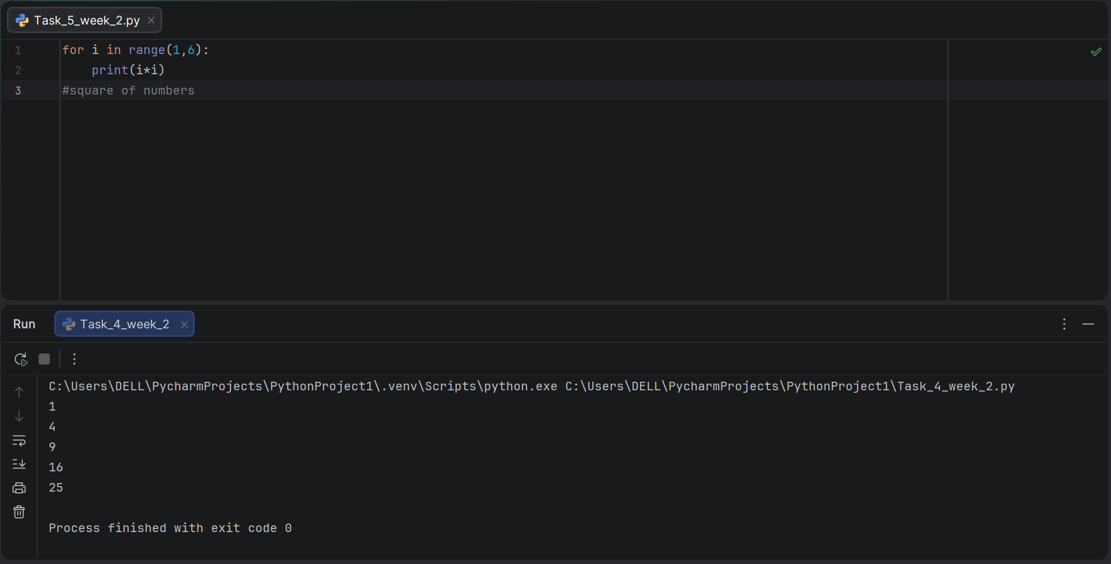

Task 6:
Program to Generate Multiplication Table of a Number Using a For Loop.

Result:

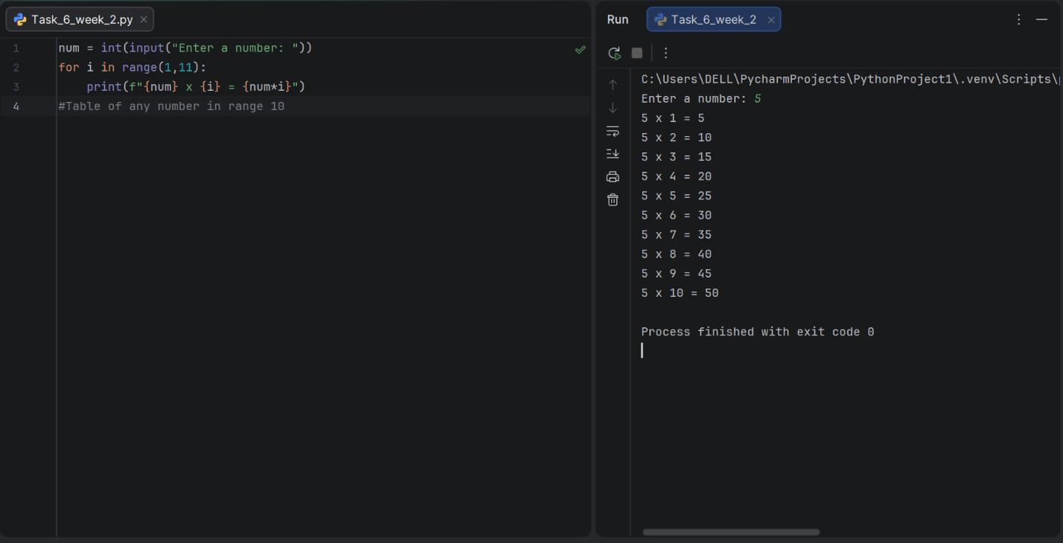
Task 7:
Program to Calculate and Display Student Grade Report Using a For Loop.

Result:

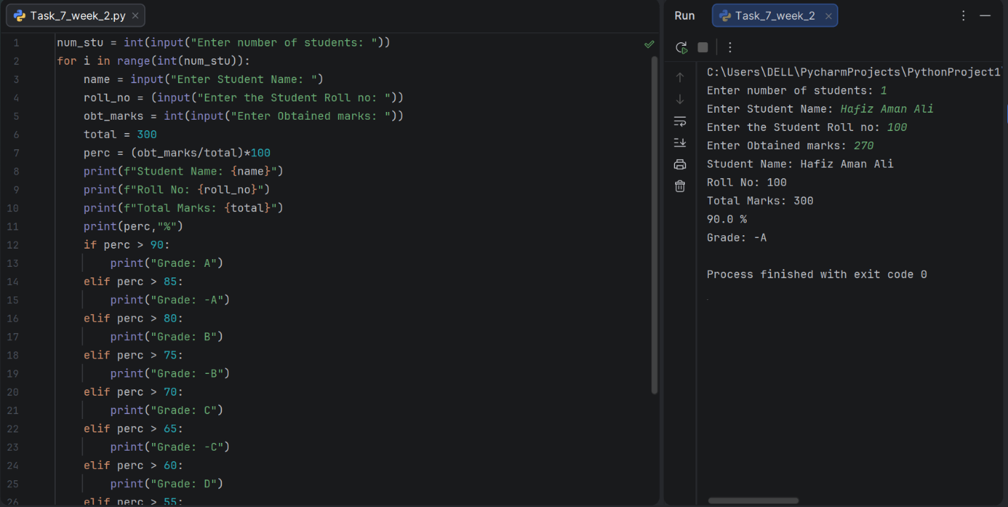

Conclusion:
In this lab, the concept of for loops was practically implemented to perform repetitive tasks in Python. Various patterns were generated using nested logic, and loops were used to print number sequences, odd numbers, squares, and multiplication tables. Additionally, a student grade report system was developed by combining for loops with conditional statements. This lab strengthened the understanding of iteration and helped in writing efficient code for tasks that require repeated execution.

