University Of Engineering and Technology, Lahore
Computer Engineering Department

Course Name: Programming Fundamentals and data science | Course Code: CMPE-112L
Assignment Type: | Dated: April 27, 2026
Semester: 1 | Session: Spring 2026
Lab/Project/Assignment #: 1 | CLOs to be covered: CLO
Lab Title: List, Tuple | Teacher Name: Hafiz Muhammad Mubashar
Lab Evaluation:

CLO3 | Apply appropriate programming techniques to create executable programs to solve well defined problems
 | Level1 | Level2 | Level3 | Level4 | Level5 | Level6
(5)
Total |  |  |  |  |  | /5
Rubrics for Current Lab Evaluation
Scale | Marks | Level | Rubric
Excellent | 5 | L1 | Submitted all lab tasks, BONUS task, have good understanding.
Very Good | 4 | L2 | Submitted the lab tasks but have good understanding
Good | 3 | L3 | Submitted the lab tasks but have weak understanding.
Basic | 2 | L4 | Submitted the lab tasks but have no understanding.
Barely Acceptable | 1 | L5 | Submitted only one lab task.
Not Acceptable | 0 | L6 | Did not attempt
LAB No 7
Lab Goals/Objectives:
Upon successful completion of this lab, students will be able to design, write, and execute programs using lists and tuples to store and manipulate collections of data.

- Understand the concept, syntax, and properties of lists and tuples in Python.
- Differentiate between mutable (list) and immutable (tuple) data structures.
- Apply indexing, slicing, and looping techniques to access and manipulate list and tuple elements.
- Use built-in list methods (append, insert, remove, sort, etc.) to modify lists.
- Apply lists and tuples to solve problems involving storage, retrieval, and organization of multiple values.

Equipment Required:

- Python interpreter (Python 3.x)
- Code editor / IDE (e.g., VS Code, PyCharm)

Theory:

A list is an ordered, mutable collection of items that can be modified after creation using various built-in methods like append(), remove(), and sort(). A tuple, on the other hand, is an ordered but immutable collection, meaning its elements cannot be changed once defined. Both lists and tuples can store multiple data types and support indexing and slicing for accessing elements. Lists are commonly used when data needs to change, while tuples are preferred for fixed collections of data that should remain constant throughout the program.

Lab Work:

Task 1:
Program to Create a List and Access an Element Using Indexing
Result:

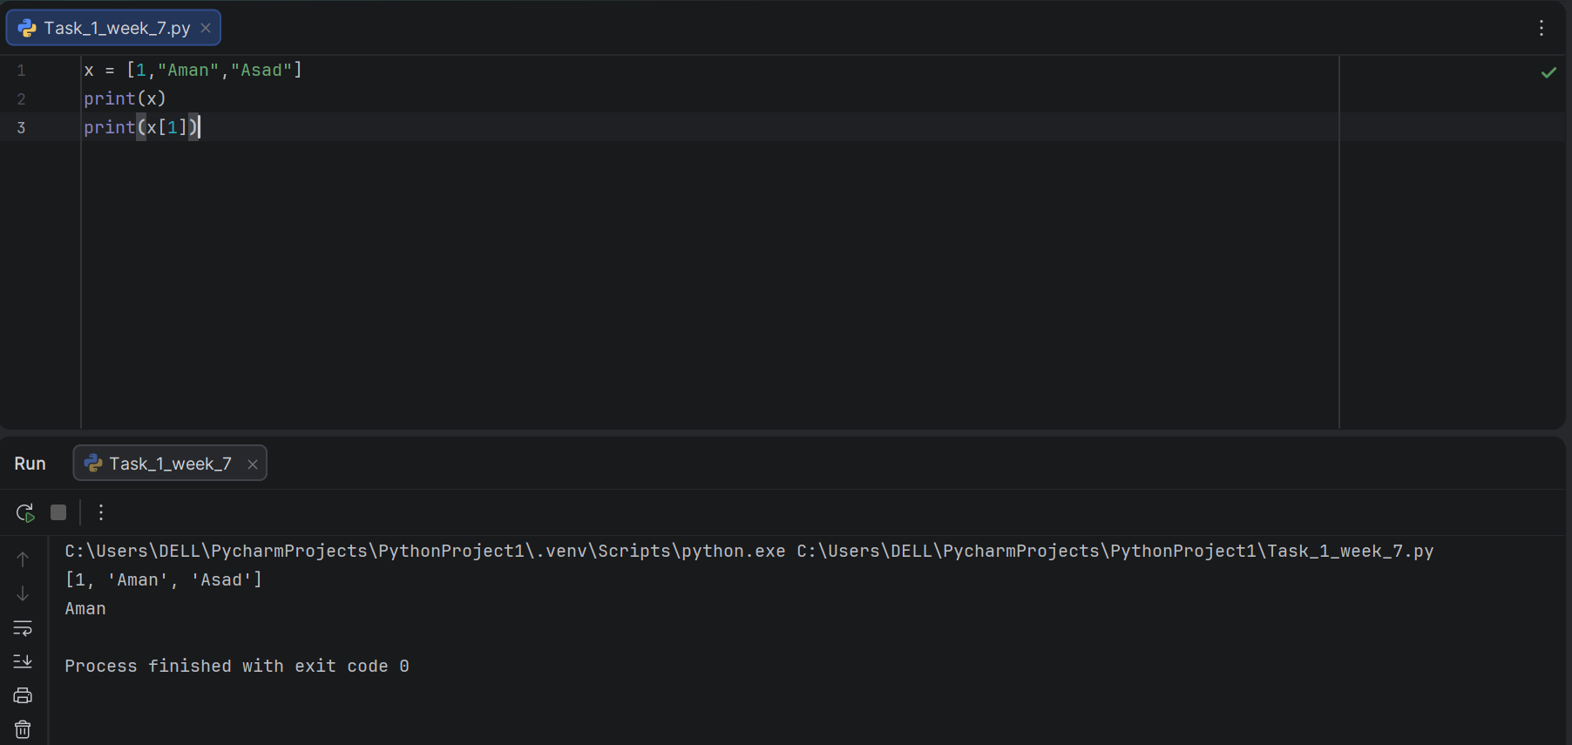
Task 2:
Program to Add an Element to a List Using the Append Method
Result:

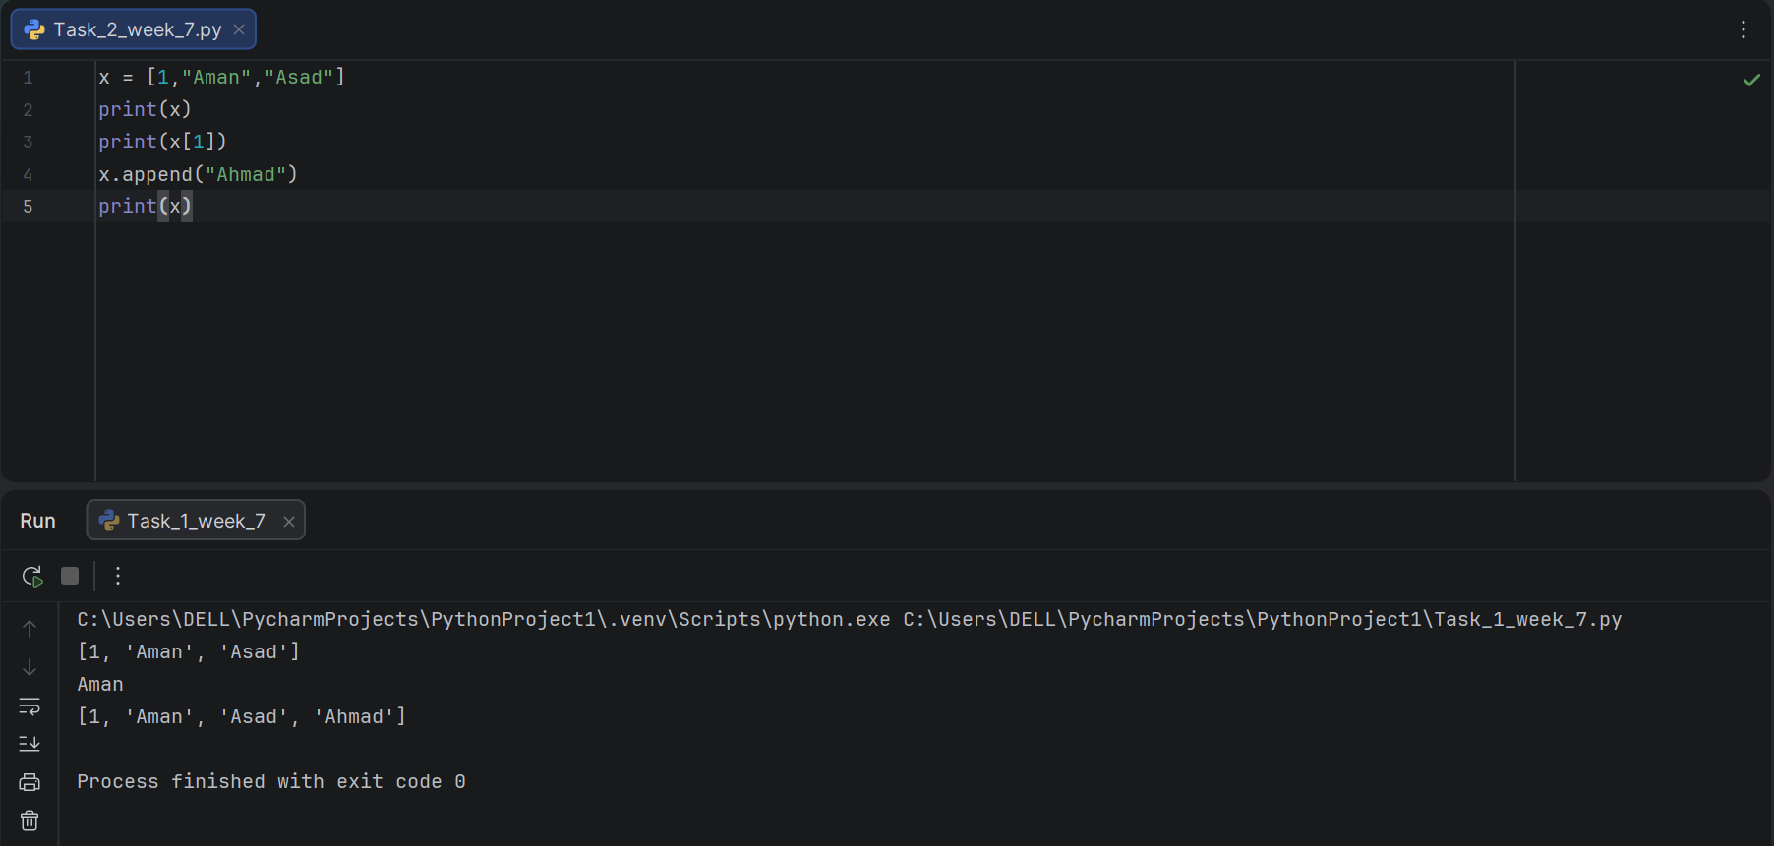

Task 3:
Program to Remove an Element from a List Using the Remove Method

Result:

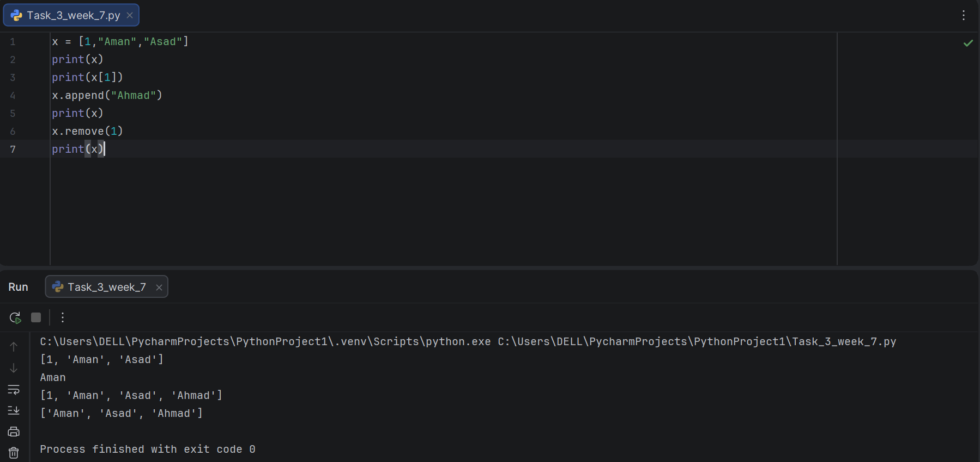

Task 4:
Program to Create a Tuple and Access an Element Using Indexing

Result:

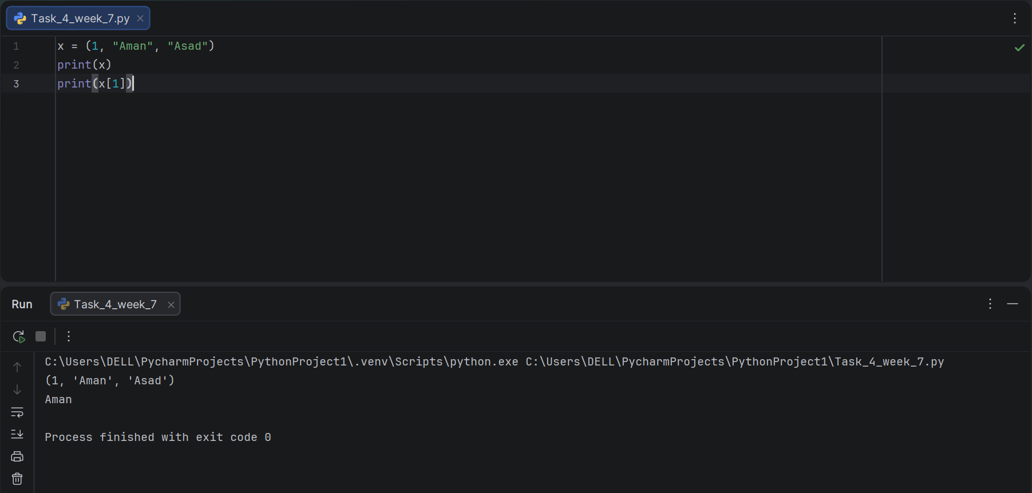

Task 5:
Program to Add an Element to a Tuple by Creating a New Tuple.

Result:

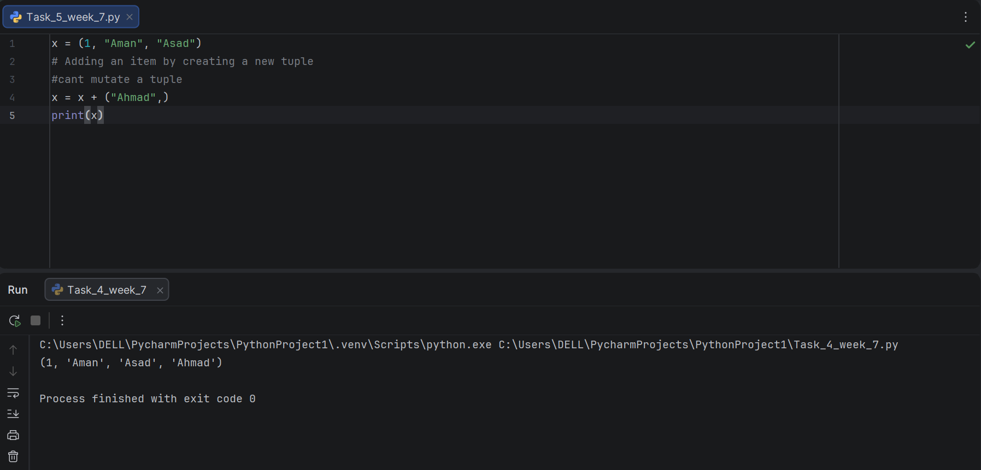

Task 6:
Program to Remove an Element from a Tuple by Converting It to a List

Result:

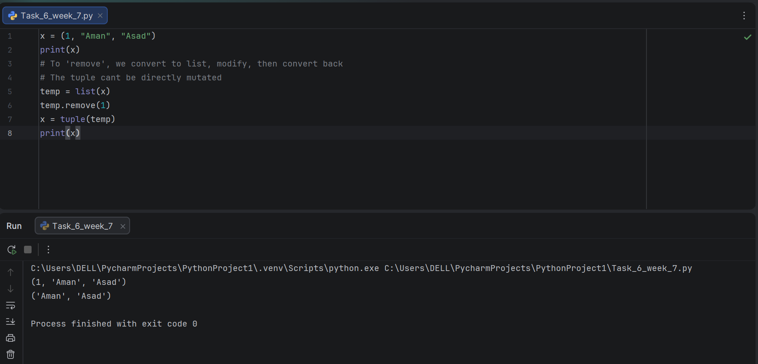

Conclusion:

In this lab, lists and tuples were practically implemented to store and manipulate collections of data in Python. Various operations such as accessing elements through indexing, adding elements, and removing elements were performed on both data structures. It was observed that lists, being mutable, allow direct modification using methods like append() and remove(), whereas tuples, being immutable, require conversion to a list or creation of a new tuple to achieve similar changes. This lab strengthened the understanding of when to use lists versus tuples based on whether data needs to remain fixed or modifiable.

