University Of Engineering and Technology, Lahore
Computer Engineering Department

Course Name: Programming Fundamentals and Data Science | Course Code: CMPE-112L
Assignment Type: | Dated: May 18, 2026
Semester: 1 | Session: Spring 2026
Lab/Project/Assignment #: 1 | CLOs to be covered: CLO
Lab Title: Recursion | Teacher Name: Hafiz Muhammad Mubashar
Lab Evaluation:

CLO2 | Apply appropriate programming techniques to create executable programs to solve well defined problems
 | Level1 | Level2 | Level3 | Level4 | Level5 | Level6
(5)
Total |  |  |  |  |  | /5
Rubrics for Current Lab Evaluation
Scale | Marks | Level | Rubric
Excellent | 5 | L1 | Submitted all lab tasks, BONUS task, have good understanding.
Very Good | 4 | L2 | Submitted the lab tasks but have good understanding
Good | 3 | L3 | Submitted the lab tasks but have weak understanding.
Basic | 2 | L4 | Submitted the lab tasks but have no understanding.
Barely Acceptable | 1 | L5 | Submitted only one lab task.
Not Acceptable | 0 | L6 | Did not attempt
LAB No 10
Lab Goals/Objectives:
Upon successful completion of this lab, students will be able to design, write, and execute recursive functions to solve problems that can be broken down into smaller subproblems.

- Understand the concept of recursion and how a function calls itself.
- Identify the base case and recursive case in a recursive function.
- Implement recursive functions to solve problems such as factorial, sum, and Fibonacci series.
- Compare recursive and iterative approaches to solving the same problem.
- Analyze the risk of infinite recursion and the importance of a proper base case.

Equipment Required:

- Python interpreter (Python 3.x)
- Code editor / IDE (e.g., VS Code, PyCharm)

Theory:

Recursion is a technique in which a function calls itself to solve a problem by breaking it down into smaller subproblems of the same type. Every recursive function must have a base case, which stops the recursion, and a recursive case, which moves the problem toward the base case. Without a proper base case, the function would call itself indefinitely, leading to a stack overflow. Recursion is commonly used for problems like calculating factorials, generating Fibonacci sequences, and traversing tree-like structures.

Lab Work:

Task 1:
Program to Print Countdown from a Number Using Recursion
Result:

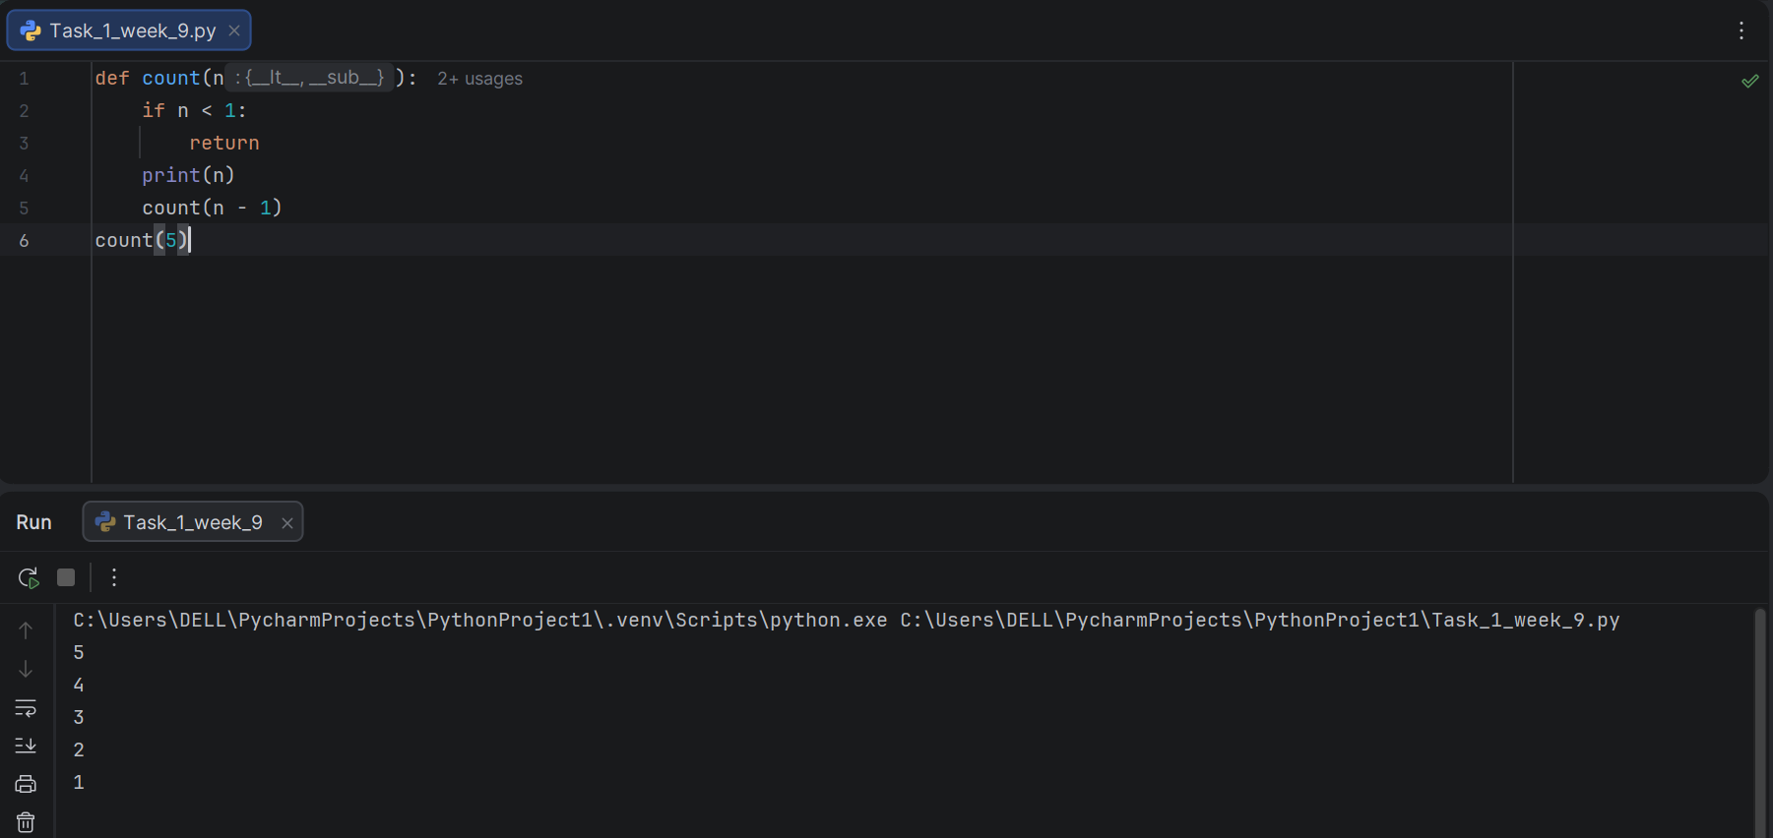

Task 2:
Program to Calculate Sum of First N Natural Numbers Using Recursion
Result:

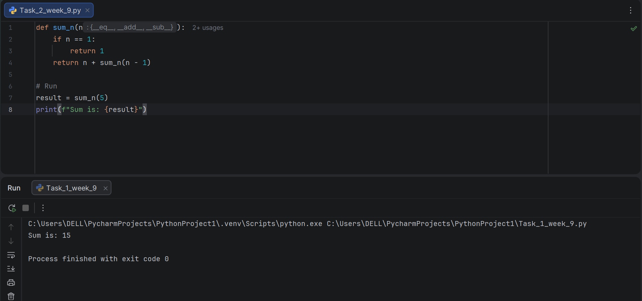

Task 3:
Program to Calculate Factorial of a Number Using Recursion.

Result:

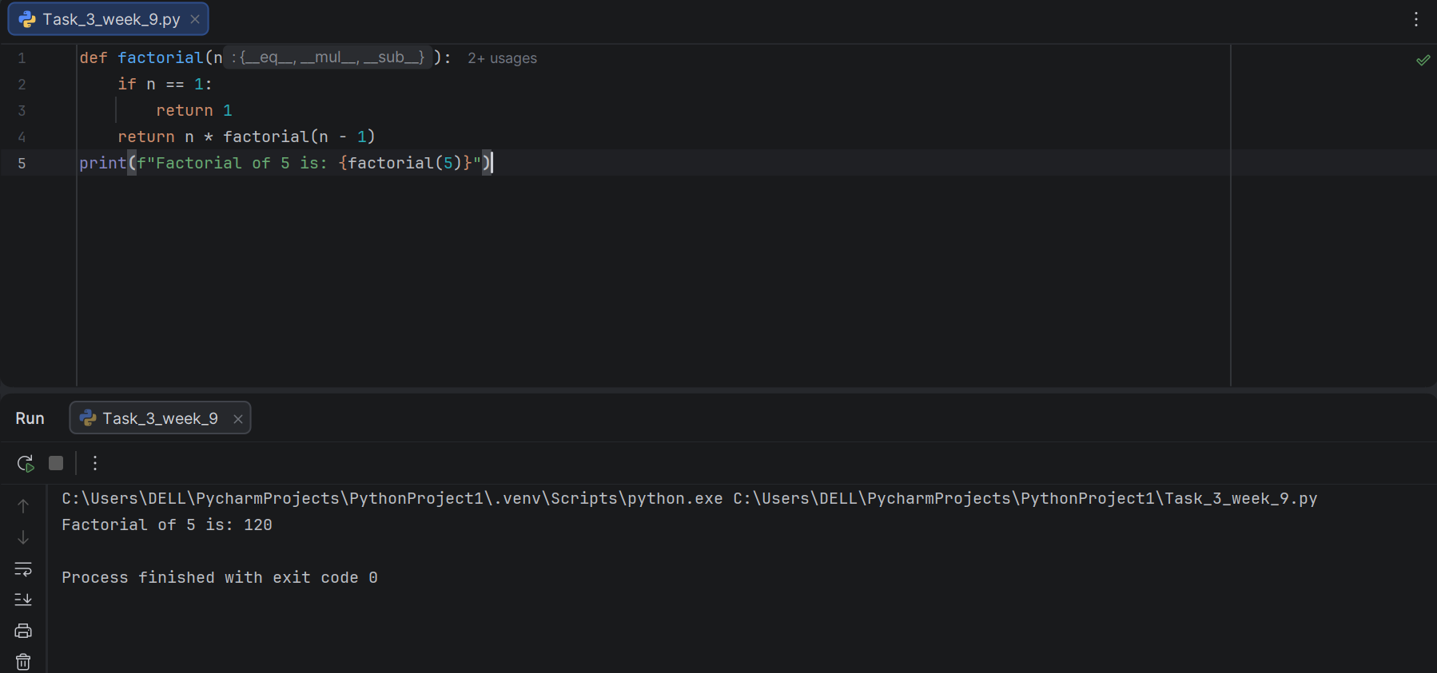

Task 4:
Program to Print a Decreasing Pattern of Stars Using Recursion.

Result:

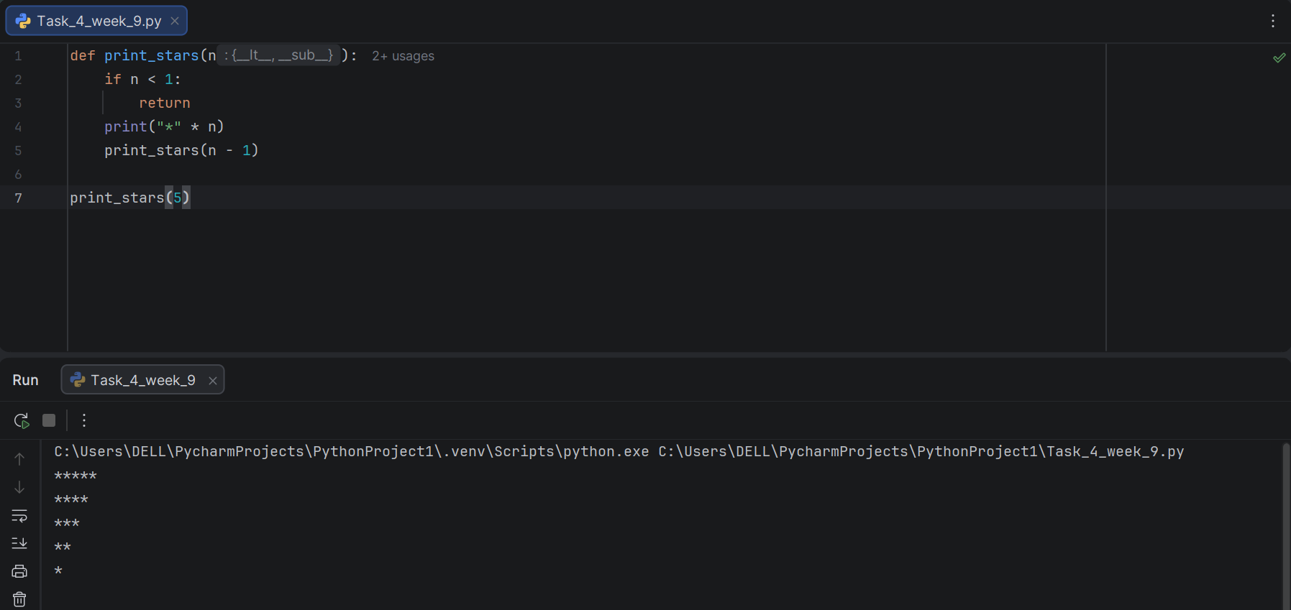

Task 5:
Program to Generate Fibonacci Series Using Recursion.

Result:

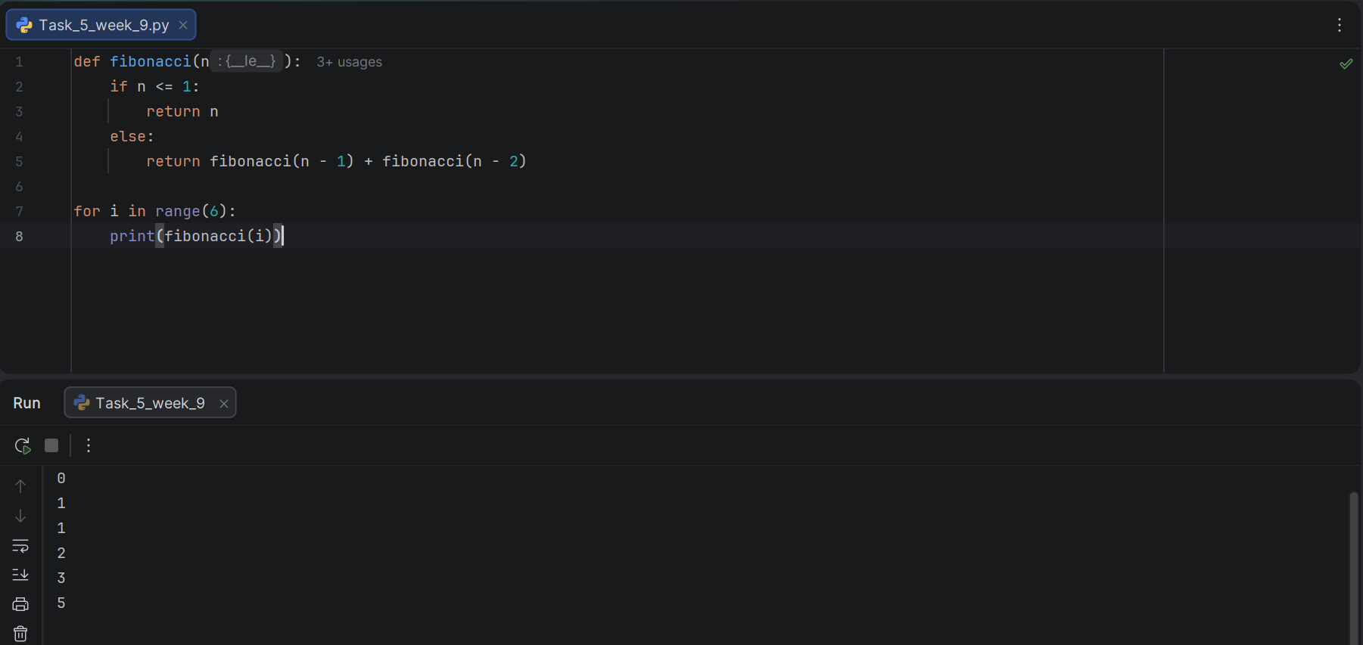

Conclusion:

In this lab, recursion was practically implemented to solve problems by breaking them into smaller subproblems. Recursive functions were used to perform countdowns, calculate sums and factorials, print patterns, and generate the Fibonacci series. Each function relied on a clearly defined base case to terminate the recursive calls, preventing infinite recursion. This lab strengthened the understanding of how recursive logic works and when it offers a cleaner alternative to iterative solutions.

