University Of Engineering and Technology, Lahore
Computer Engineering Department

Course Name: Programming Fundamentals and data science | Course Code: CMPE-112L
Assignment Type: | Dated: February 15, 2026
Semester: 1 | Session: 2026 Spring
Lab/Project/Assignment #: 1 | CLOs to be covered: CLO
Lab Title: Input/Output, Data Types, Operators, Conditional Statements (If/Else) | Teacher Name: Hafiz Muhammad Mubashar
Lab Evaluation:

CLO1 | Input/Output, Data Types, Operators, Conditional Statements (If/Else) |  |  |  |  |  | CLO
 | Level1 | Level2 | Level3 | Level4 | Level5 | Level6
(5)
Total |  |  |  |  |  | /5
Rubrics for Current Lab Evaluation
Scale | Marks | Level | Rubric
Excellent | 5 | L1 | Submitted all lab tasks, BONUS task, have good understanding.
Very Good | 4 | L2 | Submitted the lab tasks but have good understanding
Good | 3 | L3 | Submitted the lab tasks but have weak understanding.
Basic | 2 | L4 | Submitted the lab tasks but have no understanding.
Barely Acceptable | 1 | L5 | Submitted only one lab task.
Not Acceptable | 0 | L6 | Did not attempt
LAB No 1
Lab Goals/Objectives:
• Understand and apply input and output operations to read data from the user and display results on screen.
• Identify and correctly use appropriate data types (int, float, string, boolean, etc.) for storing and manipulating different kinds of values.
• Apply arithmetic, relational, and logical operators to perform calculations and comparisons within a program.
• Construct conditional statements (if, if-else, if-elif-else) to implement decision-making logic based on given conditions.
• Analyze a given problem and translate it into a working program using a combination of I/O, data types, operators, and conditionals.

Equipment Required:
• Python interpreter (Python 3.x)
• Code editor / IDE (e.g., VS Code, PyCharm)

Theory:
- Input/Output (I/O) allows a program to take data from the user (input()) and display results (print()).
- Data Types define the kind of value stored in a variable — common types include int, float, str, and bool.
- Operators perform actions on values: arithmetic (+, -, *, /), relational (==, >, <), and logical (and, or, not).
- Conditional Statements (if, if-else, if-elif-else) let a program make decisions and execute different code based on whether a condition is True or False.
- Together, these concepts let a programmer write basic interactive and decision-making programs.

Lab Work:

Task 1:
Program to Demonstrate Addition of Two Integer Variables

Result:

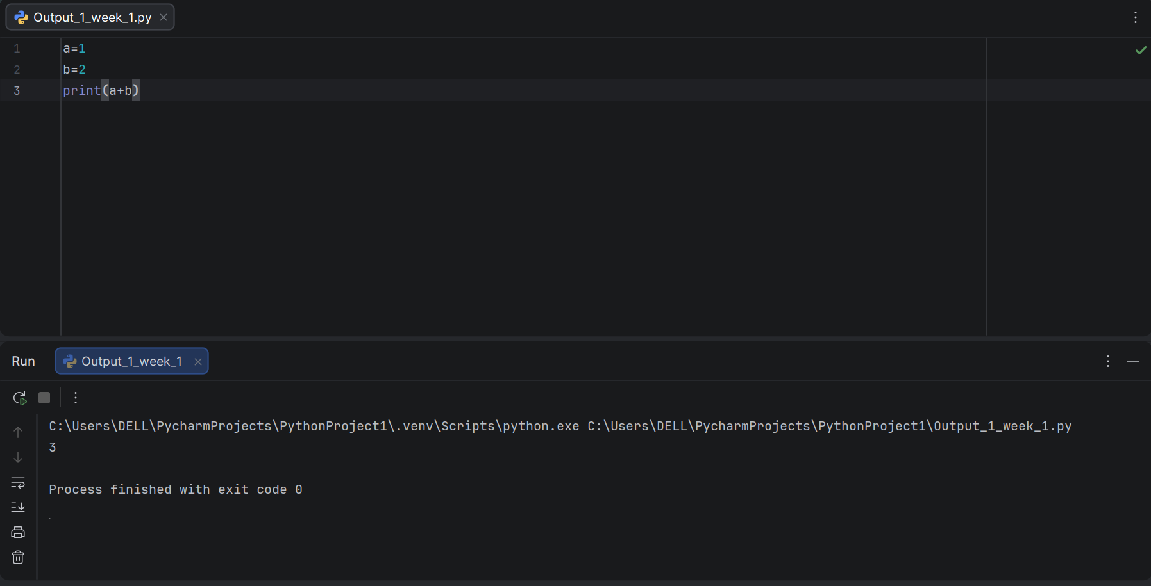

Task 2:
Program to Demonstrate String Concatenation and Data Type Coercion
Result:

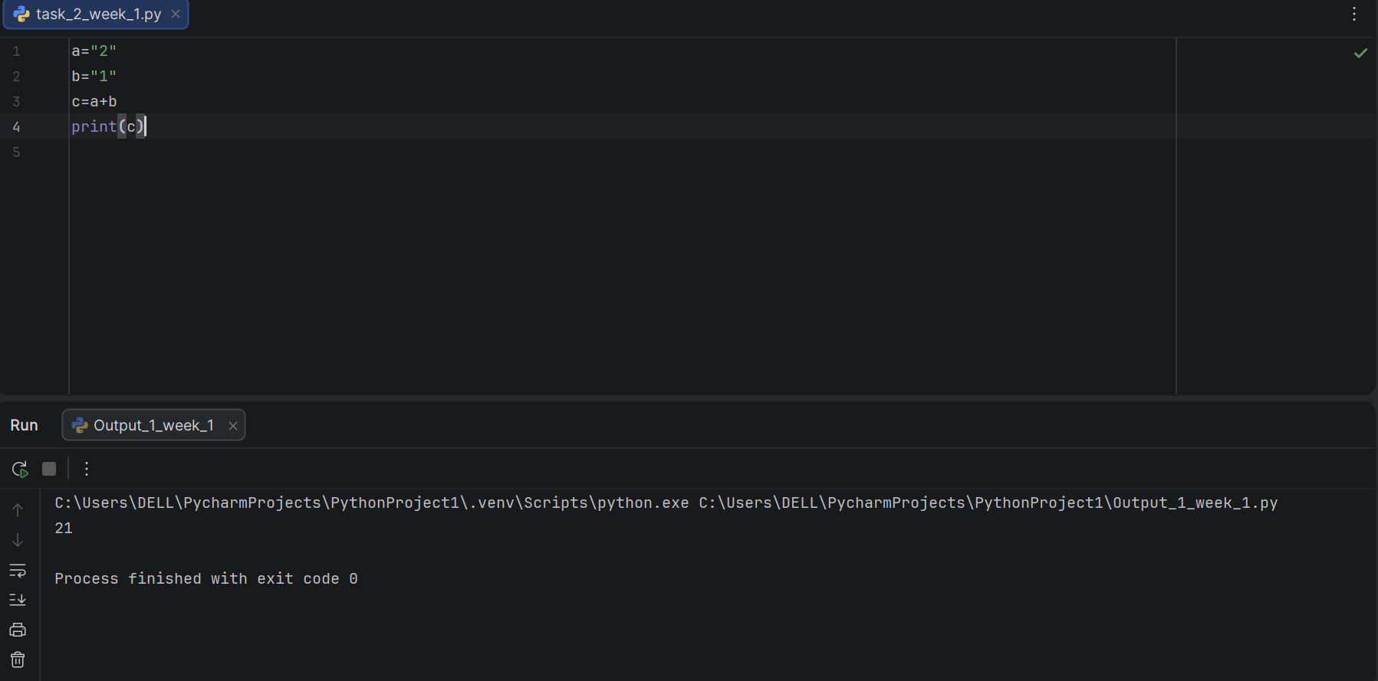
Task 3:
Program to Demonstrate Explicit Type Conversion (String to Integer)

Result:

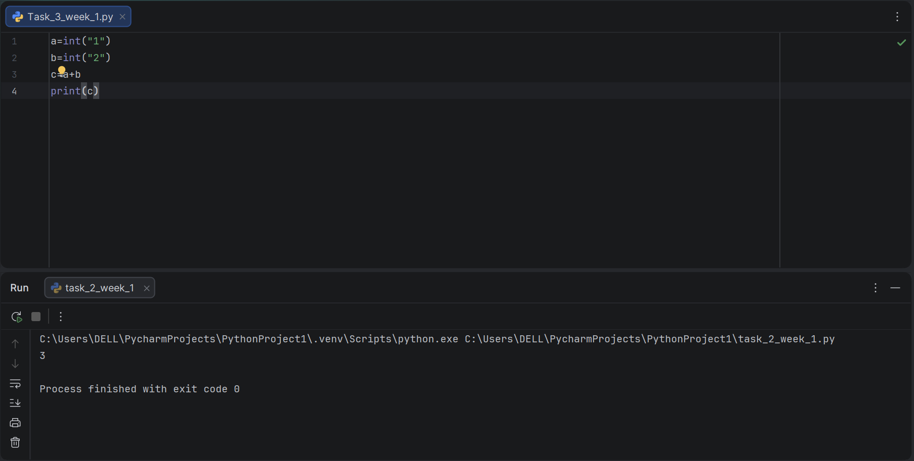

Task 4:
Program to Add Two Numbers Entered by the User (Input/Output)

Result:

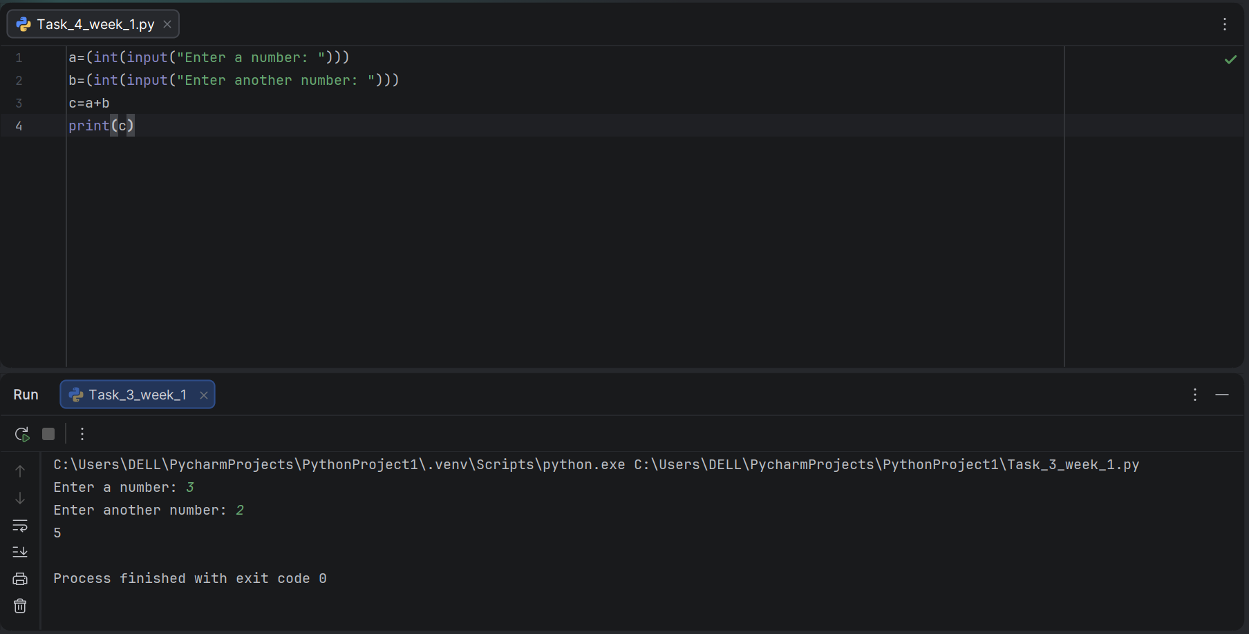
Task 5:
Program to Calculate Percentage Using Input/Output Operations

Result:

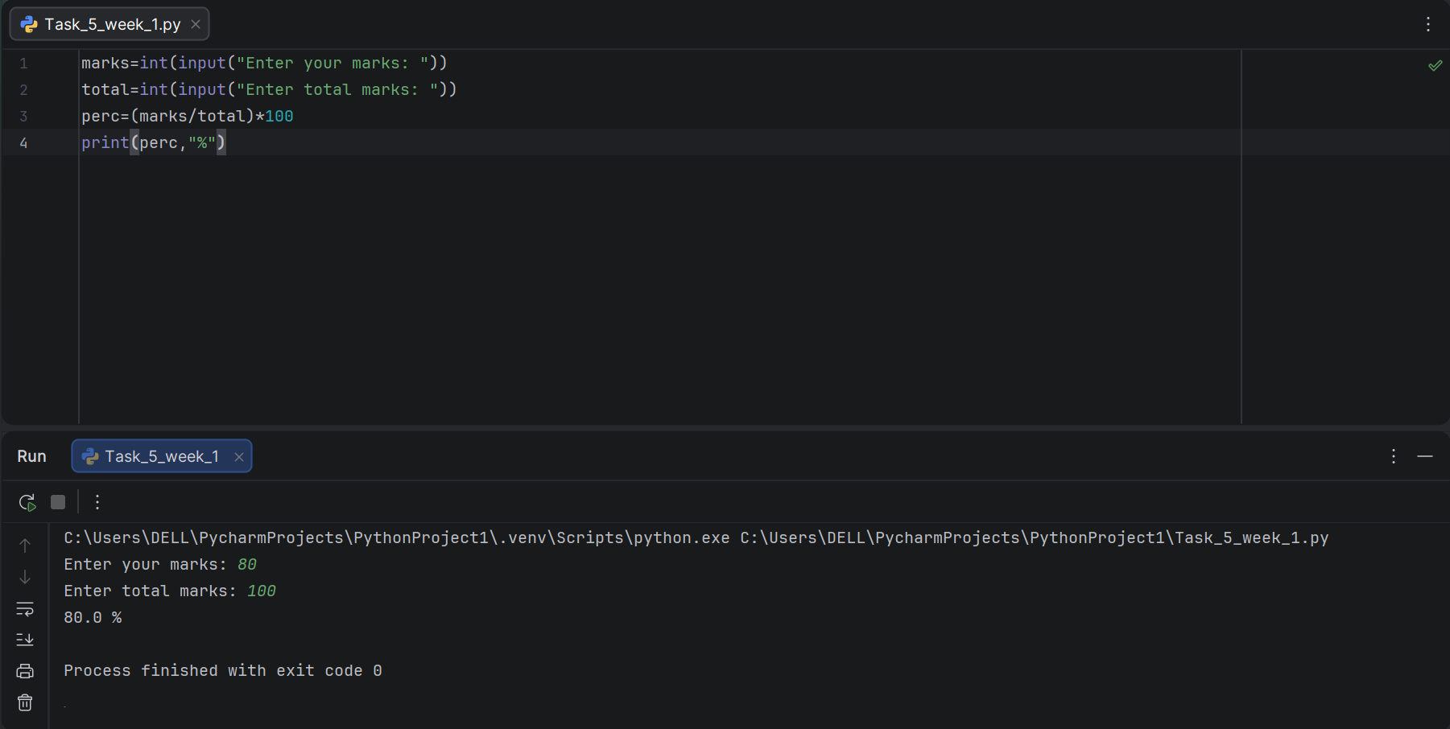

Task 6:
Program to Determine Grade Using Conditional Statements (If/Elif/Else)

Result:

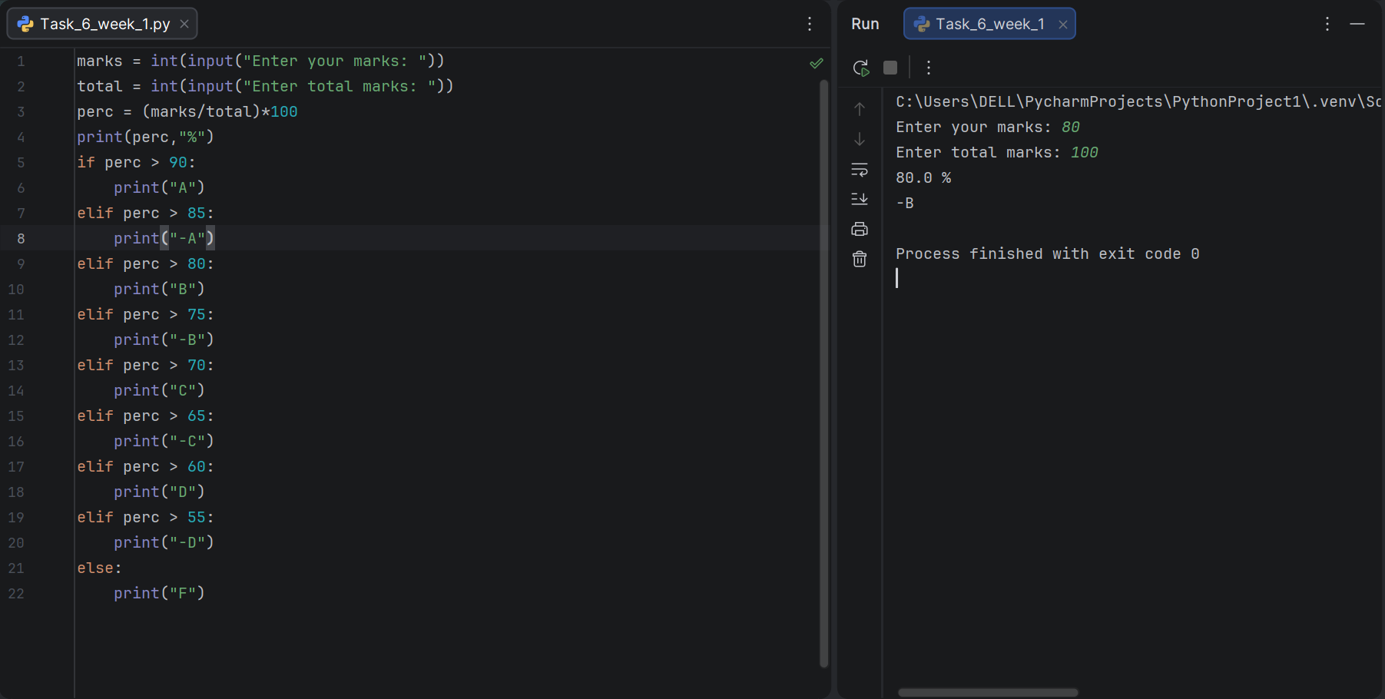

Conclusion:

In this lab, fundamental programming concepts including Input/Output operations, Data Types, Operators, and Conditional Statements were practically implemented using Python. Through various tasks, basic arithmetic operations, type conversion, user input handling, percentage calculation, and decision-making using if-elif-else structures were performed. This lab helped in building a strong understanding of how data is taken, processed, and used to make logical decisions within a program, which forms the foundation for writing more advanced and efficient code in the future.

