University Of Engineering and Technology, Lahore
Computer Engineering Department

Course Name: Programming Fundamentals and data science | Course Code: CMPE-112L
Assignment Type: | Dated: March 23, 2026
Semester: 1 | Session: Spring 2026
Lab/Project/Assignment #: 1 | CLOs to be covered: CLO
Lab Title: Nested loops | Teacher Name: Hafiz Muhammad Mubashar
Lab Evaluation:

CLO1 | Apply appropriate programming techniques to create executable programs to solve well defined problems
 | Level1 | Level2 | Level3 | Level4 | Level5 | Level6
(5)
Total |  |  |  |  |  | /5
Rubrics for Current Lab Evaluation
Scale | Marks | Level | Rubric
Excellent | 5 | L1 | Submitted all lab tasks, BONUS task, have good understanding.
Very Good | 4 | L2 | Submitted the lab tasks but have good understanding
Good | 3 | L3 | Submitted the lab tasks but have weak understanding.
Basic | 2 | L4 | Submitted the lab tasks but have no understanding.
Barely Acceptable | 1 | L5 | Submitted only one lab task.
Not Acceptable | 0 | L6 | Did not attempt
LAB No 4
Lab Goals/Objectives:
Upon successful completion of this lab, students will be able to design, write, and execute programs using nested for and while loops to solve multi-level repetitive problems.

- Understand the concept and working of nested loops (loop within a loop).
- Implement nested for loops and nested while loops to solve pattern-based problems.
- Combine for and while loops together to handle complex iteration scenarios.
- Analyze the relationship between outer and inner loop execution and control flow.
- Apply nested loops to generate patterns, matrices, and multi-level data processing tasks.

Equipment Required:

- Python interpreter (Python 3.x)
- Code editor / IDE (e.g., VS Code, PyCharm)

Theory:

Nested loops refer to a loop placed inside another loop, where the inner loop completes all its iterations for each single iteration of the outer loop. This structure is commonly used to solve problems involving multi-dimensional data, patterns, and grids. Both for and while loops can be nested independently or combined (e.g., a while loop inside a for loop), depending on the problem requirement. Understanding the execution order of nested loops is essential, as the inner loop runs completely before the outer loop proceeds to its next iteration.

Lab Work:

Task 1:
Program to Print a Right-Angled Triangle Pattern of Stars Using Nested For Loops
Result:

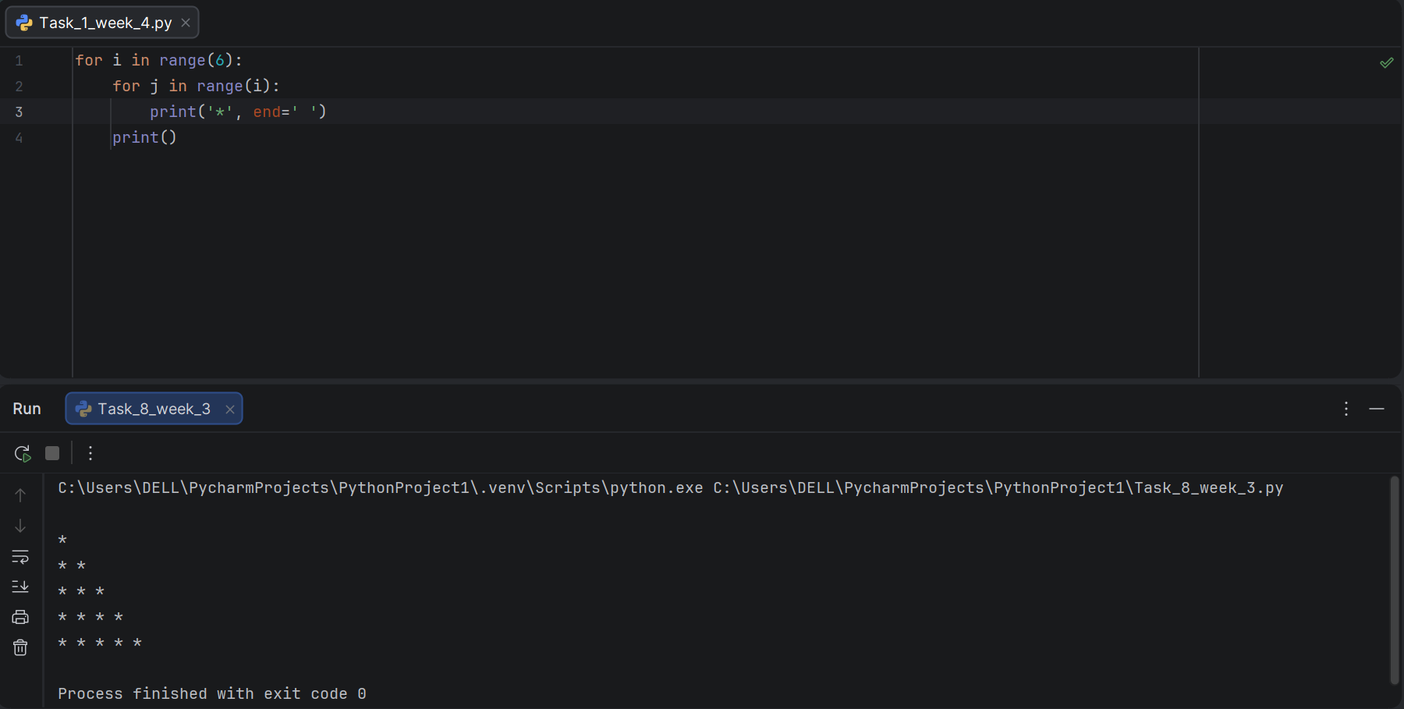

Task 2:
Program to Print a Right-Angled Triangle Pattern of Stars (Range 1–5) Using Nested For Loops
Result:

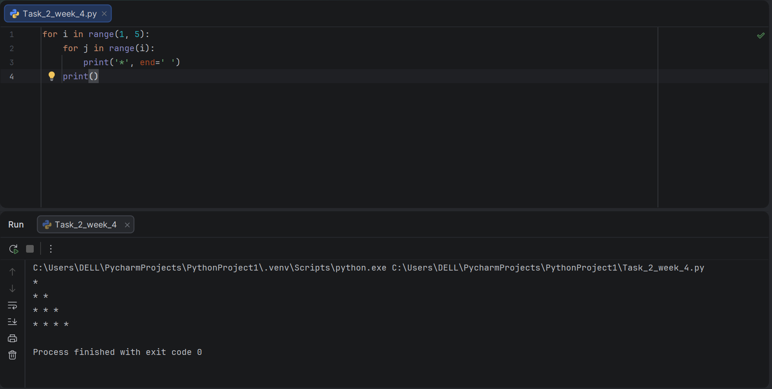
Task 3:
Program to Display Outer and Inner Loop Variable Values Using Nested For Loops.

Result:

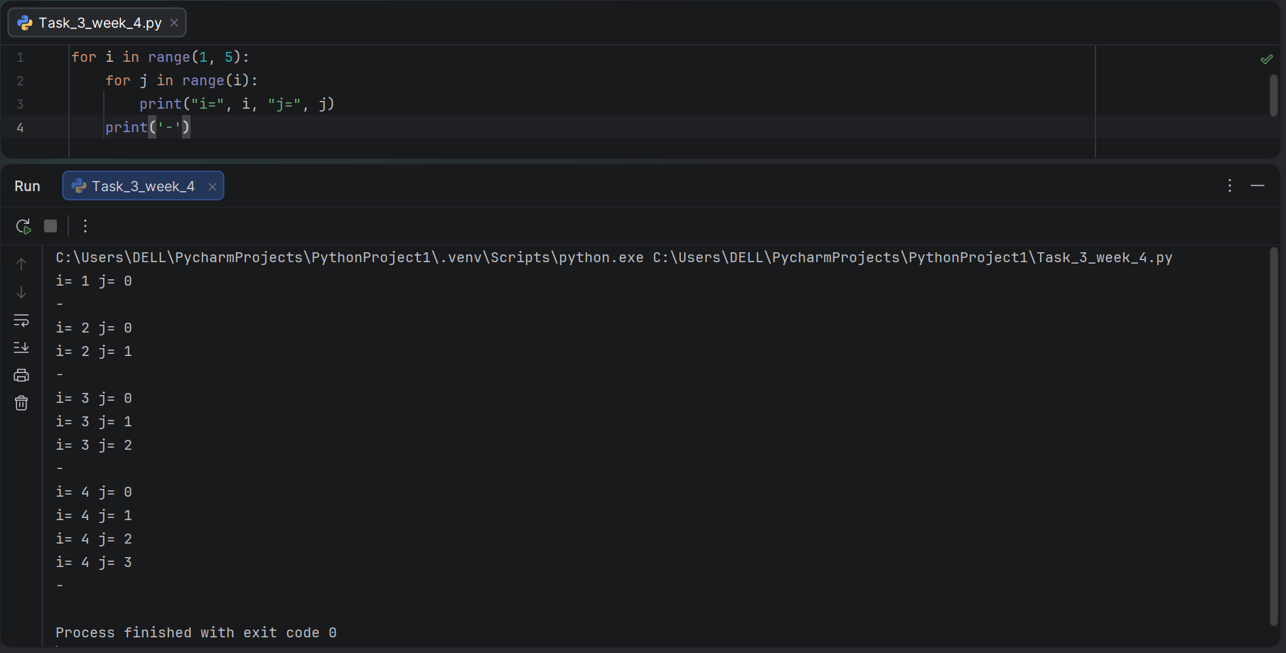

Task 4:
Program to Display Coordinate Pairs (i, j) Using Nested For Loops.

Result:

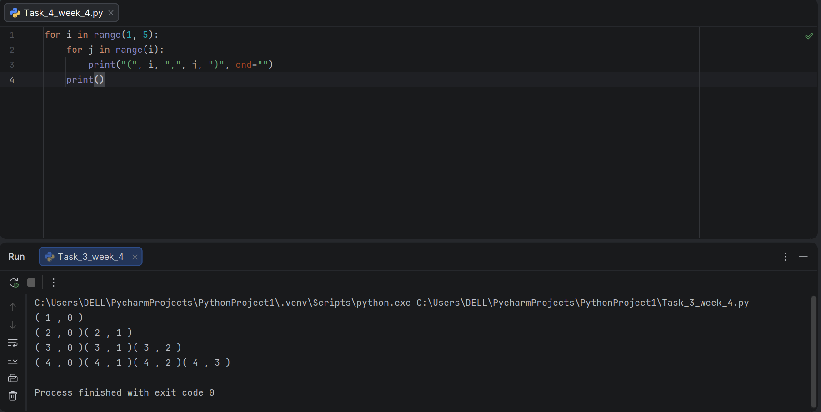
Task 5:
Program to Print Number Pattern in Single-Column Format Using Nested For Loops.

Result:

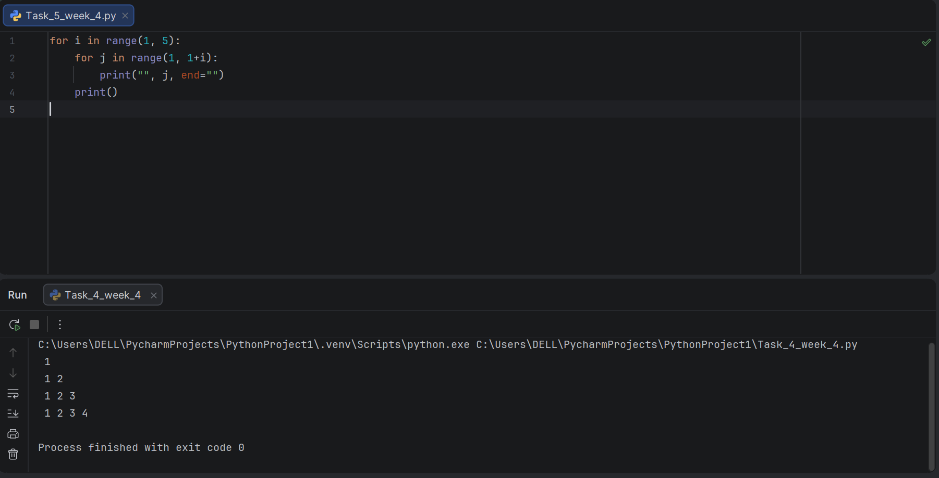

Task 6:
Program to Print Number Pattern with Repeated Outer Loop Value Using Nested For Loops.

Result:

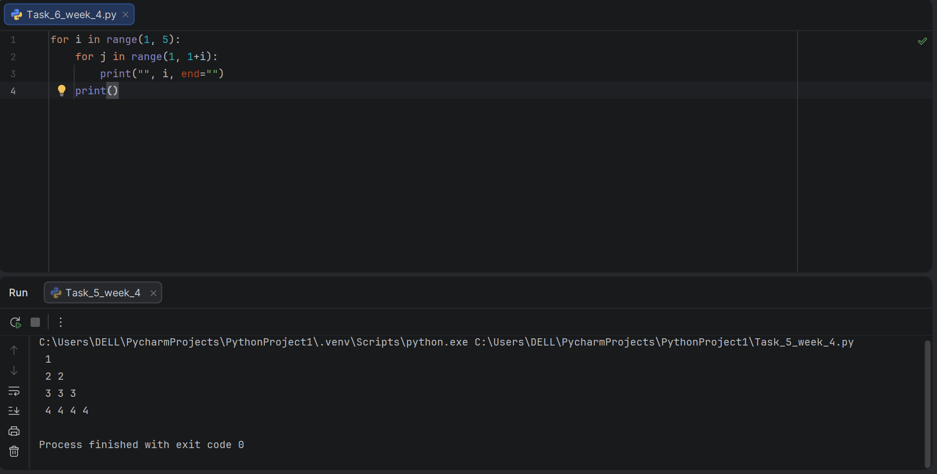
Task 7:
Program to Print Inverted Star and Number Combined Pattern Using Nested For Loops.

Result:

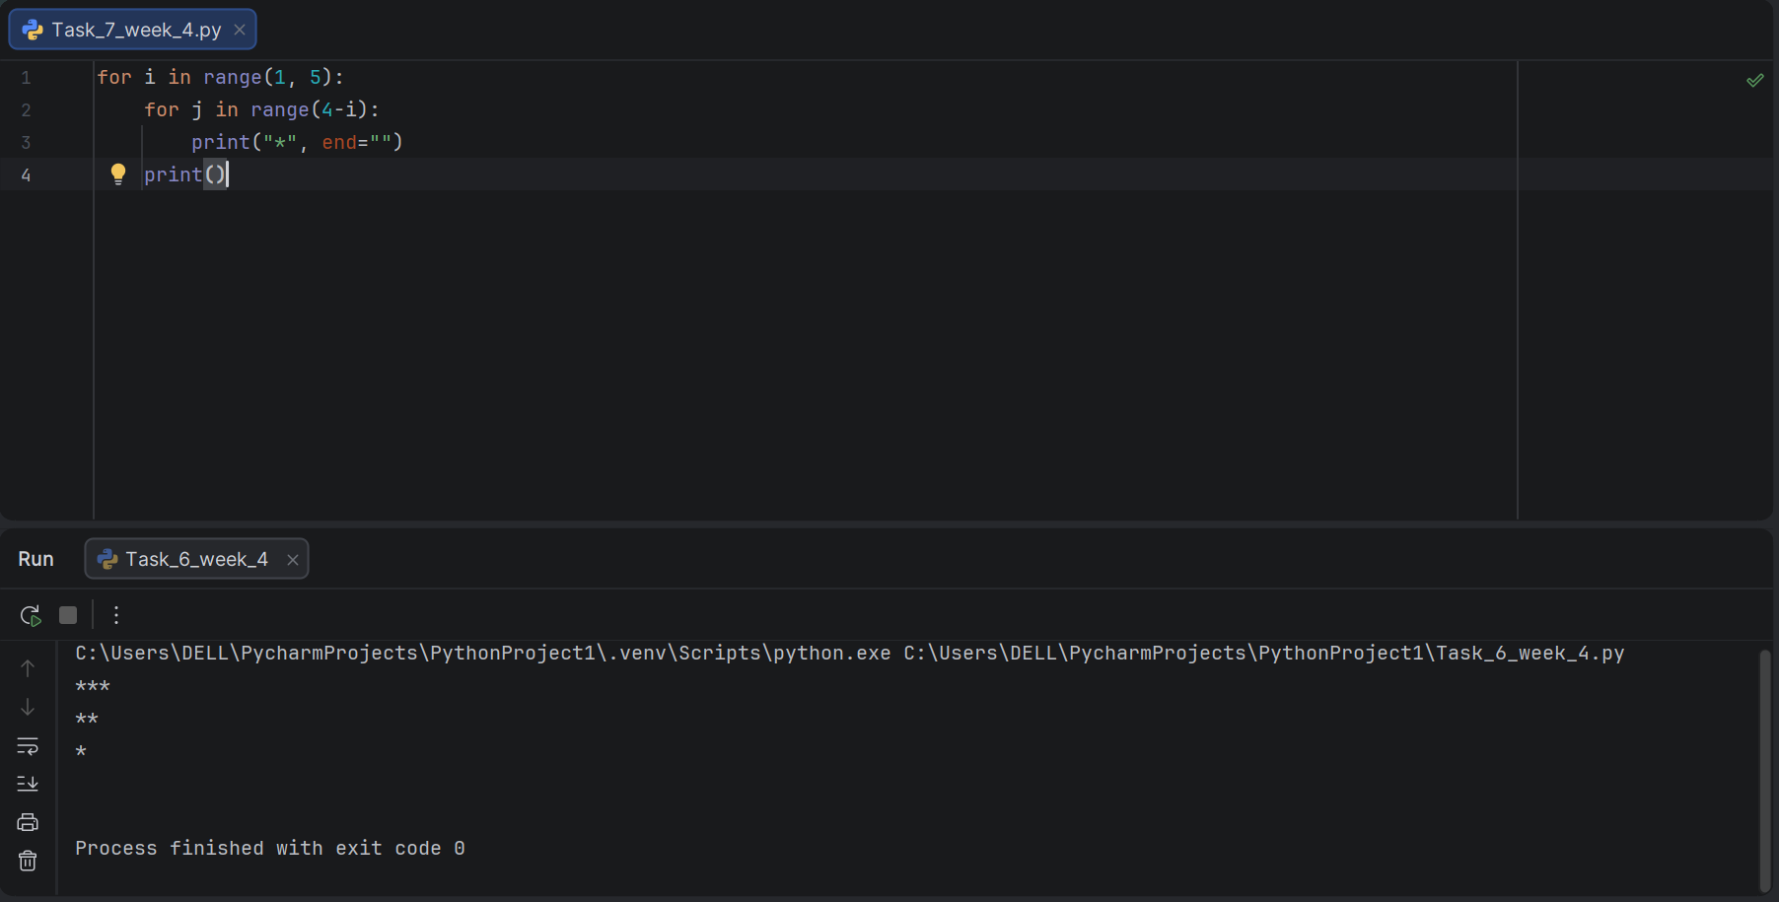

Task 8:
Program to Print Star and Number Combined Pattern (Increasing) Using Nested For Loops.

Result:

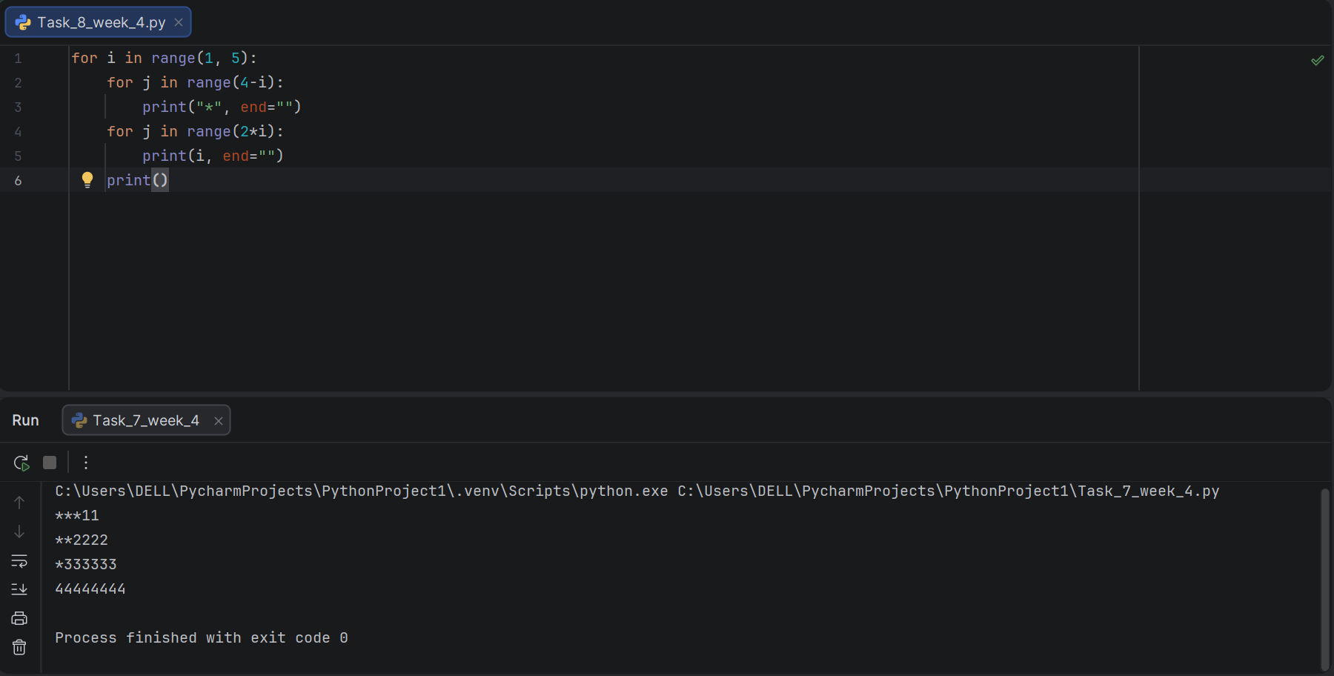

Task 9:
Program to Print Symmetric Star-Number-Star Pattern Using Nested For Loops.

Result:

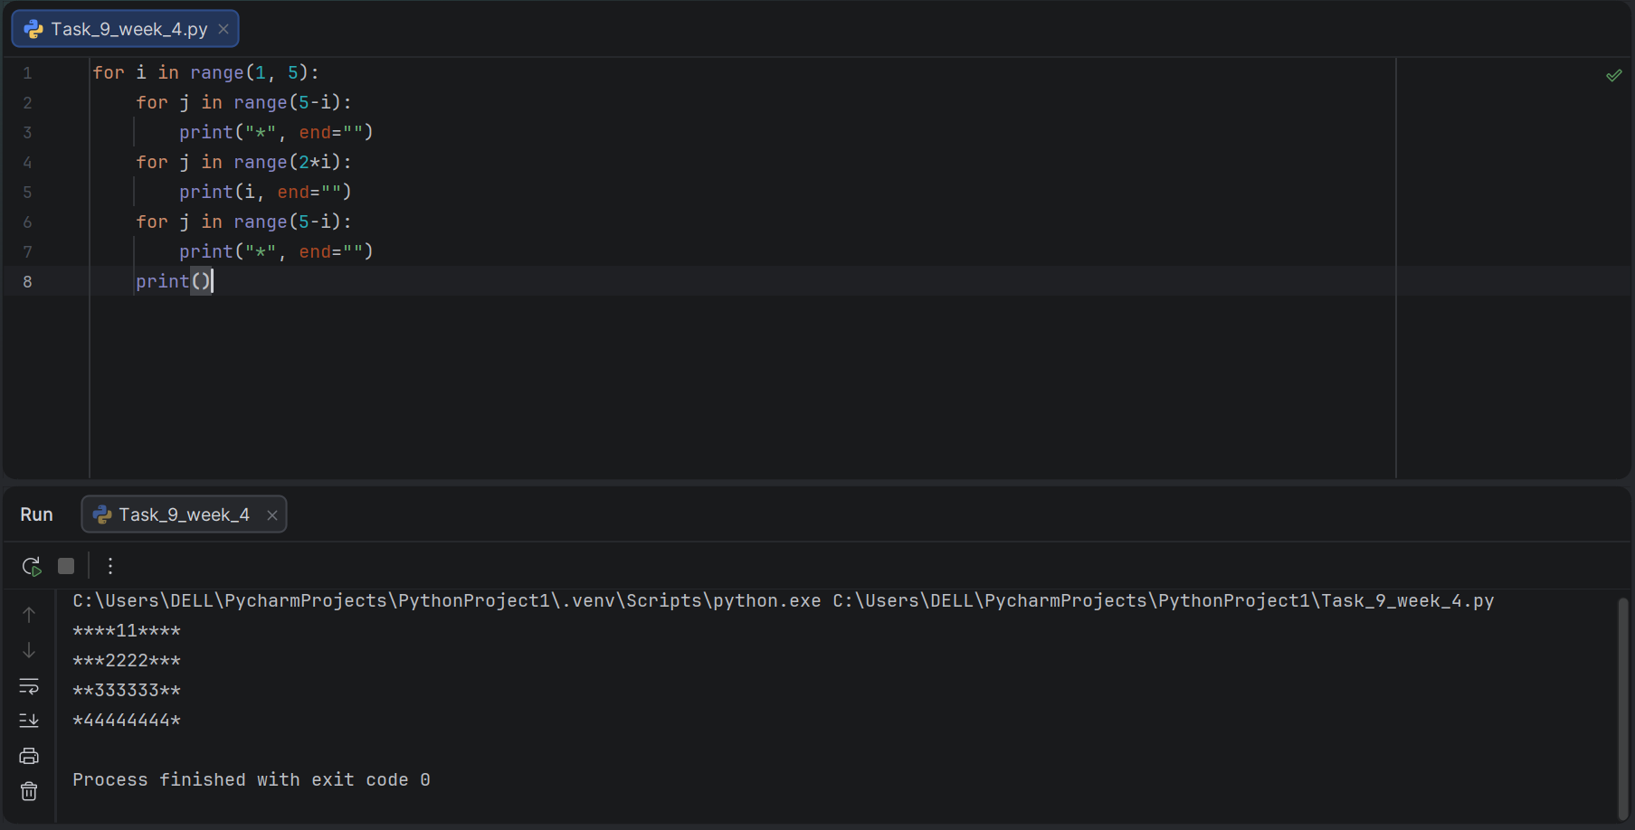

Task 10:
Program to Print a Left-Aligned Triangle Pattern of Stars Using Nested For Loops.

Result:

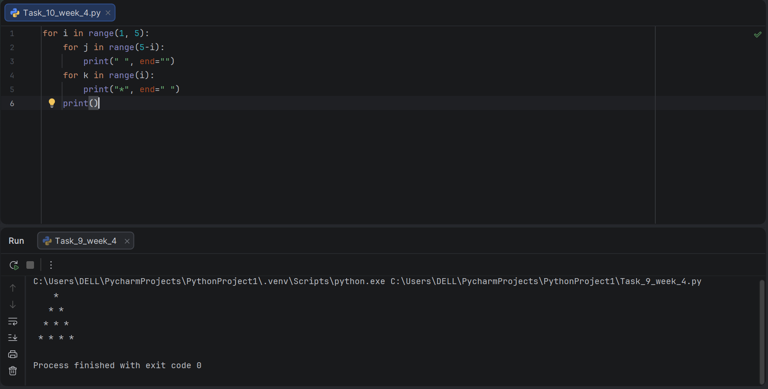

Task 11:
Program to Print a Larger Left-Aligned Triangle Pattern of Stars Using Nested For Loops.

Result:

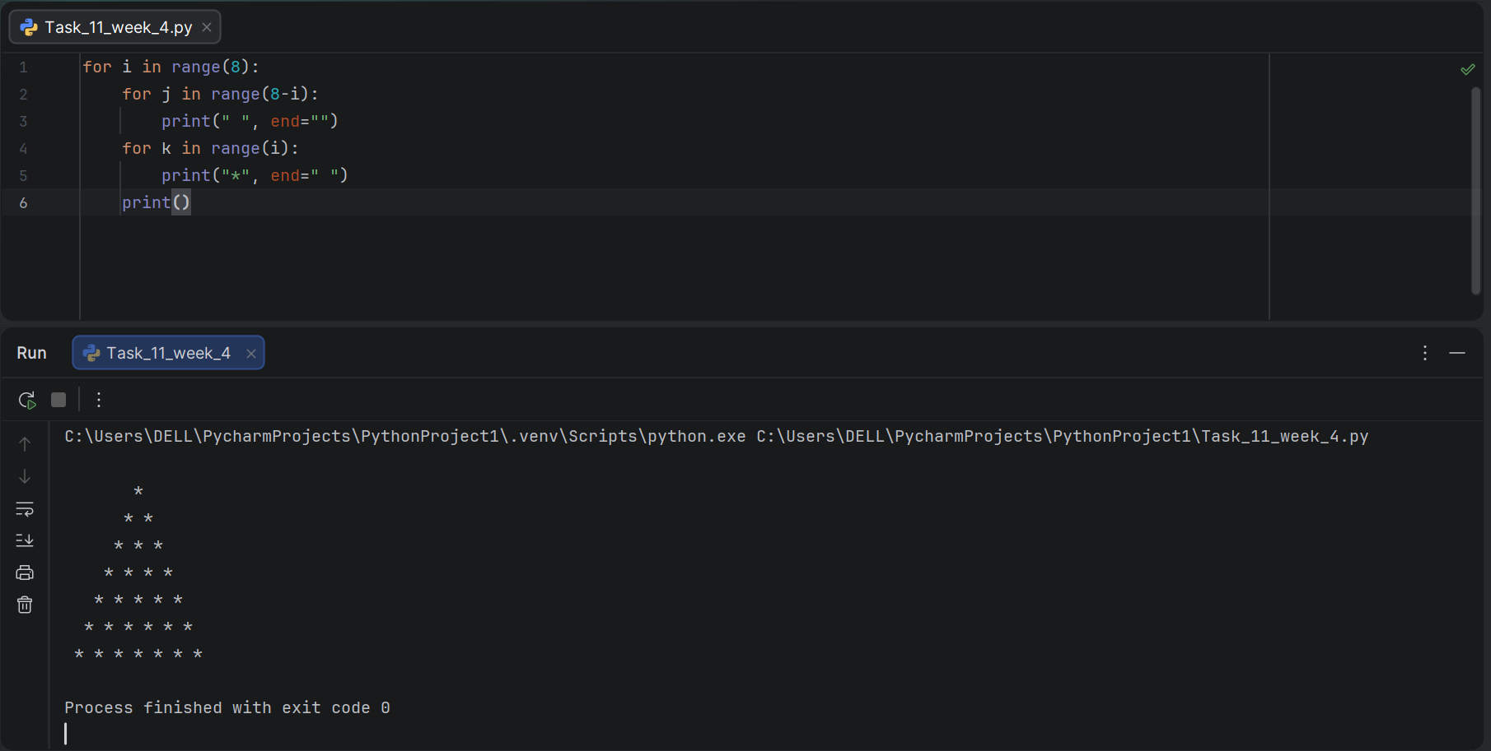

Task 12:
Program to Print a Left-Aligned Triangle Pattern of Stars Using Nested While Loops.

Result:

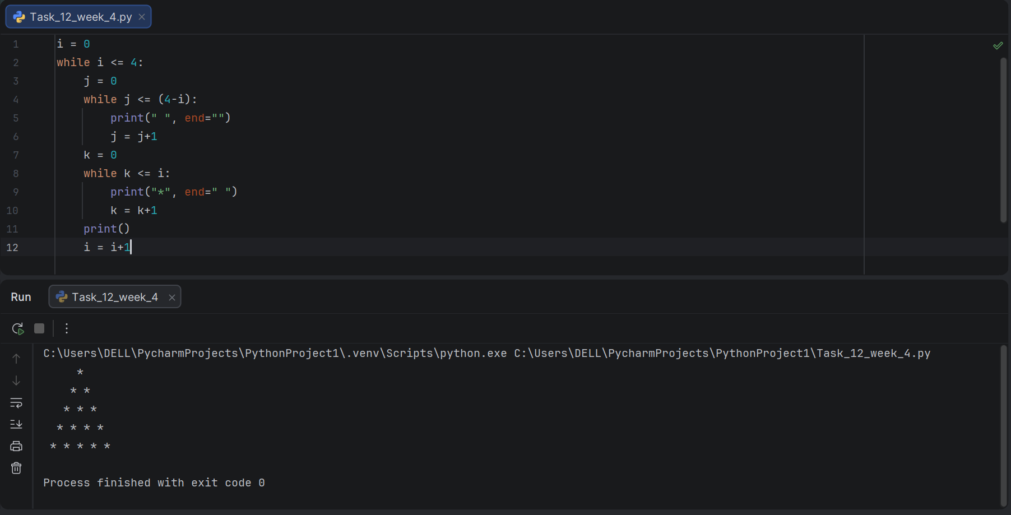

Task 13:
Program to Print a Symmetric Diamond/Triangle Pattern Combining Stars and Spaces Using Nested While Loops.

Result:

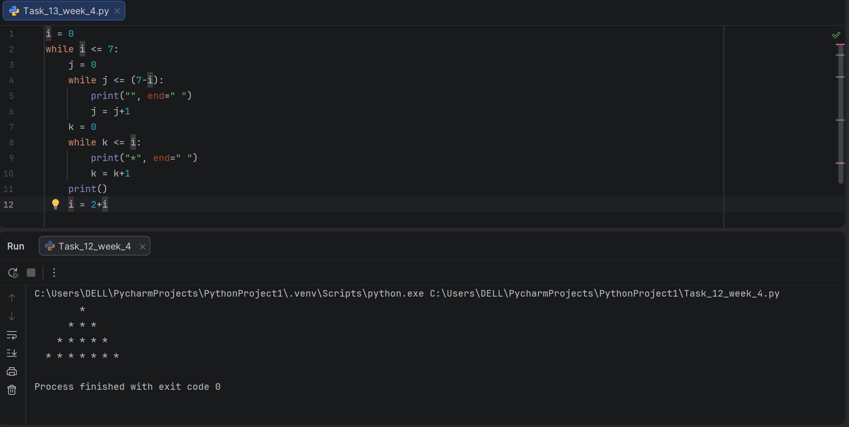

Conclusions:

In this lab, nested for and while loops were practically implemented to solve multi-level repetitive problems in Python. Various star, number, and combined patterns were generated by placing loops inside loops, along with coordinate pair displays and symmetric pattern formations. This lab strengthened the understanding of how outer and inner loops interact, with the inner loop completing all iterations before the outer loop advances, forming the basis for solving more complex, multi-dimensional programming problems.

