University Of Engineering and Technology, Lahore
Computer Engineering Department

Course Name: Programming Fundamentals and data science | Course Code: CMPE-112L
Assignment Type: | Dated: May 04, 2026
Semester: 1 | Session: Spring 2026
Lab/Project/Assignment #: 1 | CLOs to be covered: CLO
Lab Title: Sets, Dictionary | Teacher Name: Hafiz Muhammad Mubashar
Lab Evaluation:

CLO3 | Apply appropriate programming techniques to create executable programs to solve well defined problems
 | Level1 | Level2 | Level3 | Level4 | Level5 | Level6
(5)
Total |  |  |  |  |  | /5
Rubrics for Current Lab Evaluation
Scale | Marks | Level | Rubric
Excellent | 5 | L1 | Submitted all lab tasks, BONUS task, have good understanding.
Very Good | 4 | L2 | Submitted the lab tasks but have good understanding
Good | 3 | L3 | Submitted the lab tasks but have weak understanding.
Basic | 2 | L4 | Submitted the lab tasks but have no understanding.
Barely Acceptable | 1 | L5 | Submitted only one lab task.
Not Acceptable | 0 | L6 | Did not attempt
LAB No 8
Lab Goals/Objectives:
Upon successful completion of this lab, students will be able to design, write, and execute programs using sets and dictionaries to store and manage unique and key-value based data.

- Understand the concept, syntax, and properties of sets and dictionaries in Python.
- Differentiate between sets (unordered, unique elements) and dictionaries (key-value pairs).
- Apply built-in set operations such as union, intersection, and difference.
- Use dictionary methods to add, update, access, and remove key-value pairs.
- Apply sets and dictionaries to solve problems involving unique data storage and structured data mapping.

Equipment Required:

- Python interpreter (Python 3.x)
- Code editor / IDE (e.g., VS Code, PyCharm)

Theory:

A set is an unordered collection of unique elements, meaning duplicate values are automatically removed, and it supports operations like union, intersection, and difference.
A dictionary is a collection of key-value pairs, where each key is unique and used to access its corresponding value efficiently. Unlike lists and tuples, dictionaries do not rely on numeric indexing but instead use keys for accessing data. Both sets and dictionaries are widely used for handling data that requires uniqueness or structured mapping between related values.

Lab Work:

Task 1:
Program to Access and Update Values in a Dictionary Using Keys
Result:

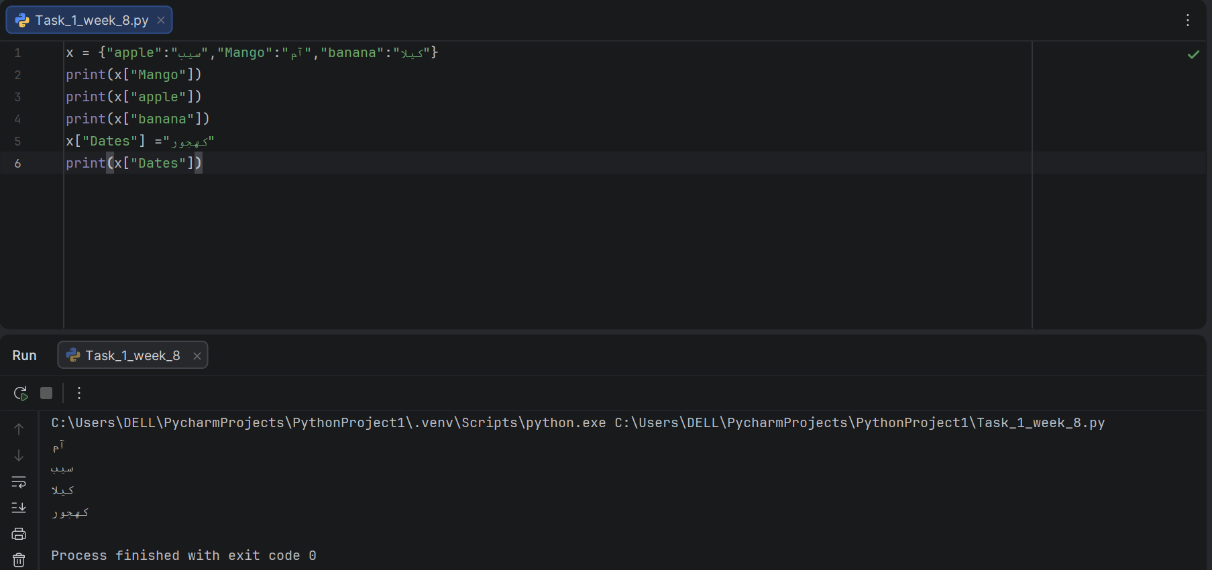

Task 2:
Program to Calculate Total Price Using Dictionary Values.
Result:

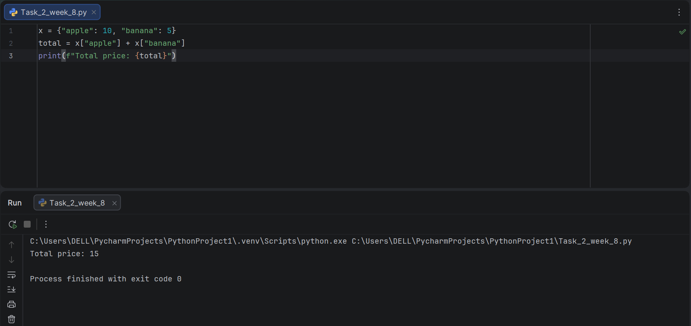

Task 3:
Program to Display Student Information Using a Dictionary.

Result:

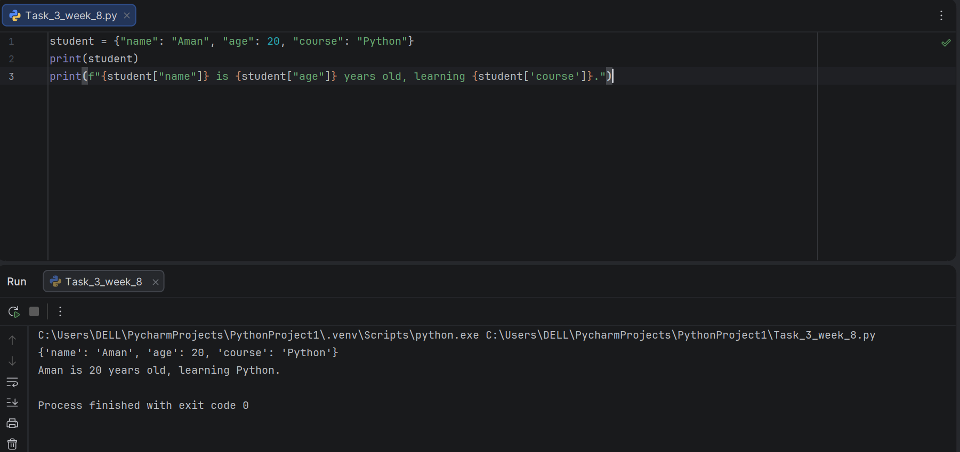

Task 4:

Program to Check if a Value Exists in a Set Using User Input.

Result:

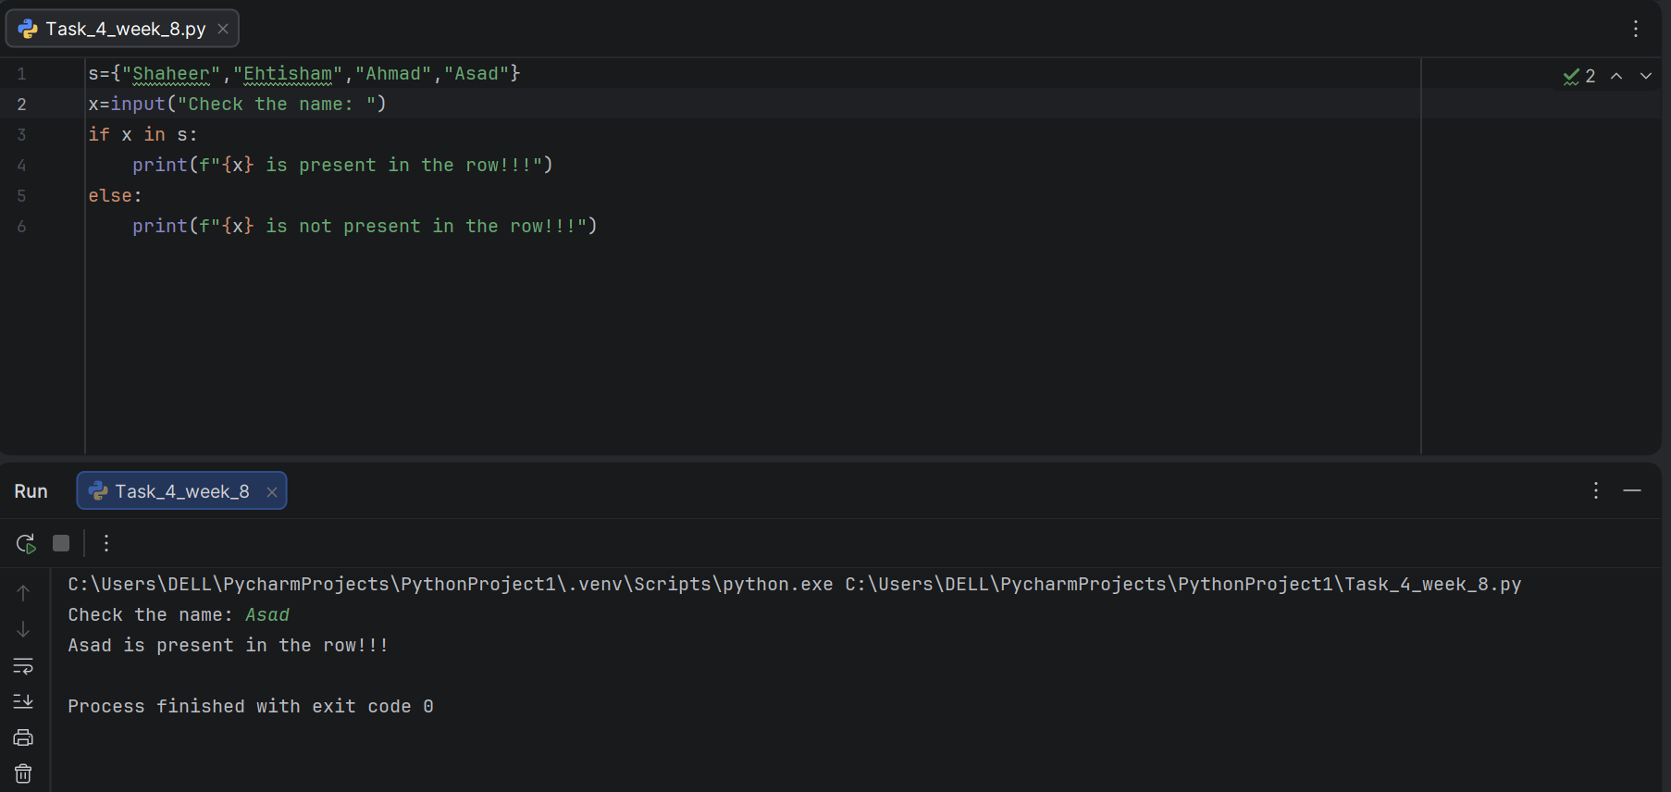

Task 5:

Program to Add and Remove Elements from a Set Using add(), discard(), remove(), pop(), and clear().

Result:

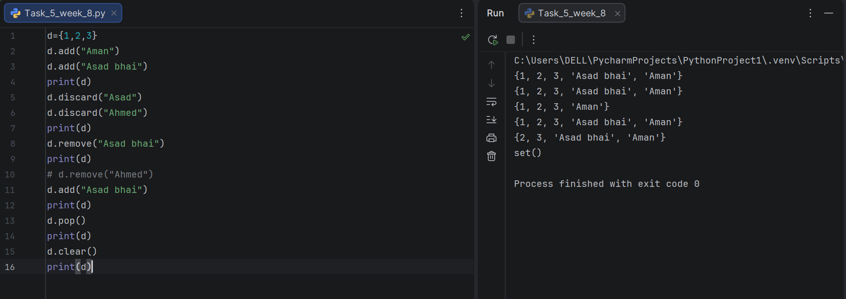

Task 6:
Program to Find the Union of Two Sets Using the set.union() Method.

Result:

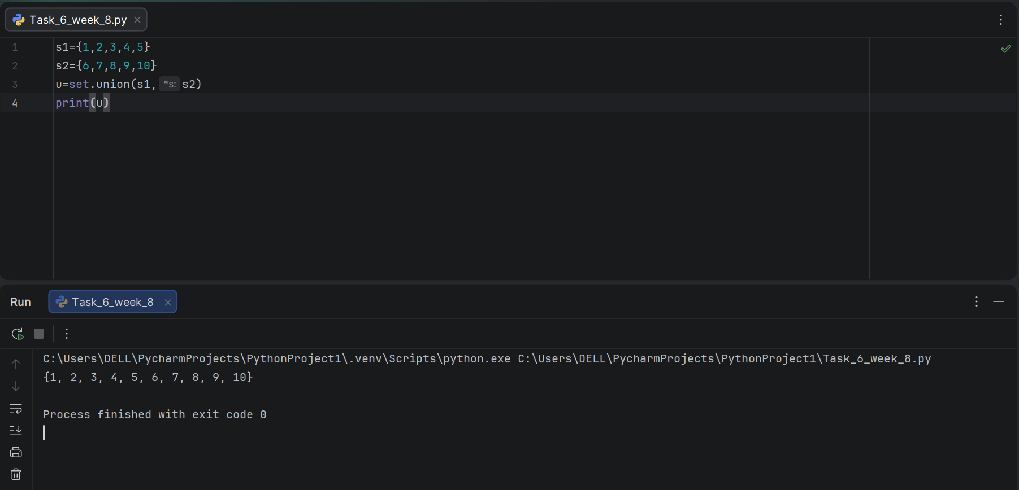

Task 7:
Program to Update Multiple Sets Using the update() Method.

Result:

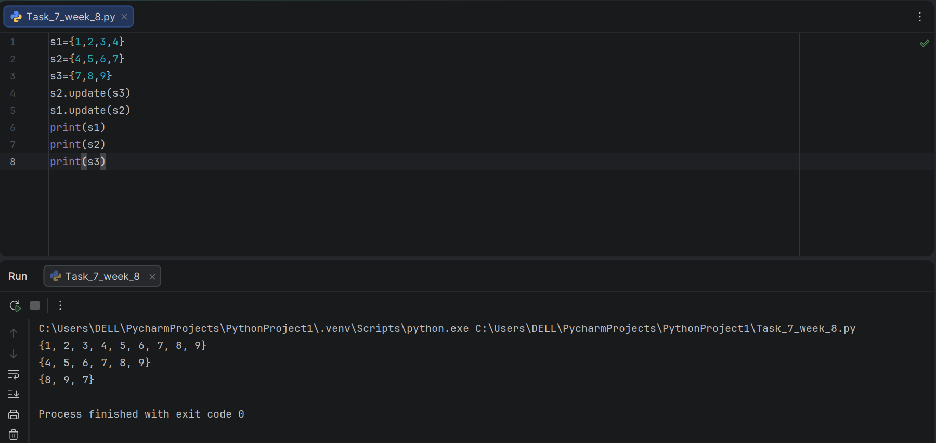

Task 8:
Program to Find the Intersection of Two Sets Using intersection() and intersection_update().

Result:

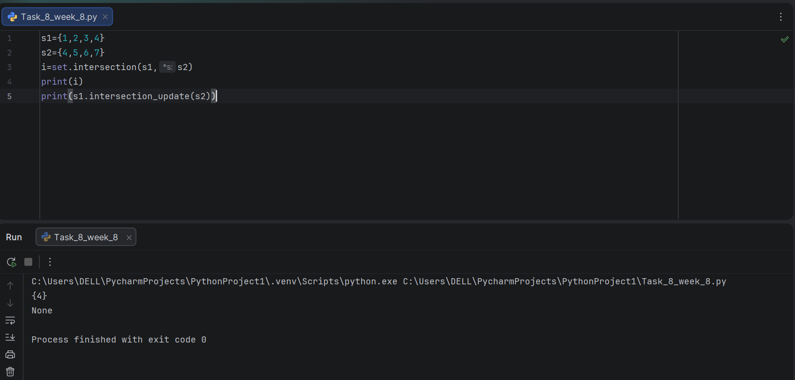

Task 9:
Program to Check if Two Sets are Disjoint Using the isdisjoint() Method.

Result:

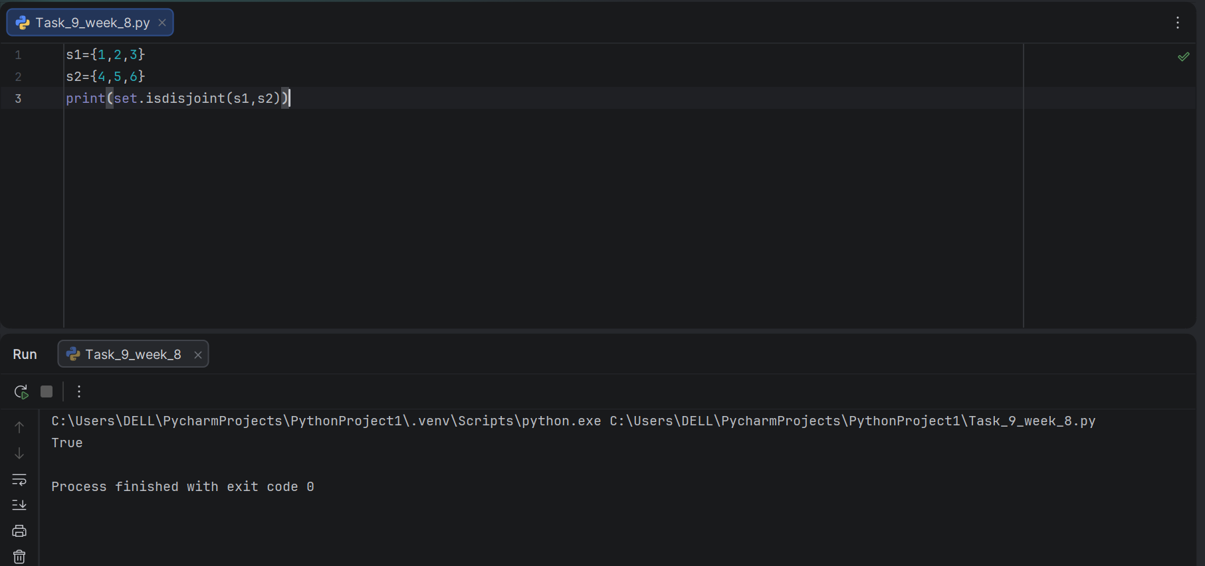

Task 10:
Program to Check Subset Relationship Between Two Sets Using the issubset() Method.

Result:

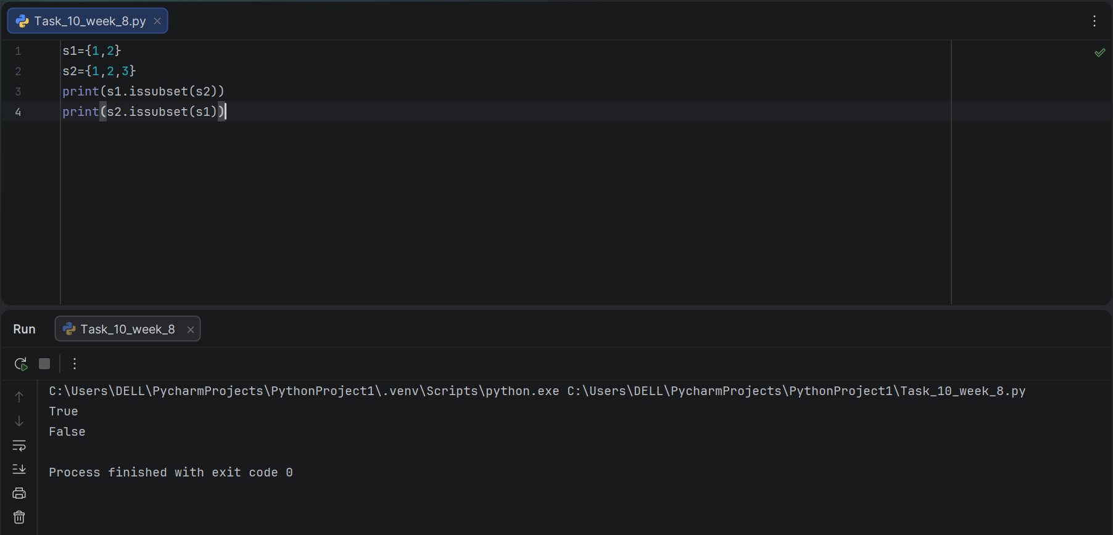

Task 11:
Program to Find the Symmetric Difference Between Two Sets Using the symmetric_difference() Method.

Result:

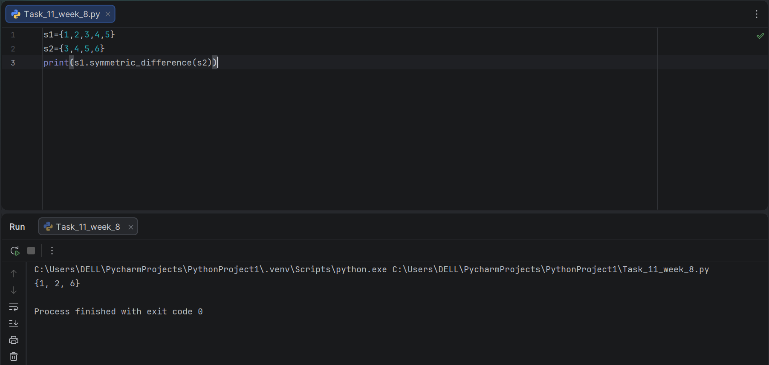

Conclusion:

In this lab, sets and dictionaries were practically implemented to manage unique and key-value based data in Python. Dictionary operations demonstrated how data can be accessed, updated, and structured using keys, while set operations such as union, intersection, difference, and subset checking illustrated how unique collections of data can be compared and combined. This lab strengthened the understanding of how sets ensure uniqueness and how dictionaries provide efficient, structured data mapping, both being essential tools for organizing data in real-world programs.

