University Of Engineering and Technology, Lahore
Computer Engineering Department

Course Name: Programming Fundamentals and data science | Course Code: CMPE-112L
Assignment Type: | Dated: March 16, 2026
Semester: 1 | Session: 2026 Spring
Lab/Project/Assignment #: 1 | CLOs to be covered: CLO
Lab Title: While loop | Teacher Name: Hafiz Muhammad Mubashar
Lab Evaluation:

CLO1 | Apply appropriate programming techniques to create executable programs to solve well defined problems
 | Level1 | Level2 | Level3 | Level4 | Level5 | Level6
(5)
Total |  |  |  |  |  | /5
Rubrics for Current Lab Evaluation
Scale | Marks | Level | Rubric
Excellent | 5 | L1 | Submitted all lab tasks, BONUS task, have good understanding.
Very Good | 4 | L2 | Submitted the lab tasks but have good understanding
Good | 3 | L3 | Submitted the lab tasks but have weak understanding.
Basic | 2 | L4 | Submitted the lab tasks but have no understanding.
Barely Acceptable | 1 | L5 | Submitted only one lab task.
Not Acceptable | 0 | L6 | Did not attempt
LAB No 3
Lab Goals/Objectives:
Upon successful completion of this lab, students will be able to design, write, and execute programs using while loops to perform condition-based repetitive tasks.

• Understand the syntax and working of the while loop in Python.
• Differentiate between for loops and while loops and identify appropriate use cases.
• Apply while loops to solve problems involving counting, summation, and condition-based iteration.
• Use break and continue statements to control loop execution.
• Implement while loops to avoid infinite loops by correctly updating loop control variables.

Equipment Required:
• Python interpreter (Python 3.x)
• Code editor / IDE (e.g., VS Code, PyCharm)

Theory:
A while loop repeatedly executes a block of code as long as a given condition remains true. Unlike a for
loop, which iterates a fixed number of times, a while loop is condition-based and continues until the condition becomes false. It is commonly used when the number of iterations is not known beforehand. Care must be taken to update the loop control variable inside the loop, otherwise it may result in an infinite loop. break and continue statements are often used with while loops to alter the normal flow of iteration.

Lab Work:

Task 1:
Program to Print a Pattern of Stars Using a While Loop

Result:

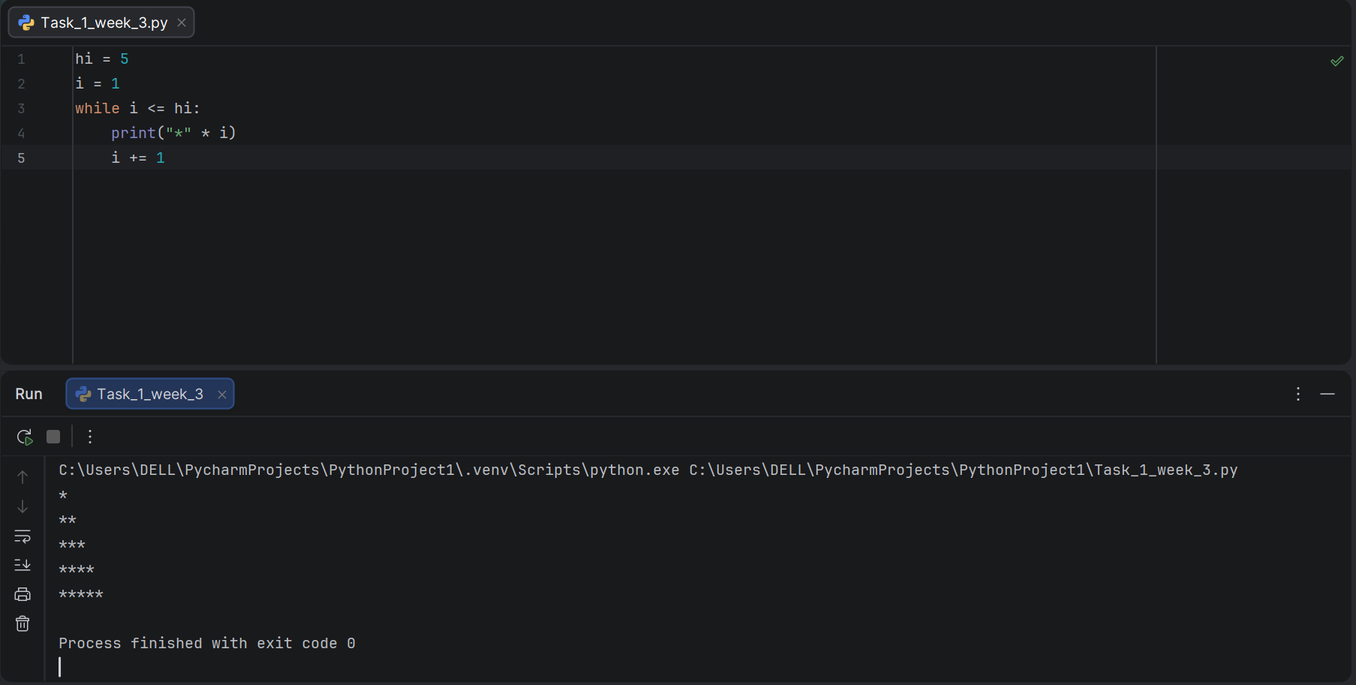

Task 2:
Program to Print a Pyramid Pattern of Stars Using a While Loop
Result:

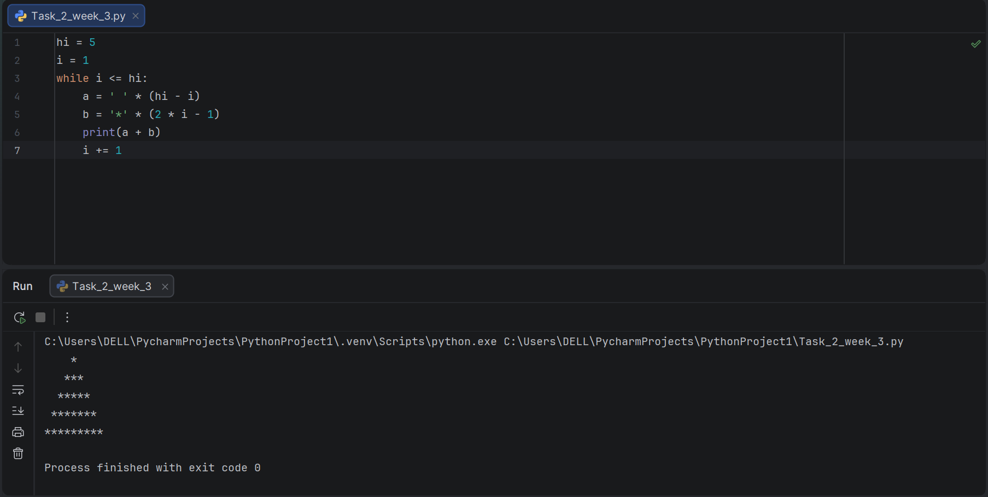
Task 3:
Program to Print Numbers from 1 to 100 Using a While Loop.

Result:

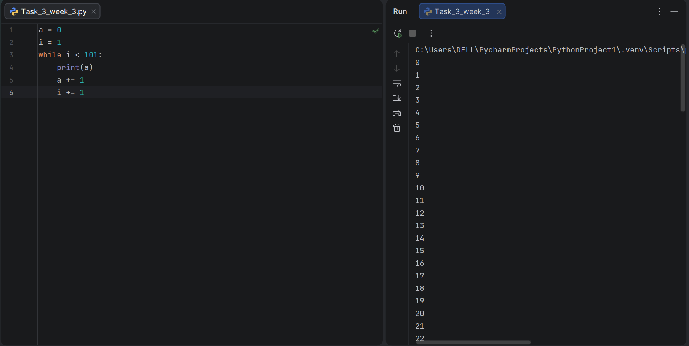

Task 4:
Program to Print Even Numbers from 1 to 100 Using a While Loop.

Result:

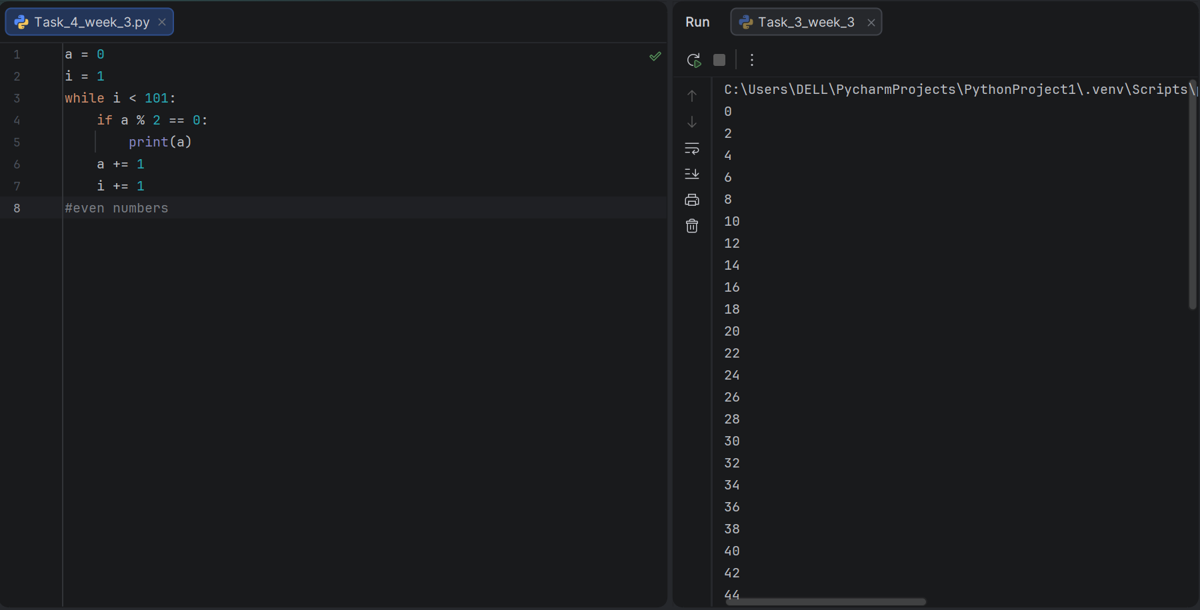
Task 5:
Program to Print Odd Numbers from 1 to 100 Using a While Loop.

Result:

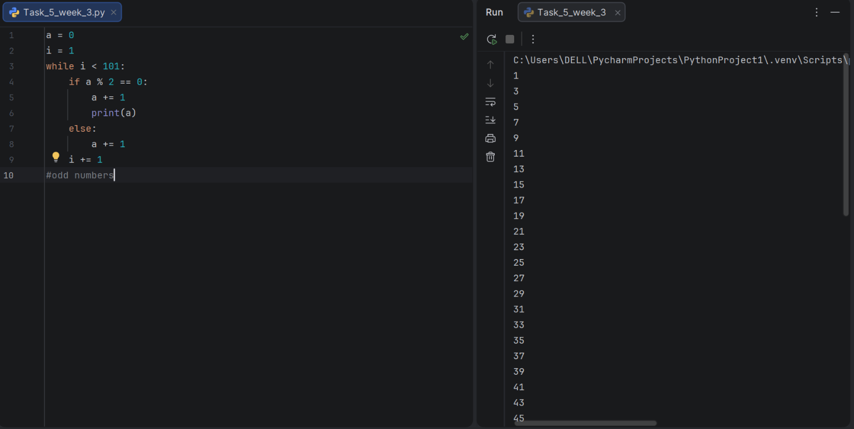

Task 6:
Program to Print Squares of Numbers Using a While Loop.

Result:

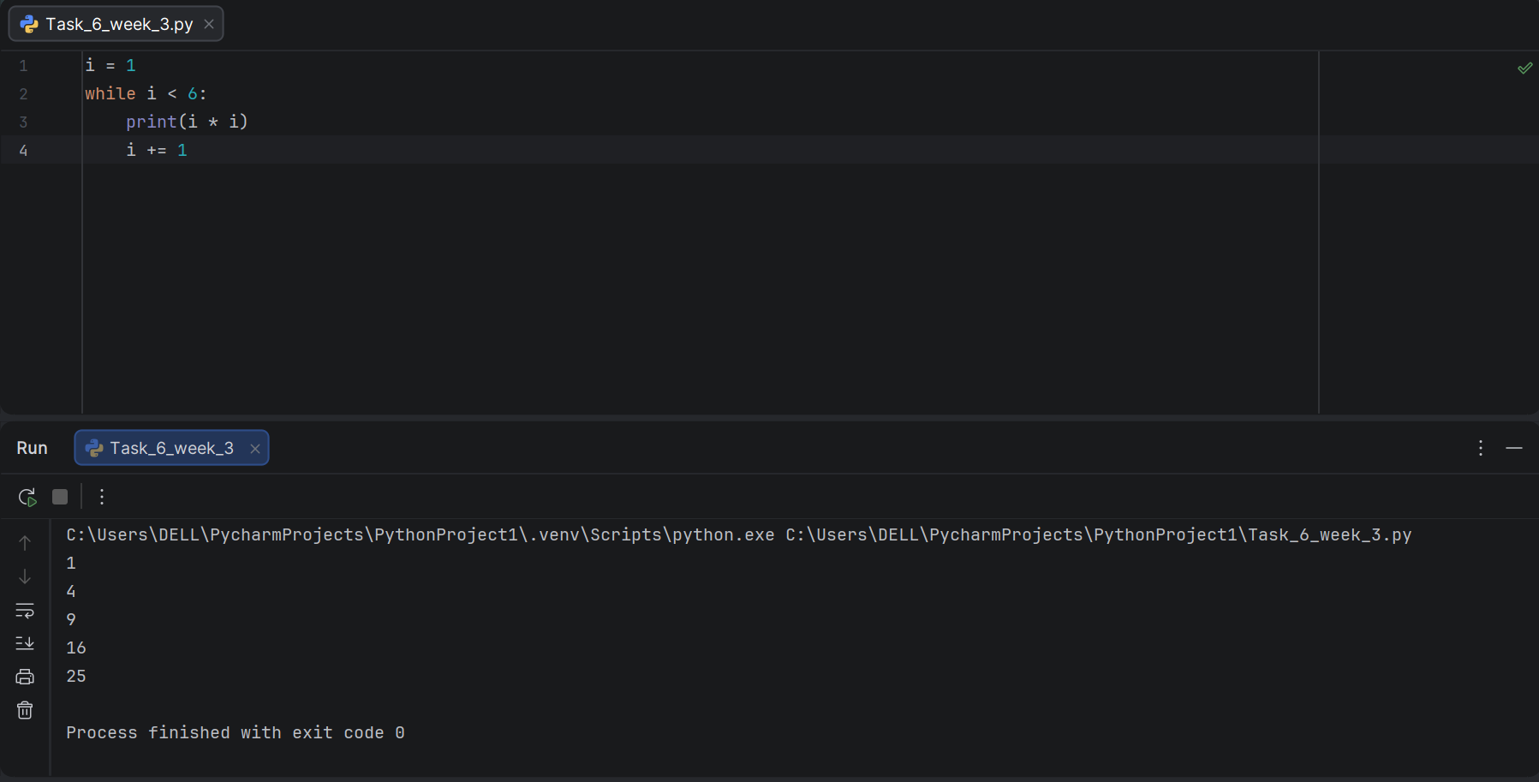
Task 7:
Program to Generate Multiplication Table of a Number Using a While Loop.

Result:

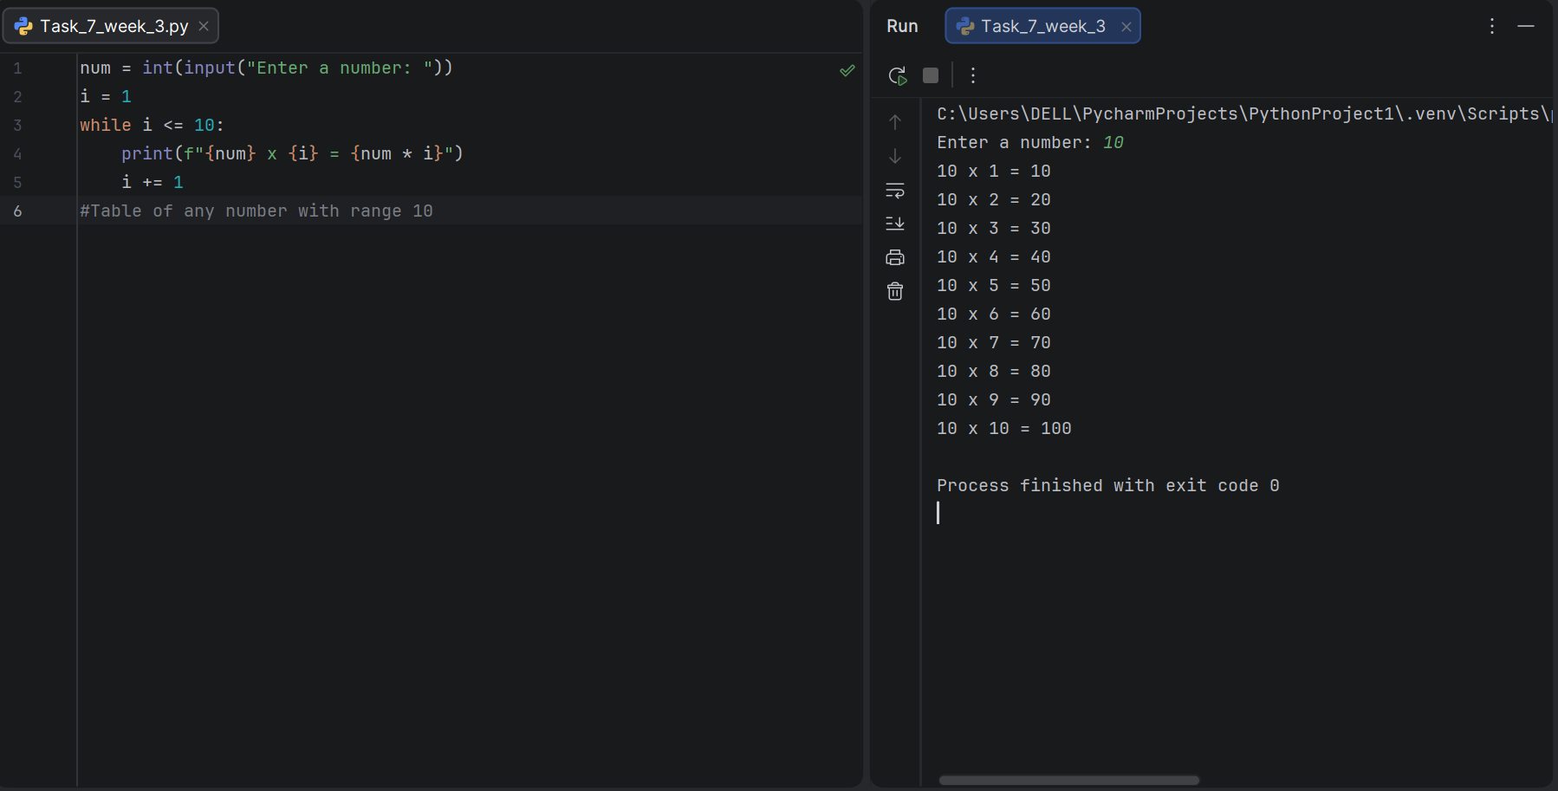

Task 8:
Program to Calculate and Display Student Grade Report Using a While Loop.

Result:

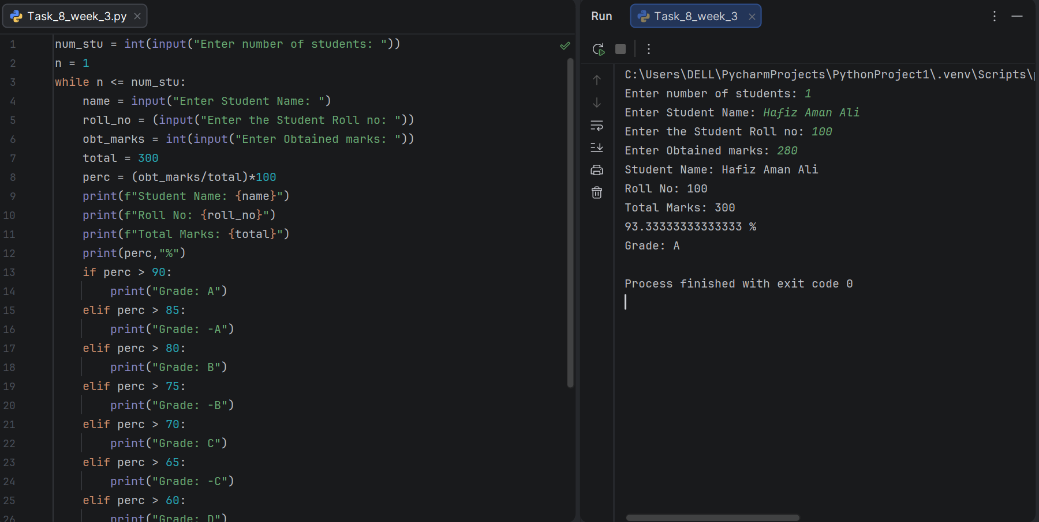

Conclusion:

In this lab, while loops were practically implemented to perform condition-based repetitive tasks in Python. Various patterns were generated, and loops were used to print number sequences, even and odd numbers, squares, and multiplication tables. A student grade report system was also developed by combining while loops with conditional statements. This lab strengthened the understanding of condition-controlled iteration and reinforced the importance of correctly updating loop variables to avoid infinite loops.

