“Arrays”

Que 3. Write a java program to find the equality of arrays?

Java Code:

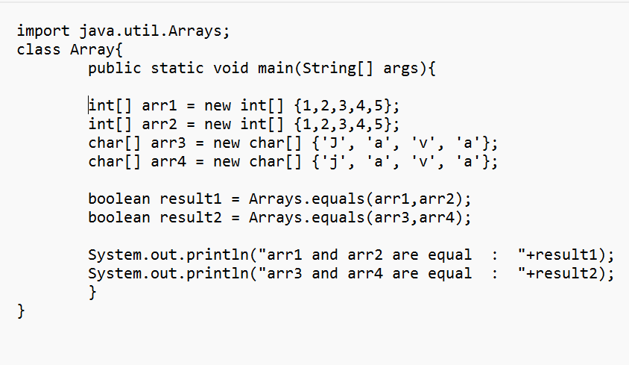

Output:

