**Module 1: Concepts of Operating System**

**Assignment-1**

**Problem 1: Read the instructions carefully and answer accordingly. If there is any need to insert some data then do that as well.**

a) Navigate and List:

a. Start by navigating to your home directory and list its contents. Then, move into a directory named "LinuxAssignment" if it exists; otherwise, create it.

=> Create a directory "LinuxAssignment" using **mkdir** command and call it using **cd** command.



b) File Management:

a. Inside the "LinuxAssignment" directory, create a new file named "file1.txt". Display its contents.

=>Using **cd** command I called "LinuxAssignment" directory and then I created a file "file1.txt" using **touch** command



=> To add content in this file use **cat** command along with **">"** and then display its content using **cat** command only.

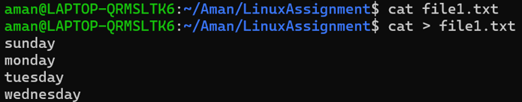

c) Directory Management:

a. Create a new directory named "docs" inside the "LinuxAssignment" directory.

=> using **mkdir** create "docs" directory inside "LinuxAssignment" directory, for that first we have to call "LinuxAssignment" directory using cd command.



d) Copy and Move Files:

a. Copy the "file1.txt" file into the "docs" directory and rename it to "file2.txt".

=>First you have to go back to "Linux Assignment" directory using **cd ..** command and copy file1.txt to docs using **cp** command

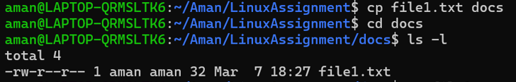

=> rename it using **mv(move)** command.

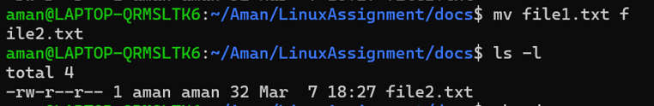

e) Permissions and Ownership:

a. Change the permissions of "file2.txt" to allow read, write, and execute permissions for the owner and only read permissions for others. Then, change the owner of "file2.txt" to the current user.

=> Use **chmod +rwx** followed by file name, +x is to add execution permission , here owner is already current user.

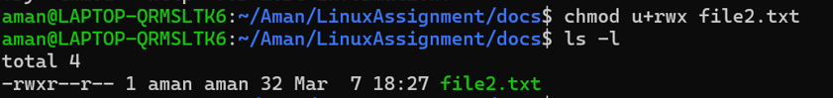

f) Final Checklist:

a. Finally, list the contents of the "LinuxAssignment" directory and the root directory to ensure that all operations were performed correctly.

=> Use **ls -l** command

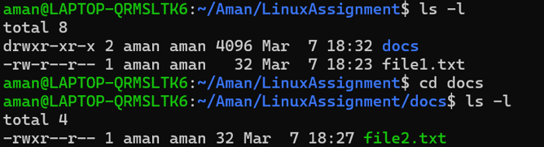

g) File Searching:

a. Search for all files with the extension ".txt" in the current directory and its subdirectories.

=>using **find *.txt** command find text file





b. Display lines containing a specific word in a file (provide a file name and the specific word to search).

=> Use **grep** command



h) System Information:

a. Display the current system date and time.



i) Networking:

a. Display the IP address of the system.

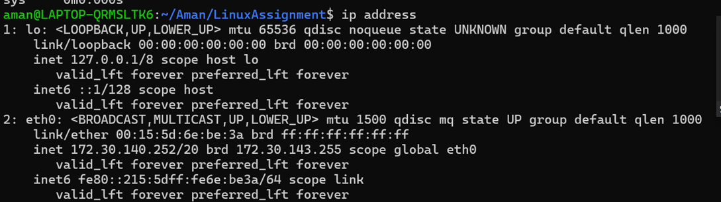

b. Ping a remote server to check connectivity (provide a remote server address to ping).

=> Use ping command followed by any website.

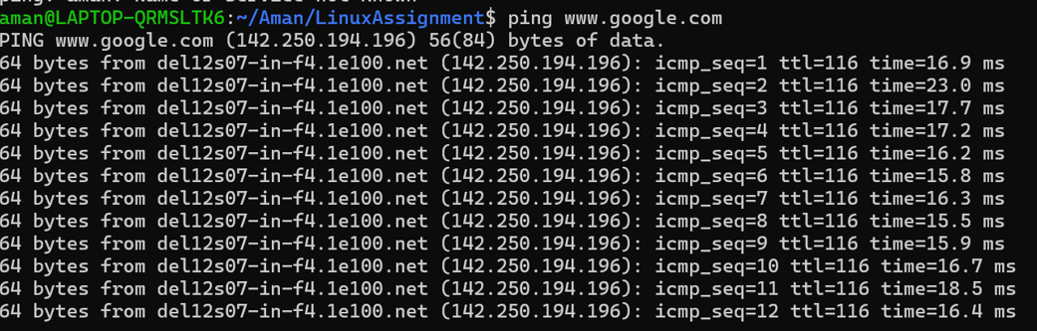

=> it will continue, to exit enter ctrl+c

j) File Compression:

a. Compress the "docs" directory into a zip file.

=> use **zip** command

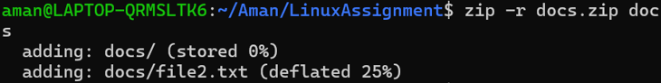

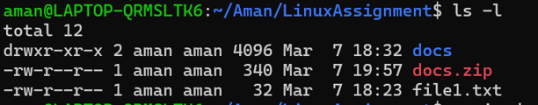

b. Extract the contents of the zip file into a new directory.

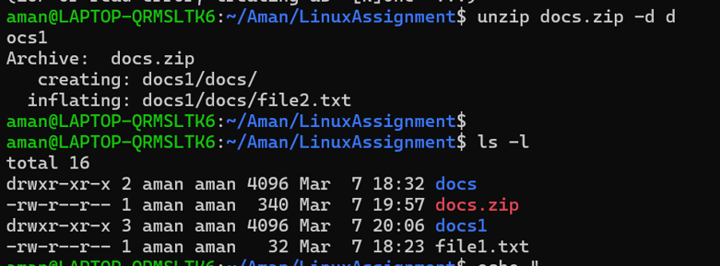

k) File Editing:

a. Open the "file1.txt" file in a text editor and add some text to it.

=> Add text using **echo** command .

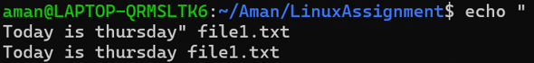

b. Replace a specific word in the "file1.txt" file with another word (provide the original word and the word to replace it with).

=> Exchange thursday word with monday using **sed** command



**Problem 2: Read the instructions carefully and answer accordingly. If there is any need to insert some data then do that as well.**

(a). Suppose you have a file named "data.txt" containing important information. Display the first 10 lines of this file to quickly glance at its contents using a command.

=>Create a data.txt file using **touch** command



=>Enter data in data.txt file using **cat** command

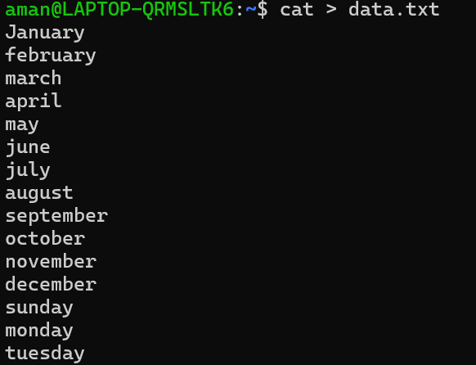

=>Print first 10 lines of data.txt file using **head** command

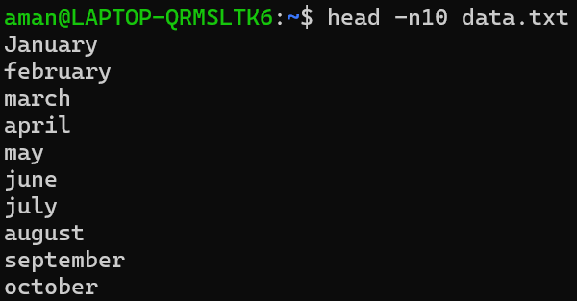

(b). Now, to check the end of the file for any recent additions, display the last 5 lines of "data.txt" using another command.

=> Print last 5 lines of data.txt file using **tail** command

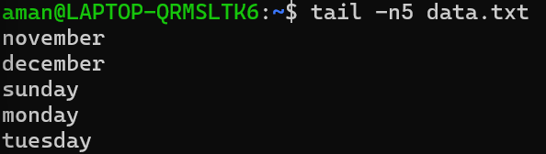

(c). In a file named "numbers.txt," there are a series of numbers. Display the first 15 lines of this file to analyze the initial data set.

=> Create a file numbers.txt using **touch** command and enter values in it using **cat** command

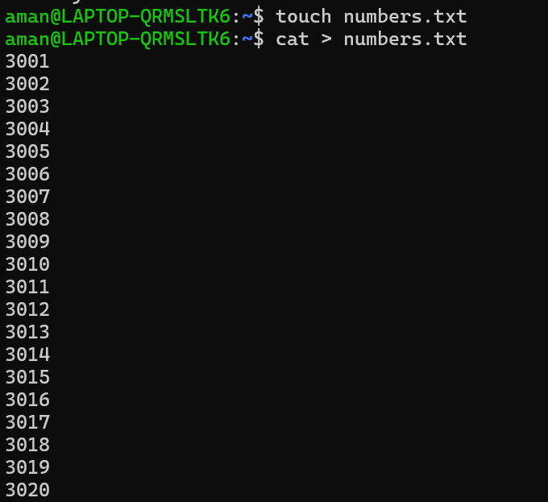

=> Print first 15 lines using **head** command

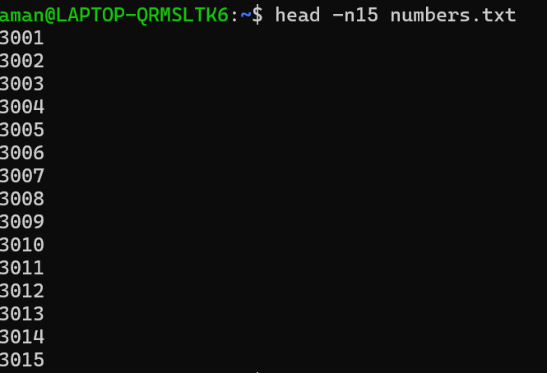

(d). To focus on the last few numbers of the dataset, display the last 3 lines of "numbers.txt".

=> Print last 3 lines using **tail** command

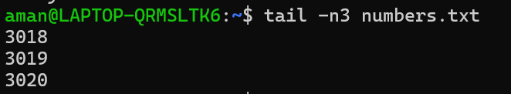

e. Imagine you have a file named "input.txt" with text content. Use a command to translate all lowercase letters to uppercase in "input.txt" and save the modified text in a new file named "output.txt."

=>Create a file input.txt using **touch** command and enter some values in it using **cat** command

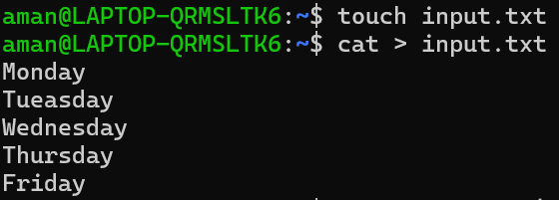

=> translate all lower case letters to uppercase letters using **tr** command

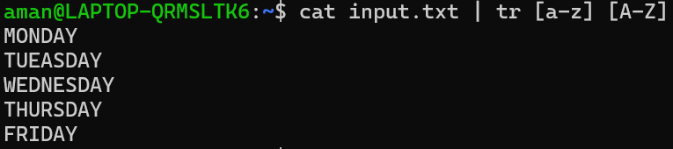

=> now save this file in new file output.txt

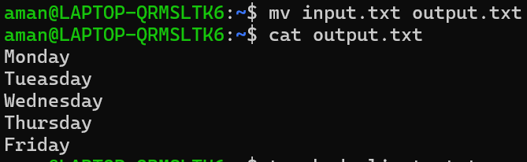

(f). In a file named "duplicate.txt," there are several lines of text, some of which are duplicates. Use a command to display only the unique lines from "duplicate.txt."

=> create a file duplicate.txt using touch, enter some content in it using cat

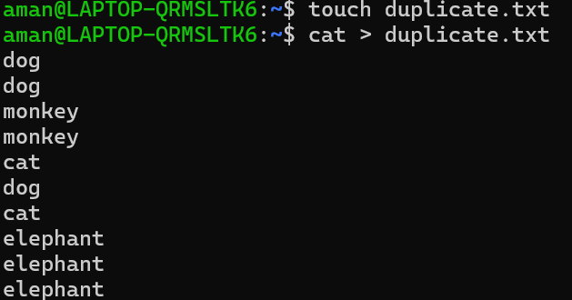

=> dispaly only unique lines using **uniq** command

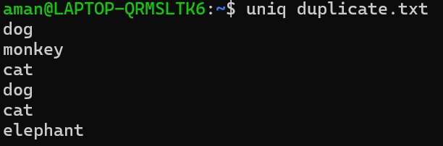

(g). In a file named "fruit.txt," there is a list of fruits, but some fruits are repeated. Use a command to display each unique fruit along with the count of its occurrences in "fruit.txt."

=> create a file fruit.txt enter some fruits name in it but some fruits are repeated

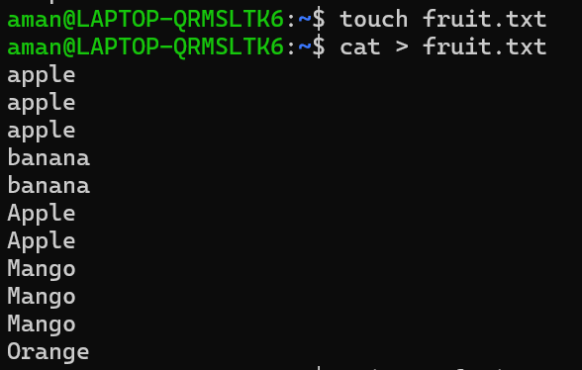

=> use **uniq -c** command to print uniq fruit name and also prints no. of time it repeated.

