Assignment - 8
Aman Verma
2401010141

Exercise on order by and group by clauses, Create Sales table with the following fields ( Sales No, Salesname, Branch, Salesamount, DOB)
( a ) Insert five records
( b ) Calculate total salesamount in each branch
( c ) Calculate average salesamount in each branch
( d ) Display all the salesmen, DOB who are born in the month of December as day in character format i.e. 21-Dec-09
( e ) Display the name and DOB of salesman in alphabetical order of the month.

a)
INSERT INTO Sales VALUES
(1, 'Aman', 'Delhi', 5000, '2003-12-21'),
(2, 'Gaurav', 'Mumbai', 7000, '2002-05-10'),
(3, 'Aryan', 'Delhi', 6000, '2001-12-15'),
(4, 'Sneha', 'Chennai', 8000, '2000-07-25'),
(5, 'Karan', 'Mumbai', 9000, '2003-12-05'),
);

b)
SELECT Branch, SUM(Salesamount) AS Total_Sales
FROM Sales
GROUP BY Branch;
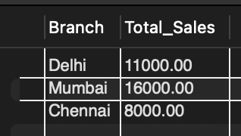

c)
SELECT Branch, AVG(Salesamount) AS Avg_Sales
FROM Sales
GROUP BY Branch;
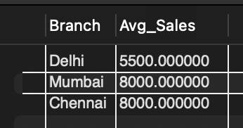

d)
SELECT Salesname,
DATE_FORMAT(DOB, '%d-%b-%y') AS DOB
FROM Sales
WHERE MONTH(DOB) = 12;
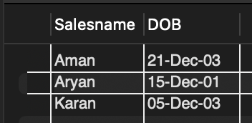

e)
SELECT Salesname, DOB
FROM Sales
ORDER BY MONTHNAME(DOB);

