Assignment-10
Aman Verma
2401010141

Using the tables “DEPARTMENTS” and “EMPLOYEES” perform the following queries.
a)Display the employee details, departments that the departments are same in both the emp and dept.
b)Display the employee name and Department name by implementing a left outer join.
c)Display the employee name and Department name by implementing a right outer join.
d)Display the details of those who draw the salary greater than the average salary.

OUTPUT:
a) SELECT e.emp_name, e.emp_salary, d.dept_name, d.dept_location
FROM Employees e
INNER JOIN Departments d
ON e.dept_no = d.dept_no;
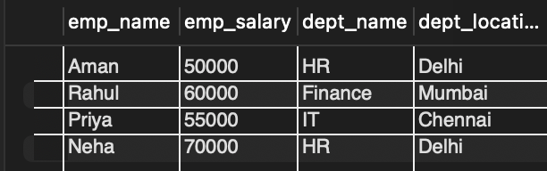

b) SELECT e.emp_name, d.dept_name
FROM Employees e
LEFT JOIN Departments d
ON e.dept_no = d.dept_no;
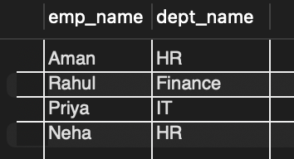

c) SELECT e.emp_name, d.dept_name
FROM Employees e
RIGHT JOIN Departments d
ON e.dept_no = d.dept_no;
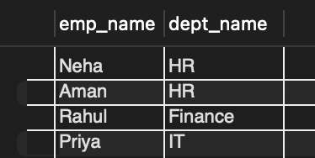

d) SELECT *
FROM Employees
WHERE emp_salary > (SELECT AVG(emp_salary) FROM Employees);
