Lab Sheet 4
Aman Verma
2401010141

Lab Assignment: SQL User Management & Access Control

Title:
Implementation of User Creation, Deletion, and Privilege Management in SQL

Problem Statement
Design and execute SQL commands to create users, manage their access privileges, and remove users in a database system. This assignment focuses on database security and access control mechanisms.

Tasks

Part A: User Creation
- Create a new user named user1 with a password.
- Create another user user2 with limited access.

Part B: Granting Privileges
- Grant SELECT and INSERT privileges on a table Student to user1.
- Grant ALL privileges on a table Course to user2.
- Provide WITH GRANT OPTION to user1 and observe its effect.

Part C: Revoking Privileges
- Revoke INSERT permission from user1 on the Student table.
- Revoke all privileges from user2 on the Course table.

Part D: User Deletion
- Drop/Delete user user2 from the database.
- Attempt to login using deleted credentials and observe the result.

Part E: Additional Commands
- Display all users in the system.
- Show privileges assigned to a specific user.

Solution:
Part A
drop user if exists ‘user1’@’localhost’;
drop user if exists ‘user2’@’localhost’;

create user ‘user1’@’localhost’ identified by ‘password1’;
create user ‘user2’@’localhost’ identified by ‘password2’;

Part B
create database labSheet4;
use labSheet4;

create table student(
id int ,
name varchar(30)
);

create table course(
cid int ,
cname varchar(30)
);

GRANT select , insert on labSheet4.student to 'user1'@'localhost';
grant all privileges on labSheet4.course to 'user2'@'localhost';
GRANT select , insert on labSheet4.student to 'user1'@'localhost' with grant option;

Part C
REVOKE insert on labSheet4.student from 'user1'@'localhost';
REVOKE ALL PRIVILEGES, GRANT OPTION
ON labSheet4.course
FROM 'user2'@'localhost';

Part D
drop user 'user2'@'localhost';

Part E
SELECT user, host FROM mysql.user;
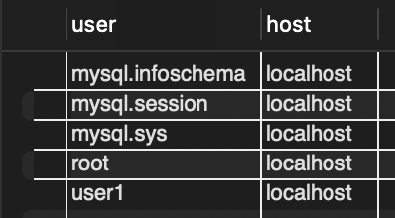

show grants for 'user1'@'localhost';
