

Database Management Lab File
(ENCS205)

Bachelor of Technology

in
Computer Science and Engineering

Submitted by

Aman (2401010141)
B. Tech CSE (Core) – 4th Semester
Section: A

Submitted To:

MS. Mansi Kajal

School of Engineering & Technology
K. R. MANGALAM UNIVERSITY

Sohna, Haryana 122103, India Jan-2026

Index
S.NO | EXPERIMENT | PAGE NO. | DATE | REMARKS
1. | To analyze the requirements for a College Database, design an EntityRelationship (ER) Diagram representing Students, Sections, Subjects, and Marks, and convert the conceptual model into a Relational Database Schema.
2. | To analyze the requirements for a Company Database, design an Entity-Relationship (ER) Diagram representing Employees, Departments, Projects, and their relationships (Works On, Manages, Supervision), and map the ER diagram into a normalized Relational Database Schema.
3. | Database Schema for a customer-sale scenario.

Experiment: 1
1.Consider following databases and draw ER diagram and convert entitiesand relationships to relation table for a given scenario:
Aim: To analyze the requirements for a College Database, design an Entity-Relationship (ER) Diagram representing Students, Sections, Subjects, and Marks, and convert the conceptual model into a Relational Database Schema.
COLLEGE DATABASE:
STUDENT (USN, SName, Address, Phone, Gender)
SEMSEC (SSID, Sem, Sec)
CLASS (USN, SSID)
SUBJECT (Subcode, Title, Sem, Credits)
IAMARKS (USN, Subcode, SSID, Test1, Test2, Test3, FinalIA)

PROCEDURE:
Step 1: Create the Strong Entities (Rectangles) Draw four rectangles to represent the main tables in your database:
- STUDENT
- SEMSEC (Semester & Section)
- SUBJECT
- IAMARKS (Internal Assessment Marks)
Step 2: Add Attributes (Ovals) Draw ovals connected to their respective entities. Make sure to identify Primary Keys and special attributes.
- For STUDENT:
  - Draw ovals: SNAME, ADDRESS, PHONE, GENDER.
  - Draw oval USN and underline the text (Primary Key).
- For SEMSEC:
  - Draw ovals: SEM, SEC.
  - Draw oval SSID and underline the text (Primary Key).
- For SUBJECT:
  - Draw ovals: Title, SEM, CREDITS.
  - Draw oval SUBCODE and underline the text (Primary Key).

- For IAMARKS:
  - Draw ovals: Test1, Test2, Test3.
  - Draw a Dashed/Dotted Oval for FinalIA. (This indicates it is a Derived Attribute, calculated from the other test scores).
Step 3: Create Relationships (Diamonds) Draw four diamond shapes to connect the entities.
- Draw "CLASS" Diamond:
  - Place it between STUDENT and SEMSEC.
  - Meaning: Represents which class/section a student belongs to.
- Draw "Secures" Diamond:
  - Place it between STUDENT and IAMARKS.
  - Meaning: Represents the marks secured by a specific student.
- Draw "CLASS_MARKS" Diamond:
  - Place it between SEMSEC and IAMARKS.
  - Meaning: Links the marks to a specific section (to identify which class the marks belong to).
- Draw "SCORED_IN" Diamond:
  - Place it between SUBJECT and IAMARKS.
  - Meaning: Identifies which subject the marks are for.
Step 4: Connect Lines & Define Cardinality (Mapping) Draw lines connecting the diamonds to the rectangles and label the cardinality (1, M, N) as shown in your image.
- For CLASS (Student - SemSec):
  - Draw a single line from STUDENT (Label 1). o Draw a double line (or crow's foot) from SEMSEC (Label N or (1, n)). o Logic: One Student is in One Section; One Section has Many Students.
- For Secures (Student - IAMarks): o Connect STUDENT to IAMARKS. o Label as M: N (Many-to-Many).
- For SCORED_IN (Subject - IAMarks):
  - Connect SUBJECT to IAMARKS.
  - Label as 1: N (One Subject has Many Marks entries).

- For CLASS_MARKS (SemSec - IAMarks):
  - Connect SEMSEC to IAMARKS.
  - Label as 1: N (One Section has Many Marks entries).
Step 5: Final Review Check that FinalIA is dashed (derived), all Primary Keys (USN, SSID, SUBCODE) are underlined, and all 4 entities are connected through the central IAMARKS relationships
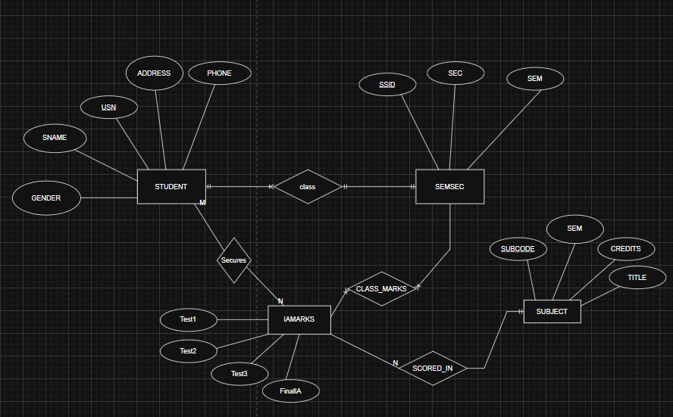

EXPERIMENT: 2

- Consider following databases and draw ER diagram and convert entities and relationships to relation table for a given scenario:
AIM: To analyze the requirements for a Company Database, design an Entity-Relationship (ER) Diagram representing Employees, Departments, Projects, and their relationships (Works On, Manages, Supervision), and map the ER diagram into a normalized Relational Database Schema.
PROCEDURE:
Step 1: Draw the 3 Main Entities (Rectangles)
Draw three rectangular boxes in the following positions:
  - DEPARTMENT: Place it in the top-middle.
  - Employee: Place it on the right side.
  - PROJECT: Place it in the bottom-left.
Step 2: Add Attributes (Ovals)
Draw ovals connected to their respective rectangles. Crucially, include the Foreign Keys as shown in your image:
  - For DEPARTMENT:
    - Add ovals: DNAME, MGRSSN, MGRSTARTDATE.
    - Add oval DNO and underline it (Primary Key).
  - For Employee:
    - Add ovals: NAME, ADDRESS, SALARY, SEX. o Add oval SSN and underline it (Primary Key).
    - Add Foreign Keys: Add ovals for SUPERSSN and DNO attached to this entity.
  - For PROJECT:
    - Add ovals: PNAME, PLOCATION.
    - Add oval PNO and underline it (Primary Key).
    - Add Foreign Key: Add an oval for DNO attached to this entity.
  - For Locations:
    - Draw a separate oval labeled LOOC below the Department table.
Step 3: Draw Relationships (Diamonds)
Draw three diamond shapes to represent the connections:
  - WORKS_FOR: Place this between DEPARTMENT and Employee.
  - LOCATED_AT: Place this between DEPARTMENT and the LOOC oval.
  - WORKS_ON: Place this to the left of the PROJECT table.
Step 4: Connect Lines & Define Cardinality
1. Connect WORKS_FOR:
    - Draw a line from DEPARTMENT to the diamond. Label it 1 (or N depending on your specific image logic, usually Many Employees work for 1 Dept). In your image, N is near Employee and 1 is near Dept.
    - Draw a line from Employee to the diamond.
2. Connect LOCATED_AT:
    - Draw a line from DEPARTMENT down to the diamond. Label it 1. o Draw a line from the diamond down to the LOOC oval. Label it N.
- Connect WORKS_ON:
    - Draw a line from PROJECT to the diamond.
    - Draw a long line from the other side of the diamond that goes Up, turns Right (across the top of the page), turns Down, and connects to the Employee table.
    - This represents the Many-to-Many relationship between Employees and Projects.

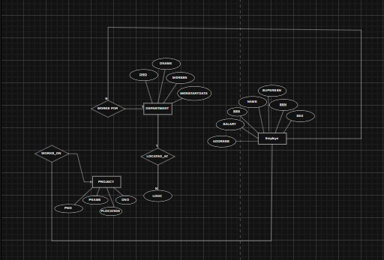
Experiment – 3
Database Schema for a customer-sale scenario
Customer(Cust id : integer, cust_name: string)
Item(item_id: integer, item_name:string, price: integer)
Sale(bill_no:integer,bill_data:date,cust_id: integer, item_id: integer, qty_sold:
integer)
All Commands:
CREATE DATABASE IF NOT EXISTS CustomerSaleDB;
USE CustomerSaleDB;

CREATE TABLE Customer (
cust_id INT PRIMARY KEY,
cust_name VARCHAR(100) NOT NULL
);

CREATE TABLE Item (
item_id INT PRIMARY KEY,
item_name VARCHAR(100) NOT NULL,
price INT NOT NULL CHECK (price > 0)
);

CREATE TABLE Sale (
bill_no INT,
bill_date DATE NOT NULL,
cust_id INT,
item_id INT,
qty_sold INT NOT NULL CHECK (qty_sold > 0),
PRIMARY KEY (bill_no, item_id),
FOREIGN KEY (cust_id) REFERENCES Customer(cust_id),
FOREIGN KEY (item_id) REFERENCES Item(item_id)
);

INSERT INTO Customer VALUES
(1,'Aman'),
(2,'aryan'),
(3,'gaurav'),
(4,'yash'),
(5,'lucky'),
(6,'prince'),
(7,'divesh'),
(8,'priyanshu'),
(9,'bhavik'),
(10,'muskan');

INSERT INTO Item VALUES
(101,'Laptop',500),
(102,'Mouse',50),
(103,'Keyboard',80),
(104,'Monitor',120),
(105,'USB Cable',200),
(106,'Headphones',150),
(107,'Charger',90),
(108,'Tablet',250),
(109,'Smartphone',300),
(110,'Pen Drive',70);

INSERT INTO Sale VALUES
(101,CURDATE(),1,101,1),
(102,CURDATE(),2,102,2),
(103,CURDATE(),3,104,1),
(104,CURDATE(),4,105,3),
(105,CURDATE(),5,108,1),
(106,CURDATE(),6,110,4),
(107,CURDATE(),7,103,2),
(108,CURDATE(),8,109,1),
(109,CURDATE(),9,106,1),
(110,CURDATE(),10,107,2);

SELECT s.bill_no, c.cust_name, s.item_id
FROM Sale s
JOIN Customer c ON s.cust_id = c.cust_id
WHERE s.bill_date = CURDATE();

SELECT
s.bill_no,
s.qty_sold,
i.price,
(s.qty_sold * i.price) AS final_amount
FROM Sale s
JOIN Item i ON s.item_id = i.item_id;

SELECT DISTINCT c.cust_id, c.cust_name
FROM Customer c
JOIN Sale s ON c.cust_id = s.cust_id
JOIN Item i ON s.item_id = i.item_id
WHERE i.price > 200;

SELECT
c.cust_id,
c.cust_name,
SUM(s.qty_sold) AS total_products_bought
FROM Customer c
JOIN Sale s ON c.cust_id = s.cust_id
GROUP BY c.cust_id, c.cust_name;

SELECT i.item_id, i.item_name
FROM Sale s
JOIN Item i ON s.item_id = i.item_id
WHERE s.cust_id = 5;

SELECT DISTINCT i.*
FROM Item i
JOIN Sale s ON i.item_id = s.item_id
WHERE s.bill_date = CURDATE();

CREATE OR REPLACE VIEW Bill_View AS
SELECT
s.bill_no,
s.bill_date,
s.cust_id,
s.item_id,
i.price,
s.qty_sold,
(s.qty_sold * i.price) AS amount
FROM Sale s
JOIN Item i ON s.item_id = i.item_id;

SELECT * FROM Bill_View;

CREATE OR REPLACE VIEW Weekly_Sales AS
SELECT
s.bill_date,
SUM(s.qty_sold * i.price) AS total_sales
FROM Sale s
JOIN Item i ON s.item_id = i.item_id
WHERE s.bill_date >= CURDATE() - INTERVAL 7 DAY
GROUP BY s.bill_date;

SELECT * FROM Weekly_Sales;

