PAPER 1:

BLOCKCHAIN

**PRACTICAL 01**

**AIM: Types of Variables**

**PROGRAM:**

pragma solidity ^0.5.0;

contract Pract1{

int x=15; //state var

int public y=10;//global

function getValue(int z) public{

y=y+z;

}

function show() public view returns (int)

{

return x;

}

}

**OUTPUT:**

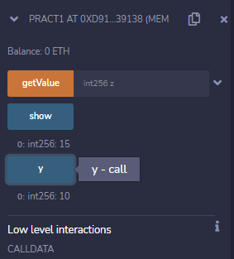

**PRACTICAL 02**

**AIM: Relational Operators**

**Program:**

pragma solidity ^0.5.0;

contract Pract2{

bool public a=true;

bool  public b=false;

bool public  r1or=a||b;

bool public r2and=a&&b;

bool public r3not=!b;

}

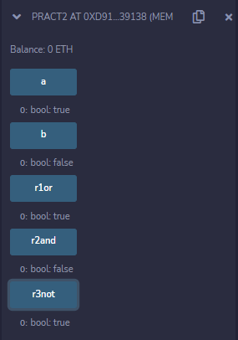**OUTPUT:**

**PRACTICAL 03**

**AIM: FOR loop**

**Program:**

pragma solidity ^0.5.0;

contract Pract3{

function test(int s, int e) public view returns(int)

{

int i;

int sum=0;

for(i=s;i<=e;i++)

{

sum+=i; //sum=sum+i;

}

return sum;

}

}

**OUTPUT:**

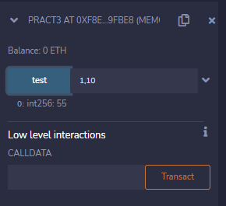

**PRACTICAL 04**

**AIM: WHILE loop**

**Program:**

pragma solidity ^0.5.0;

contract Pract3{

function test(int s, int e) public view returns(int)

{

int i;

int sum=0;

i=s;

while(i<=e)

{

sum+=i; //sum=sum+i;

i++;

}

return sum;

}

}

**OUTPUT:**

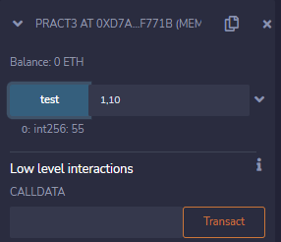

**PRACTICAL 05**

**AIM: DO- WHILE loop**

**Program:**

pragma solidity ^0.5.0;

contract Pract3{

function test(int s, int e) public view returns(int)

{

int i;

int sum=0;

i=s;

do

{

sum+=i; //sum=sum+i;

i++;

}while(i<=e);

return sum;

}

}

OUTPUT:

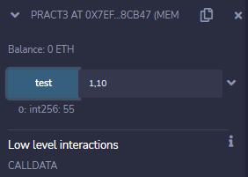

**PRACTICAL 06**

**AIM: IF-ELSE Statement**

**Program:**

pragma solidity ^0.5.0;

contract Pract4{

function test(int x) public view returns(string memory)

{

if(x%2==0)

return "Number is even";

else

return "Number is odd";

}

}

OUTPUT:

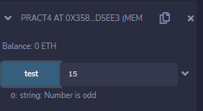

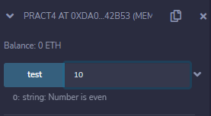

**PRACTICAL 07**

**AIM: STRING**

**Program:**

pragma solidity ^0.5.0;

contract Pract4{

function test(int x) public view returns(string memory)

{

if(x%2==0)

return "Number is even";

else

return "Number is odd";

}

}

OUTPUT:





**PRACTICAL 08**

**AIM: ARRAY**

**Program:**

contract Types {

uint[5] data;

constructor() public

{

data = [uint(10), 20, 30, 40, 50];

}

function array_example() public view returns (uint,uint)

{

return (data[0],data[4]);

}

function array_example2() public view returns (uint [5] memory)

{

return data;

}

}

OUTPUT:

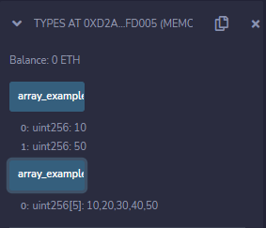

**PRACTICAL 09**

**AIM: ENUM**

**Program:**

pragma solidity ^0.5.0;

contract Types {

enum week_days

{

Monday,Tuesday,Wednesday,Thursday,Friday,Saturday,

Sunday

}

week_days choice;

function set_value() public {

choice = week_days.Thursday;

}

function get_choice() public view returns (week_days) {

return choice;

}

}

OUTPUT:

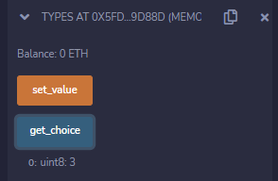

**PRACTICAL 10**

**AIM: ARITHMETIC OPERATIONS**

**Program:**

pragma solidity ^0.5.0;

// Creating a contract

contract SolidityTest {

// Initializing variables

uint16 public a = 20;

uint16 public b = 10;

// Initializing a variable

// with sum

uint public sum = a + b;

// Initializing a variable

// with the difference

uint public diff = a - b;

// Initializing a variable

// with product

uint public mul = a * b;

// Initializing a variable

// with quotient

uint public div = a / b;

// Initializing a variable

// with modulus

uint public mod = a % b;

// Initializing a variable

// decrement value

uint public dec = --b;

// Initializing a variable

// with increment value

uint public inc = ++a;

}

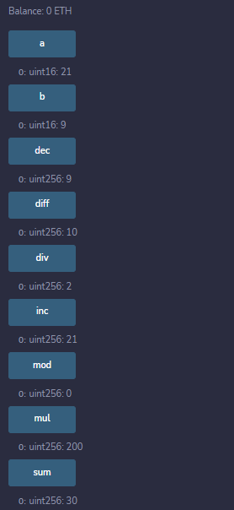

OUTPUT:

**PRACTICAL 11**

**AIM: STRUCTURE**

**Program:**

pragma solidity ^0.5.0;

contract test {

struct Book {

string title;

string author;

uint book_id;

}

Book book;

function setBook() public {

book = Book('Learn Java', 'TP', 1);

}

function getBookId() public view returns (uint) {

return book.book_id;

}

function getBookDetail() public view returns (string memory, string memory,uint) {

return (book.title, book.author, book.book_id);

}

}

OUTPUT:

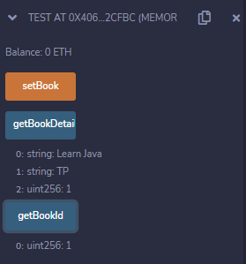

**PRACTICAL 12**

**AIM: type of function(view, pure)**

**Program:**

pragma solidity ^0.5.0;

contract Test {

int public x=10; //global

int y=90;//state

function f1() public returns(int){

    //read and update is allowed

    x=100;

return x;

}

function f2() public view returns(int){

  //  x=100; //erro beacuse x is global/state

  //we can access but we cannot update state or global variable int view function

return x;

}

function f3() public pure returns(int){

    //we cannot access or update state or global variable in pure function

    int z=80;

return z;

}

}

OUTPUT:

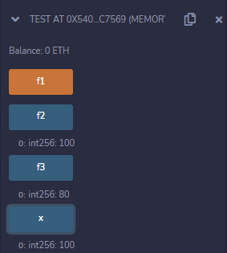

**PRACTICAL 13**

**AIM: Function Overloading**

**Program:**

pragma solidity ^0.5.0;

contract Test {

function getSum(uint a, uint b) public pure returns(uint){

return a + b;

}

function getSum(uint a, uint b, uint c ) public pure returns(uint){

return a + b + c;

}

}

OUTPUT:

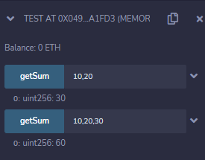

**PRACTICAL 14**

**AIM: Mathematical function**

**Program:**

pragma solidity ^0.5.0;

contract Test {

function callAddMod() public pure returns(uint){

return addmod(4, 5, 3);

}

function callMulMod() public pure returns(uint){

return mulmod(4, 5, 3);

}

}

OUTPUT:

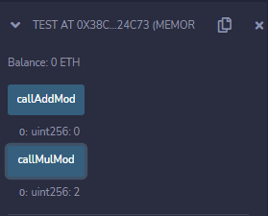

**PRACTICAL 15**

**AIM: cryptographic function**

**Program:**

pragma solidity ^0.5.0;

contract Test {

function callKeccak256() public pure returns(bytes32 result){

return keccak256("ABC");

}

}

OUTPUT:

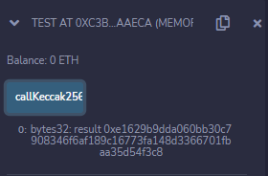

**PRACTICAL 16**

**AIM: Write a Python program to create a simple client class that generates the private and public keys by using the built-in Python RSA algorithm and test it.**

**Program:**

# following imports are required by PKI

pip3 install crypto

pip3 install pycrypto

import hashlib

import random

import string

import json

import binascii

import numpy as np

import pandas as pd

import logging

import datetime

import collections

from Crypto.PublicKey import RSA

from Crypto import Random

from Crypto.Cipher import PKCS1_v1_5

class Client:

def __init__(self):

random = Random.new().read

self._private_key = RSA.generate(1024, random)

self._public_key = self._private_key.publickey()

self._signer = PKCS1_v1_5.new(self._private_key)

@property

def identity(self):

return binascii.hexlify(self._public_key.exportKey(format='DER')).decode('ascii')

Dinesh = Client()

print ("sender ",Dinesh.identity)

**PRACTICAL 17**

**AIM:** Write a Python program to create a transaction class to send and receive money and test it.

**Program:**

import hashlib

import random

import binascii

import datetime

import collections

from Crypto.PublicKey import RSA

from Crypto import Random

from Crypto.Cipher import PKCS1_v1_5

from collections import OrderedDict

import Crypto

import Crypto.Random

from Crypto.Hash import SHA

from Crypto.Signature import PKCS1_v1_5

class Client:

def __init__(self):

random = Random.new().read

self._private_key = RSA.generate(1024, random)

self._public_key = self._private_key.publickey()

self._signer = PKCS1_v1_5.new(self._private_key)

@property

def identity(self):

return binascii.hexlify(self._public_key.exportKey(format='DER')).decode('ascii')

class Transaction:

def __init__(self, sender, recipient, value):

self.sender = sender

self.recipient = recipient

self.value = value

self.time = datetime.datetime.now()

def to_dict(self):

if self.sender == "Genesis":

identity = "Genesis"

else:

identity = self.sender.identity

return collections.OrderedDict({

'sender': identity,

'recipient': self.recipient,

'value': self.value,

'time' : self.time})

def sign_transaction(self):

private_key = self.sender._private_key

signer = PKCS1_v1_5.new(private_key)

h = SHA.new(str(self.to_dict()).encode('utf8'))

return binascii.hexlify(signer.sign(h)).decode('ascii')

def display_transaction(transaction):

#for transaction in transactions:

dict = transaction.to_dict()

print ("sender: " + dict['sender'])

print ('-----')

print ("recipient: " + dict['recipient'])

print ('-----')

print ("value: " + str(dict['value']))

print ('-----')

print ("time: " + str(dict['time']))

print ('-----')

transactions = []

Dinesh = Client()

Ramesh = Client()

t1 = Transaction(

Dinesh,

Ramesh.identity,

15.0

)

t1.sign_transaction()

display_transaction (t1)

**PRACTICAL 18**

**AIM:** Write a Python program to create a mining function and test it

**Program:**

**import hashlib**

**def sha256(message):**

**return hashlib.sha256(message.encode('ascii')).hexdigest()**

**def mine(message, difficulty=1):**

**assert difficulty >= 1**

**#if(difficulty <1):**

**# return**

**#'1'*3=> '111'**

**prefix = '1' * difficulty**

**print("prefix",prefix)**

**for i in range(1000):**

**digest = sha256(str(hash(message)) + str(i))**

**print("testing=>"+digest)**

**if digest.startswith(prefix):**

**print ("after " + str(i) + " iterations found nonce: "+ digest)**

**return i #i= nonce value**

**mine ("test message",3)**

**PRACTICAL 19**

**AIM:** Demonstrate the use of Bitcoin Core API.

**Program:**

**#pip install bitcoinlib**

**from bitcoinlib.wallets import Wallet**

**w = Wallet.create('Wallet3')**

**key1 = w.get_key()**

**print(key1.address)**

**w.scan()**

**print(w.info())**

PAPER 2:

NATURAL LANGUAGE PROCESSING

**NLP Lab Manual**

**Practical No. 1:**

**b) Convert the given text to speech.**

**Source code:**

# text to speech

# for google colab put ! at the start of pip.

# pip install gtts

# pip install playsound

from playsound import playsound

# import required for textto speech conversion

from gtts import gTTS

mytext = "Welcome to Natural Language programming"

language = "en"

myobj = gTTS(text=mytext, lang=language, slow=False)

myobj.save("myfile.mp3")

playsound("myfile.mp3")

**Output:**

welcomeNLP.mp3 audio file is getting created and it plays the file with playsound() method, while running the program.

**c) Convert audio file Speech to Text.**

**Source code:**

Note: required to store the input file "male.wav" in the current folder before running the program.

#pip3 install SpeechRecognitionpydub

# for google colab put ! at the start of pip.

import speech_recognition as sr

filename = "male.wav"

# initialize the recognizer

r = sr.Recognizer()

# open the file

with sr.AudioFile(filename) as source:

# listen for the data (load audio to memory)

audio_data = r.record(source)

# recognize (convert from speech to text)

text = r.recognize_google(audio_data)

print(text)

Input:

male.wav (any wav file)

**Output:**

**Practical No. 2:**

**a. Study of various Corpus – Brown, Inaugural, Reuters, udhr with various methods like filelds, raw, words, sents, categories.**

**b. Create and use your own corpora(plaintext, categorical)**

**c. Study Conditional frequency distributions**

**d. Study of tagged corpora with methods like tagged_sents, tagged_words.**

**e. Write a program to find the most frequent noun tags.**

**f. Map Words to Properties Using Python Dictionaries**

**g. Study DefaultTagger, Regular expression tagger, UnigramTagger**

**h. Find different words from a given plain text without any space by comparing this text with a given corpus of words. Also find the score of words.**

**a. Study of various Corpus – Brown, Inaugural, Reuters, udhr with various methods like fields, raw, words, sents, categories,**

**source code:**

'''NLTK includes a small selection of texts from the Project brown electronic text archive, which contains some 25,000 free electronic books, hosted at http://www.brown.org/. We begin by getting the Python interpreter to load the NLTK package, then ask to see nltk.corpus.brown.fileids(), the file identifiers in this corpus:'''

import nltk

from nltk.corpus import brown

print ('File ids of brown corpus\n',brown.fileids())

'''Let’s pick out the first of these texts — Emma by Jane Austen — and give it a short name, emma, then find out how many words it contains:'''

ca01 = brown.words('ca01')

# display first few words

print('\nca01 has following words:\n',ca01)

# total number of words in ca01

print('\nca01 has',len(ca01),'words')

#categories or files

print ('\n\nCategories or file in brown corpus:\n')

print (brown.categories())

'''display other information about each text, by looping over all the values of fileid corresponding to the brown file identifiers listed earlier and then computing statistics for each text.'''

print ('\n\nStatistics for each text:\n')

print ('AvgWordLen\tAvgSentenceLen\tno.ofTimesEachWordAppearsOnAvg\t\tFileName')

for fileid in brown.fileids():

num_chars = len(brown.raw(fileid))

num_words = len(brown.words(fileid))

num_sents = len(brown.sents(fileid))

num_vocab = len(set([w.lower() for w in brown.words(fileid)]))

print (int(num_chars/num_words),'\t\t\t', int(num_words/num_sents),'\t\t\t', int(num_words/num_vocab),'\t\t\t', fileid)

**output:**

**b. Create and use your own corpora(plaintext, categorical)**

**source code:**

'''NLTK includes a small selection of texts from the Project filelist electronic text archive, which contains some 25,000 free electronic books, hosted at http://www.filelist.org/. We begin by getting the Python interpreter to load the NLTK package, then ask to see nltk.corpus.filelist.fileids(), the file identifiers in this corpus:'''

**Plaintext Corpora:**

import nltk

from nltk.corpus import PlaintextCorpusReader

corpus_root = 'D:/2020/NLP/Practical/uni'

filelist = PlaintextCorpusReader(corpus_root, '.*')

print ('\n File list: \n')

print (filelist.fileids())

print (filelist.root)

'''display other information about each text, by looping over all the values of fileid corresponding to the filelist file identifiers listed earlier and then computing statistics for each text.'''

print ('\n\nStatistics for each text:\n')

print ('AvgWordLen\tAvgSentenceLen\tno.ofTimesEachWordAppearsOnAvg\tFileName')

for fileid in filelist.fileids():

num_chars = len(filelist.raw(fileid))

num_words = len(filelist.words(fileid))

num_sents = len(filelist.sents(fileid))

num_vocab = len(set([w.lower() for w in filelist.words(fileid)]))

print (int(num_chars/num_words),'\t\t\t', int(num_words/num_sents),'\t\t\t', int(num_words/num_vocab),'\t\t', fileid)

**output:**

**Categorial Corpara:**

from nltk.corpus.reader import CategorizedPlaintextCorpusReader

mycat = CategorizedPlaintextCorpusReader(

'C:\\MYCorpus_cat', r'sample.*\.txt', cat_pattern = r'.*?_(one|two).*')

print ("Categorize : ", mycat.categories())

print ("\nOne : ", mycat.fileids(categories =['one']))

print ("\nTwo : ", mycat.fileids(categories =['two']))

mycat.words(categories='one')

print ('Avg Word Len\tAvg Sentence Len\t No of Times Each Word Appears On Avg\t FileName')

for fileid in mycat.fileids():

num_chars = len(mycat.raw(fileid))

num_words = len(mycat.words(fileid))

num_sents = len(mycat.sents(fileid))

num_vocab = len(set([w.lower() for w in mycat.words(fileid)]))

print (int(num_chars/num_words),'\t\t\t', int(num_words/num_sents), '\t\t\t', int(num_words/num_vocab), '\t\t\t\t', fileid)

**c. Study Conditional frequency distributions**

**source code:**

#process a sequence of pairs

text = ['The', 'Fulton', 'County', 'Grand', 'Jury', 'said', ...]

pairs = [('news', 'The'), ('news', 'Fulton'), ('news', 'County'), ...]

import nltk

from nltk.corpus import brown

fd = nltk.ConditionalFreqDist(

(genre, word)

for genre in brown.categories()

for word in brown.words(categories=genre))

genre_word = [(genre, word)

for genre in ['news', 'romance']

for word in brown.words(categories=genre)]

print(len(genre_word))

print(genre_word[:4])

print(genre_word[-4:])

cfd = nltk.ConditionalFreqDist(genre_word)

print(cfd)

print(cfd.conditions())

print(cfd['news'])

print(cfd['romance'])

print(list(cfd['romance']))

from nltk.corpus import inaugural

cfd = nltk.ConditionalFreqDist(

(target, fileid[:4])

for fileid in inaugural.fileids()

for w in inaugural.words(fileid)

for target in ['america', 'citizen']

if w.lower().startswith(target))

from nltk.corpus import udhr

languages = ['Chickasaw', 'English', 'German_Deutsch',

'Greenlandic_Inuktikut', 'Hungarian_Magyar', 'Ibibio_Efik']

cfd = nltk.ConditionalFreqDist(

(lang, len(word))

for lang in languages

for word in udhr.words(lang + '-Latin1'))

cfd.tabulate(conditions=['English', 'German_Deutsch'],

samples=range(10), cumulative=True)

**output:**

**d. Study of tagged corpora with methods like tagged_sents, tagged_words.**

**Source code**:

#study of tagged corpora – tagged words

nltk.corpus.brown.tagged_words()

from nltk.corpus import brown

brown_news_tagged = brown.tagged_words(categories='news', tagset='universal')

tag_fd = nltk.FreqDist(tag for (word, tag) in brown_news_tagged)

tag_fd.keys()

#Tagged Sentences

brown_tagged_sents = brown.tagged_sents(categories='news')

brown_sents = brown.sents(categories='news')

print(brown_sents)

print(brown_tagged_sents)

**e. Write a program to find the most frequent noun tags.**

**Code:**

import nltk

from collections import defaultdict

text = nltk.word_tokenize("Nick likes to play football. Nick does not like to play cricket.")

tagged = nltk.pos_tag(text)

print(tagged)

# checking if it is a noun or not

addNounWords = []

count=0

for words in tagged:

val = tagged[count][1]

if(val == 'NN' or val == 'NNS' or val == 'NNPS' or val == 'NNP'):

addNounWords.append(tagged[count][0])

count+=1

print (addNounWords)

temp = defaultdict(int)

# memoizing count

for sub in addNounWords:

for wrd in sub.split():

temp[wrd] += 1

# getting max frequency

res = max(temp, key=temp.get)

# printing result

print("Word with maximum frequency : " + str(res))

output:

**f. Map Words to Properties Using Python Dictionaries**

**code:**

#creating and printing a dictionay by mapping word with its properties

thisdict = {

"brand": "Ford",

"model": "Mustang",

"year": 1964

}

print(thisdict)

print(thisdict["brand"])

print(len(thisdict))

print(type(thisdict))

**output:**

**g. Study i) DefaultTagger, ii) Regular expression tagger, iii) UnigramTagger**

**i) DefaultTagger**

**code:**

import nltk

from nltk.tag import DefaultTagger

exptagger = DefaultTagger('NN')

from nltk.corpus import treebank

testsentences = treebank.tagged_sents() [1000:]

print(exptagger.evaluate (testsentences))

#Tagging a list of sentences

import nltk

from nltk.tag import DefaultTagger

exptagger = DefaultTagger('NN')

print(exptagger.tag_sents([['Hi', ','], ['How', 'are', 'you', '?']]))

**output**

**ii) Regular expression tagger,**

**code:**

from nltk.corpus import brown

from nltk.tag import RegexpTagger

test_sent = brown.sents(categories='news')[0]

regexp_tagger = RegexpTagger(

[(r'^-?[0-9]+(.[0-9]+)?$', 'CD'), # cardinal numbers

(r'(The|the|A|a|An|an)$', 'AT'), # articles

(r'.*able$', 'JJ'), # adjectives

(r'.*ness$', 'NN'), # nouns formed from adjectives

(r'.*ly$', 'RB'), # adverbs

(r'.*s$', 'NNS'), # plural nouns

(r'.*ing$', 'VBG'), # gerunds

(r'.*ed$', 'VBD'), # past tense verbs

(r'.*', 'NN') # nouns (default)

])

print(regexp_tagger)

print(regexp_tagger.tag(test_sent))

**output:**

**iii) UnigramTagger**

**code:**

# Loading Libraries

from nltk.tag import UnigramTagger

from nltk.corpus import treebank

# Training using first 10 tagged sentences of the treebank corpus as data.

# Using data

train_sents = treebank.tagged_sents()[:10]

# Initializing

tagger = UnigramTagger(train_sents)

# Lets see the first sentence

# (of the treebank corpus) as list

print(treebank.sents()[0])

print('\n',tagger.tag(treebank.sents()[0]))

#Finding the tagged results after training.

tagger.tag(treebank.sents()[0])

#Overriding the context model

tagger = UnigramTagger(model ={'Pierre': 'NN'})

print('\n',tagger.tag(treebank.sents()[0]))

**output:**

**h. Find different words from a given plain text without any space by comparing this text with a given corpus of words. Also find the score of words.**

**Question:**

Initialize the hash tag test data or URL test data and convert to plain text without any space.. Read a text file of different words and compare the plain text data with the words exist in that text file and find out different words available in that plain text. Also find out how many words could be found. (for example, text = "#whatismyname" or text = [www.whatismyname.com](http://www.whatismyname.com). Convert that to plain text without space as: whatismyname and read text file as words.txt. Now compare plain text with words given in a file and find the words form the plain text and the count of words which could be found)

**Source code:**

from __future__ import with_statement #with statement for reading file

import re # Regular expression

words = [] # corpus file words

testword = [] # test words

ans = [] # words matches with corpus

print("MENU")

print("-----------")

print(" 1 . Hash tag segmentation ")

print(" 2 . URL segmentation ")

print("enter the input choice for performing word segmentation")

choice = int(input())

if choice == 1:

text = "#whatismyname" # hash tag test data to segment

print("input with HashTag",text)

pattern=re.compile("[^\w']")

a = pattern.sub('', text)

elif choice == 2:

text = "www.whatismyname.com" # url test data to segment

print("input with URL",text)

a=re.split('\s|(?<!\d)[,.](?!\d)', text)

splitwords = ["www","com","in"] # remove the words which is containg in the list

a ="".join([each for each in a if each not in splitwords])

else:

print("wrong choice...try again")

print(a)

for each in a:

testword.append(each) #test word

test_lenth = len(testword) # lenth of the test data

# Reading the corpus

with open('words.txt', 'r') as f:

lines = f.readlines()

words =[(e.strip()) for e in lines]

def Seg(a,lenth):

ans=[]

for k in range(0,lenth+1): # this loop checks char by char in the corpus

if a[0:k] in words:

print(a[0:k],"-appears in the corpus")

ans.append(a[0:k])

break

if ans != []:

g = max(ans,key=len)

return g

test_tot_itr = 0 #each iteration value

answer = [] # Store the each word contains the corpus

Score = 0 # initial value for score

N = 37 # total no of corpus

M = 0

C = 0

while test_tot_itr<test_lenth:

ans_words = Seg(a,test_lenth)

if ans_words != 0:

test_itr = len(ans_words)

answer.append(ans_words)

a = a[test_itr:test_lenth]

test_tot_itr += test_itr

Aft_Seg = " ".join([each for each in answer])

# print segmented words in the list

print("output")

print("---------")

print(Aft_Seg) # print After segmentation the input

# Calculating Score

C = len(answer)

score = C * N / N # Calculate the score

print("Score",score)

**Input:**

**Words.txt**

--------------

check

domain

big

rocks

name

cheap

being

human

current

rates

ought

to

go

down

apple

domains

honesty

hour

follow

back

social

media

30

seconds

earth

this

is

insane

it

time

what

is

my

name

let

us

go

**Output:**

3. a. **Study of Wordnet Dictionary with methods as synsets, definitions, examples, antonyms**

**Source code:**

'''WordNet provides synsets which is the collection of synonym words also called “lemmas”'''

import nltk

from nltk.corpus import wordnet

print(wordnet.synsets("computer"))

# definition and example of the word ‘computer’

print(wordnet.synset("computer.n.01").definition())

#examples

print("Examples:", wordnet.synset("computer.n.01").examples())

#get Antonyms

print(wordnet.lemma('buy.v.01.buy').antonyms())

**output:**

**b. Study lemmas, hyponyms, hypernyms.**

**Source code:**

import nltk

from nltk.corpus import wordnet

print(wordnet.synsets("computer"))

print(wordnet.synset("computer.n.01").lemma_names())

#all lemmas for each synset.

for e in wordnet.synsets("computer"):

print(f'{e} --> {e.lemma_names()}')

#print all lemmas for a given synset

print(wordnet.synset('computer.n.01').lemmas())

#get the synset corresponding to lemma

print(wordnet.lemma('computer.n.01.computing_device').synset())

#Get the name of the lemma

print(wordnet.lemma('computer.n.01.computing_device').name())

#Hyponyms give abstract concepts of the word that are much more specific

#the list of hyponyms words of the computer

syn = wordnet.synset('computer.n.01')

print(syn.hyponyms)

print([lemma.name() for synset in syn.hyponyms() for lemma in synset.lemmas()])

#the semantic similarity in WordNet

vehicle = wordnet.synset('vehicle.n.01')

car = wordnet.synset('car.n.01')

print(car.lowest_common_hypernyms(vehicle))

**Output:**

**c. Write a program using python to find synonym and antonym of word "active" using Wordnet.**

**Source code:**

from nltk.corpus import wordnet

synonyms = []

antonyms = []

for syn in wordnet.synsets("active"):

for l in syn.lemmas():

synonyms.append(l.name())

if l.antonyms():

antonyms.append(l.antonyms()[0].name())

print(set(synonyms))

print(set(antonyms))

**d. Compare two nouns**

**source code:**

import nltk

from nltk.corpus import wordnet

syn1 = wordnet.synsets('football')

syn2 = wordnet.synsets('soccer')

# A word may have multiple synsets, so need to compare each synset of word1 with synset of word2

for s1 in syn1:

for s2 in syn2:

print("Path similarity of: ")

print(s1, '(', s1.pos(), ')', '[', s1.definition(), ']')

print(s2, '(', s2.pos(), ')', '[', s2.definition(), ']')

print(" is", s1.path_similarity(s2))

print()

**output:**

**e. Handling stopword:**

**i) Using nltk Adding or Removing Stop Words in NLTK's Default Stop Word List**

**code:**

import nltk

from nltk.corpus import stopwords

nltk.download('stopwords')

from nltk.tokenize import word_tokenize

text = "Yashesh likes to play football, however he is not too fond of tennis."

text_tokens = word_tokenize(text)

tokens_without_sw = [word for word in text_tokens if not word in stopwords.words()]

print(tokens_without_sw)

#add the word play to the NLTK stop word collection

all_stopwords = stopwords.words('english')

all_stopwords.append('play')

text_tokens = word_tokenize(text)

tokens_without_sw = [word for word in text_tokens if not word in all_stopwords]

print(tokens_without_sw)

#remove ‘not’ from stop word collection

all_stopwords.remove('not')

text_tokens = word_tokenize(text)

tokens_without_sw = [word for word in text_tokens if not word in all_stopwords]

print(tokens_without_sw)

**output**

**ii) Using Gensim Adding and Removing Stop Words in Default Gensim Stop Words List**

**code:**

#pip install gensim

import gensim

from gensim.parsing.preprocessing import remove_stopwords

text = "Yashesh likes to play football, however he is not too fond of tennis."

filtered_sentence = remove_stopwords(text)

print(filtered_sentence)

all_stopwords = gensim.parsing.preprocessing.STOPWORDS

print(all_stopwords)

'''The following script adds likes and play to the list of stop words in Gensim:'''

from gensim.parsing.preprocessing import STOPWORDS

all_stopwords_gensim = STOPWORDS.union(set(['likes', 'play']))

text = "Yashesh likes to play football, however he is not too fond of tennis."

text_tokens = word_tokenize(text)

tokens_without_sw = [word for word in text_tokens if not word in all_stopwords_gensim]

print(tokens_without_sw)

'''Output:

['Yashesh', 'football', ',', 'fond', 'tennis', '.']

The following script removes the word "not" from the set of stop words in Gensim:'''

from gensim.parsing.preprocessing import STOPWORDS

all_stopwords_gensim = STOPWORDS

sw_list = {"not"}

all_stopwords_gensim = STOPWORDS.difference(sw_list)

text = "Yashesh likes to play football, however he is not too fond of tennis."

text_tokens = word_tokenize(text)

tokens_without_sw = [word for word in text_tokens if not word in all_stopwords_gensim]

print(tokens_without_sw)

**output**

Microsoft Visual C++ 14.0 is required. Get it with "Build Tools for Visual Studio": <https://visualstudio.microsoft.com/downloads/>

**iii) Using Spacy Adding and Removing Stop Words in Default Spacy Stop Words List**

**code:**

#pip install spacy

#python -m spacy download en_core_web_sm

#python -m spacy download en

import spacy

import nltk

from nltk.tokenize import word_tokenize

sp = spacy.load('en_core_web_sm')

#add the word play to the NLTK stop word collection

all_stopwords = sp.Defaults.stop_words

all_stopwords.add("play")

text = "Yashesh likes to play football, however he is not too fond of tennis."

text_tokens = word_tokenize(text)

tokens_without_sw = [word for word in text_tokens if not word in all_stopwords]

print(tokens_without_sw)

#remove 'not' from stop word collection

all_stopwords.remove('not')

tokens_without_sw = [word for word in text_tokens if not word in all_stopwords]

print(tokens_without_sw)

**output:**

1. **Text Tokenization**

**a. Tokenization using Python’s split() function**

**code:**

text = """ This tool is an a beta stage. Alexa developers can use Get Metrics API to seamlessly analyse metric. It also supports custom skill model, prebuilt Flash Briefing model, and the Smart Home Skill API. You can use this tool for creation of monitors, alarms, and dashboards that spotlight changes. The release of these three tools will enable developers to create visual rich skills for Alexa devices with screens. Amazon describes these tools as the collection of tech and tools for creating visually rich and interactive voice experiences. """

data = text.split('.')

for i in data:

print (i)

**output:**

**b. Tokenization using Regular Expressions (RegEx)**

**code:**

import nltk

# import RegexpTokenizer() method from nltk

from nltk.tokenize import RegexpTokenizer

# Create a reference variable for Class RegexpTokenizer

tk = RegexpTokenizer('\s+', gaps = True)

# Create a string input

str = "I love to study Natural Language Processing in Python"

# Use tokenize method

tokens = tk.tokenize(str)

print(tokens)

**output:**

**c. Tokenization using NLTK**

**code:**

import nltk

from nltk.tokenize import word_tokenize

# Create a string input

str = "I love to study Natural Language Processing in Python"

# Use tokenize method

print(word_tokenize(str))

**output:**

**d. Tokenization using the spaCylibrary**

**code:**

import spacy

nlp = spacy.blank("en")

# Create a string input

str = "I love to study Natural Language Processing in Python"

# Create an instance of document;

# doc object is a container for a sequence of Token objects.

doc = nlp(str)

# Read the words; Print the words

#

words = [word.text for word in doc]

print(words)

**output:**

**e. Tokenization using Keras**

**code:**

#pip install keras

#pip install tensorflow

import keras

from keras.preprocessing.text import text_to_word_sequence

# Create a string input

str = "I love to study Natural Language Processing in Python"

# tokenizing the text

tokens = text_to_word_sequence(str)

print(tokens)

**output:**

**f. Tokenization using Gensim**

**code:**

#pip install gensim

from gensim.utils import tokenize

# Create a string input

str = "I love to study Natural Language Processing in Python"

# tokenizing the text

list(tokenize(str))

**output:**

Microsoft Visual C++ 14.0 is required. Get it with "Build Tools for Visual Studio": <https://visualstudio.microsoft.com/downloads/>

1. **Import NLP Libraries for Indian Languages and perform:**

Note: Execute this practical in https://colab.research.google.com/

**a) word tokenization in Hindi**

**Source code:**

!pip install torch==1.3.1+cpu -f <https://download.pytorch.org/whl/torch_stable.html>

pip install torch==1.3.1+cpu -f https://download.pytorch.org/whl/torch_stable.html

pip install inltk

!pip install inltk

!pip install tornado==4.5.3

from inltk.inltk import setup

setup('hi')

from inltk.inltk import tokenize

hindi_text = """प्राकृतिकभाषासीखनाबहुतदिलचस्पहै।"""

# tokenize(input text, language code)

tokenize(hindi_text, "hi")

**output**

['▁प्राकृतिक', '▁भाषा', '▁सीखना', '▁बहुत', '▁दिलचस्प', '▁है', '।']

**b) Generate similar sentences from a given Hindi text input**

**Source code:**

!pip install torch==1.3.1+cpu -f <https://download.pytorch.org/whl/torch_stable.html>

!pip install inltk

!pip install tornado==4.5.3

from inltk.inltk import setup

setup('hi')

from inltk.inltk import get_similar_sentences

# get similar sentences to the one given in hindi

output = get_similar_sentences('मैंआजबहुतखुशहूं', 5, 'hi')

print(output)

**Output:**

['मैंआजकलबहुतखुशहूं', 'मैंआजअत्यधिकखुशहूं', 'मैंअभीबहुतखुशहूं', 'मैंवर्तमानबहुतखुशहूं', 'मैंवर्तमानबहुतखुशहूं']

**c) Identify the Indian language of a text**

**Source code:**

!pip install torch==1.3.1+cpu -f <https://download.pytorch.org/whl/torch_stable.html>

!pip install inltk

!pip install tornado==4.5.3

from inltk.inltk import setup

setup('gu')

from inltk.inltk import identify_language

#Identify the Lnaguage of given text

identify_language('બીનાકાપડિયા')

**Output:**

gujarati

1. **Illustrate part of speech tagging.**

**a. Part of speech Tagging and chunking of user defined text.**

**b. Named Entity recognition of user defined text.**

**c. Named Entity recognition with diagram using NLTK corpus – treebank**

**POS Tagging, chunking and NER:**

**a) sentence tokenization, word tokenization, Part of speech Tagging and chunking of user defined text.**

**Source code:**

import nltk

from nltk import tokenize

nltk.download('punkt')

from nltk import tag

from nltk import chunk

nltk.download('averaged_perceptron_tagger')

nltk.download('maxent_ne_chunker')

nltk.download('words')

para = "Hello! My name is Beena Kapadia. Today you'll be learning NLTK."

sents = tokenize.sent_tokenize(para)

print("\nsentence tokenization\n===================\n",sents)

# word tokenization

print("\nword tokenization\n===================\n")

for index in range(len(sents)):

words = tokenize.word_tokenize(sents[index])

print(words)

# POS Tagging

tagged_words = []

for index in range(len(sents)):

tagged_words.append(tag.pos_tag(words))

print("\nPOS Tagging\n===========\n",tagged_words)

# chunking

tree = []

for index in range(len(sents)):

tree.append(chunk.ne_chunk(tagged_words[index]))

print("\nchunking\n========\n")

print(tree)

**Output:**

sentence tokenization

===================

['Hello!', 'My name is Beena Kapadia.', "Today you'll be learning NLTK."]

word tokenization

===================

['Hello', '!']

['My', 'name', 'is', 'Beena', 'Kapadia', '.']

['Today', 'you', "'ll", 'be', 'learning', 'NLTK', '.']

POS Tagging

===========

[[('Today', 'NN'), ('you', 'PRP'), ("'ll", 'MD'), ('be', 'VB'), ('learning', 'VBG'), ('NLTK', 'NNP'), ('.', '.')], [('Today', 'NN'), ('you', 'PRP'), ("'ll", 'MD'), ('be', 'VB'), ('learning', 'VBG'), ('NLTK', 'NNP'), ('.', '.')], [('Today', 'NN'), ('you', 'PRP'), ("'ll", 'MD'), ('be', 'VB'), ('learning', 'VBG'), ('NLTK', 'NNP'), ('.', '.')]]

chunking

========

[Tree('S', [('Today', 'NN'), ('you', 'PRP'), ("'ll", 'MD'), ('be', 'VB'), ('learning', 'VBG'), Tree('ORGANIZATION', [('NLTK', 'NNP')]), ('.', '.')]), Tree('S', [('Today', 'NN'), ('you', 'PRP'), ("'ll", 'MD'), ('be', 'VB'), ('learning', 'VBG'), Tree('ORGANIZATION', [('NLTK', 'NNP')]), ('.', '.')]), Tree('S', [('Today', 'NN'), ('you', 'PRP'), ("'ll", 'MD'), ('be', 'VB'), ('learning', 'VBG'), Tree('ORGANIZATION', [('NLTK', 'NNP')]), ('.', '.')])]

**b) Named Entity recognition using user defined text.**

**Source code:**

!pip install -U spacy

!python -m spacy download en_core_web_sm

import spacy

# Load English tokenizer, tagger, parser and NER

nlp = spacy.load("en_core_web_sm")

# Process whole documents

text = ("When Sebastian Thrun started working on self-driving cars at "

"Google in 2007, few people outside of the company took him "

"seriously. “I can tell you very senior CEOs of major American "

"car companies would shake my hand and turn away because I wasn’t "

"worth talking to,” said Thrun, in an interview with Recode earlier "

"this week.")

doc = nlp(text)

# Analyse syntax

print("Noun phrases:", [chunk.text for chunk in doc.noun_chunks])

print("Verbs:", [token.lemma_ for token in doc if token.pos_ == "VERB"])

**Output:**

Noun phrases: ['Sebastian Thrun', 'self-driving cars', 'Google', 'few people', 'the company', 'him', 'I', 'you', 'very senior CEOs', 'major American car companies', 'my hand', 'I', 'Thrun', 'an interview', 'Recode']

Verbs: ['start', 'work', 'drive', 'take', 'tell', 'shake', 'turn', 'be', 'talk', 'say']

**c) Named Entity recognition with diagram using NLTK corpus – treebank.**

**Source code:**

Note: It runs on Python IDLE

import nltk

nltk.download('treebank')

from nltk.corpus import treebank_chunk

treebank_chunk.tagged_sents()[0]

treebank_chunk.chunked_sents()[0]

treebank_chunk.chunked_sents()[0].draw()

**Output:**

1. **Finite state automata**
2. **Define grammar using nltk. Analyze a sentence using the same.**

**Code:**

import nltk

from nltk import tokenize

grammar1 = nltk.CFG.fromstring("""

S -> VP

VP -> VP NP

NP ->Det NP

Det -> 'that'

NP -> singular Noun

NP -> 'flight'

VP -> 'Book'

""")

sentence = "Book that flight"

for index in range(len(sentence)):

all_tokens = tokenize.word_tokenize(sentence)

print(all_tokens)

parser = nltk.ChartParser(grammar1)

for tree in parser.parse(all_tokens):

print(tree)

tree.draw()

output:

**b) Accept the input string with Regular expression of Finite Automaton: 101+.**

**Source code:**

def FA(s):

#if the length is less than 3 then it can't be accepted, Therefore end the process.

if len(s)<3:

return "Rejected"

#first three characters are fixed. Therefore, checking them using index

if s[0]=='1':

if s[1]=='0':

if s[2]=='1':

# After index 2 only "1" can appear. Therefore break the process if any other character is detected

for i in range(3,len(s)):

if s[i]!='1':

return "Rejected"

return "Accepted" # if all 4 nested if true

return "Rejected" # else of 3rd if

return "Rejected" # else of 2nd if

return "Rejected" # else of 1st if

inputs=['1','10101','101','10111','01010','100','','10111101','1011111']

for i in inputs:

print(FA(i))

**Output:**

Rejected

Rejected

Accepted

Accepted

Rejected

Rejected

Rejected

Rejected

Accepted

1. **Accept the input string with Regular expression of FA: (a+b)*bba.**

**Code:**

def FA(s):

size=0

#scan complete string and make sure that it contains only 'a' & 'b'

for i in s:

if i=='a' or i=='b':

size+=1

else:

return "Rejected"

#After checking that it contains only 'a' & 'b'

#check it's length it should be 3 atleast

if size>=3:

#check the last 3 elements

if s[size-3]=='b':

if s[size-2]=='b':

if s[size-1]=='a':

return "Accepted" # if all 4 if true

return "Rejected" # else of 4th if

return "Rejected" # else of 3rd if

return "Rejected" # else of 2nd if

return "Rejected" # else of 1st if

inputs=['bba', 'ababbba', 'abba','abb', 'baba','bbb','']

for i in inputs:

print(FA(i))

**output:**

Rejected

Rejected

Accepted

Accepted

Rejected

Rejected

Rejected

Rejected

Accepted

1. **Implementation of Deductive Chart Parsing using context free grammar and a givensentence.**

**Source code:**

import nltk

from nltk import tokenize

grammar1 = nltk.CFG.fromstring("""

S -> NP VP

PP -> P NP

NP -> Det N | Det N PP | 'I'

VP -> V NP | VP PP

Det -> 'a' | 'my'

N -> 'bird' | 'balcony'

V -> 'saw'

P -> 'in'

""")

sentence = "I saw a bird in my balcony"

for index in range(len(sentence)):

all_tokens = tokenize.word_tokenize(sentence)

print(all_tokens)

# all_tokens = ['I', 'saw', 'a', 'bird', 'in', 'my', 'balcony']

parser = nltk.ChartParser(grammar1)

for tree in parser.parse(all_tokens):

print(tree)

tree.draw()

**output:**

**8.** **Study PorterStemmer, LancasterStemmer, RegexpStemmer, SnowballStemmer**

**Study WordNetLemmatizer**

**Code:**

#**PorterStemmer**

import nltk

from nltk.stem import PorterStemmer

word_stemmer = PorterStemmer()

print(word_stemmer.stem('writing'))

**Output:**

 **#LancasterStemmer**

import nltk

from nltk.stem import LancasterStemmer

Lanc_stemmer = LancasterStemmer()

print(Lanc_stemmer.stem('writing'))

**Output:**



**#RegexpStemmer**

import nltk

from nltk.stem import RegexpStemmer

Reg_stemmer = RegexpStemmer('ing$|s$|e$|able$', min=4)

print(Reg_stemmer.stem('writing'))

**output**



**#SnowballStemmer**

import nltk

from nltk.stem import SnowballStemmer

english_stemmer = SnowballStemmer('english')

print(english_stemmer.stem ('writing'))

**output**



**#WordNetLemmatizer**

from nltk.stem import WordNetLemmatizer

lemmatizer = WordNetLemmatizer()

print("word :\tlemma")

print("rocks :", lemmatizer.lemmatize("rocks"))

print("corpora :", lemmatizer.lemmatize("corpora"))

# a denotes adjective in "pos"

print("better :", lemmatizer.lemmatize("better", pos ="a"))

**Output:**

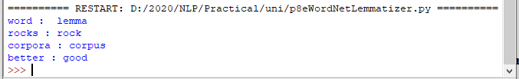

**9. Implement Naive Bayes classifier**

**Code:**

#pip install pandas

#pip install sklearn

import pandas as pd

import numpy as np

sms_data = pd.read_csv("spam.csv", encoding='latin-1')

import re

import nltk

from nltk.corpus import stopwords

from nltk.stem.porter import PorterStemmer

stemming = PorterStemmer()

corpus = []

for i in range (0,len(sms_data)):

s1 = re.sub('[^a-zA-Z]',repl = ' ',string = sms_data['v2'][i])

s1.lower()

s1 = s1.split()

s1 = [stemming.stem(word) for word in s1 if word not in set(stopwords.words('english'))]

s1 = ' '.join(s1)

corpus.append(s1)

from sklearn.feature_extraction.text import CountVectorizer

countvectorizer =CountVectorizer()

x = countvectorizer.fit_transform(corpus).toarray()

print(x)

y = sms_data['v1'].values

print(y)

from sklearn.model_selection import train_test_split

x_train,x_test,y_train,y_test = train_test_split(x,y,test_size = 0.3, stratify=y,random_state=2)

#Multinomial Naïve Bayes.

from sklearn.naive_bayes import MultinomialNB

multinomialnb = MultinomialNB()

multinomialnb.fit(x_train,y_train)

# Predicting on test data:

y_pred = multinomialnb.predict(x_test)

print(y_pred)

#Results of our Models

from sklearn.metrics import classification_report, confusion_matrix

from sklearn.metrics import accuracy_score

print(classification_report(y_test,y_pred))

print("accuracy_score: ",accuracy_score(y_test,y_pred))

**input:**

spam.csv file from github

**output:**

**10. a. Speech Tagging:**

**i.Speech tagging using spacy**

**code**

import spacy

sp = spacy.load('en_core_web_sm')

sen = sp(u"I like to play football. I hated it in my childhood though")

print(sen.text)

print(sen[7].pos_)

print(sen[7].tag_)

print(spacy.explain(sen[7].tag_))

for word in sen:

print(f'{word.text:{12}} {word.pos_:{10}} {word.tag_:{8}} {spacy.explain(word.tag_)}')

sen = sp(u'Can you google it?')

word = sen[2]

print(f'{word.text:{12}} {word.pos_:{10}} {word.tag_:{8}} {spacy.explain(word.tag_)}')

sen = sp(u'Can you search it on google?')

word = sen[5]

print(f'{word.text:{12}} {word.pos_:{10}} {word.tag_:{8}} {spacy.explain(word.tag_)}')

#Finding the Number of POS Tags

sen = sp(u"I like to play football. I hated it in my childhood though")

num_pos = sen.count_by(spacy.attrs.POS)

num_pos

for k,v in sorted(num_pos.items()):

print(f'{k}. {sen.vocab[k].text:{8}}: {v}')

#Visualizing Parts of Speech Tags

from spacy import displacy

sen = sp(u"I like to play football. I hated it in my childhood though")

displacy.serve(sen, style='dep', options={'distance': 120})

**output**:

To view the dependency tree, type the following address in your browser: http://127.0.0.1:5000/. You will see the following dependency tree:

**ii. Speech tagging using nktl**

**code:**

import nltk

from nltk.corpus import state_union

from nltk.tokenize import PunktSentenceTokenizer

#create our training and testing data:

train_text = state_union.raw("2005-GWBush.txt")

sample_text = state_union.raw("2006-GWBush.txt")

#train the Punkt tokenizer like:

custom_sent_tokenizer = PunktSentenceTokenizer(train_text)

# tokenize:

tokenized = custom_sent_tokenizer.tokenize(sample_text)

def process_content():

try:

for i in tokenized[:2]:

words = nltk.word_tokenize(i)

tagged = nltk.pos_tag(words)

print(tagged)

except Exception as e:

print(str(e))

process_content()

output:

**b. Statistical parsing:**

**i. Usage of Give and Gave in the Penn Treebank sample**

**Source code:**

#probabilitistic parser

#Usage of Give and Gave in the Penn Treebank sample

import nltk

import nltk.parse.viterbi

import nltk.parse.pchart

def give(t):

return t.label() == 'VP' and len(t) > 2 and t[1].label() == 'NP'\

and (t[2].label() == 'PP-DTV' or t[2].label() == 'NP')\

and ('give' in t[0].leaves() or 'gave' in t[0].leaves())

def sent(t):

return ' '.join(token for token in t.leaves() if token[0] not in '*-0')

def print_node(t, width):

output = "%s %s: %s / %s: %s" %\

(sent(t[0]), t[1].label(), sent(t[1]), t[2].label(), sent(t[2]))

if len(output) > width:

output = output[:width] + "..."

print (output)

for tree in nltk.corpus.treebank.parsed_sents():

for t in tree.subtrees(give):

print_node(t, 72)

**Output:**

**ii. probabilistic parser**

**Source code:**

import nltk

from nltk import PCFG

grammar = PCFG.fromstring('''

NP -> NNS [0.5] | JJ NNS [0.3] | NP CC NP [0.2]

NNS -> "men" [0.1] | "women" [0.2] | "children" [0.3] | NNS CC NNS [0.4]

JJ -> "old" [0.4] | "young" [0.6]

CC -> "and" [0.9] | "or" [0.1]

''')

print(grammar)

viterbi_parser = nltk.ViterbiParser(grammar)

token = "old men and women".split()

obj = viterbi_parser.parse(token)

print("Output: ")

for x in obj:

print(x)

**Output:**

**c. Malt parsing:**

**Parse a sentence and draw a tree using malt parsing.**

Note: 1) Java should be installed.

2) maltparser-1.7.2 zip file should be copied in C:\Users\Beena Kapadia\AppData\Local\Programs\Python\Python39 folder and should be extracted in the same folder.

3) engmalt.linear-1.7.mco file should be copied to C:\Users\Beena Kapadia\AppData\Local\Programs\Python\Python39 folder

**Source code:**

# copy maltparser-1.7.2(unzipped version) and engmalt.linear-1.7.mco files to C:\Users\Beena Kapadia\AppData\Local\Programs\Python\Python39 folder

# java should be installed

# environment variables should be set - MALT_PARSER - C:\Users\Beena Kapadia\AppData\Local\Programs\Python\Python39\maltparser-1.7.2 and MALT_MODEL - C:\Users\Beena Kapadia\AppData\Local\Programs\Python\Python39\engmalt.linear-1.7.mco

from nltk.parse import malt

mp = malt.MaltParser('maltparser-1.7.2', 'engmalt.linear-1.7.mco')#file

t = mp.parse_one('I saw a bird from my window.'.split()).tree()

print(t)

t.draw()

**Output:**

(saw I (bird a (from (window. my))))

1. **a) Multiword Expressions in NLP**

**Source code:**

# Multiword Expressions in NLP

from nltk.tokenize import MWETokenizer

from nltk import sent_tokenize, word_tokenize

s = '''Good cake cost Rs.1500\kg in Mumbai. Please buy me one of them.\n\nThanks.'''

mwe = MWETokenizer([('New', 'York'), ('Hong', 'Kong')], separator='_')

for sent in sent_tokenize(s):

print(mwe.tokenize(word_tokenize(sent)))

**Output:**

**b) Normalized Web Distance and Word Similarity**

**Source code:**

# Normalized Web Distance and Word Similarity

#convert

#Reliance supermarket

#Reliance hypermarket

#Reliance

#Reliance

#Reliance downtown

#Relianc market

#Mumbai

#Mumbai Hyper

#Mumbai dxb

#mumbai airport

#k.m trading

#KM Trading

#KM trade

#K.M. Trading

#KM.Trading

#into

#Reliance

#Reliance

#Reliance

#Reliance

#Reliance

#Reliance

#Mumbai

#Mumbai

#Mumbai

#Mumbai

#KM Trading

#KM Trading

#KM Trading

#KM Trading

#KM Trading

import numpy as np

import re

import textdistance # pip install textdistance

# we will need scikit-learn>=0.21

import sklearn #pip install sklearn

from sklearn.cluster import AgglomerativeClustering

texts = [

'Reliance supermarket', 'Reliance hypermarket', 'Reliance', 'Reliance', 'Reliance downtown', 'Relianc market',

'Mumbai', 'Mumbai Hyper', 'Mumbai dxb', 'mumbai airport',

'k.m trading', 'KM Trading', 'KM trade', 'K.M. Trading', 'KM.Trading'

]

def normalize(text):

""" Keep only lower-cased text and numbers"""

return re.sub('[^a-z0-9]+', ' ', text.lower())

def group_texts(texts, threshold=0.4):

""" Replace each text with the representative of its cluster"""

normalized_texts = np.array([normalize(text) for text in texts])

distances = 1 - np.array([

[textdistance.jaro_winkler(one, another) for one in normalized_texts]

for another in normalized_texts

])

clustering = AgglomerativeClustering(

distance_threshold=threshold, # this parameter needs to be tuned carefully

affinity="precomputed", linkage="complete", n_clusters=None

).fit(distances)

centers = dict()

for cluster_id in set(clustering.labels_):

index = clustering.labels_ == cluster_id

centrality = distances[:, index][index].sum(axis=1)

centers[cluster_id] = normalized_texts[index][centrality.argmin()]

return [centers[i] for i in clustering.labels_]

print(group_texts(texts))

**Output:**

**Source code:**

#Word Sense Disambiguation

from nltk.corpus import wordnet as wn

def get_first_sense(word, pos=None):

if pos:

synsets = wn.synsets(word,pos)

else:

synsets = wn.synsets(word)

return synsets[0]

best_synset = get_first_sense('bank')

print ('%s: %s' % (best_synset.name, best_synset.definition))

best_synset = get_first_sense('set','n')

print ('%s: %s' % (best_synset.name, best_synset.definition))

best_synset = get_first_sense('set','v')

print ('%s: %s' % (best_synset.name, best_synset.definition))

**Output:**

**c. Word Sense Disambiguation**

import codecs

from nltk.tokenize import PunktSentenceTokenizer,sent_tokenize, word_tokenize

from nltk.corpus import stopwords, wordnet

from nltk.stem import WordNetLemmatizer, PorterStemmer

def simpleFilter(sentence):

filtered_sent = []

lemmatizer = WordNetLemmatizer()

stop_words = set(stopwords.words("english"))

words = word_tokenize(sentence)

for w in words:

if w not in stop_words:

filtered_sent.append(lemmatizer.lemmatize(w))

return filtered_sent

def simlilarityCheck(word1, word2):

word1 = word1 + ".n.01"

word2 = word2 + ".n.01"

try:

w1 = wordnet.synset(word1)

w2 = wordnet.synset(word2)

return w1.wup_similarity(w2)

except:

return 0

def synonymsCreator(word):

synonyms = []

for syn in wordnet.synsets(word):

for i in syn.lemmas():

synonyms.append(i.name())

return synonyms

# Remove Stop Words . Word Stemming . Return new tokenised list.

def filteredSentence(sentence):

filtered_sent = []

lemmatizer = WordNetLemmatizer() #lemmatizes the words

ps = PorterStemmer() #stemmer stems the root of the word.

stop_words = set(stopwords.words("english"))

words = word_tokenize(sentence)

for w in words:

if w not in stop_words:

filtered_sent.append(lemmatizer.lemmatize(ps.stem(w)))

for i in synonymsCreator(w):

filtered_sent.append(i)

return filtered_sent

if __name__ == '__main__':

cricfile = codecs.open("E:\\Department\\MscIT_Sem_III_and sem I nov 2020\\NLP\\cricketbat.txt", 'r', "utf-8")

sent2 = cricfile.read().lower()

vampirefile = codecs.open("E:\\Department\\MscIT_Sem_III_and sem I nov 2020\\NLP\\vampirebat.txt", 'r', 'utf-8')

sent1 = vampirefile.read().lower()

sent3 = "start"

while(sent3 != "end"):

sent3 = input("Enter Query: ").lower()

filtered_sent1 = []

filtered_sent2 = []

filtered_sent3 = []

counter1 = 0

counter2 = 0

sent31_similarity = 0

sent32_similarity = 0

filtered_sent1 = simpleFilter(sent1)

filtered_sent2 = simpleFilter(sent2)

filtered_sent3 = simpleFilter(sent3)

for i in filtered_sent3:

for j in filtered_sent1:

counter1 = counter1 + 1

sent31_similarity = sent31_similarity + simlilarityCheck(i,j)

for j in filtered_sent2:

counter2 = counter2 + 1

sent32_similarity = sent32_similarity + simlilarityCheck(i,j)

filtered_sent1 = []

filtered_sent2 = []

filtered_sent3 = []

filtered_sent1 = filteredSentence(sent1)

filtered_sent2 = filteredSentence(sent2)

filtered_sent3 = filteredSentence(sent3)

sent1_count = 0

sent2_count = 0

for i in filtered_sent3:

for j in filtered_sent1:

if(i==j):

sent1_count = sent1_count + 1

for j in filtered_sent2:

if(i==j):

sent2_count = sent2_count + 1

if((sent1_count + sent31_similarity)>(sent2_count+sent32_similarity)):

print ("Mammal Bat")

else:

print ("Cricket Bat")

#-----------------------------------------------

#Sentence1: the river bank has water in it and it has fishes trees . lots of water is stored in the banks. boats float in it and animals come and drink water from it.

#sentence2: the commercial banks are used for finance. all the financial matters are managed by financial banks and they have lots of money, user accounts like salary account and savings account, current account. money can also be withdrawn from this bank.

#query: from which bank should i withdraw money.

#sen1: any of various nocturnal flying mammals of the order Chiroptera, having membranous wings that extend from the forelimbs to the hind limbs or tail and anatomical adaptations for echolocation, by which they navigate and hunt prey.

#sen 2: a cricket wooden bat is used for playing criket. it is rectangular in shape and has handle and is made of wood or plastic and is used by cricket players.

print ("\nTERMINATED")

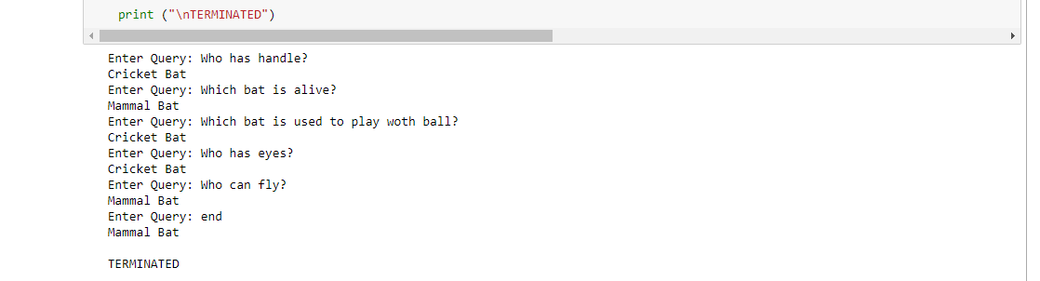

PAPER 3:

DEEP LEARNING

# Practical No:1

**Aim: Performing matrix multiplication and finding eigen vectors and eigen values using TensorFlow.**

import tensorflow as tf print("Matrix Multiplication Demo") x=tf.constant([1,2,3,4,5,6],shape=[2,3]) print(x)

y=tf.constant([7,8,9,10,11,12],shape=[3,2]) print(y) z=tf.matmul(x,y) print("Product:",z)

e_matrix_A=tf.random.uniform([2,2],minval=3,maxval=10,dtype=tf.float32,name="matrixA") print("Matrix A:\n{}\n\n".format(e_matrix_A)) eigen_values_A,eigen_vectors_A=tf.linalg.eigh(e_matrix_A)

print("Eigen Vectors:\n{}\n\nEigen Values:\n{}\n".format(eigen_vectors_A,eigen_values_A))

**OUTPUT:**

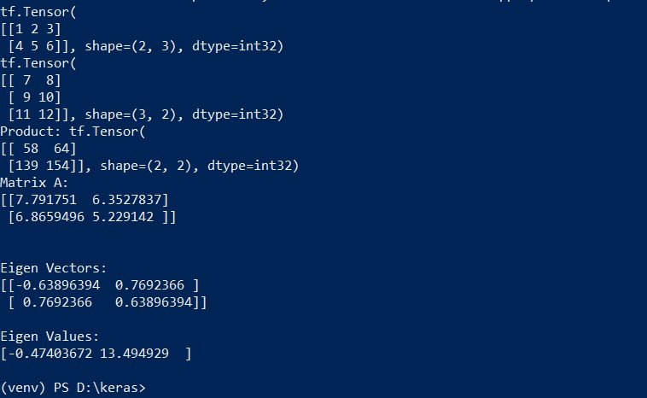

# Practical No:2

**Aim: Solving XOR problem using deep feed forward network.**

import numpy as np from keras.layers import Dense from keras.models import Sequential model=Sequential()

model.add(Dense(units=2,activation='relu',input_dim=2)) model.add(Dense(units=1,activation='sigmoid'))

model.compile(loss='binary_crossentropy',optimizer='adam',metrics=['accuracy']) print(model.summary()) print(model.get_weights())

X=np.array([[0.,0.],[0.,1.],[1.,0.],[1.,1.]]) Y=np.array([0.,1.,1.,0.])

model.fit(X,Y,epochs=1000,batch_size=4) print(model.get_weights()) print(model.predict(X,batch_size=4))

**OUTPUT:**

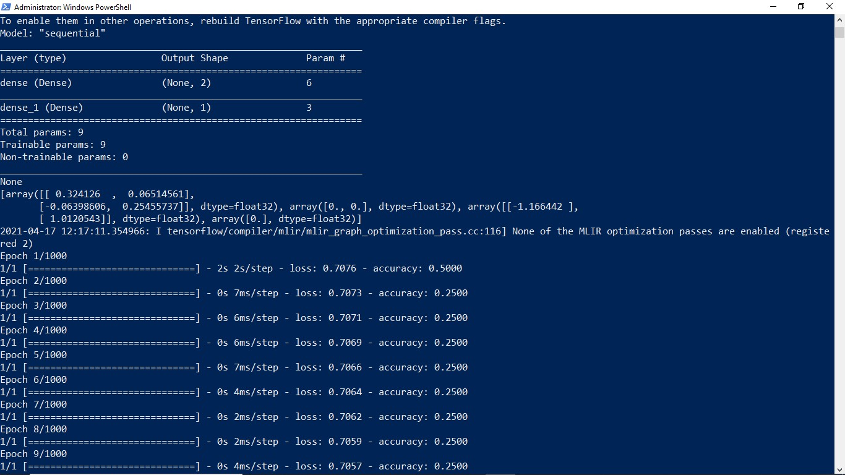

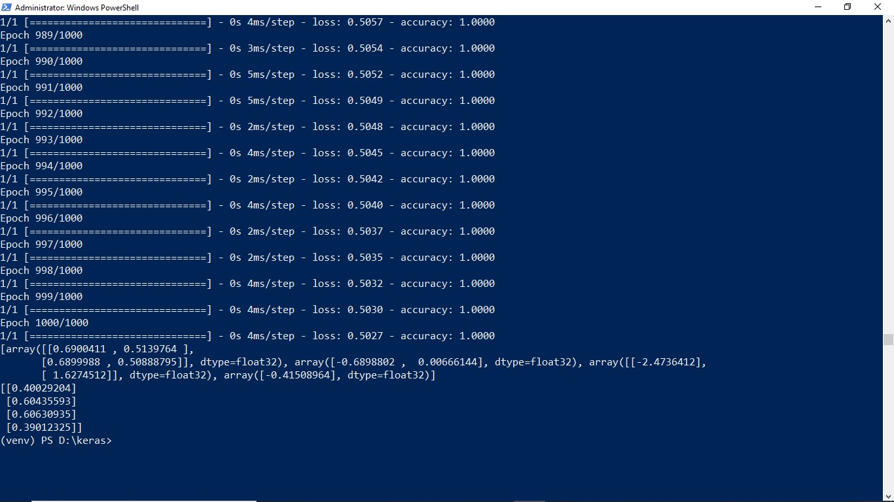

# Practical No:3

**Aim: Implementing deep neural network for performing classification task.**

**Problem statement:** the given dataset comprises of health information about diabetic women patient. we need to create deep feed forward network that will classify women suffering from diabetes mellitus as 1.

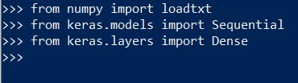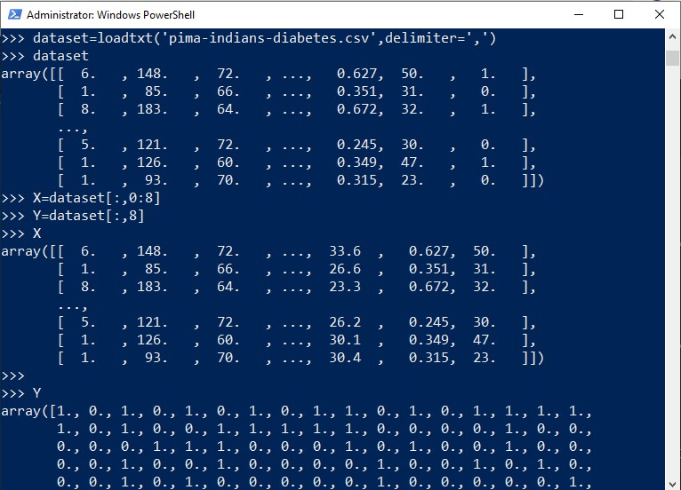

Creating model:

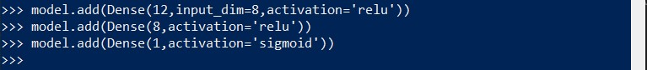

Compiling and fitting model:

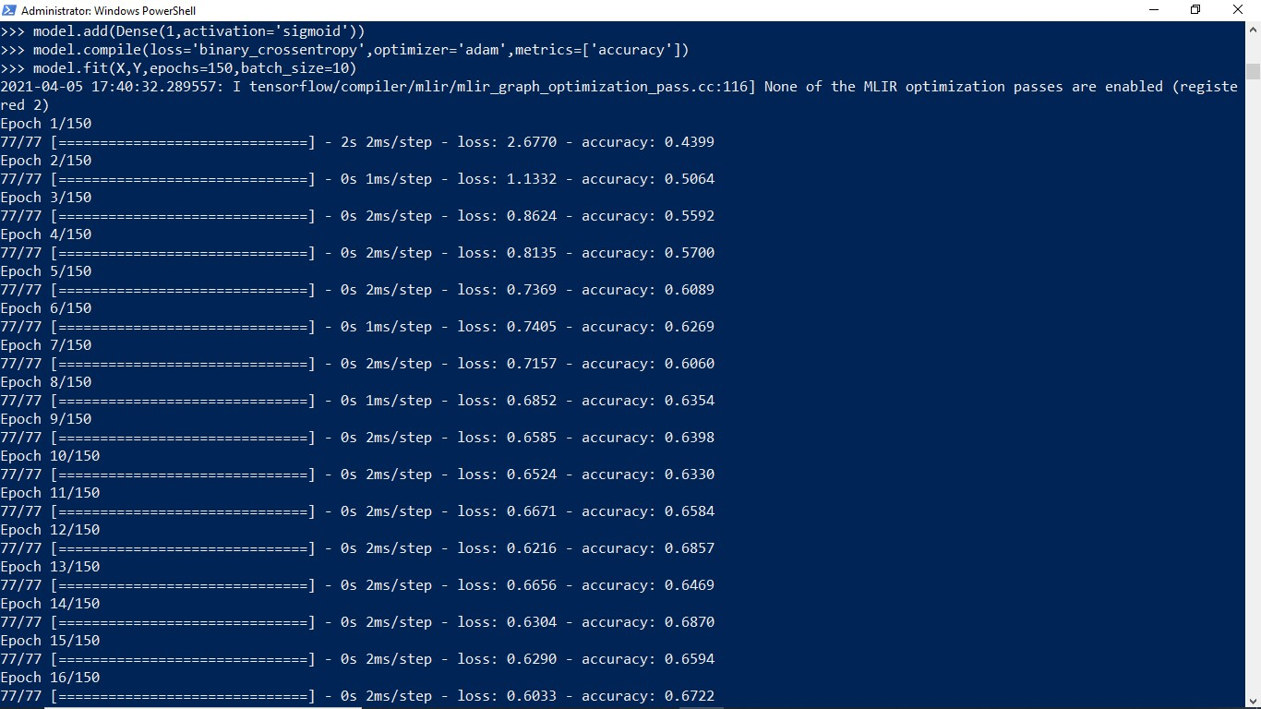

Evaluating the accuracy:

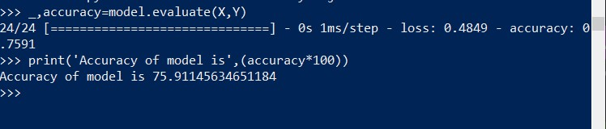

Using model for prediction class:



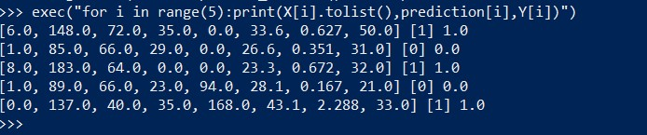

# Practical No:4

**a) Aim: Using deep feed forward network with two hidden layers for performing classification and predicting the class.**

from keras.models import Sequential from keras.layers import Dense from sklearn.datasets import make_blobs from sklearn.preprocessing import MinMaxScaler

X,Y=make_blobs(n_samples=100,centers=2,n_features=2,random_state=1) scalar=MinMaxScaler() scalar.fit(X)

X=scalar.transform(X)

model=Sequential()

model.add(Dense(4,input_dim=2,activation='relu')) model.add(Dense(4,activation='relu')) model.add(Dense(1,activation='sigmoid'))

model.compile(loss='binary_crossentropy',optimizer='adam') model.fit(X,Y,epochs=500)

Xnew,Yreal=make_blobs(n_samples=3,centers=2,n_features=2,random_state=1) Xnew=scalar.transform(Xnew)

Ynew=model.predict_classes(Xnew) for i in range(len(Xnew)):

print("X=%s,Predicted=%s,Desired=%s"%(Xnew[i],Ynew[i],Yreal[i]))

**OUTPUT:**

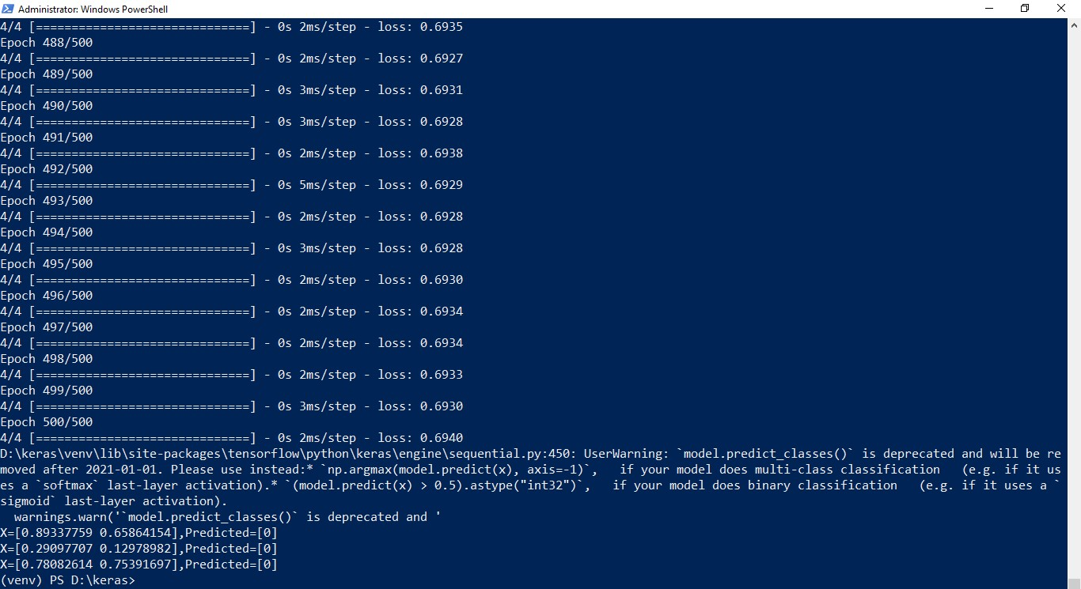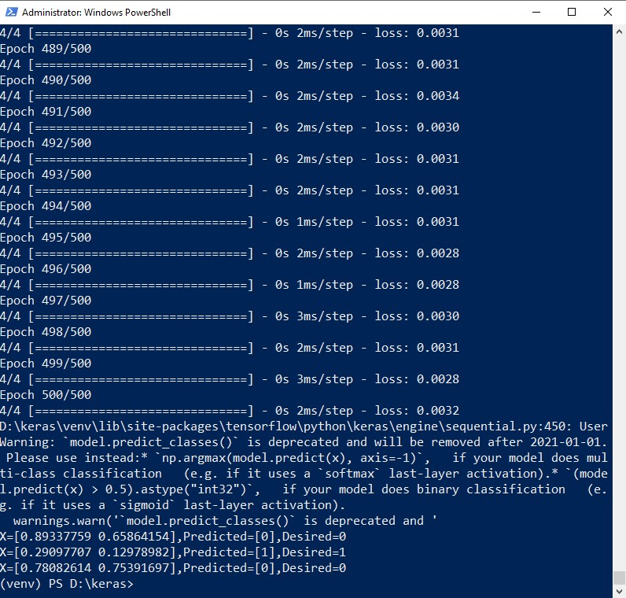

**b) Aim: Using a deep field forward network with two hidden layers for performing classification and predicting the probability of class.**

from keras.models import Sequential from keras.layers import Dense from sklearn.datasets import make_blobs from sklearn.preprocessing import MinMaxScaler

X,Y=make_blobs(n_samples=100,centers=2,n_features=2,random_state=1) scalar=MinMaxScaler() scalar.fit(X)

X=scalar.transform(X) model=Sequential()

model.add(Dense(4,input_dim=2,activation='relu')) model.add(Dense(4,activation='relu')) model.add(Dense(1,activation='sigmoid'))

model.compile(loss='binary_crossentropy',optimizer='adam') model.fit(X,Y,epochs=500)

Xnew,Yreal=make_blobs(n_samples=3,centers=2,n_features=2,random_state=1)

Xnew=scalar.transform(Xnew)

Yclass=model.predict_classes(Xnew) Ynew=model.predict_proba(Xnew) for i in range(len(Xnew)):

print("X=%s,Predicted_probability=%s,Predicted_class=%s"%(Xnew[i],Ynew[i],Yclass[i]))

**OUTPUT:**

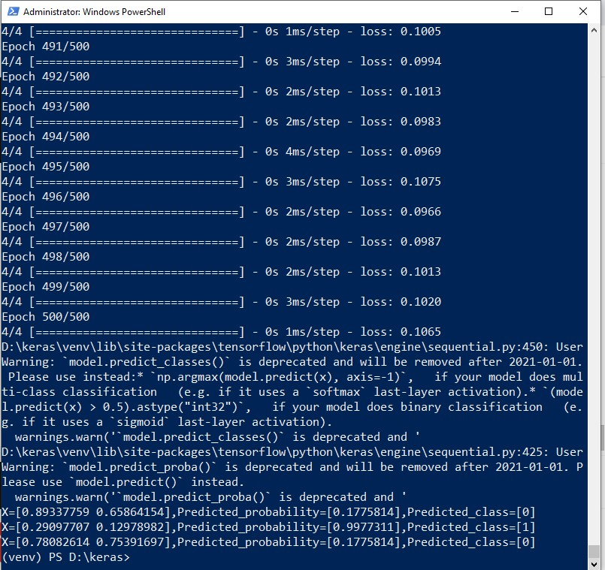

**c) Aim: Using a deep field forward network with two hidden layers for performing linear regression and predicting values.**

from keras.models import Sequential from keras.layers import Dense from sklearn.datasets import make_regression from sklearn.preprocessing import MinMaxScaler

X,Y=make_regression(n_samples=100,n_features=2,noise=0.1,random_state=1) scalarX,scalarY=MinMaxScaler(),MinMaxScaler()

scalarX.fit(X)

scalarY.fit(Y.reshape(100,1))

X=scalarX.transform(X)

Y=scalarY.transform(Y.reshape(100,1))

model=Sequential()

model.add(Dense(4,input_dim=2,activation='relu')) model.add(Dense(4,activation='relu')) model.add(Dense(1,activation='sigmoid')) model.compile(loss='mse',optimizer='adam') model.fit(X,Y,epochs=1000,verbose=0)

Xnew,a=make_regression(n_samples=3,n_features=2,noise=0.1,random_state=1)

Xnew=scalarX.transform(Xnew)

Ynew=model.predict(Xnew)

for i in range(len(Xnew)):

print("X=%s,Predicted=%s"%(Xnew[i],Ynew[i]))

**OUTPUT:**

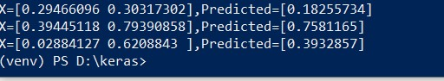

# Practical No:5(a)

**Aim: Evaluating feed forward deep network for regression using KFold cross validation.**

import pandas as pd

from keras.models import Sequential from keras.layers import Dense

from keras.wrappers.scikit_learn import KerasRegressor from sklearn.model_selection import cross_val_score from sklearn.model_selection import KFold from sklearn.preprocessing import StandardScaler from sklearn.pipeline import Pipeline

dataframe=pd.read_csv("housing.csv",delim_whitespace=True,header=None) dataset=dataframe.values

X=dataset[:,0:13] Y=dataset[:,13] def wider_model():

model=Sequential()

model.add(Dense(15,input_dim=13,kernel_initializer='normal',activation='relu')) model.add(Dense(13,kernel_initializer='normal',activation='relu')) model.add(Dense(1,kernel_initializer='normal')) model.compile(loss='mean_squared_error',optimizer='adam') return model estimators=[]

estimators.append(('standardize',StandardScaler()))

estimators.append(('mlp',KerasRegressor(build_fn=wider_model,epochs=100,batch_size=5))) pipeline=Pipeline(estimators) kfold=KFold(n_splits=10)

results=cross_val_score(pipeline,X,Y,cv=kfold)

print("Wider: %.2f (%.2f) MSE" % (results.mean(), results.std()))

**OUTPUT:**



(After changing neuron)

model.add(Dense(20, input_dim=13,kernel_initializer='normal',activation='relu'))



## Practical No :6

**Aim: implementing regularization to avoid overfitting in binary classification.**

from matplotlib import pyplot from sklearn.datasets import make_moons from keras.models import Sequential from keras.layers import Dense

X,Y=make_moons(n_samples=100,noise=0.2,random_state=1) n_train=30

trainX,testX=X[:n_train,:],X[n_train:] trainY,testY=Y[:n_train],Y[n_train:]

#print(trainX)

#print(trainY)

#print(testX) #print(testY) model=Sequential()

model.add(Dense(500,input_dim=2,activation='relu')) model.add(Dense(1,activation='sigmoid'))

model.compile(loss='binary_crossentropy',optimizer='adam',metrics=['accuracy']) history=model.fit(trainX,trainY,validation_data=(testX,testY),epochs=4000) pyplot.plot(history.history['accuracy'],label='train') pyplot.plot(history.history['val_accuracy'],label='test') pyplot.legend() pyplot.show()

**OUTPUT:**

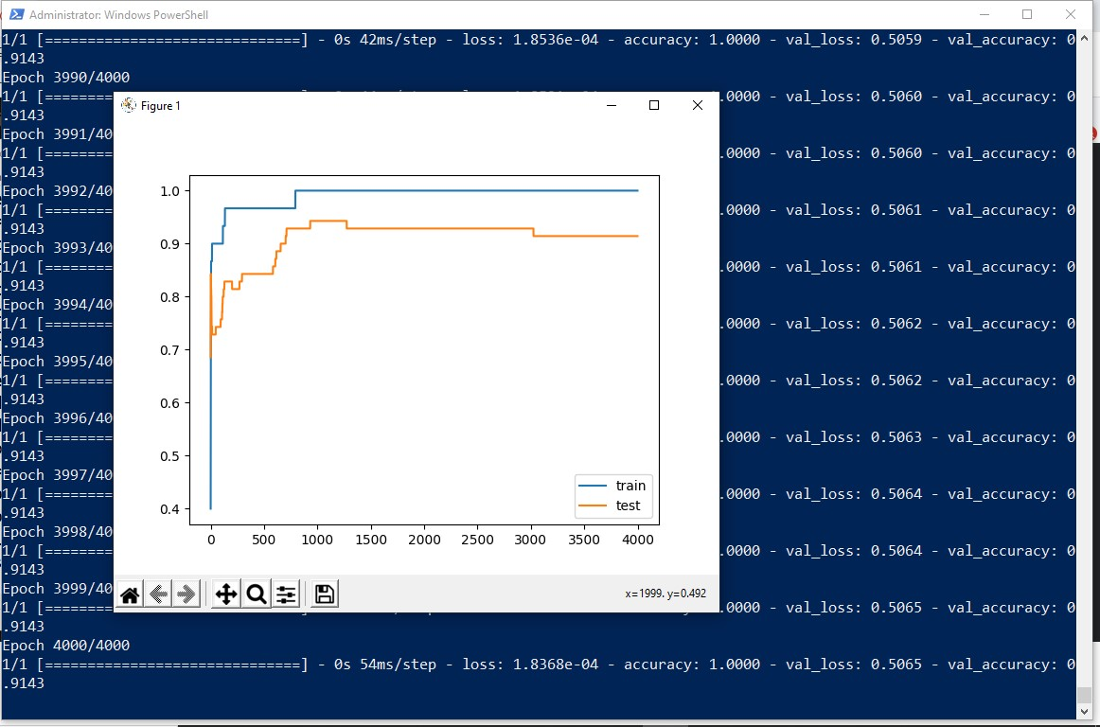

The above code and resultant graph demonstrate overfitting with accuracy of testing data less than accuracy of training data also the accuracy of testing data increases once and then start decreases gradually.to solve this problem we can use regularization

Hence, we will add two lines in the above code as highlighted below to implement l2 regularization with alpha=0.001

from matplotlib import pyplot from sklearn.datasets import make_moons from keras.models import Sequential from keras.layers import Dense **from keras.regularizers import l2**

X,Y=make_moons(n_samples=100,noise=0.2,random_state=1) n_train=30

trainX,testX=X[:n_train,:],X[n_train:] trainY,testY=Y[:n_train],Y[n_train:]

#print(trainX)

#print(trainY)

#print(testX) #print(testY) model=Sequential()

model.add(Dense(500,input_dim=2,activation='relu',**kernel_regularizer=l2(0.001)))** model.add(Dense(1,activation='sigmoid')) model.compile(loss='binary_crossentropy',optimizer='adam',metrics=['accuracy']) history=model.fit(trainX,trainY,validation_data=(testX,testY),epochs=4000) pyplot.plot(history.history['accuracy'],label='train') pyplot.plot(history.history['val_accuracy'],label='test') pyplot.legend() pyplot.show()

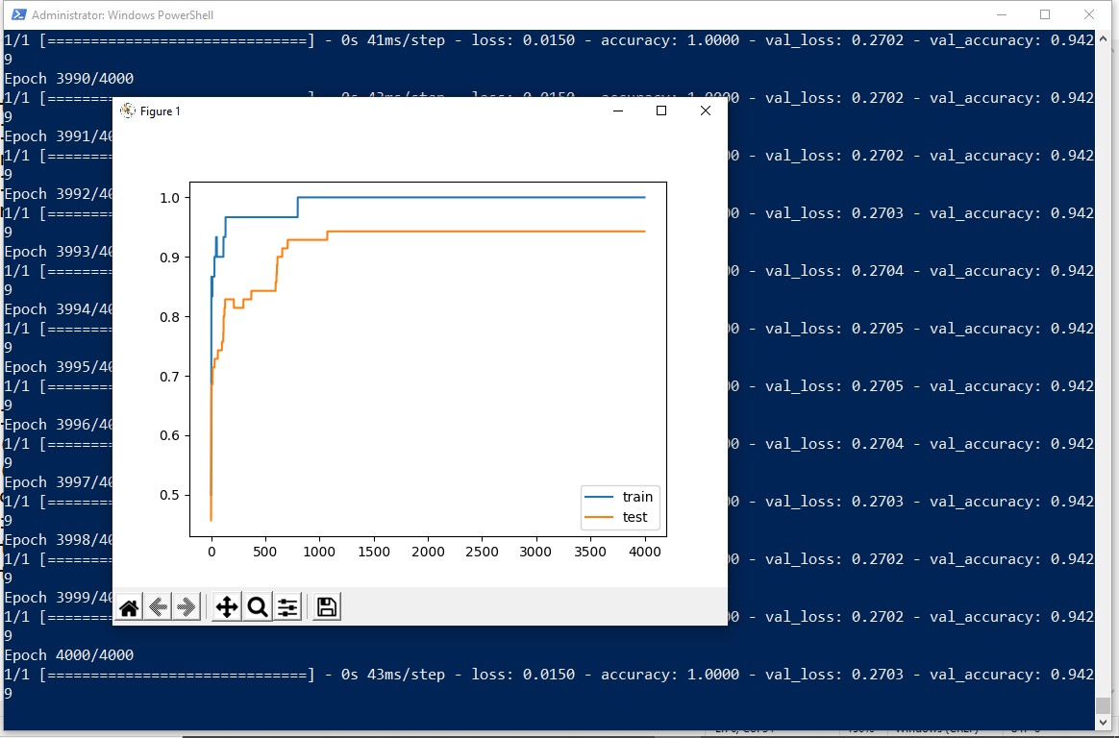

By replacing l2 regularizer with l1 regularizer at the same learning rate 0.001 we get the following output.

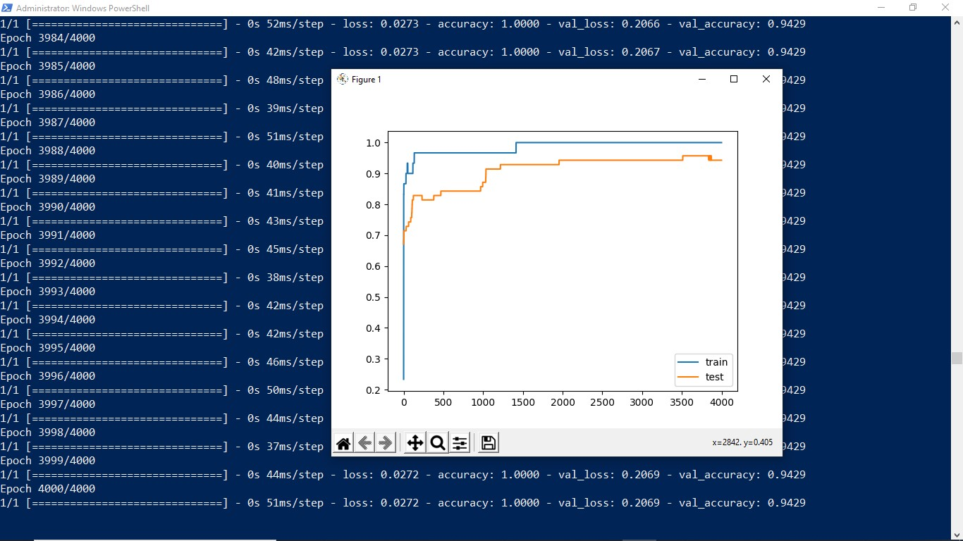

By applying l1 and l2 regularizer we can observe the following changes in accuracy of both trainig and testing data. The changes in code are also highlighted.

from matplotlib import pyplot from sklearn.datasets import make_moons from keras.models import Sequential from keras.layers import Dense **from keras.regularizers import l1_l2**

X,Y=make_moons(n_samples=100,noise=0.2,random_state=1) n_train=30

trainX,testX=X[:n_train,:],X[n_train:] trainY,testY=Y[:n_train],Y[n_train:]

#print(trainX)

#print(trainY)

#print(testX) #print(testY) model=Sequential()

model.add(Dense(500,input_dim=2,activation='relu',kernel_regularizer=**l1_l2(l1=0.001,l2=0.001)**)) model.add(Dense(1,activation='sigmoid'))

model.compile(loss='binary_crossentropy',optimizer='adam',metrics=['accuracy']) history=model.fit(trainX,trainY,validation_data=(testX,testY),epochs=4000) pyplot.plot(history.history['accuracy'],label='train') pyplot.plot(history.history['val_accuracy'],label='test') pyplot.legend() pyplot.show()

**OUTPUT:**

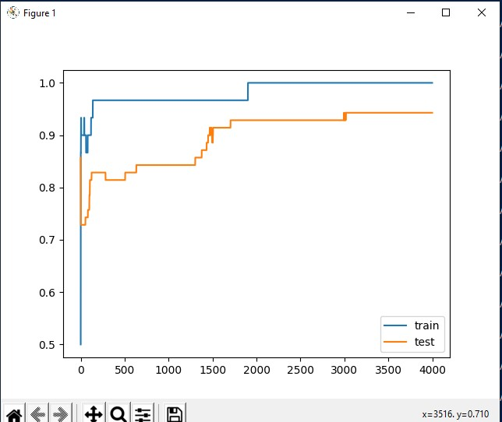

## Practical No:7

**Aim: Demonstrate recurrent neural network that learns to perform sequence analysis for stock price.**

import numpy as np import matplotlib.pyplot as plt import pandas as pd from keras.models import Sequential from keras.layers import Dense from keras.layers import LSTM from keras.layers import Dropout from sklearn.preprocessing import MinMaxScaler dataset_train=pd.read_csv('Google_Stock_price_train.csv')

#print(dataset_train)

training_set=dataset_train.iloc[:,1:2].values

#print(training_set) sc=MinMaxScaler(feature_range=(0,1)) training_set_scaled=sc.fit_transform(training_set)

#print(training_set_scaled)

X_train=[] Y_train=[] for i in range(60,1258):

X_train.append(training_set_scaled[i-60:i,0])

Y_train.append(training_set_scaled[i,0]) X_train,Y_train=np.array(X_train),np.array(Y_train) print(X_train) print('*********************************************') print(Y_train)

X_train=np.reshape(X_train,(X_train.shape[0],X_train.shape[1],1)) print('**********************************************') print(X_train) regressor=Sequential() regressor.add(LSTM(units=50,return_sequences=True,input_shape=(X_train.shape[1],1))) regressor.add(Dropout(0.2)) regressor.add(LSTM(units=50,return_sequences=True)) regressor.add(Dropout(0.2)) regressor.add(LSTM(units=50,return_sequences=True)) regressor.add(Dropout(0.2)) regressor.add(LSTM(units=50)) regressor.add(Dropout(0.2)) regressor.add(Dense(units=1))

regressor.compile(optimizer='adam',loss='mean_squared_error') regressor.fit(X_train,Y_train,epochs=100,batch_size=32)

dataset_test=pd.read_csv('Google_Stock_price_Test.csv') real_stock_price=dataset_test.iloc[:,1:2].values

dataset_total=pd.concat((dataset_train['Open'],dataset_test['Open']),axis=0) inputs=dataset_total[len(dataset_total)-len(dataset_test)-60:].values inputs=inputs.reshape(-1,1) inputs=sc.transform(inputs) X_test=[] for i in range(60,80):

X_test.append(inputs[i-60:i,0])

X_test=np.array(X_test)

X_test=np.reshape(X_test,(X_test.shape[0],X_test.shape[1],1)) predicted_stock_price=regressor.predict(X_test)

predicted_stock_price=sc.inverse_transform(predicted_stock_price) plt.plot(real_stock_price,color='red',label='real google stock price') plt.plot(predicted_stock_price,color='blue',label='predicted stock price') plt.xlabel('time') plt.ylabel('google stock price') plt.legend() plt.show()

**OUTPUT:**

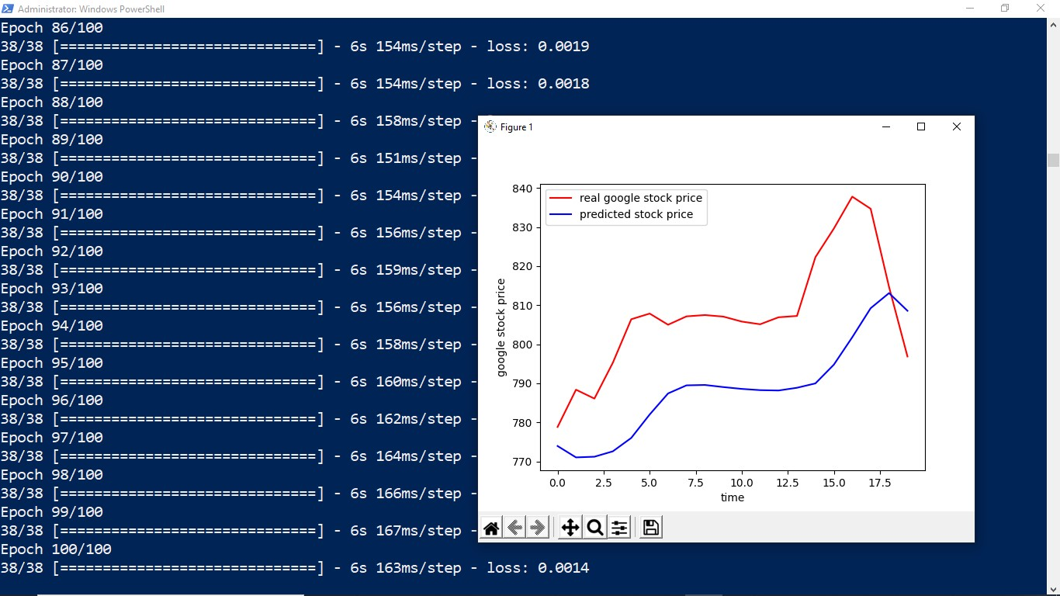

## Practical No:8

**Aim: Performing encoding and decoding of images using deep autoencoder.**

import keras from keras import layers from keras.datasets import mnist import numpy as np encoding_dim=32

#this is our input image input_img=keras.Input(shape=(784,))

#"encoded" is the encoded representation of the input encoded=layers.Dense(encoding_dim, activation='relu')(input_img)

#"decoded" is the lossy reconstruction of the input decoded=layers.Dense(784, activation='sigmoid')(encoded)

#creating autoencoder model autoencoder=keras.Model(input_img,decoded)

#create the encoder model encoder=keras.Model(input_img,encoded) encoded_input=keras.Input(shape=(encoding_dim,)) #Retrive the last layer of the autoencoder model decoder_layer=autoencoder.layers[-1] #create the decoder model decoder=keras.Model(encoded_input,decoder_layer(encoded_input)) autoencoder.compile(optimizer='adam',loss='binary_crossentropy')

#scale and make train and test dataset

(X_train,_),(X_test,_)=mnist.load_data() X_train=X_train.astype('float32')/255.

X_test=X_test.astype('float32')/255.

X_train=X_train.reshape((len(X_train),np.prod(X_train.shape[1:]))) X_test=X_test.reshape((len(X_test),np.prod(X_test.shape[1:]))) print(X_train.shape) print(X_test.shape)

#train autoencoder with training dataset autoencoder.fit(X_train,X_train, epochs=50, batch_size=256, shuffle=True, validation_data=(X_test,X_test)) encoded_imgs=encoder.predict(X_test) decoded_imgs=decoder.predict(encoded_imgs) import matplotlib.pyplot as plt n = 10 # How many digits we will display plt.figure(figsize=(40, 4)) for i in range(10): # display original ax = plt.subplot(3, 20, i + 1) plt.imshow(X_test[i].reshape(28, 28)) plt.gray() ax.get_xaxis().set_visible(False) ax.get_yaxis().set_visible(False) # display encoded image ax = plt.subplot(3, 20, i + 1 + 20) plt.imshow(encoded_imgs[i].reshape(8,4)) plt.gray() ax.get_xaxis().set_visible(False) ax.get_yaxis().set_visible(False) # display reconstruction ax = plt.subplot(3, 20, 2*20 +i+ 1) plt.imshow(decoded_imgs[i].reshape(28, 28)) plt.gray() ax.get_xaxis().set_visible(False) ax.get_yaxis().set_visible(False) plt.show()

**OUTPUT:**

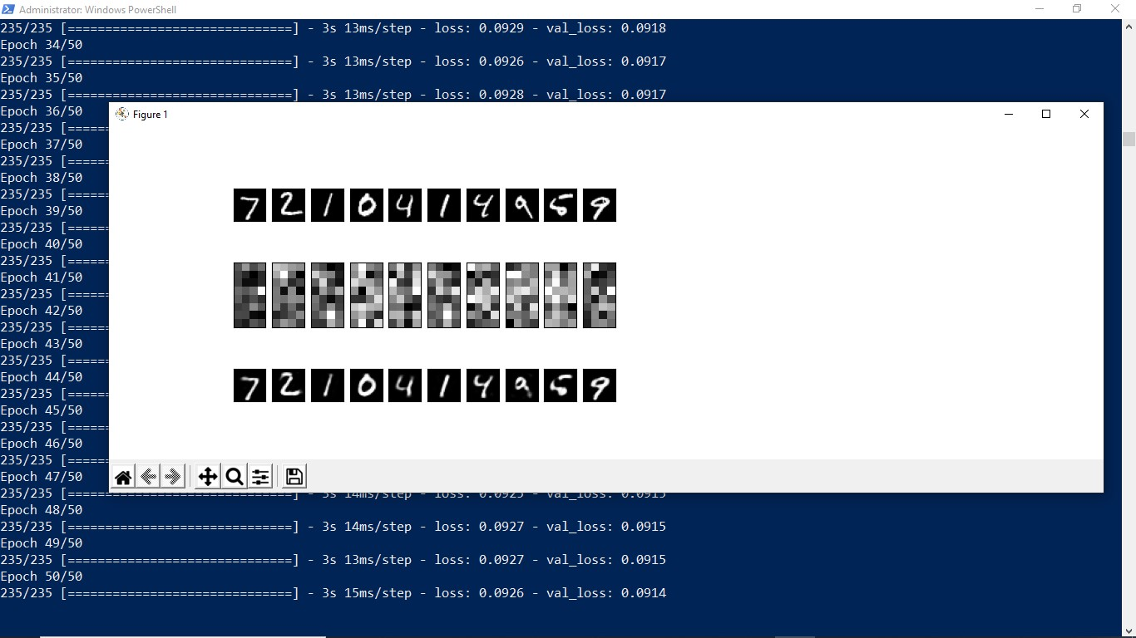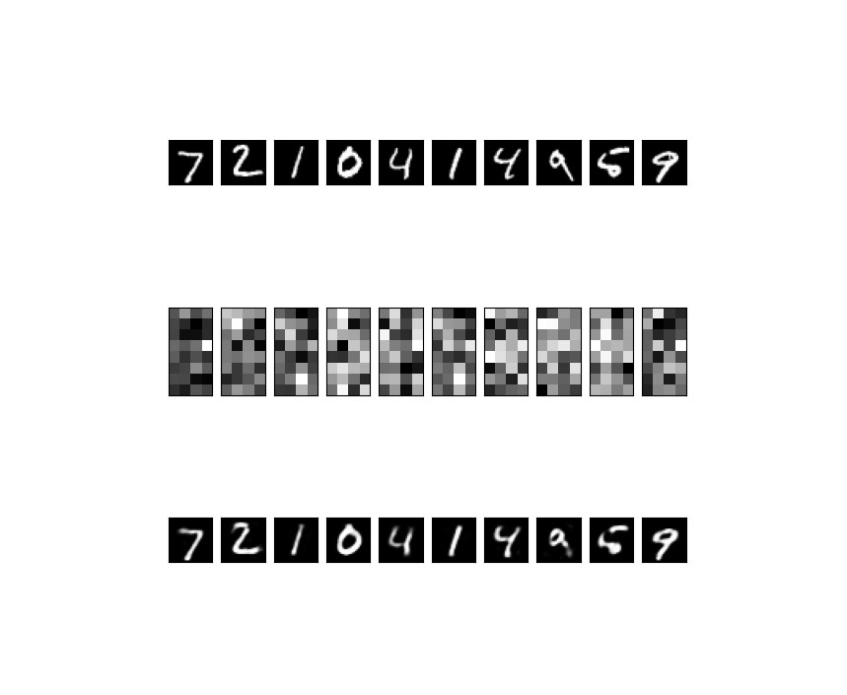

## Practical No:5b

**Aim: Evaluating feed forward deep network for multiclass Classification using KFold cross-validation.**

#loading libraries import pandas

from keras.models import Sequential

from keras.layers import Dense

from keras.wrappers.scikit_learn import KerasClassifier from keras.utils import np_utils

from sklearn.model_selection import cross_val_score from sklearn.model_selection import KFold from sklearn.preprocessing import LabelEncoder

#loading dataset

df=pandas.read_csv('Flower.csv',header=None) print(df)

#splitting dataset into input and output variables X = df.iloc[:,0:4].astype(float) y=df.iloc[:,4] #print(X)

#print(y)

#encoding string output into numeric output encoder=LabelEncoder() encoder.fit(y)

encoded_y=encoder.transform(y) print(encoded_y)

dummy_Y=np_utils.to_categorical(encoded_y) print(dummy_Y) def baseline_model():

# create model model = Sequential()

model.add(Dense(8, input_dim=4, activation='relu')) model.add(Dense(3, activation='softmax'))

# Compile model

model.compile(loss='categorical_crossentropy', optimizer='adam', metrics=['accuracy']) return model

estimator=baseline_model()

estimator.fit(X,dummy_Y,epochs=100,shuffle=True) action=estimator.predict(X)

for i in range(25):

print(dummy_Y[i]) print('^^^^^^^^^^^^^^^^^^^^^^') for i in range(25): print(action[i])

**OUTPUT:**

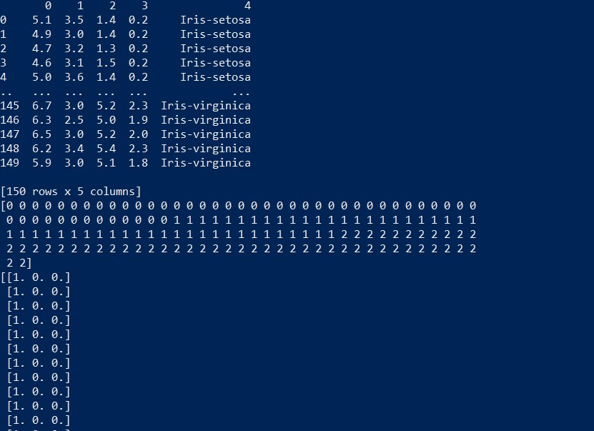

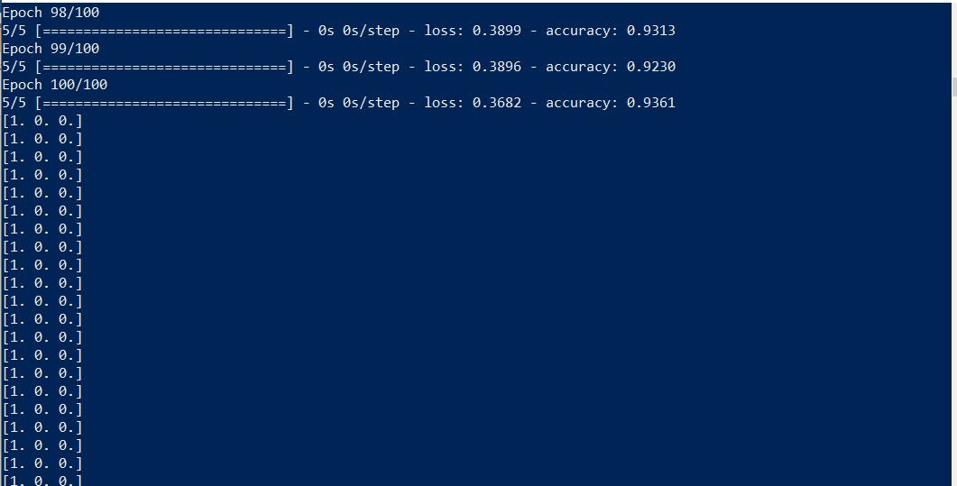

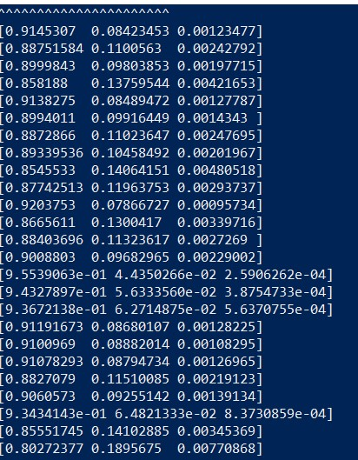

**Code 2:** import pandas

from keras.models import Sequential from keras.layers import Dense

from keras.wrappers.scikit_learn import KerasClassifier from keras.utils import np_utils

from sklearn.model_selection import cross_val_score from sklearn.model_selection import KFold from sklearn.preprocessing import LabelEncoder

dataset=pandas.read_csv("Flower.csv",header=None) dataset1=dataset.values

X=dataset1[:,0:4].astype(float) Y=dataset1[:,4] print(Y)

encoder=LabelEncoder() encoder.fit(Y)

encoder_Y=encoder.transform(Y) print(encoder_Y)

dummy_Y=np_utils.to_categorical(encoder_Y) print(dummy_Y) def baseline_model():

model=Sequential()

model.add(Dense(8,input_dim=4,activation='relu')) model.add(Dense(3,activation='softmax'))

model.compile(loss='categorical_crossentropy',optimizer='adam',metrics=['accuracy']) return model

estimator=KerasClassifier(build_fn=baseline_model,epochs=100,batch_size=5) kfold = KFold(n_splits=10, shuffle=True)

results = cross_val_score(estimator, X, dummy_Y, cv=kfold)

print("Baseline: %.2f%% (%.2f%%)" % (results.mean()*100, results.std()*100))



(Changing neuron)

model.add(Dense(10,input_dim=4,activation='relu'))



**Practical No:10**

**AIM : Denoising of images using autoencoder.**

import keras from keras.datasets import mnist from keras import layers import numpy as np

from keras.callbacks import TensorBoard import matplotlib.pyplot as plt (X_train,_),(X_test,_)=mnist.load_data() X_train=X_train.astype('float32')/255.

X_test=X_test.astype('float32')/255.

X_train=np.reshape(X_train,(len(X_train),28,28,1)) X_test=np.reshape(X_test,(len(X_test),28,28,1)) noise_factor=0.5

X_train_noisy=X_train+noise_factor*np.random.normal(loc=0.0,scale=1.0,size=X_train.shape)

X_test_noisy=X_test+noise_factor*np.random.normal(loc=0.0,scale=1.0,size=X_test.shape)

X_train_noisy=np.clip(X_train_noisy,0.,1.) X_test_noisy=np.clip(X_test_noisy,0.,1.) n=10

plt.figure(figsize=(20,2)) for i in range(1,n+1): ax=plt.subplot(1,n,i) plt.imshow(X_test_noisy[i].reshape(28,28)) plt.gray() ax.get_xaxis().set_visible(False) ax.get_yaxis().set_visible(False) plt.show() input_img=keras.Input(shape=(28,28,1))

x=layers.Conv2D(32,(3,3),activation='relu',padding='same')(input_img) x=layers.MaxPooling2D((2,2),padding='same')(x) x=layers.Conv2D(32,(3,3),activation='relu',padding='same')(x) encoded=layers.MaxPooling2D((2,2),padding='same')(x) x=layers.Conv2D(32,(3,3),activation='relu',padding='same')(encoded) x=layers.UpSampling2D((2,2))(x) x=layers.Conv2D(32,(3,3),activation='relu',padding='same')(x) x=layers.UpSampling2D((2,2))(x) decoded=layers.Conv2D(1,(3,3),activation='sigmoid',padding='same')(x) autoencoder=keras.Model(input_img,decoded) autoencoder.compile(optimizer='adam',loss='binary_crossentropy') autoencoder.fit(X_train_noisy,X_train,

epochs=3, batch_size=128, shuffle=True,

validation_data=(X_test_noisy,X_test),

callbacks=[TensorBoard(log_dir='/tmo/tb',histogram_freq=0,write_graph=False)]) predictions=autoencoder.predict(X_test_noisy) m=10

plt.figure(figsize=(20,2)) for i in range(1,m+1): ax=plt.subplot(1,m,i) plt.imshow(predictions[i].reshape(28,28)) plt.gray() ax.get_xaxis().set_visible(False) ax.get_yaxis().set_visible(False) plt.show()

**OUTPUT:**

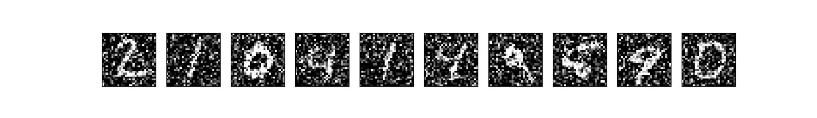

After 3 epochs:

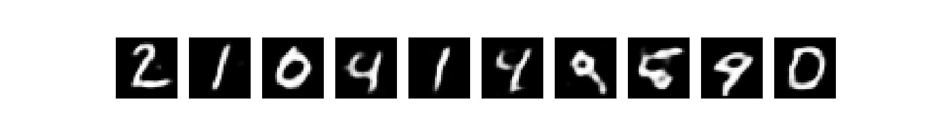

## Practical No:9

**Aim: Implementation of convolutional neural network to predict numbers from number images**

from keras.datasets import mnist from keras.utils import to_categorical from keras.models import Sequential from keras.layers import Dense,Conv2D,Flatten import matplotlib.pyplot as plt

#download mnist data and split into train and test sets

(X_train,Y_train),(X_test,Y_test)=mnist.load_data()

#plot the first image in the dataset plt.imshow(X_train[0]) plt.show()

print(X_train[0].shape)

X_train=X_train.reshape(60000,28,28,1)

X_test=X_test.reshape(10000,28,28,1)

Y_train=to_categorical(Y_train)

Y_test=to_categorical(Y_test) Y_train[0] print(Y_train[0])

model=Sequential() #add model layers #learn image features

model.add(Conv2D(64,kernel_size=3,activation='relu',input_shape=(28,28,1))) model.add(Conv2D(32,kernel_size=3,activation='relu'))

model.add(Flatten())

model.add(Dense(10,activation='softmax')) model.compile(optimizer='adam',loss='categorical_crossentropy',metrics=['accuracy'])

#train

model.fit(X_train,Y_train,validation_data=(X_test,Y_test),epochs=3)

print(model.predict(X_test[:4]))

#actual results for 1st 4 images in the test set print(Y_test[:4])

**OUTPUT:**

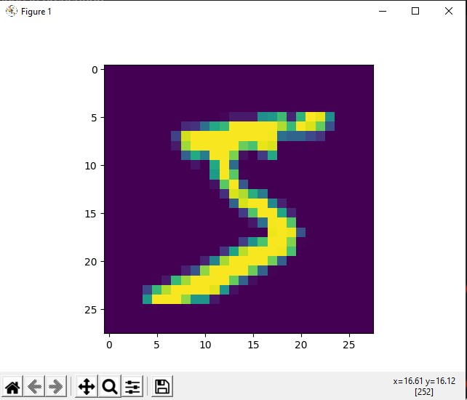

(28, 28)

[0. 0. 0. 0. 0. 1. 0. 0. 0. 0.]



