ASRS Predictive Maintenance System
Weekly Progress Report — Executive Summary
Lenskart fulfilment plant · six-aisle ASRS | Week ending 6 July 2026

This report summarises the ASRS Predictive Maintenance (PdM) system and this week's progress. The system infers the health of every physical component in the automated storage & retrieval system purely from Grafana operational and error data — there is no maintenance logbook — and predicts what is degrading, how urgently, and why, so maintenance is scheduled proactively instead of reacting to breakdowns. The module set is complete (11/11) and the system is running against live plant data. This summary covers the system's purpose, architecture, and methodology; the eleven equipment modules; the current live fleet state; this week's deliverables; and the outlook.
11  Modules (complete) | 771  Components monitored | 90  Fleet health / 100 | 22  Critical now | 36  Automated tests | CSV  Single database store

1 The Problem & Our Approach

The plant runs a six-aisle ASRS — lifts, shuttles, conveyors, gates, bins, scanners, decant stations, a comms layer and a controller. When a component degrades the usual outcomes are an unplanned breakdown (lost throughput, missed dispatch) or over-servicing of parts that were fine. Crucially there is no maintenance logbook or failure history to train a classical model on — but the plant already produces rich Grafana operational and error data. This system turns that data into predictive maintenance using four ideas:
- Condition monitoring, not failure regression — each component starts at 100 health and loses weighted, capped penalties for each unhealthy signal (error/fault rate, severity mix, recurrence, peer & self deviation): health = clamp(100 − Σ penalties, 0, 100), mapped to a tier (ok / watch / warn / critical).
- The store beats the 2-day window — Grafana retains ~2 days, so every run snapshots each component's metrics into a longitudinal store. Over runs this becomes a history far longer than any single fetch, enabling recurrence, persistence and trend-based remaining-useful-life (RUL).
- Per-component → per-module → system — each physical unit gets its own verdict; a module tile shows its worst component; and a Meta layer collapses correlated failures across modules into one compound incident with a likely common cause, so operators chase one root issue rather than ten symptoms.
- Explainable & auditable — every flag carries a root-cause attribution (dominant signals + error mix) and a confidence, and every run is a traceable trigger, so a recommendation can always be justified to the maintenance team.
2 System Architecture

A single process on one LAN PC serves the dashboard and runs automation. A PdM run is a four-stage pipeline — fetch → features → health → persist — and the CSV database is the shared source of truth: written by every run, read by the dashboard.
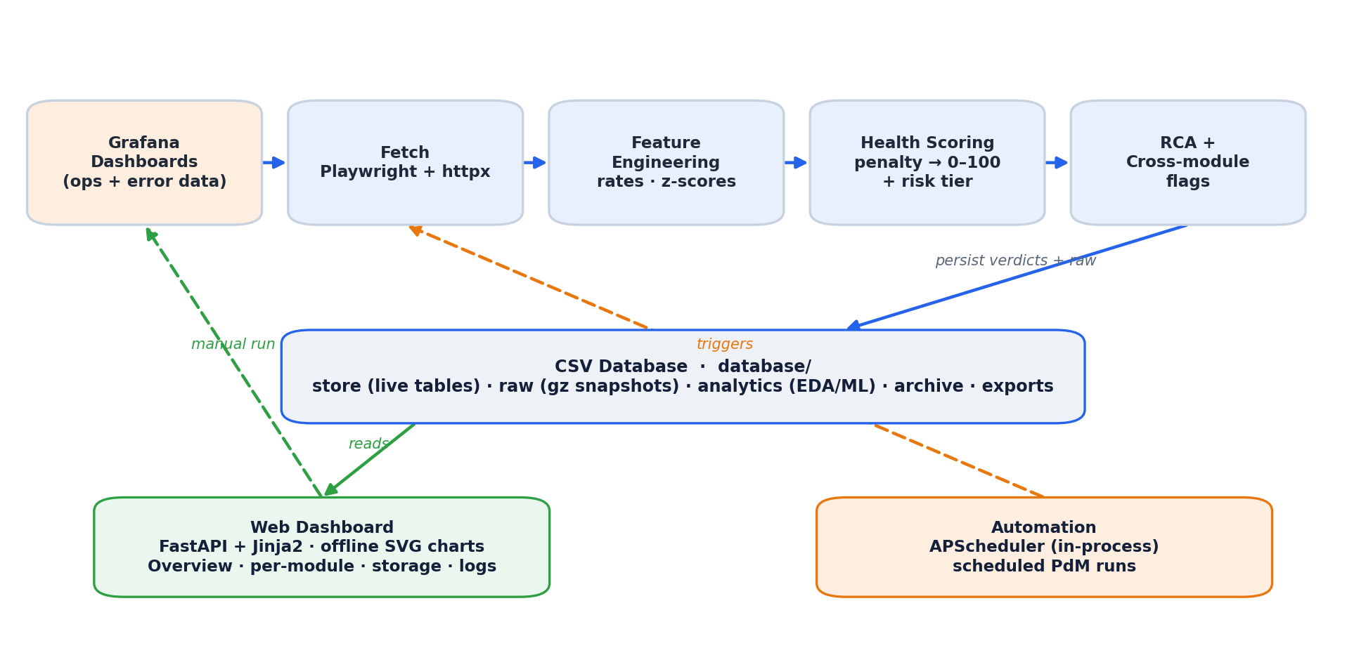
Figure 1 — End-to-end architecture: Grafana data is fetched, scored, explained and persisted to the CSV database; the dashboard reads it and automation (or an operator) triggers runs.
Stack: Python 3.11+, FastAPI + Uvicorn (web), APScheduler (in-process automation), Playwright (Chromium) + httpx (Grafana fetch), numpy / pandas / scikit-learn (modelling), server-rendered Jinja2 with vendored SVG charts (fully offline on the LAN — no CDN). A plugin registry lets each equipment type self-register as a module, so adding equipment needs no changes to the core.
3 How a Run Works — Methodology

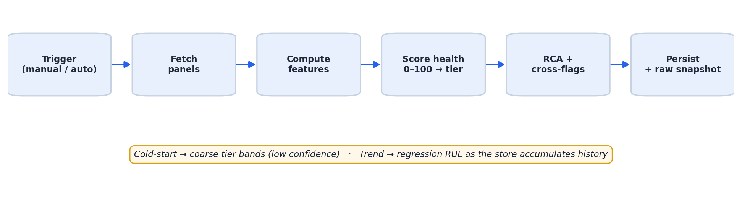
Figure 2 — The PdM run pipeline. Predictions are labelled cold-start or trend and carry a confidence that rises as history grows.
Every trigger (manual or scheduled) fetches each mapped panel, derives normalised, dimensionless features (rates, ratios, robust z-scores vs the unit's own baseline and its peers — never raw counts, so a busy unit isn't punished for being busy), scores health, attributes a root cause, and persists the run. Two regimes are always labelled: cold-start (little history → coarse, low-confidence tier bands) and trend (enough history → a fitted health trajectory projects when a maintenance threshold is crossed). Running it regularly is what makes it predictive — each run sharpens the forecast.
4 What It Monitors — 11 Modules

# | Module | Leading health signal | Units
1 | GTP Station + Scanner | scanner misread rate + station pick-discrepancy rate | 325
2 | Network / Comms | network downtime % + today-vs-window spike + aisle clustering | 124
3 | Shuttle | errors per million cycles + severity + cycles-based RUL | 124
4 | Tracker / Position-Sensor | mislocated-tote clustering + cross-run recurrence | 56
5 | Gate / Door-Actuator | stuck-non-closed latency + cross-run persistence | 52
6 | Bin / Tote-Mechanical | block-age + chronic-slot history + recurrence | 41
7 | Decant Station + Scanner | scanner misread rate + station status/throughput | 19
8 | Lift | error rate + severity + mechanical-wear mix + peer deviation | 16
9 | System-Wide Anomaly (Meta) | cross-module compound-risk (co-occurrence + causal chains) | 7
10 | Conveyor | congestion (queue vs limit) + stall detection | 6
11 | Controller / Compute | CPU utilisation % + sustained-high + trend | 1

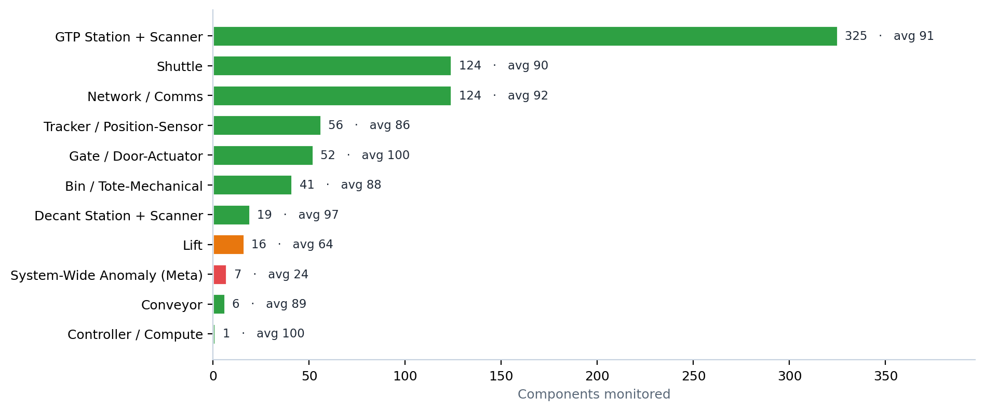
Figure 3 — Components monitored per module (bar length) and average health (label & colour: green ok · amber watch · orange warn · red critical).
5 Per-Module Methodology, Features & Formulas

All eleven modules share one scoring model — health = clamp(100 − Σ capped penalties, 0, 100), mapped to a risk tier, with each prediction labelled cold-start or trend. What differs per module is the equipment it watches and the signals (features) it derives from the Grafana data. Each block below states what the module does, the features it uses, and its distinctive formulas (the shared health formula above is not repeated).
1. Lift lift · 16 units
Each lift is scored from its fault events over the analysis window — how often it faults, how serious those faults are, whether the same fault keeps recurring, and how it compares to peer lifts.
Signals (features): Error rate — Faults per day over the window (time-normali… · Peer deviation — Robust z-score of error rate vs the peer med… · Severity & mechanical share — Motor/brake/belt/axis/roller faults weigh he… · Recurrence & diversity — Same code repeating, and how many distinct f… · Current status — Whether the lift is currently reporting ERROR · Load context — Per-lift task counts as a relative load/wear…
Formulas: error_rate_per_day = error_count / window_days rate_peer_z = (rate − median_rate) / (1.4826 · MAD)
2. Shuttle shuttle · 124 units
Each shuttle is scored from its fault events normalised by how much work it has done (errors per million cycles), so a busy shuttle is judged fairly against its usage.
Signals (features): Errors per Mcycle — Usage-normalised fault rate — the primary ti… · Error severity & mechanical share — Fork/telescope/servo faults weigh heaviest (… · Recurrence — Same fault repeating = degradation, not a on… · Reshuffle load — Excess reshuffles vs fleet = added stress · Peer deviation — Robust z-score of errors/Mcycle vs the fleet… · Current status — Live errors, SHUTTLE_PICK_ERROR recurrence,…
Formulas: errors_per_mcycle = error_count / total_cycles × 1,000,000 reshuffle_share = RESHUFFLING / (PUTAWAY+PICKING+RESHUFFLING) RUL (trend) = cycles_to_critical / cycle_accrual_rate(cycles per hour)
3. Conveyor zone · 6 units
Each conveyor zone is scored from how backed-up it runs.
Signals (features): Congestion (actual/limit) — Queue depth vs the zone's limit over the win… · Severe saturation — Share of time the queue runs ≥ the severe ra… · Peak backup — Worst spike (max actual/limit) — extreme sta… · Buffer fill — Buffer filling means downstream isn't cleari… · Peer deviation — Robust z-score of mean congestion vs peer zo…
Formulas: congestion = conveyor_actual_count / conveyor_limit_count severe_saturation_share = fraction of samples with congestion ≥ 1.5
4. Tracker / Position-Sensor position_sensor · 56 units
Each component is a grid LOCATION (e.g.
Signals (features): Cluster size — How many totes are currently mislocated at t… · Recency (active vs stale) — Totes stuck recently (within the window) wei… · Cross-run recurrence — How many prior PdM runs flagged this same lo… · Robot breadth — Many distinct shuttles failing at one locati… · Peer deviation — Robust z-score of this location's cluster si…
Formulas: bad_count = count of mislocated totes currently at the location recurrence_runs = number of prior PdM runs that flagged this location
5. Gate / Door-Actuator gate · 52 units
Each component is a physical GATE (e.g.
Signals (features): Stuck latency — Minutes a non-closed gate has been stuck (fr… · Mid-actuation — Caught in OPEN REQUEST INITIATED — an open w… · Persistence — How many consecutive PdM runs the gate has s… · Stuck recurrence — How many prior runs this gate was stuck — re… · Non-closed rate & peer deviation — Fraction of runs the gate is non-closed, and…
Formulas: stuck_excess_minutes = max(stuck_minutes - grace, 0) non_closed_rate = prior runs non-closed / runs observed consecutive_non_closed = consecutive most-recent runs (incl. now) with status != CLOSED
6. Bin / Tote-Mechanical bin_location · 41 units
Each component is a physical bin LOCATION (slot address like 001-14-1-119-1-02 = Aisle-Level-Rack-Location-Deep).
Signals (features): Block-age — How long the tote has stayed blocked/unresol… · Current cluster — How many totes are blocked at this same slot… · Historical block frequency — How many times this slot blocked in the hist… · Cross-run recurrence — How many prior PdM runs flagged this same sl… · Peer deviation — Robust z-score of this slot's block-age vs p…
Formulas: block_age_hours = max(blockedTime) − this block's blockedTime (hours) historical_block_count = occurrences of this slot as SOURCE in the frozen block log recurrence_runs = number of prior PdM runs that flagged this slot blocked
7. GTP Station + Scanner station/scanner · 325 units
This module scores two physical component types.
Signals (features): Scanner misread rate — NoReadCount/(ReadCount+NoReadCount) per scan… · Scan volume — Usage per scanner — scales the misread penal… · Scanner peer deviation — Robust z of misread% vs peer scanners with e… · Station discrepancy rate — Per-station pick-verification discrepancies/… · Station peer deviation — Robust z of discrepancies/day vs peer statio… · Active/Inactive status — Context (many stations legitimately Inactive… · Cross-run recurrence / trend — Prior runs a scanner/station read elevated;…
Formulas: misread_rate = NoReadCount / (ReadCount + NoReadCount) volume_factor = min(1, total_scans / min_volume_full) discrepancy_per_day = discrepancy_count / window_days
8. Decant Station + Scanner station/scanner · 19 units
This module scores two physical component types.
Signals (features): Scanner misread rate — NoReadCount/(ReadCount+NoReadCount) per deca… · Scan volume — Scans per device — scales the misread penalt… · Scanner peer deviation — Robust z of misread% vs peer decant devices… · Station active/inactive — Context (a station may be unstaffed, not bro… · Station throughput — Per-station decanted cartons -> detects idle… · Cross-run recurrence / trend — Prior runs a scanner read elevated / a stati…
Formulas: misread_rate = NoReadCount / (ReadCount + NoReadCount) volume_factor = min(1, total_scans / min_volume_full) idle_while_active = is_active AND carton_count <= idle_floor AND line_total_cartons >= line_busy_min
9. Network / Comms network_link · 124 units
This module scores the per-shuttle COMMS LINK — the wireless channel between the controller and each shuttle (124 links, keyed by shuttle_id).
Signals (features): Network downtime% — 100 - uptime% per shuttle link over the wind… · Peer deviation — Robust z of downtime% vs peer links (within-… · Today recency spike — Today's downtime% above a floor AND worse th… · Aisle clustering — Downtime clustering on one aisle -> a candid… · Cross-run recurrence / trend — Prior runs a link's downtime% was elevated;…
Formulas: uptime_pct = (1 - SUM(disconnect_seconds) / elapsed_seconds) * 100 (SHUTTLE_NETWORK_STATUS) downtime_pct = 100 - uptime_pct today_delta = today_downtime_pct - window_downtime_pct (>0 = degrading now)
10. Controller / Compute compute_node · 1 units
This module scores the controller COMPUTE NODE(S) — a single node this snapshot, the SQL/DBA database-controller server ('db_controller').
Signals (features): CPU utilization% — 100 - cpu_idle per node — the core compute-s… · SQL CPU share — The SQL Server's share of CPU — context (a D… · Sustained-high — Consecutive recent runs with utilization% >=… · Trend — The node's health trajectory over runs (risi…
Formulas: utilization_pct = 100 - cpu_idle sql_share = cpu_sql / utilization_pct
11. System-Wide Anomaly (Meta) incident_scope · 7 units
This is the meta-module: it does NOT read Grafana.
Signals (features): Breadth (co-occurrence) — >=2 modules flagged on the same aisle/scope… · Realized causal chain — An edge counts only when a flagged member na… · Severity — Amplifies a compound incident (applied only… · Controller trigger + aisle breadth — A saturated controller is a system incident… · Persistence — Consecutive prior meta runs this scope was c…
Formulas: breadth = count(distinct modules with a flagged component in the scope) chain_edge = flagged member m -> target T iff T in m.rca.cross_module_flags AND T is also flagged in the scope compound_incident = breadth >= 2
6 Current System State (live data)

The snapshot below is computed from the most recent scored run of the live fleet. The donut shows how the monitored components split across the four risk tiers; the table lists the specific units with the lowest health for the maintenance team to review first. These figures update automatically every time a PdM run completes.
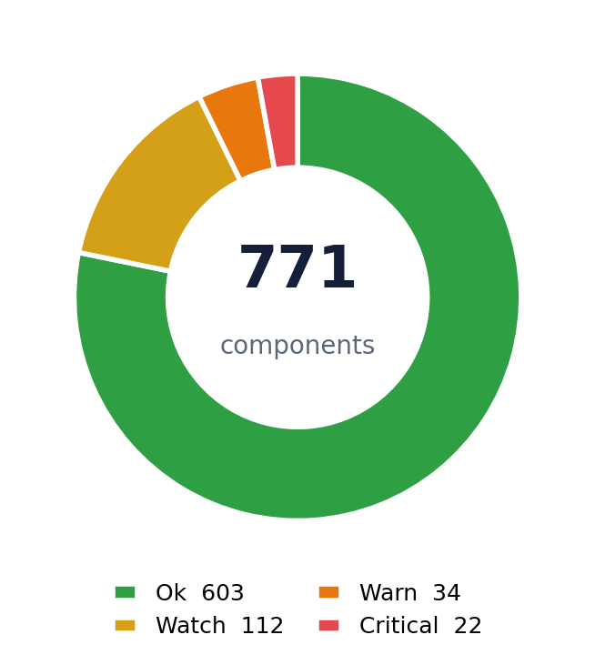 | Across 771 monitored components the fleet averages 90/100 health. 22 critical and 34 warn components are surfaced for attention; the rest sit in watch/ok.  Top at-risk components  Component Module Health  aisle_04_inbound_lift_02 Lift 0  QD_Shuttle_03_06 Shuttle 0  QD_Shuttle_03_13 Shuttle 0  aisle_04_outbound_lift_01 Lift 1  aisle_04 System-Wide Anomaly (Meta) 4
Note: all components are currently in the cold-start regime — the store is early in its accumulation. As scheduled runs continue, confidence and trend-based RUL sharpen automatically; the Meta module already flags the aisles carrying compound risk.
7 This Week's Progress

Deliverable | Status | What it means
Graphical Overview analytics tab | ✓ Delivered | New tab on the Overview page: KPI row + 7 dependency-free SVG charts (fleet trend, status donut, per-module risk, score distribution, aisle×module heatmap, top at-risk, time-to-maintenance).
Single CSV 'database' store | ✓ Delivered | Consolidated all persistence into one database/ folder (store · analytics · raw · archive · exports); migrated live history into it.
Raw data capture per run | ✓ Delivered | Every run now snapshots the raw fetched Grafana data (gzipped CSV per panel) — full audit trail; nothing is discarded.
Analytics / EDA-ML datasets | ✓ Delivered | Builder emits tidy time-series + per-module feature matrices + data dictionary for future trend analysis, EDA and ML.
Dockerisation + deploy guide | ✓ Delivered | One-container image (dashboard + automation) with host-mounted data; step-by-step LAN deployment guide added to the README.
Correctness hardening | ✓ Delivered | Adversarial multi-agent code review; fixed 3 confirmed defects (window-unit parsing, TTM boundary, module sort) and a missing PyYAML dependency that would break fresh installs.
Documentation & tests | ✓ Delivered | Refreshed all docs + rebuilt the Word notebook; automated test suite expanded to 36 (all passing).
8 Data Store & Deployment

CSV-only, analysis-ready
Storage is CSV-only (MySQL designed but dormant behind a permission gate). Everything lives in one database/ folder: store/ (the live longitudinal tables — one row per component per run), raw/ (per-run gzipped snapshots of the exact fetched data), analytics/ (flat, tidy time-series + per-module feature matrices ready for pandas / scikit-learn), plus archive/ and exports/. A data dictionary ships with it. All feature and root-cause data is kept as JSON so future ML/analytics never needs a schema migration.
database/ folder | Contents
store/ | Live longitudinal tables — one row per component per run (the health history).
raw/ | Per-run gzipped snapshots of the exact fetched Grafana data (full audit trail).
analytics/ | Flat, tidy time-series + per-module feature matrices — ready for EDA / ML.
archive/ · exports/ | Aged-out rows and one-off CSV / JSON / Excel exports.

One-container delivery
The system is packaged as a single Docker container (dashboard + automation) with the database and logs bind-mounted to the host for easy backup. It binds the LAN and is reached at http://<host-ip>:8800; automation runs inside the container independent of any browser. A step-by-step deployment guide (build, run, firewall, operations) is in the README for installation on the target plant PC.
9 Outlook & Next Steps

- Accumulate history — keep scheduled runs going so components move from cold-start to trend, unlocking sharper RUL and higher-confidence predictions.
- MySQL when provisioned — flip one flag and run a one-command migration; no application code changes (the storage layer is already abstracted).
- Operator feedback loop — optional 'mark maintenance done' acknowledgements to annotate flags and reset baselines (never drives detection).
- Leverage the raw/analytics datasets — the newly-captured raw data and EDA/ML extracts open the door to learned failure models as labelled outcomes accrue.

