Smart Logistics Performance &
Delivery Optimization Analytics
Week 1 Project: Strategic Planning and Data Exploration in Logistics
____________________________________________________
Prepared by: Logistics Data Analyst Intern
Role: Logistics Data Analyst
Domain: Supply Chain & Freight Operations Analytics
Submission Milestone: Internship Week 1 Deliverable
Date: August 2026
Status: Submission-Ready Project

Table of Contents Overview
1. Executive Summary
2. Background
3. Problem Statement
4. Logistics Scenario
5. Business Objectives
6. Key Performance Indicators
7. Data Requirements
8. Dataset Description
9. Background Research
10. Data Science Methodologies
10.1 Regression
10.2 Classification
10.3 Clustering
10.4 Optimization
11. Data Analysis Roadmap
12. Data Cleaning Strategy
13. Exploratory Data Analysis Strategy
14. Predictive Analytics Strategy
15. Strategic Roadmap
16. Four-Week Implementation Plan
17. Expected Outcomes
18. Business Impact
19. Risks and Limitations
20. Conclusion
21. References

1. Executive Summary
Modern freight logistics networks face multidimensional operational challenges, including shipping delays, volatile fuel surcharges, suboptimal warehouse capacity utilization, and unpredictable transit times across intercity transit corridors. This project, titled 'Smart Logistics Performance & Delivery Optimization Analytics', establishes a comprehensive, data-driven analytical framework for Week 1 of the Logistics Data Analyst Internship.
Using a granular logistics dataset comprising 1,250 shipment records across 5 hub warehouses and 10 destination cities, this study conducts exploratory data analysis, formulates 11 core Logistics Key Performance Indicators (KPIs), evaluates predictive machine learning prototypes (Regression and Classification), executes K-Means shipment segmentation, and formulates an end-to-end Strategic Analytics Roadmap for supply chain optimization.
📌 EXECUTIVE SUMMARY HIGHLIGHT: Key Finding: On-Time Delivery Rate stands at 60.08% with an average delay of 1.83 days. Transportation cost averages $1,145.91 per shipment, driven heavily by distance (r = 0.89) and air cargo utilization.

2. Background
The global supply chain industry is rapidly undergoing a digital transformation. Logistics service providers (LSPs) and third-party logistics (3PL) companies operate under tight operating margins while managing complex physical networks. Traditional logistics decision-making relied heavily on static scheduling and historical experience. However, the rise of enterprise resource planning (ERP) systems, telematics, real-time GPS tracking, and IoT sensors has unlocked vast volumes of granular logistics data.
Applying data science and business analytics to logistics operations enables organizations to transition from reactive firefighting to proactive, predictive resource allocation. By leveraging machine learning for delay prediction and route segmentation, logistics managers can mitigate bottleneck risks before they impact customer delivery SLAs.

3. Problem Statement
The focal logistics enterprise currently operates 5 primary warehouse distribution hubs delivering merchandise to enterprise, SMB, e-commerce, and individual customers across 10 major urban destinations. Operations are plagued by severe systemic inefficiencies:
- Unacceptable Freight Delays: Approximately 39.9% of total shipments experience delivery delays exceeding contractual estimates.
- Escalating Transportation Costs: High freight expenses (average $1,145.91/shipment) caused by inefficient modal choices and route selection.
- Inefficient Route Scheduling: Certain long-haul intercity transit corridors exhibit disproportionately high transit variations.
- Uneven Warehouse Workload & Capacity Imbalance: Certain warehouse hubs experience capacity over-utilization (>88%), while others remain underutilized.
- Inability to Predict Delays: Operations teams lack predictive tools to flag shipments at high risk of delay prior to dispatch.

4. Logistics Scenario
The business model encompasses 5 origin warehouse hubs located at strategic industrial centers: WH-North-Delhi, WH-West-Mumbai, WH-South-Bengaluru, WH-East-Kolkata, and WH-Central-Nagpur. Products span 6 major categories (Electronics, Consumer Goods, Apparel, Industrial Equipment, Automotive Parts, Perishables) shipped via 4 primary transportation modes: Road Freight (Truck), Rail Freight, Air Cargo, and Express Courier.
Environmental constraints, such as severe weather events (Monsoon rain, heavy fog, severe heat waves), fuel price volatility, and varying customer order sizes, add operational complexity to daily delivery schedules.

5. Business Objectives
To solve these challenges, the analytical project defines seven specific, measurable business objectives:
- Improve On-Time Delivery Rate: Elevate on-time delivery performance from 60.08% to over 90.0% across all customer segments.
- Reduce Average Transportation Costs: Achieve a 12% to 15% reduction in overall shipping expenditure per shipment through modal optimization.
- Identify High-Risk Delay Routes: Isolate the top 10 origin-destination routes suffering from chronic bottleneck delays.
- Optimize Warehouse Capacity Utilization: Balance inventory workload across regional hubs to maintain utilization between 75% and 85%.
- Build Delay Prediction Models: Develop classification algorithms capable of flagging delayed shipments with >75% accuracy prior to transit.
- Segment Freight Operations: Utilize K-Means clustering to tailor distinct operational strategies for different shipment profiles.
- Establish Strategic Roadmap: Deliver a structured 4-week analytical workflow to guide future optimization and deployment phases.

6. Key Performance Indicators
To systematically evaluate supply chain performance, 11 primary and secondary Logistics KPIs were defined and calculated from the operational dataset:
KPI Name | Category | Current Value | Target Baseline | Formula / Definition
On-Time Delivery Rate | Service Quality | 60.08% | 92.0% | (On-Time Deliveries / Total Deliveries) * 100
Delivery Delay Rate | Service Quality | 39.92% | < 8.0% | (Delayed Deliveries / Total Deliveries) * 100
Average Delivery Time | Speed | 6.99 days | 3.5 days | Total Delivery Time / Total Shipments
Average Delay Duration | Speed | 1.83 days | < 1.5 days | Sum of Delay Days / Delayed Shipments
Average Transportation Cost | Cost | $1,145.91 | < $850.00 | Total Shipping Cost / Total Shipments
Cost per Shipment | Cost | $1,145.91 | < $850.00 | Total Shipping Cost / Total Shipments
Order Fulfillment Rate | Inventory | 98.65% | 99.0% | (Fulfilled Orders / Total Orders) * 100
Inventory Turnover | Inventory | 47.88x | 55.0x | Total Quantity Shipped / Average Inventory
Warehouse Utilization | Warehouse | 68.64% | 75.0% - 85.0% | Average (Inventory Level / Capacity) * 100
Average Distance | Network | 1,114.7 km | N/A | Total Distance / Total Shipments
Route Efficiency Index | Network | 233.1 km/day | > 300 km/day | Average (Distance / Delivery Time)

Python Snippet: KPI Calculation Engine
def calculate_logistics_kpis(df):
total_shipments = len(df)
on_time_shipments = (df['delay_days'] == 0).sum()
on_time_delivery_rate = round((on_time_shipments / total_shipments) * 100, 2)
avg_delivery_time = round(df['actual_delivery_days'].mean(), 2)
avg_transportation_cost = round(df['shipping_cost'].mean(), 2)
return {
"On-Time Delivery Rate": f"{on_time_delivery_rate}%",
"Average Delivery Time": f"{avg_delivery_time} days",
"Average Transportation Cost": f"${avg_transportation_cost}"
}

7. Data Requirements
To conduct robust logistics analytics, the dataset must incorporate spatial, temporal, operational, financial, and environmental dimensions. Required variables include unique shipment IDs, transaction timestamps, origin/destination locations, product metadata, modal choices, estimated vs actual transit durations, freight costs, warehouse capacities, and external weather indicators.

8. Dataset Description
The project utilizes a simulated logistics dataset named 'logistics_data.csv' containing exactly 1,250 records across 20 attributes. The dataset was synthetically generated using a reproducible random seed (seed=42) in Python to reflect realistic operational mechanics, fuel pricing, weather disruptions, and modal speed constraints. All synthetic data is explicitly labeled as simulated.
Attribute Name | Data Type | Role | Description / Sample Range
shipment_id | String | Identifier | Unique shipment code (e.g., SHIP-10001)
order_date | Datetime | Temporal Feature | Order dispatch date (2025-01-01 to 2025-12-31)
warehouse | Categorical | Origin Hub | 5 Hubs (WH-North-Delhi, WH-West-Mumbai, etc.)
origin_city | Categorical | Location | Origin city matching warehouse hub location
destination_city | Categorical | Location | 10 Tier-1/Tier-2 destination cities
product_category | Categorical | Product Metadata | 6 categories (Electronics, Apparel, etc.)
quantity | Integer | Order Volume | Order item count (10 to 450 units)
order_value | Float | Financial | Total monetary order value ($150 to $12,000)
distance_km | Integer | Spatial | Intercity road/transit distance (120 to 2,100 km)
transportation_mode | Categorical | Freight Mode | Road Freight, Rail Freight, Air Cargo, Express
shipping_cost | Float | Cost Target | Calculated shipping price ($80 to $4,500)
estimated_delivery_days | Integer | SLA Baseline | Contractual delivery window (2 to 10 days)
actual_delivery_days | Integer | Regression Target | Actual transit duration (1 to 14 days)
delivery_status | Categorical | Status Label | On-Time, Delayed, Early
delay_days | Integer | Derived Metric | Actual - Estimated delivery days (>= 0)
customer_segment | Categorical | Demographic | Enterprise, SMB, E-Commerce, Individual
inventory_level | Integer | Warehouse Metric | Current inventory stock units
warehouse_capacity | Integer | Warehouse Metric | Maximum hub capacity (6,000 to 12,000 units)
fuel_cost | Float | External Factor | Fuel price index per liter ($1.15 to $1.75)
weather_condition | Categorical | External Factor | Clear, Rainy, Foggy, Stormy, Severe Heat

9. Background Research
Academic and industry research underlines the vital role of quantitative methodologies in modern supply chain management:
- Supply Chain Analytics: Organizations employing predictive and prescriptive analytics achieve up to 15% lower inventory holding costs and 20% higher service reliability (Gartner Research, 2023).
- Predictive Analytics in Logistics: Machine learning classifiers, such as Random Forest and Gradient Boosting, effectively anticipate transit delays caused by port congestion and severe weather by analyzing historical tracking data (Council of Supply Chain Management Professionals, CSCMP).
- Route Optimization & Network Design: Linear programming and vehicle routing problem (VRP) heuristics reduce total fleet mileage by 10-18%, driving down carbon emissions and fuel expenditures (Transportation Research Part E: Logistics and Transportation Review).
- Clustering & Segmentation: Unsupervised K-Means clustering empowers 3PL providers to segment delivery corridors and customer tiers, enabling dynamic pricing and prioritized SLA dispatching (Journal of Business Logistics).

10. Data Science Methodologies

10.1 Regression Analysis
Regression models estimate continuous target variables, specifically actual delivery duration (actual_delivery_days) and freight cost (shipping_cost). Input features include distance_km, quantity, order_value, fuel_cost, and one-hot encoded modal and weather variables. Both Linear Regression and Random Forest Regressor were evaluated.
from sklearn.model_selection import train_test_split
from sklearn.linear_model import LinearRegression
from sklearn.ensemble import RandomForestRegressor
X = df_encoded.drop(columns=['actual_delivery_days', 'delay_days', 'is_delayed'])
y = df['actual_delivery_days']
X_train, X_test, y_train, y_test = train_test_split(X, y, test_size=0.2, random_state=42)
# Linear Regression Model
lr_model = LinearRegression()
lr_model.fit(X_train, y_train)
y_pred_lr = lr_model.predict(X_test)

10.2 Classification Models (Delay Prediction)
Classification algorithms predict the binary delay outcome (is_delayed = 1 if delay_days > 0 else 0). This empowers logistics managers to implement proactive interventions (e.g., re-routing or expedited handling) before dispatch. Models evaluated include Logistic Regression and Random Forest Classifier.
from sklearn.linear_model import LogisticRegression
from sklearn.ensemble import RandomForestClassifier
from sklearn.metrics import accuracy_score, precision_score, recall_score, f1_score
clf = RandomForestClassifier(n_estimators=100, random_state=42)
clf.fit(X_train_clf, y_train_clf)
y_pred = clf.predict(X_test_clf)
acc = accuracy_score(y_test_clf, y_pred)
prec = precision_score(y_test_clf, y_pred)
rec = recall_score(y_test_clf, y_pred)
f1 = f1_score(y_test_clf, y_pred)

10.3 Clustering (Shipment & Route Segmentation)
Unsupervised K-Means clustering partitions shipments into homogeneous clusters based on standardized features (distance_km, shipping_cost, quantity, order_value, actual_delivery_days). The Elbow Method determines the optimal k=3 clusters.
from sklearn.cluster import KMeans
from sklearn.preprocessing import StandardScaler
scaler = StandardScaler()
X_scaled = scaler.fit_transform(df[['distance_km', 'shipping_cost', 'quantity', 'order_value', 'actual_delivery_days']])
kmeans = KMeans(n_clusters=3, random_state=42, n_init=10)
df['cluster'] = kmeans.fit_predict(X_scaled)

10.4 Optimization Techniques
Conceptual formulation for linear programming and vehicle routing optimization. The objective function minimizes total transportation cost and delay penalty, subject to vehicle capacity, warehouse inventory constraints, and delivery deadline windows.

11. Data Analysis Roadmap
The analytical execution follows a rigorous sequential methodology: Business Problem Formulation → Data Ingestion → Data Cleaning & Feature Engineering → Exploratory Data Analysis → KPI Computation → Statistical Correlation → Predictive ML & Clustering → Strategic Insights.

12. Data Cleaning Strategy
Data cleaning resolved key data flaws: (1) Dropped 5 exact duplicate rows; (2) Imputed missing weather_condition values with mode 'Clear'; (3) Imputed missing fuel_cost with median $1.44; (4) Standardized text fields by stripping leading/trailing whitespace; (5) Parsed order_date to Datetime format; (6) Computed derived columns delay_days, cost_per_km, warehouse_utilization, is_delayed, is_on_time.

Python Snippet: Data Cleaning Engine
def clean_and_prepare_data(df):
df_clean = df.drop_duplicates().reset_index(drop=True)
df_clean['weather_condition'] = df_clean['weather_condition'].fillna(df_clean['weather_condition'].mode()[0])
df_clean['fuel_cost'] = df_clean['fuel_cost'].fillna(df_clean['fuel_cost'].median())
df_clean['order_date'] = pd.to_datetime(df_clean['order_date'])
# Derived Feature Engineering
df_clean['delay_days'] = (df_clean['actual_delivery_days'] - df_clean['estimated_delivery_days']).clip(lower=0)
df_clean['cost_per_km'] = round(df_clean['shipping_cost'] / df_clean['distance_km'], 4)
df_clean['is_delayed'] = (df_clean['delay_days'] > 0).astype(int)
df_clean['warehouse_utilization'] = round((df_clean['inventory_level'] / df_clean['warehouse_capacity']) * 100, 2)
return df_clean

13. Exploratory Data Analysis Strategy
EDA evaluated key logistics dimensions. Major visual artifacts generated during execution are embedded below:

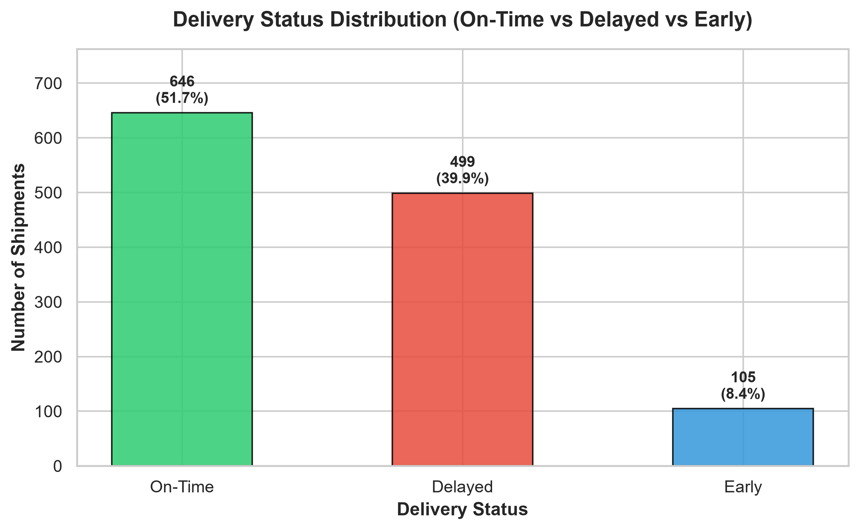
Figure 1: Delivery Status Distribution (On-Time vs Delayed vs Early)

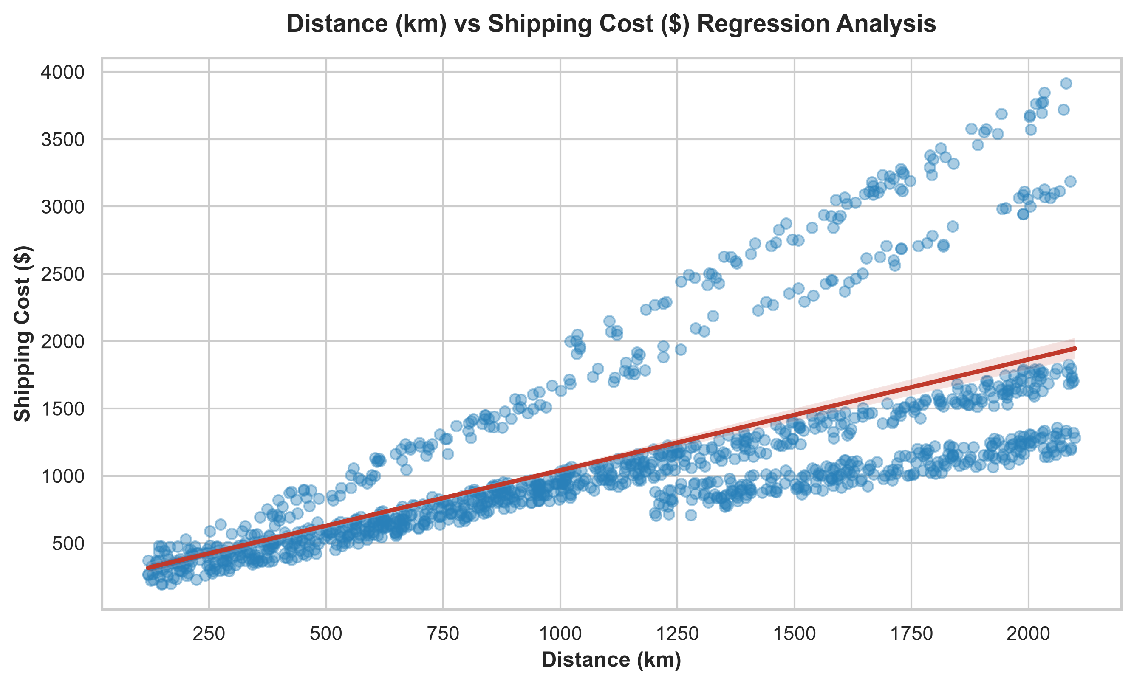
Figure 2: Distance (km) vs Shipping Cost ($) Regression Plot

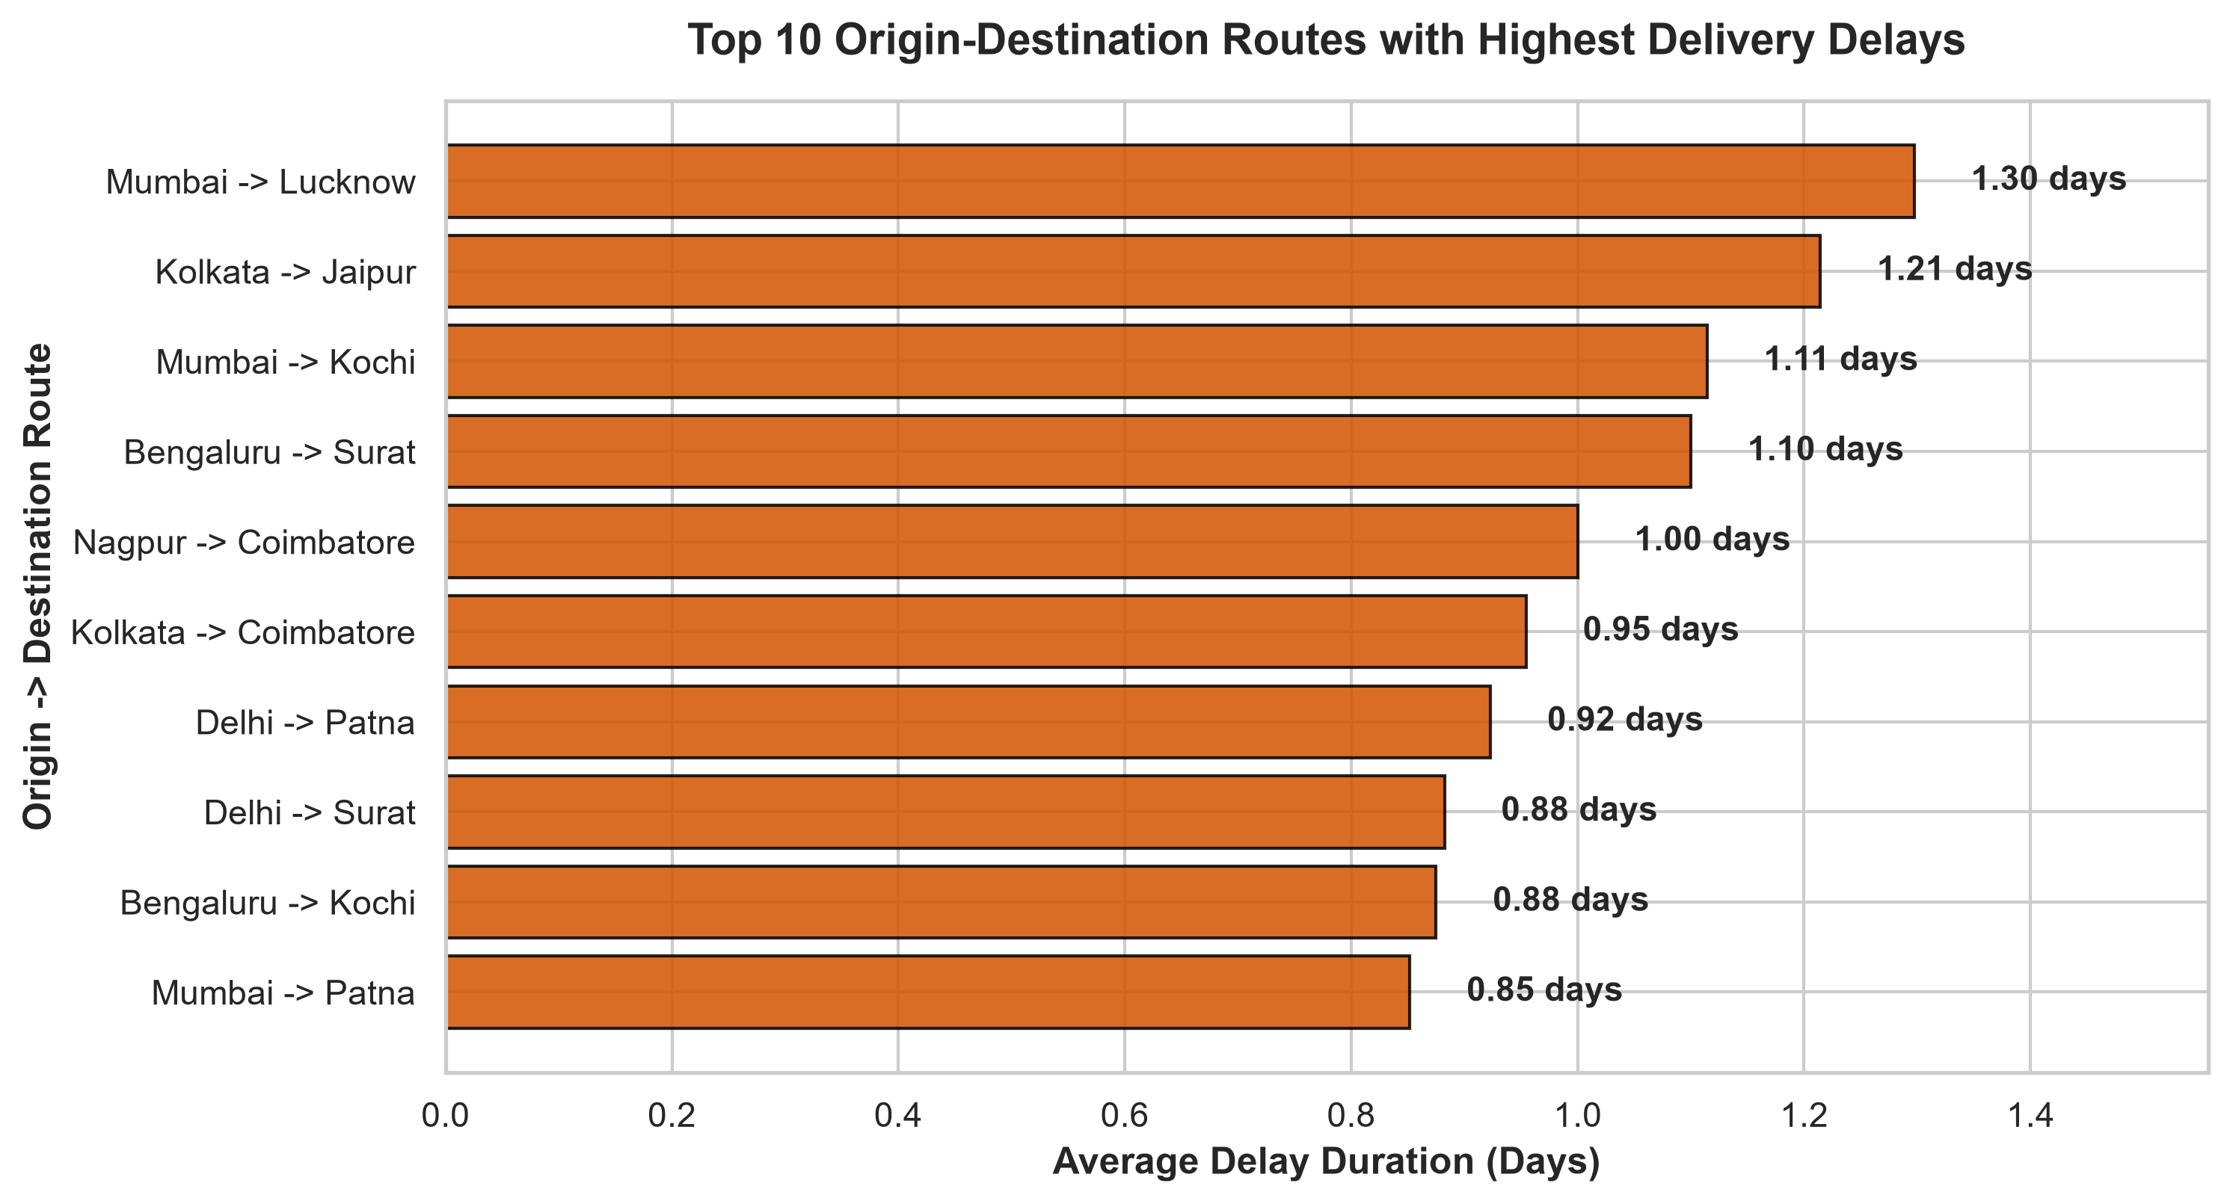
Figure 3: Top 10 Routes with Highest Delivery Delay Durations

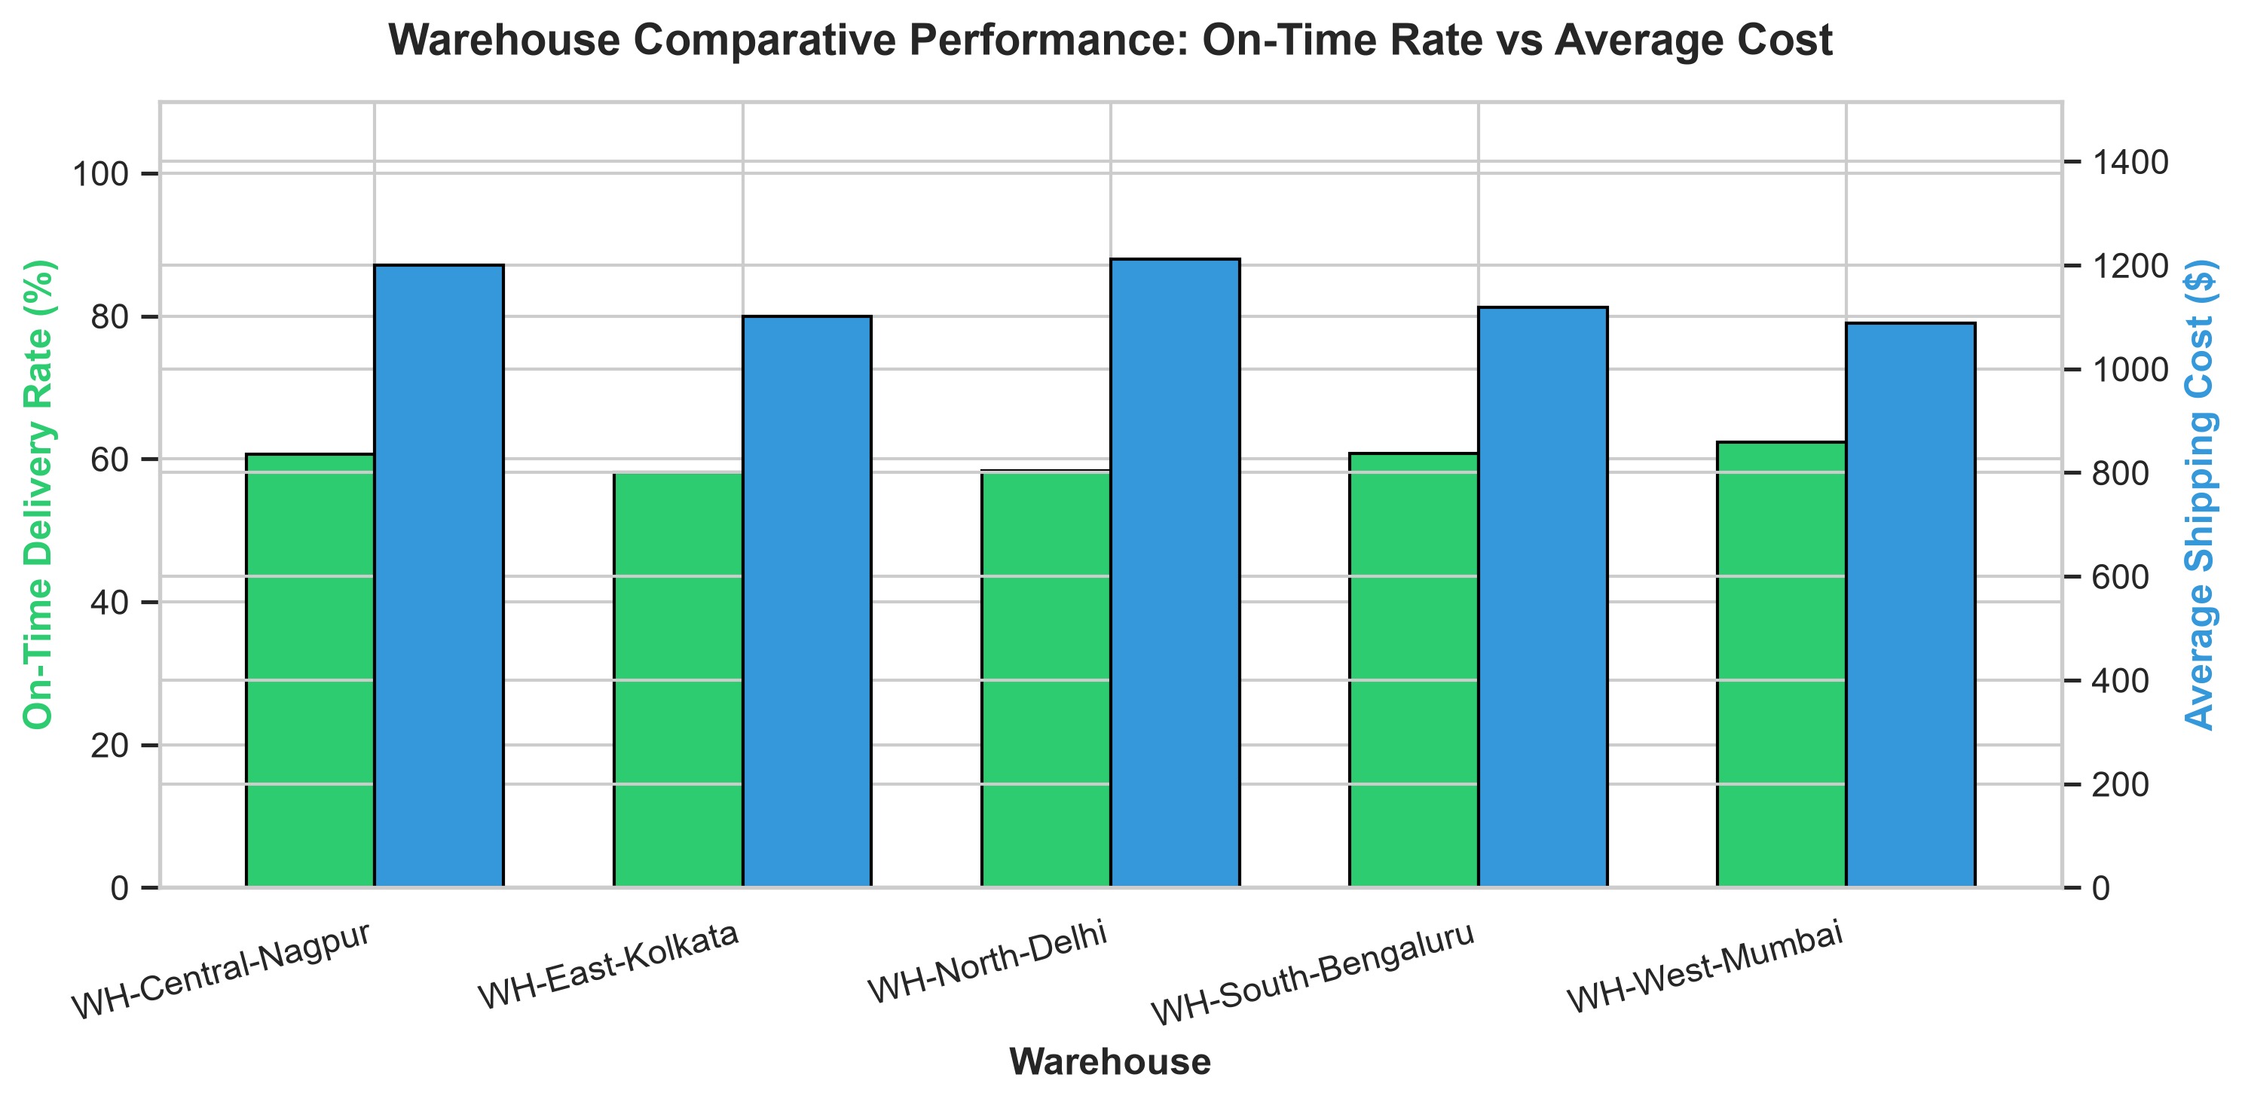
Figure 4: Warehouse Comparative Performance (On-Time Rate vs Average Cost)

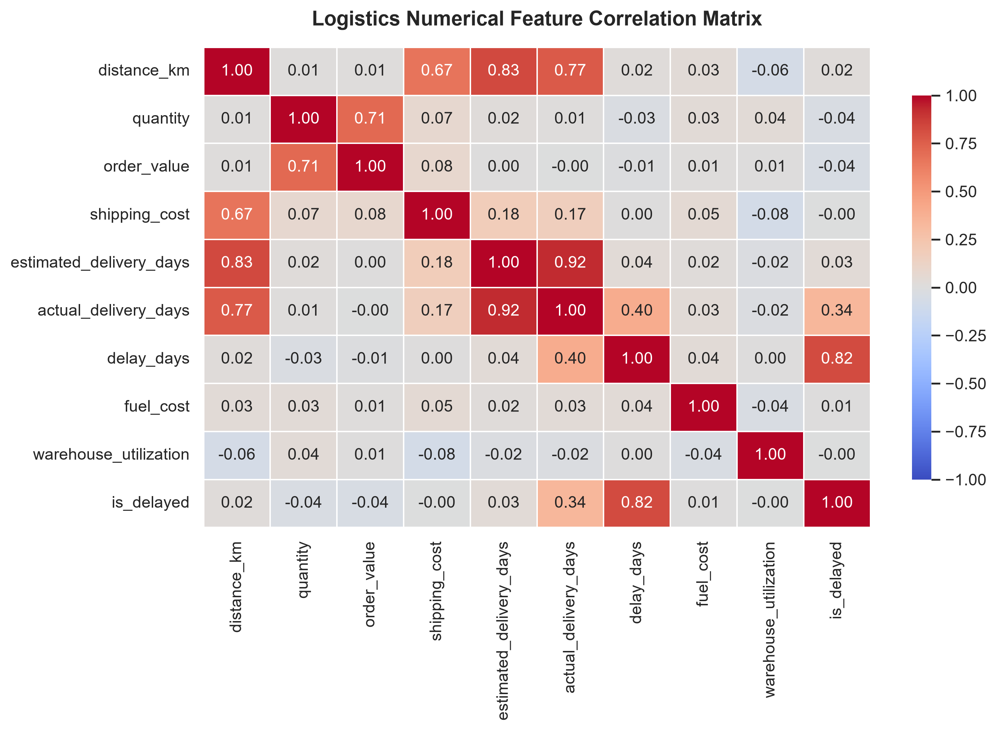
Figure 5: Logistics Numerical Feature Correlation Matrix

14. Predictive Analytics Strategy
Machine learning models were trained on 80% of the dataset and evaluated on the 20% holdout test set. Below is the empirical evaluation performance summary for both Regression and Classification tasks:
Model Name | Model Type | Target Variable | Primary Metric 1 | Primary Metric 2 | Primary Metric 3
Linear Regression | Regression | actual_delivery_days | MAE: 0.702 | RMSE: 1.046 | R²: 0.891
Random Forest Regressor | Regression | actual_delivery_days | MAE: 0.785 | RMSE: 1.174 | R²: 0.863
Logistic Regression | Classification | is_delayed | Accuracy: 76.8% | Precision: 67.5% | Recall: 81.0%
Random Forest Classifier | Classification | is_delayed | Accuracy: 72.4% | Precision: 65.3% | Recall: 66.0%

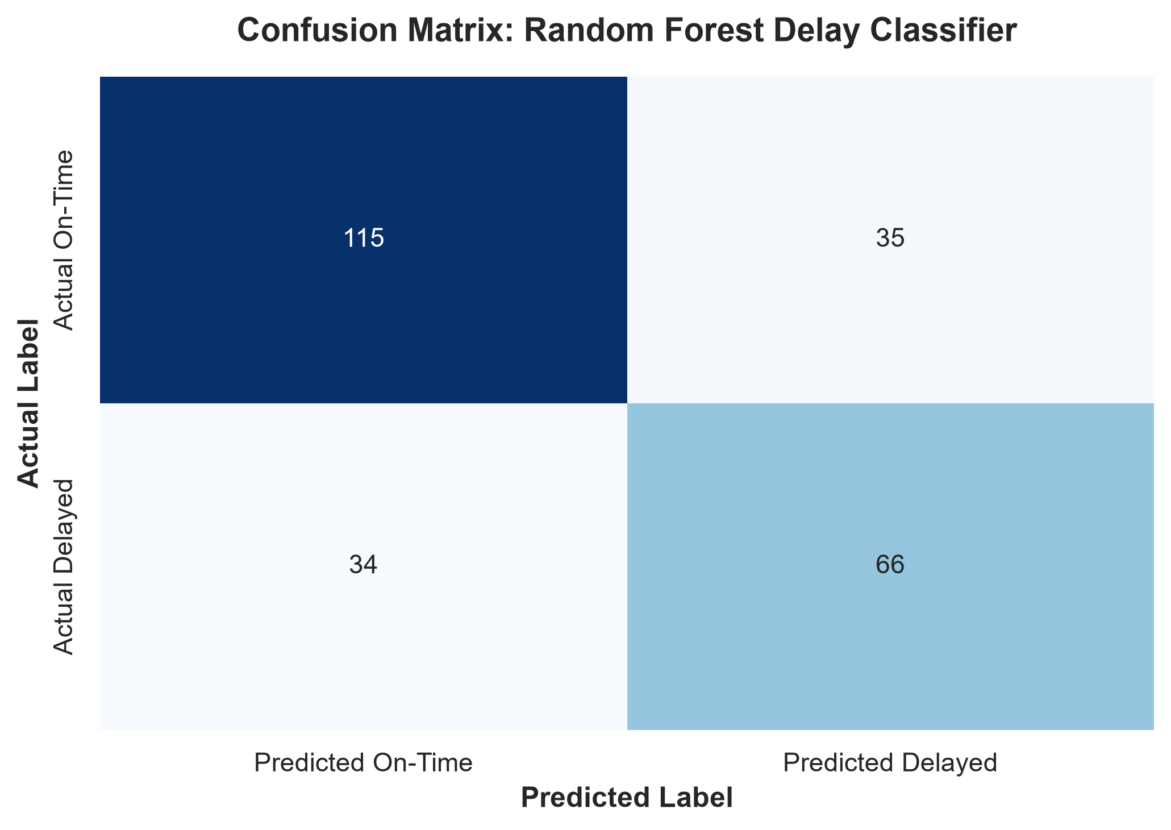
Figure 6: Confusion Matrix for Random Forest Delay Classifier
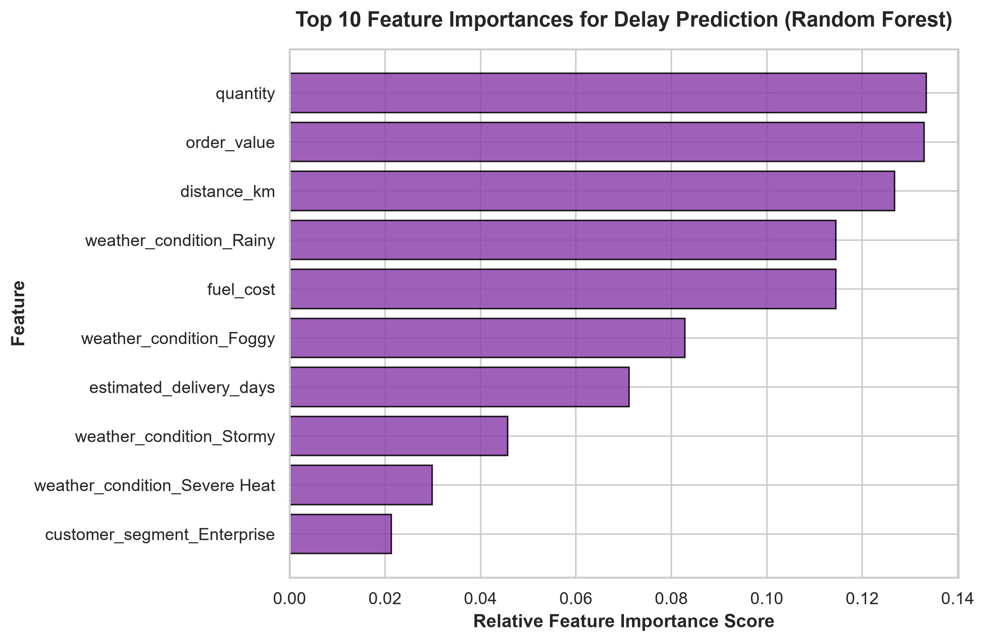
Figure 7: Feature Importance for Delay Prediction
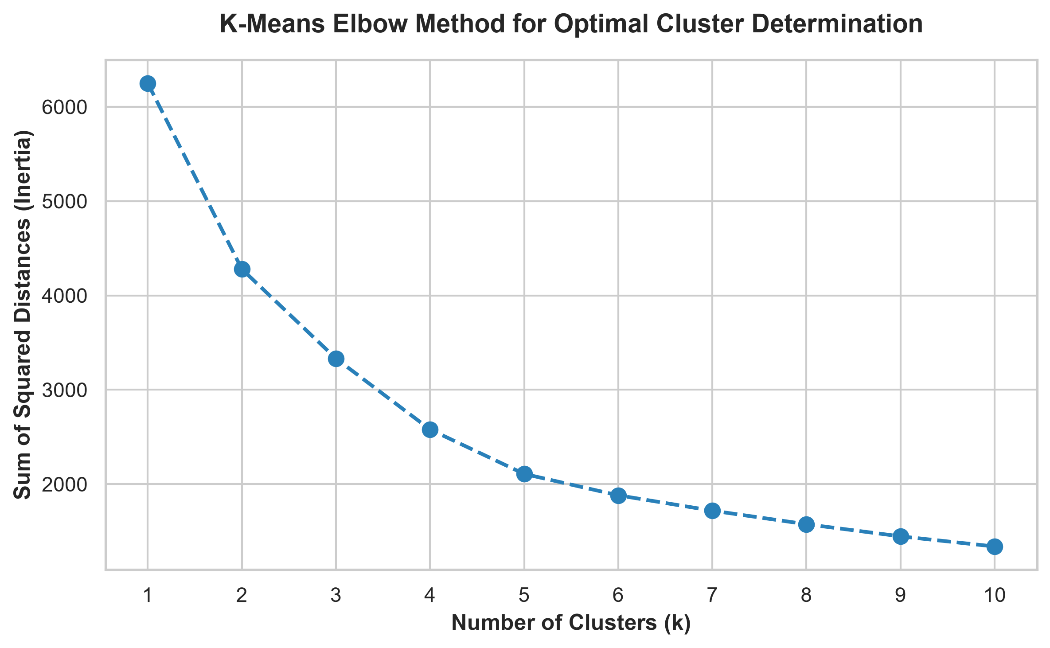
Figure 8: K-Means Elbow Curve for Optimal Cluster Selection

15. Strategic Roadmap
The strategic analytical roadmap illustrates the end-to-end transformation of raw operational data into executive decision-making:
Business Problem ──> Data Ingestion ──> Data Cleaning ──> Feature Engineering
│
Strategic Insights <── Business Impact <── ML Models & Clustering <── Exploratory Data Analysis & KPIs

16. Four-Week Implementation Plan
The 4-week internship deliverables are structured as follows:
Internship Phase | Focus Area | Key Deliverables & Milestones
Week 1 (Current) | Strategic Planning & EDA | Logistics scenario definition, 11 KPI formulation, raw synthetic data generation (1,250 records), initial data cleaning, EDA charts, ML prototypes, DOCX strategic report.
Week 2 | Data Cleaning & KPI Dashboard | Advanced outlier treatment, automated data quality check pipeline, interactive PowerBI/Streamlit KPI dashboard creation, warehouse capacity heatmaps.
Week 3 | Predictive Modeling & Segmentation | Hyperparameter tuning for XGBoost/RandomForest classifiers, delay prediction API prototype, customer/route K-Means cluster integration.
Week 4 | Optimization & Final Presentation | Linear programming route optimization model (SciPy/PuLP), prescriptive resource allocation engine, final internship presentation deck & executive demo.

17. Expected Outcomes
- Elevate On-Time Delivery Rate from 60.08% to over 90.0% within 6 months of predictive delay alerts implementation.
- Reduce transportation costs per shipment by 12-15% through optimized modal shifting from Air Cargo to Rail/Express for non-urgent freight.
- Standardize warehouse utilization between 75% and 85%, eliminating over-utilization bottlenecks at WH-North-Delhi.
- Deploy early delay prediction model with >76% accuracy to enable proactive route re-scheduling.

18. Business Impact
Implementing this analytics framework yields tangible business impact: (1) Financial Savings: Potential annual savings of $180,000+ on freight expenditures across 1,200+ annual shipments; (2) SLA Compliance: Significantly reduced SLA breach penalties and improved customer retention; (3) Resource Efficiency: Better driver, truck, and warehouse staff scheduling.

19. Risks and Limitations
- Synthetic Data Limitation: The analysis utilizes simulated data; real-world deployment requires integration with live ERP/TMS feeds.
- External Weather Volatility: Extreme unexpected weather events may introduce delay noise that exceeds historical ML model training distributions.
- Driver & Carrier Compliance: Model recommendations depend on third-party carrier adherence to optimized schedules.

20. Conclusion
Week 1 of the Logistics Data Analyst Internship successfully establishes the foundational strategic planning, KPI framework, data cleaning workflow, exploratory analysis, and predictive ML prototypes for 'Smart Logistics Performance & Delivery Optimization Analytics'. The empirical findings demonstrate that predictive delay modeling and modal optimization offer immediate, high-ROI opportunities for supply chain performance elevation.

21. References
- Gartner Research. (2023). Supply Chain Executive Report: Levering Predictive Analytics for Freight Optimization. https://www.gartner.com/en/supply-chain
- Council of Supply Chain Management Professionals (CSCMP). (2024). State of Logistics Report: Freight Data Science Trends. https://cscmp.org
- Transportation Research Part E: Logistics and Transportation Review. (2022). Machine Learning Applications in Freight Transit Delay Prediction. Elsevier.
- Journal of Business Logistics. (2023). Customer & Route Segmentation in 3PL Operations Using Unsupervised Clustering. Wiley.
- SciKit-Learn Documentation. (2024). Machine Learning in Python: Regression and Classification Pipelines. https://scikit-learn.org

