

System Provisioning & Configuration Management

**ASSIGNMENT-1**

SUBMITTED BY:-

NAME: AARUSHI

SAP ID: 500107049

BATCH: 1 HONS. (DevOps) ROLL NO: R2142220907

**Write Terraform script to do perform following tasks on AWS cloud Platform**

Step 1: Create Terraform Configuration File (main.tf):

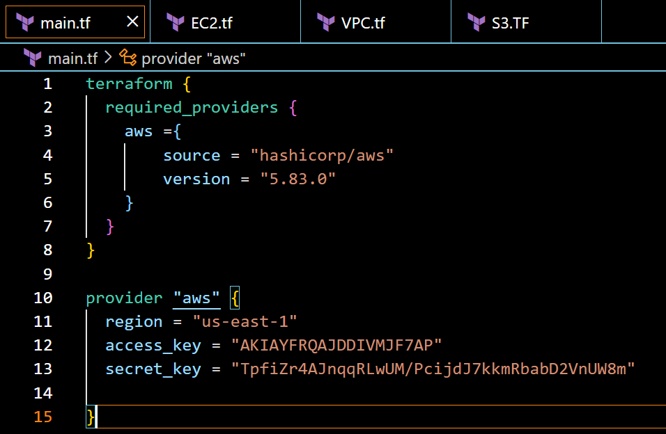

Step 2: To create two T3 Micro EC2 Instances create EC2.tf :

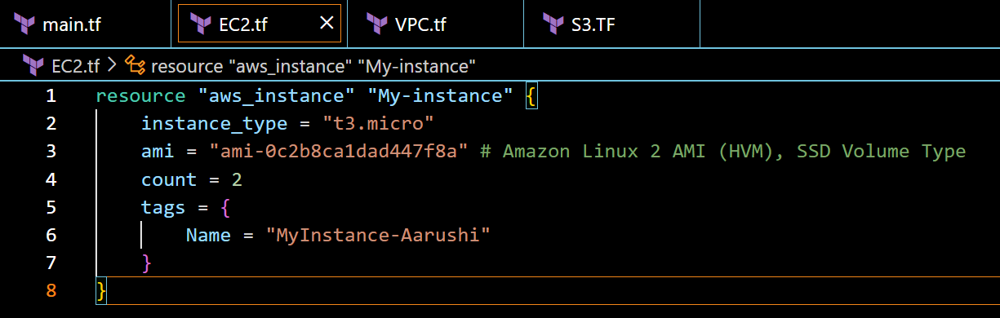

Step 3: To Create a VPC on AWS create VPC.tf :

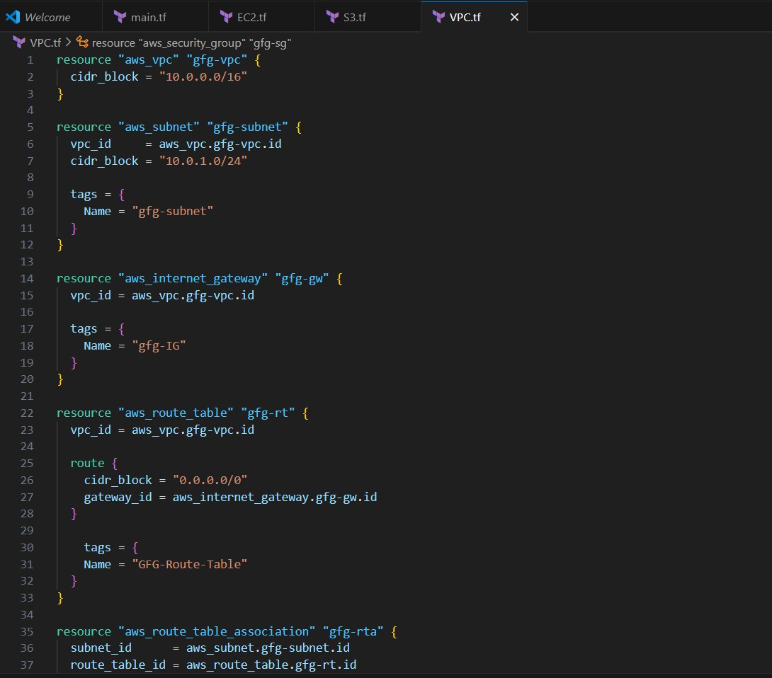

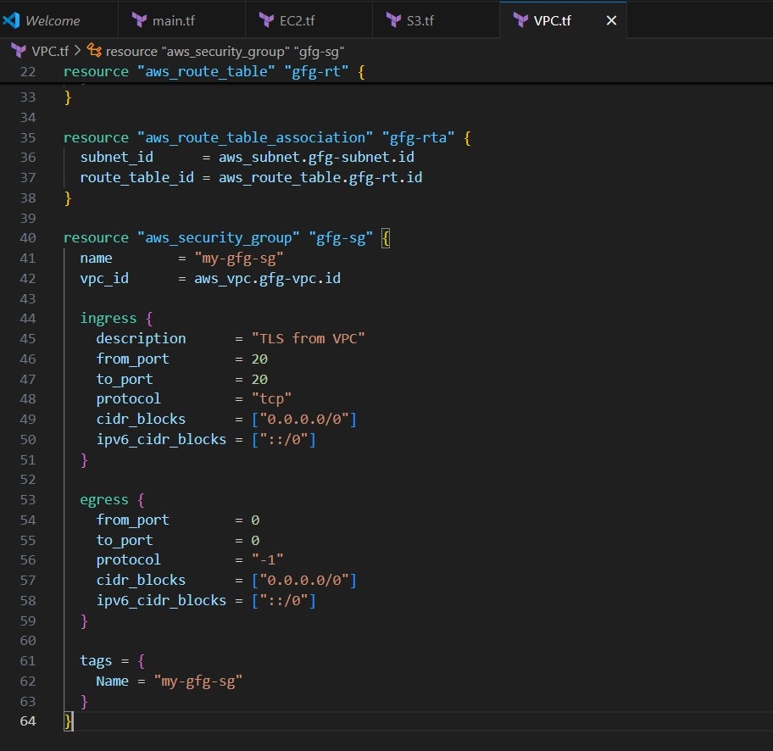

Step 4: To Create a S3 Bucket create S3.tf :

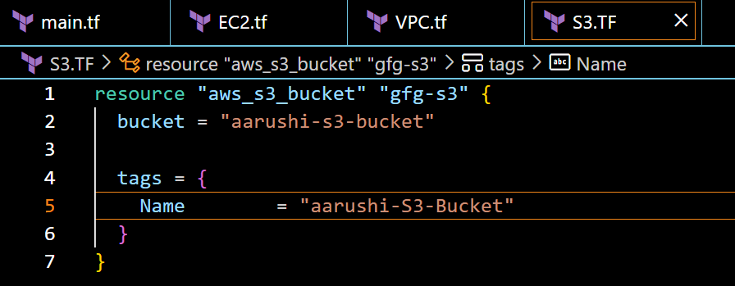

# Step 5: Initialize Terraform

Run the following command to initialize your Terraform working directory:

*terraform init*

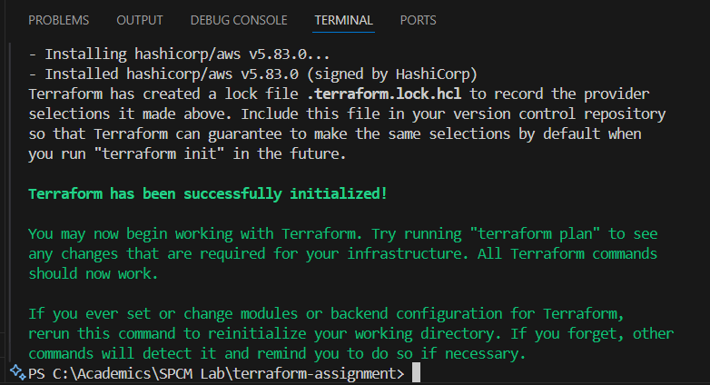

# Step 6: Review Plan

Run the following command to see what Terraform will do:

*terraform plan*

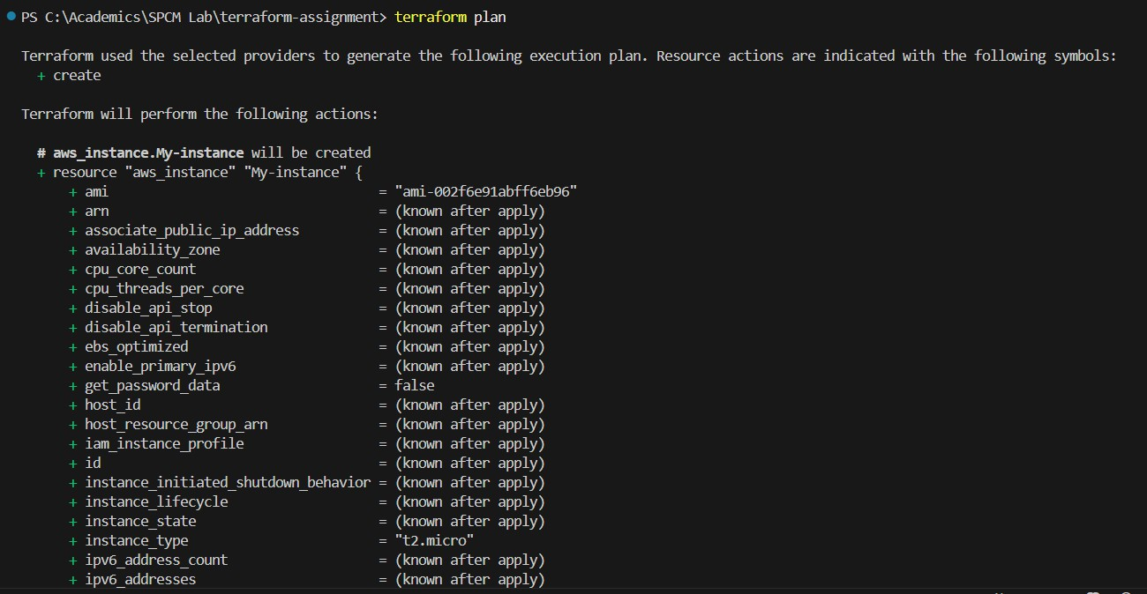

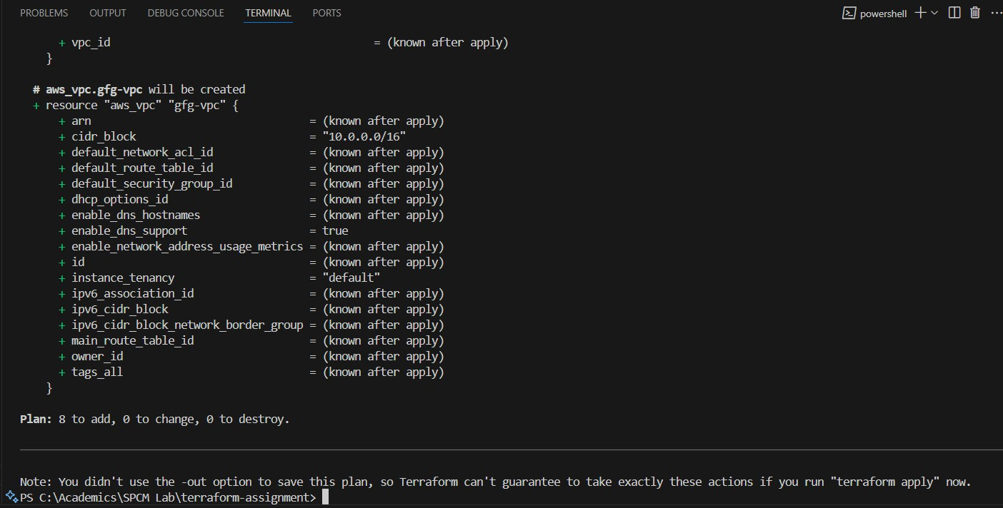

# Step 7: Apply Changes:

Apply the changes to create the AWS resources:

*terraform apply*

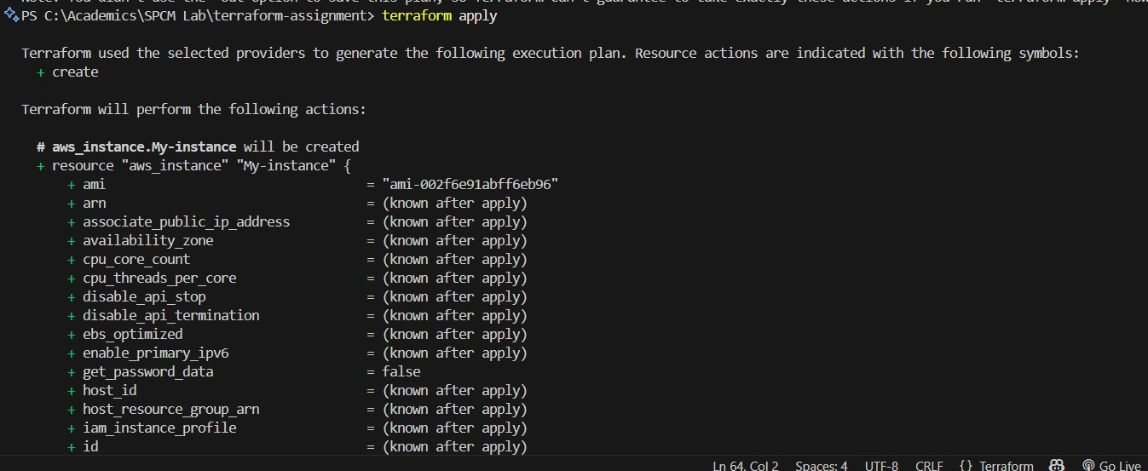

It will ask for approval before creating, enter “yes” to continue.

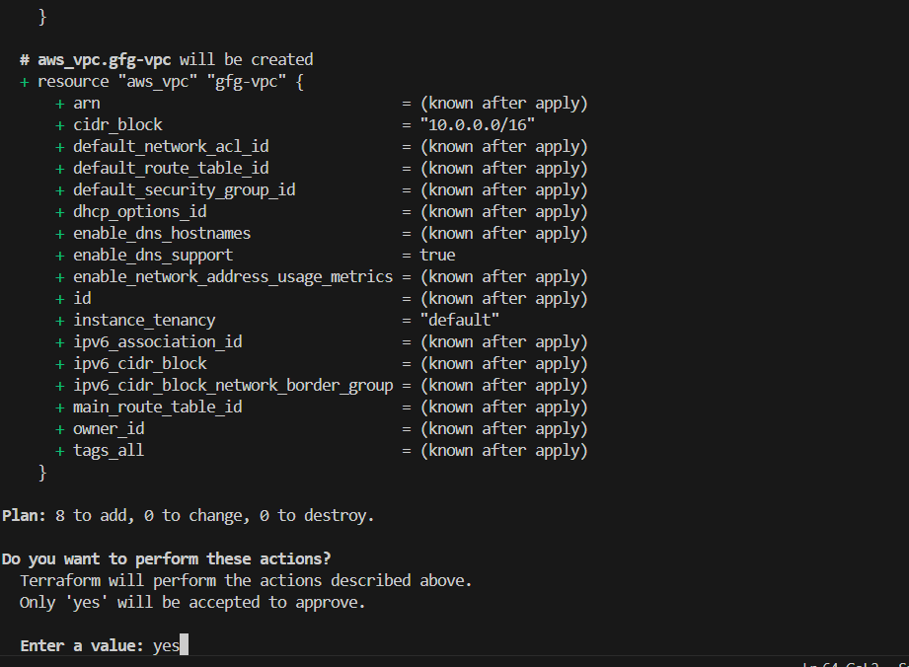

After approval, changes will be made

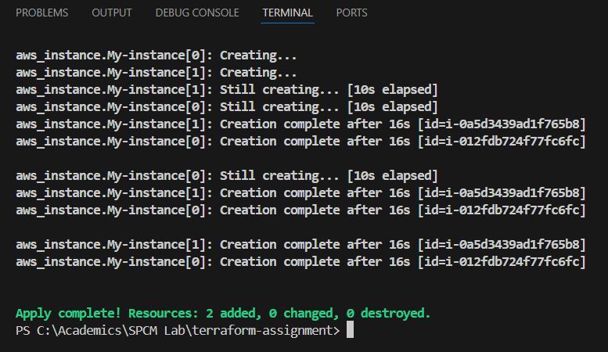

# Verification

Creation of 2 EC2 instances:



Creation of VPC:



# Step 8: Cleanup Resources

When done experimenting, run the following command to destroy the created resources:

*terraform destroy*

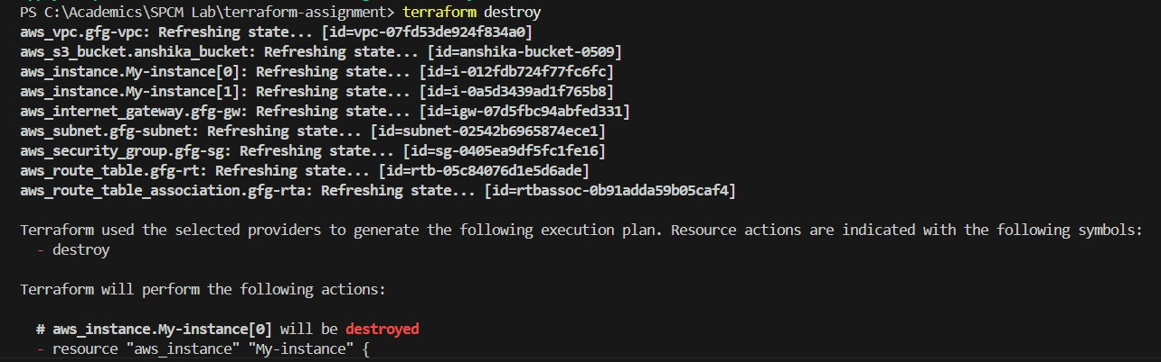

It will ask for approval before destroying, enter “yes” to continue.

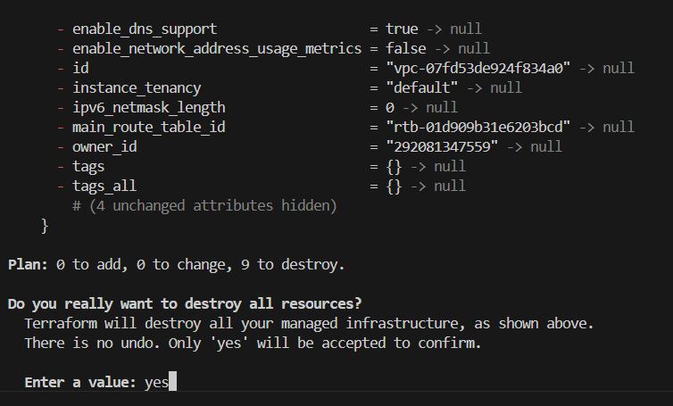

After approval, it starts destroying

