

System Provisioning and Configuration Module Lab

**Assignment 1**

**Under the Guidance of: Dr. Hitesh Kumar Sharma**

Submitted by – Karandeep Singh Ghai

SAP ID - 500105718

Roll No - R2142220534

Batch - DevOps B1(H)

1. **Create two T2 Micro EC2 Instances. This instance.tf file contains the Iac code to create two instances of type t2.micro and ami of ubuntu.**

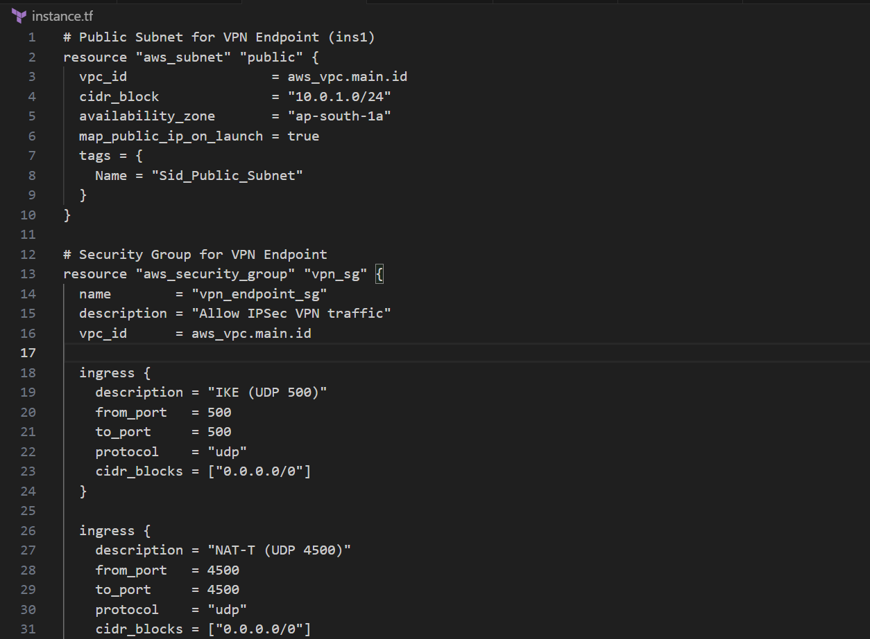

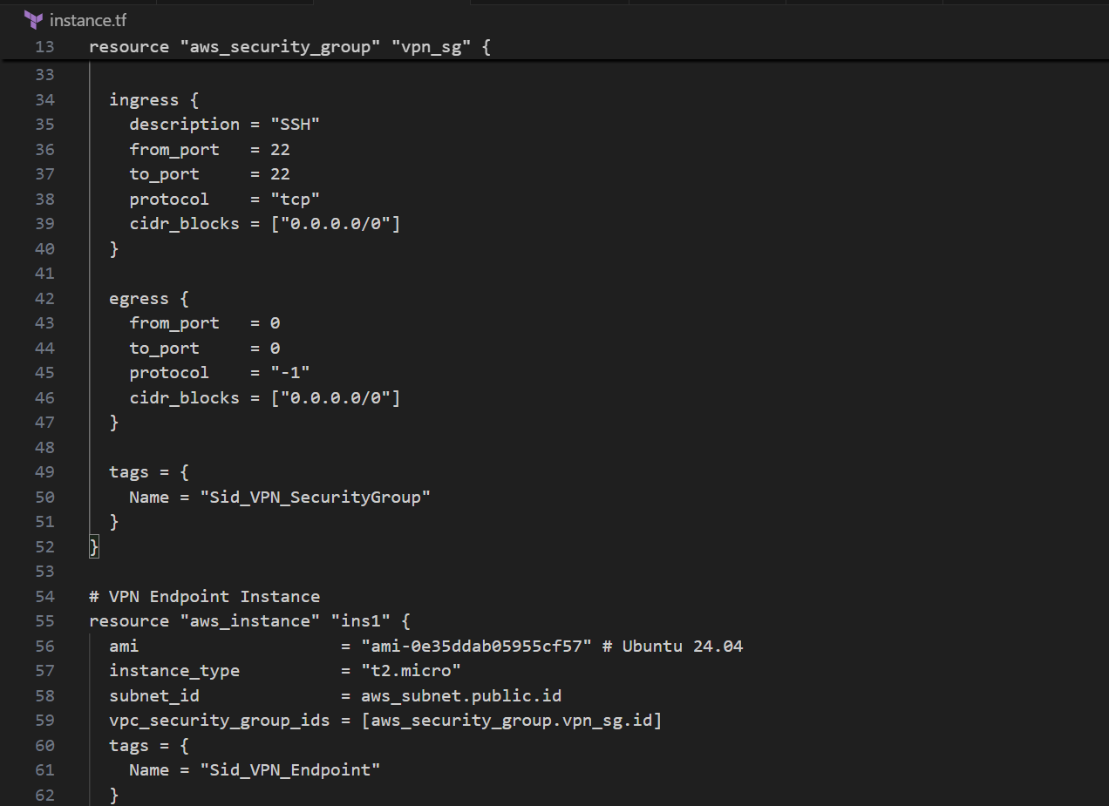

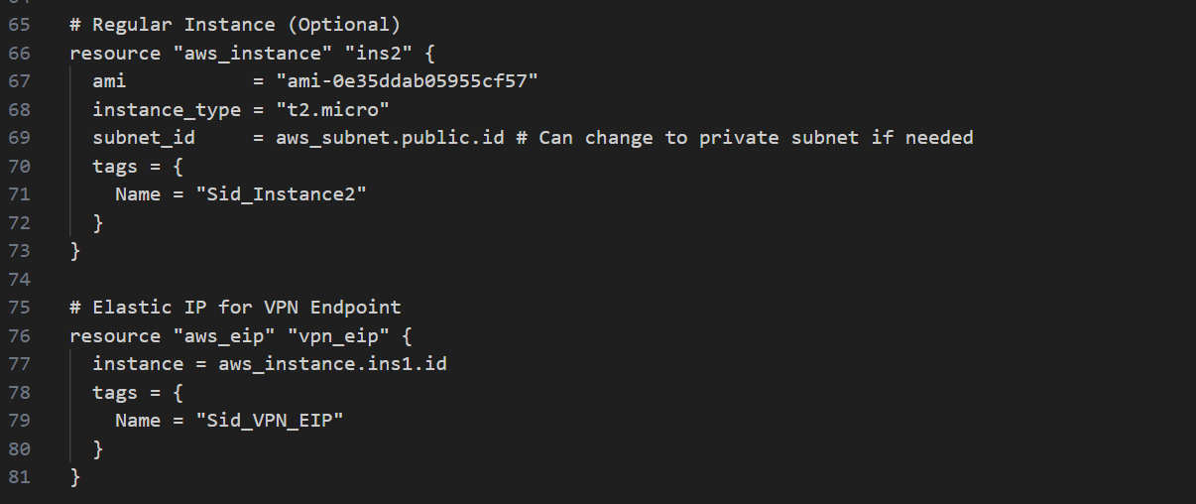

1. **Create a VPN on AWS This resource.tf file contains the complete code to make a VPN. It consists of resources like vpc, customer gateway and vpn connection.**

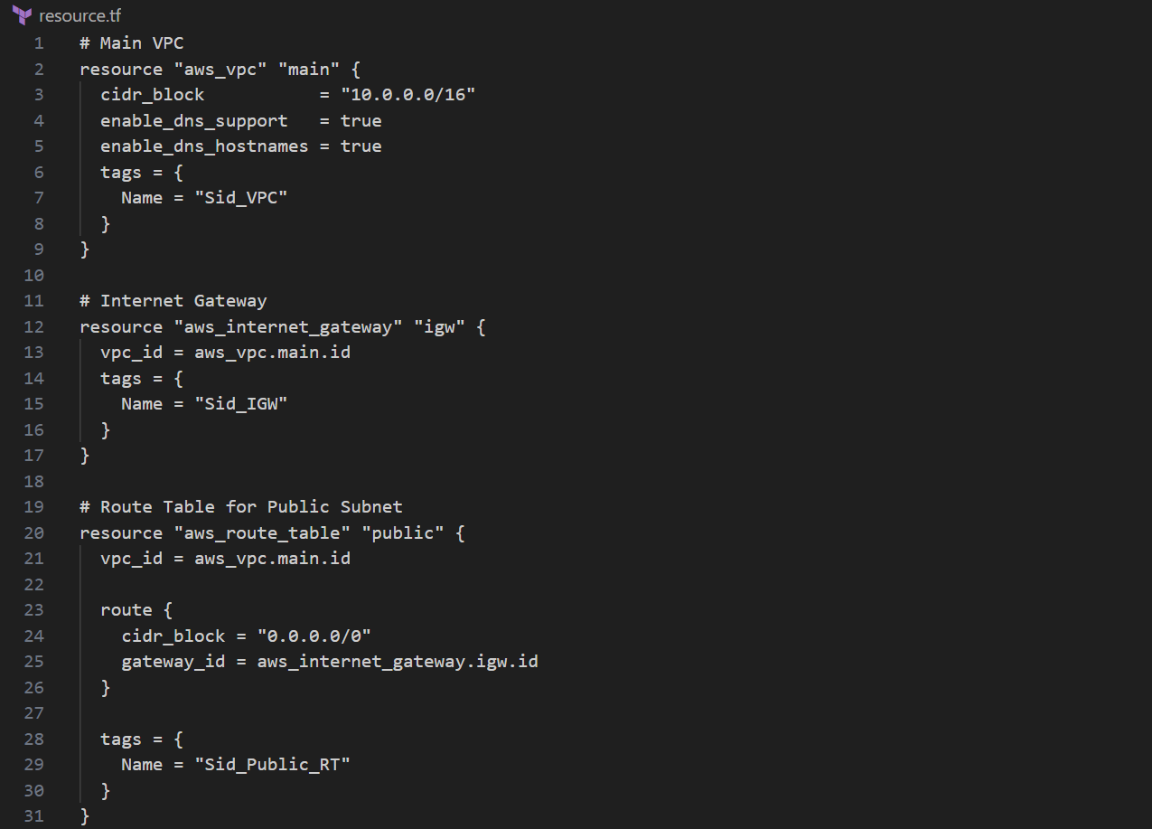

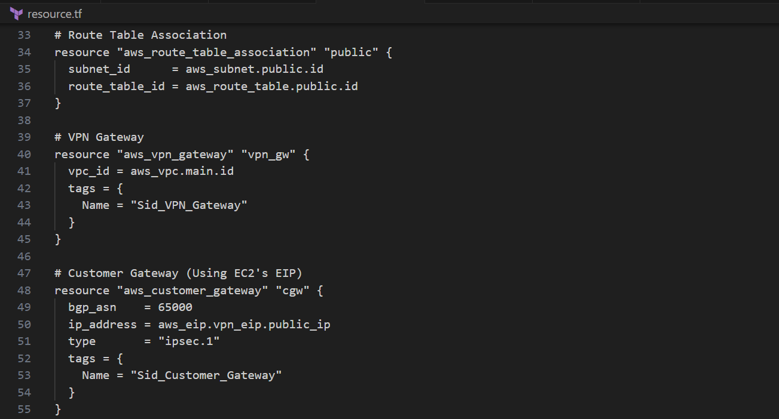

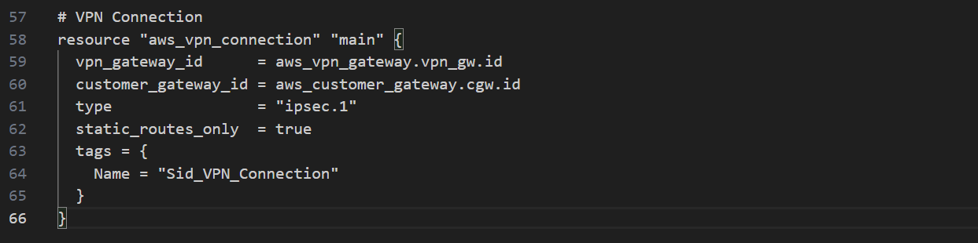

1. **Create a S3 Bucket Code to create a s3 bucket.**

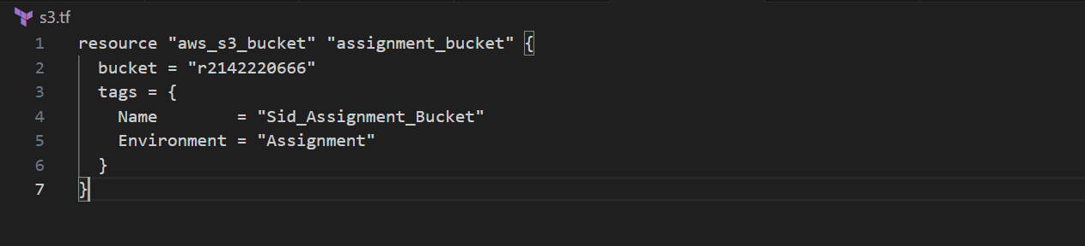

1. **Main.tf file to perform the above-mentioned tasks**

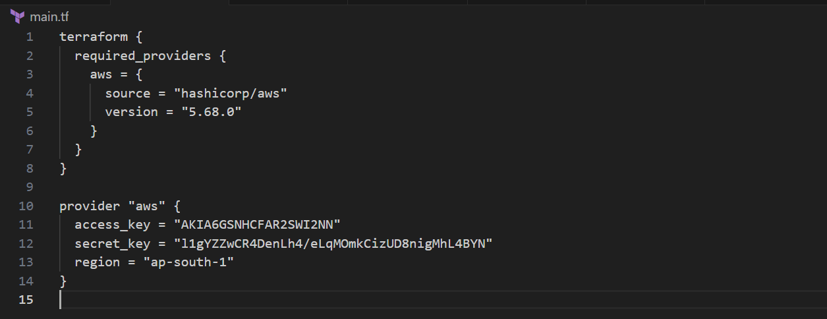

1. **Terraform init to initialize the terraform folder which will have the aws provider.**

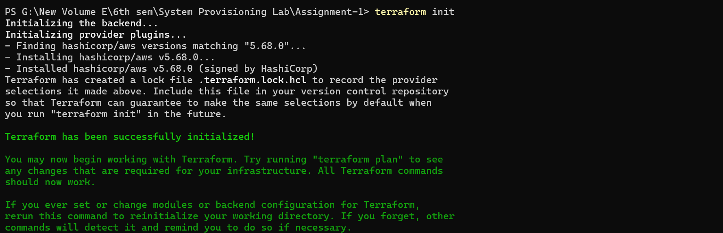

1. **Terraform plan to see the resources that will be created.**

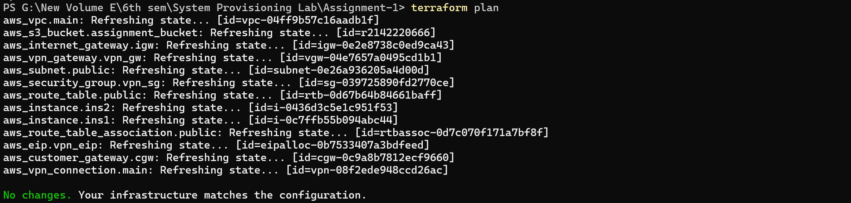

**P.s. - I performed terraform plan after terraform apply so the resources were actually created. In practice, it is advised to perform terraform plan before terraform apply to see what resources will be created.**

1. **Terraform apply to create the mentioned resources.**

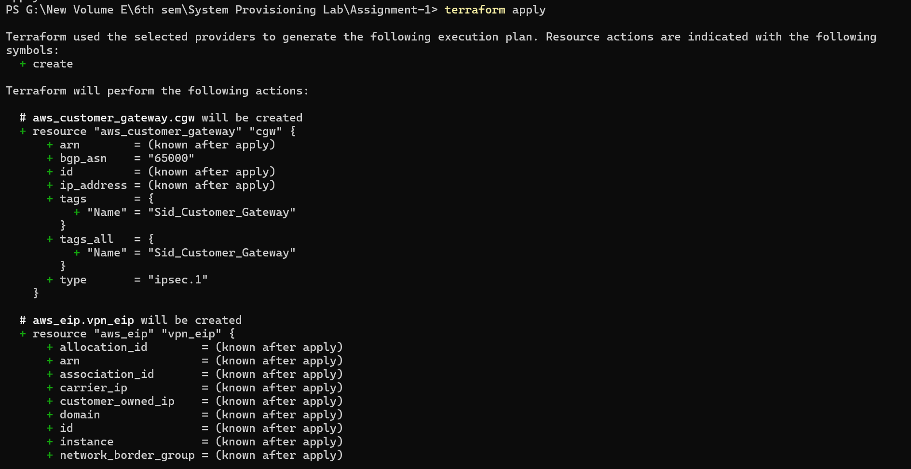

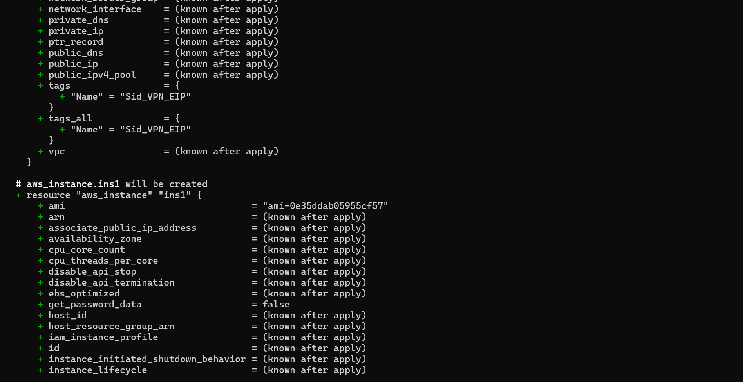

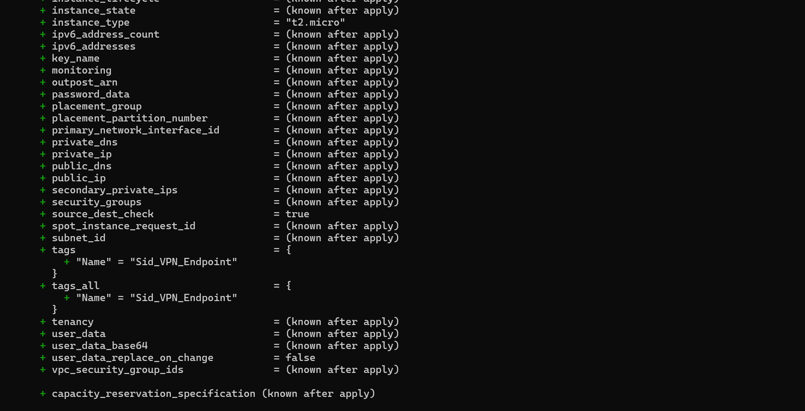

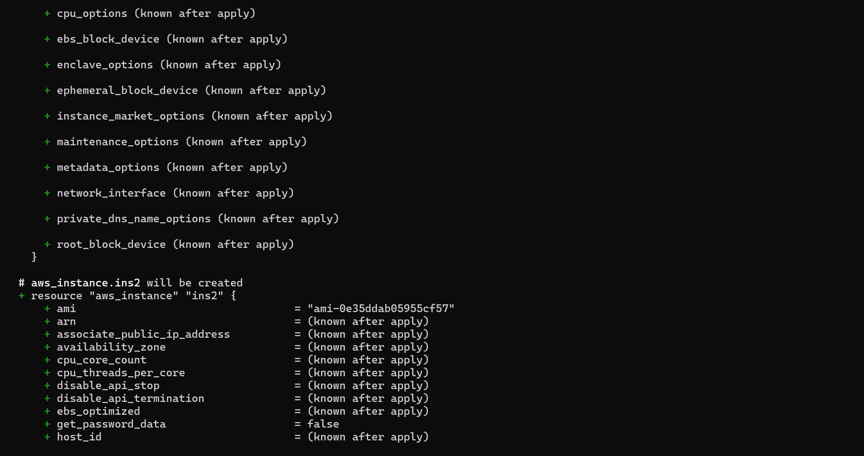

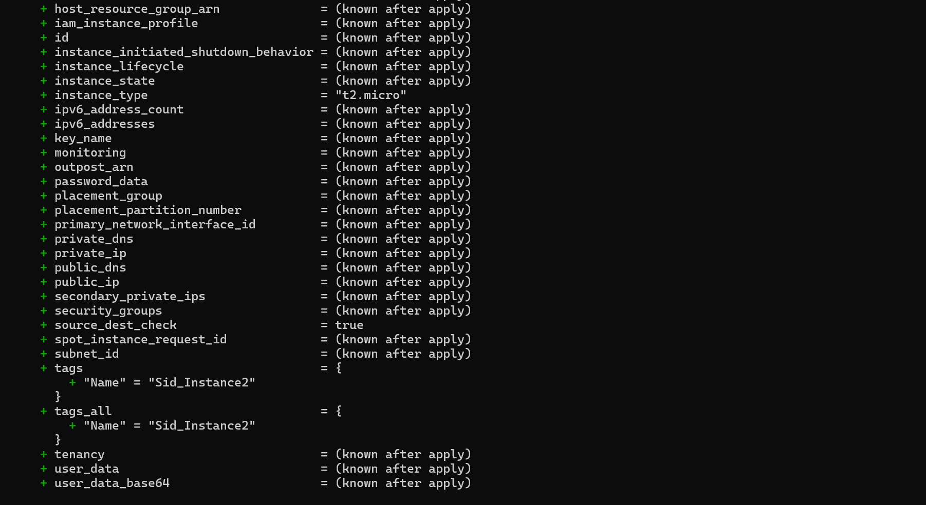

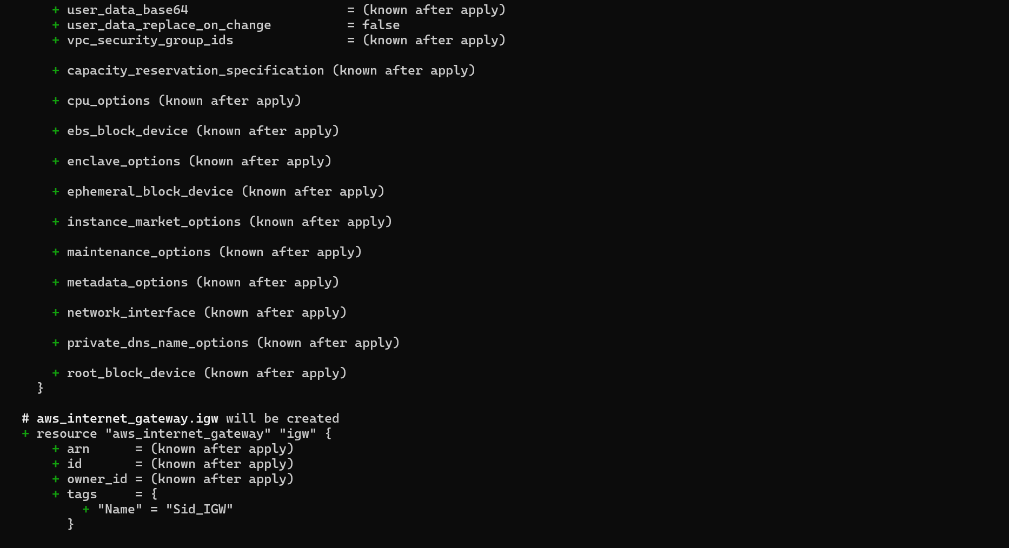

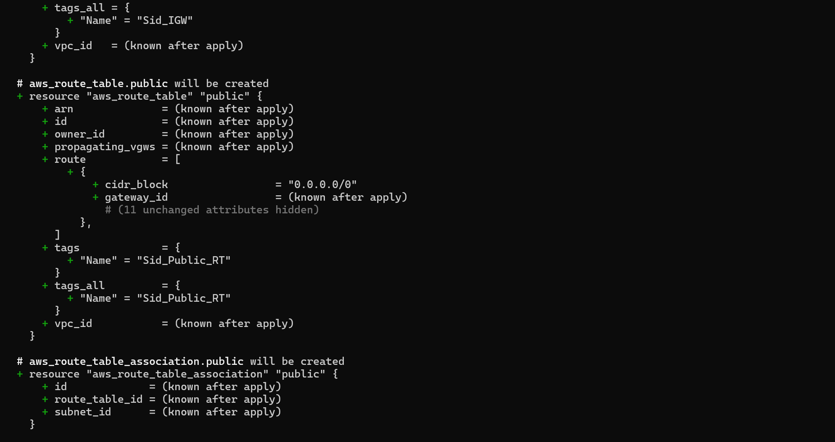

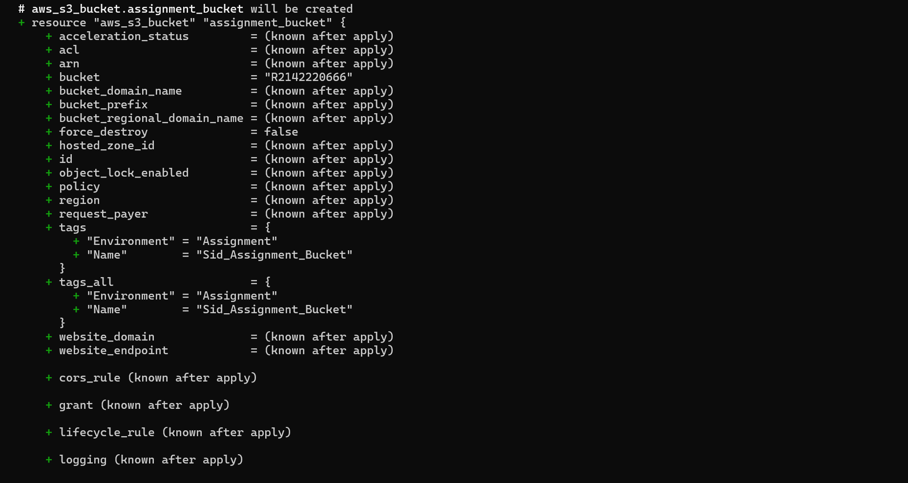

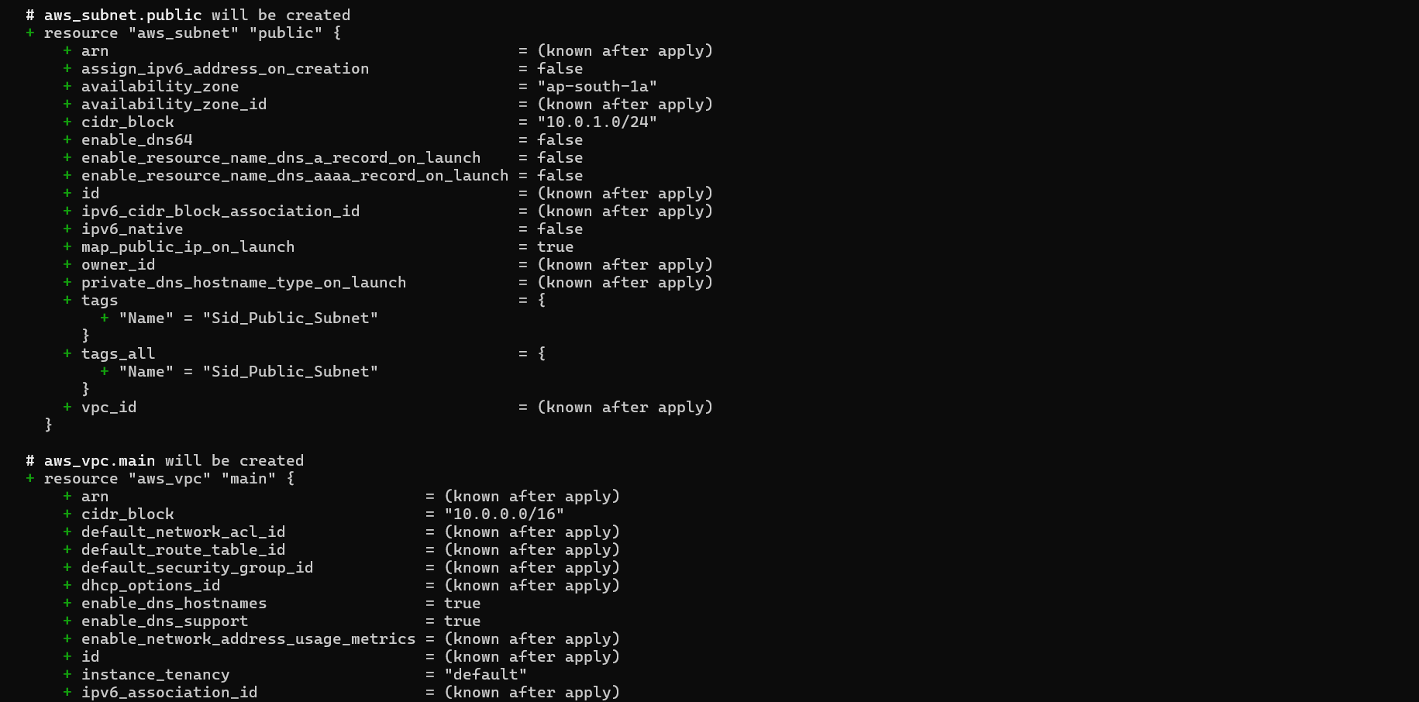

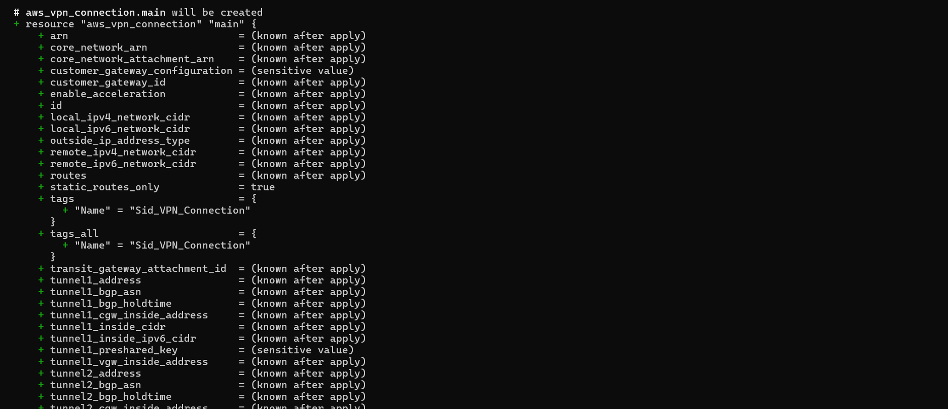

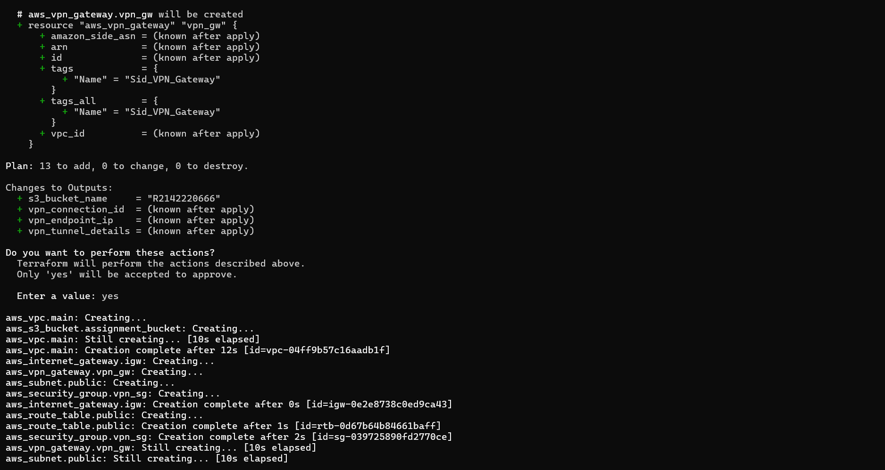

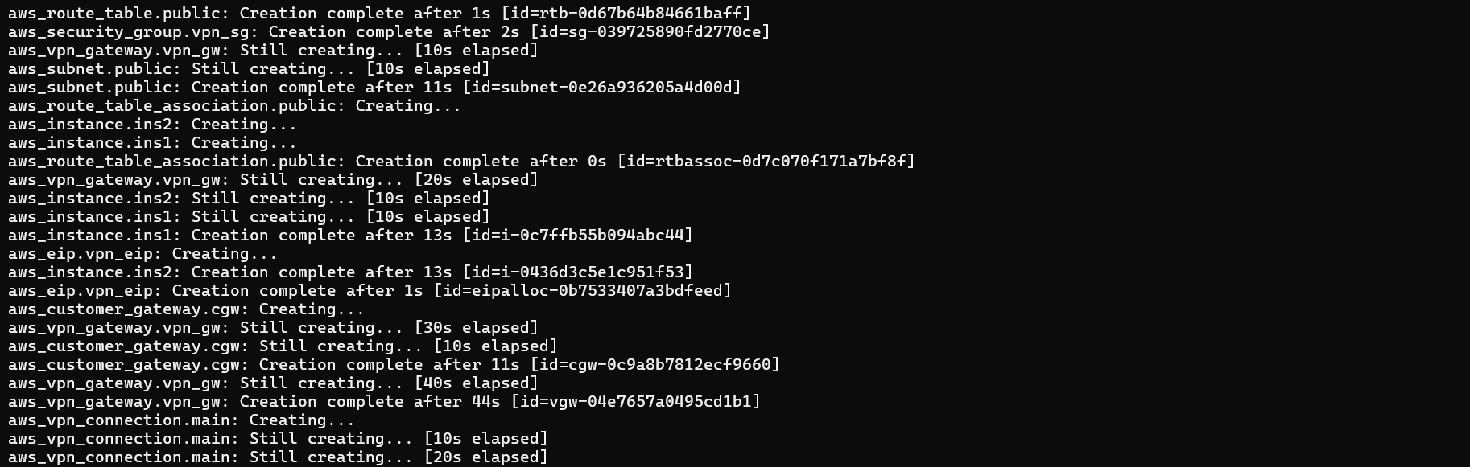





**Resources Created -**

1. **Instances**

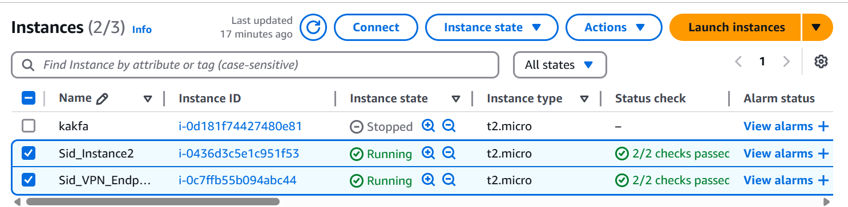

1. **S3 Bucket**

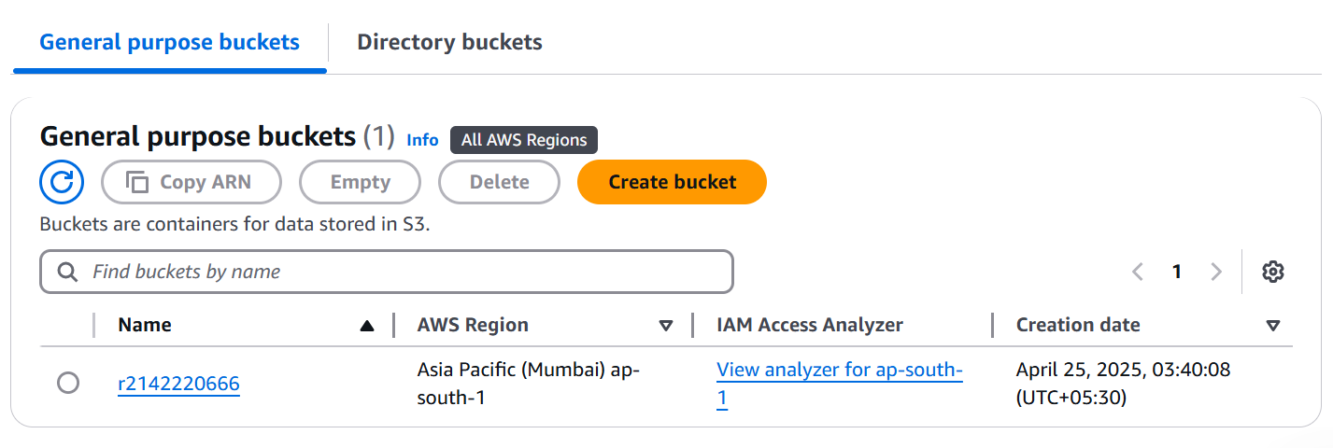

1. **Customer Gateway**

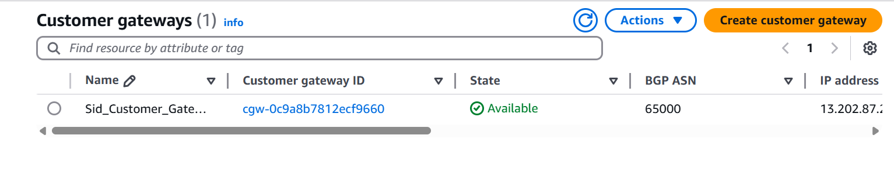

1. **VPC**

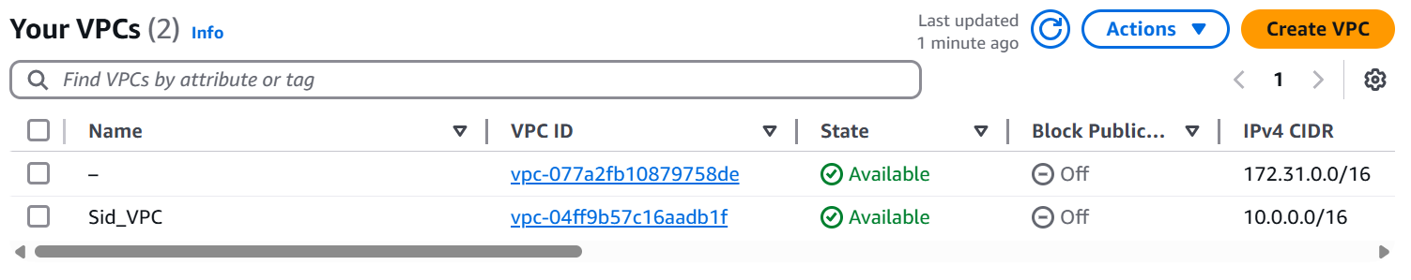

1. **VPN Connections**

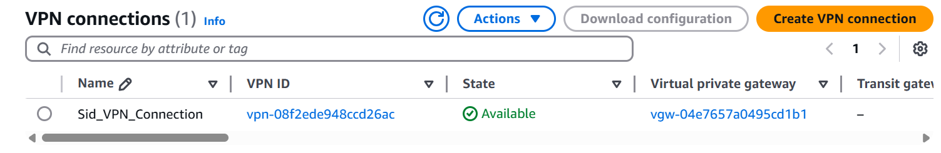

**Then use terraform destroy to clean up all the resources.**

